Additional File S4

Xylanase and endoglucanase activities

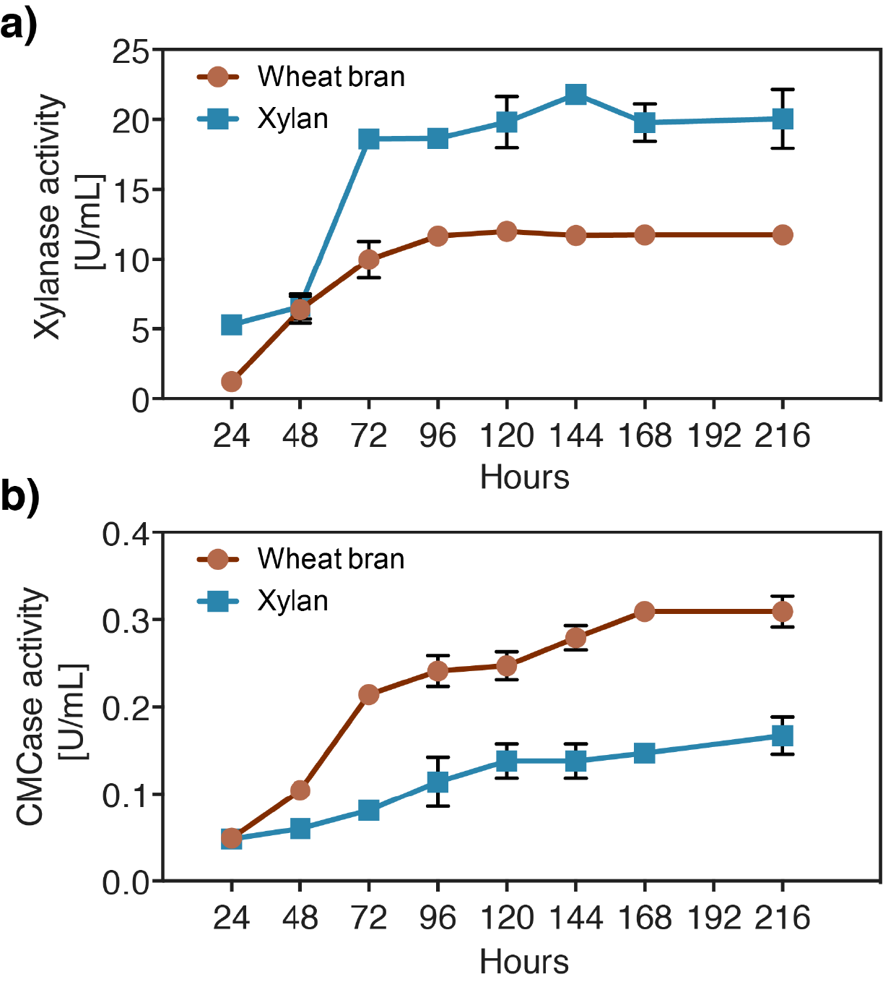
Additional Files S4. Enzyme assays evaluating xylanase (a) and endoglucanase (CMCase) (b) activities in the culture filtrate of M. cinnamomea FCH 10.5 cultivations on beechwood xylan (blue) and wheat bran (red) over the course 216 hours (=9 days).

