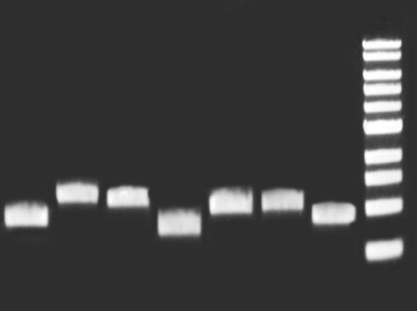
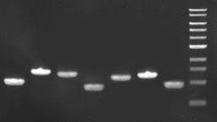
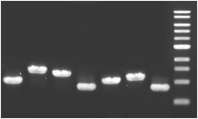
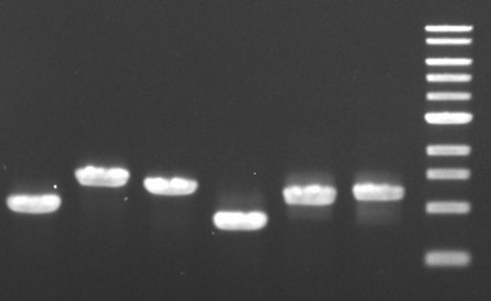
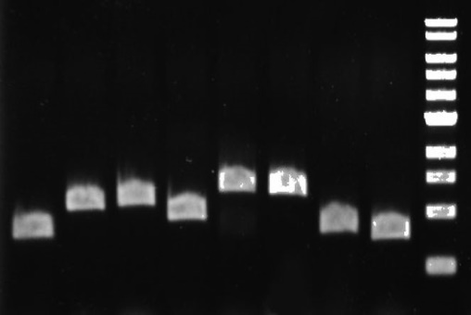
B 1 2 3 4 5 6 7
A 1 2 3 4 5 6
C 1 2 3 4 5 6 7
D 1 2 3 4 5 6 7
E 1 2 3 4 5 6 7 8
Figure S1 PCR verification of Y. lipolytica transformants expressing multiple cellulases and accessory enzymes (A) YLC7, Lane 1 to 6: BGL1, BGL2, 4UASTrEGI, TrEGII, 4UASNcCBHI, 4UASTrCBHII; (B) YLC8, Lane 1 to 6: BGL1, BGL2, 4UASTrEGI, TrEGII, 4UASNcCBHI, 4UASTrCBHII, TrXYNII; (C) YLC9, Lane 1 to 7: BGL1, BGL2, 4UASTrEGI, TrEGII, 4UASNcCBHI, 4UASTrCBHII, TrLPMOA; (D) YLC10, Lane 1 to 7: BGL1, BGL2, 4UASTrEGI, TrEGII, 4UASNcCBHI, 4UASTrCBHII, TrSWO1; (D) YLC11, Lane 1 to 8: BGL1, BGL2, 4UASTrEGI, TrEGII, 4UASNcCBHI, 4UASTrCBHII, TrXYNII, TrLPMOA.

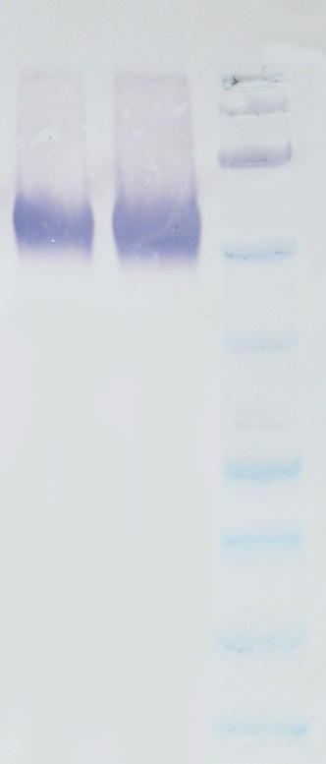
1 2
150kD
100
75

50

37

Figure S2 Western blot analysis of the heterologous rhTrEGI protein secreted by the engineered Y. lipolytica strains: lane 1, Endo H-treated secretome of YLC6 (20 μL); lane 2, Endo H-treated secretome of YLC7 (20 μL).

Figure S3 Characterization of the recombinant XYNII expressed in Y. lipolytica. (a) Effect of pH on the activity of rhXYNII; (b) Effect of temperature on the activity of rhXYNII.

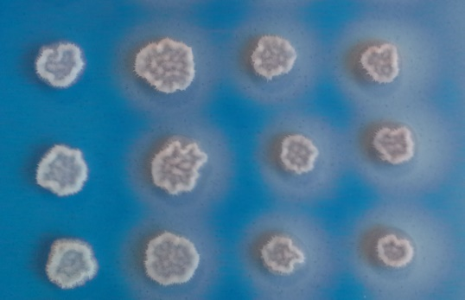
1 2 3 4
Figure S4 Screening of Y. lipolytica expressing cellulases and accessory enzymes on YNB indication plate containing supplemented with 0.2% w/v Azo-CM-Cellulose. Lane 1, Y. lipolytica control; Lane 2 to 4, YLC8, YLC9 and YLC10.

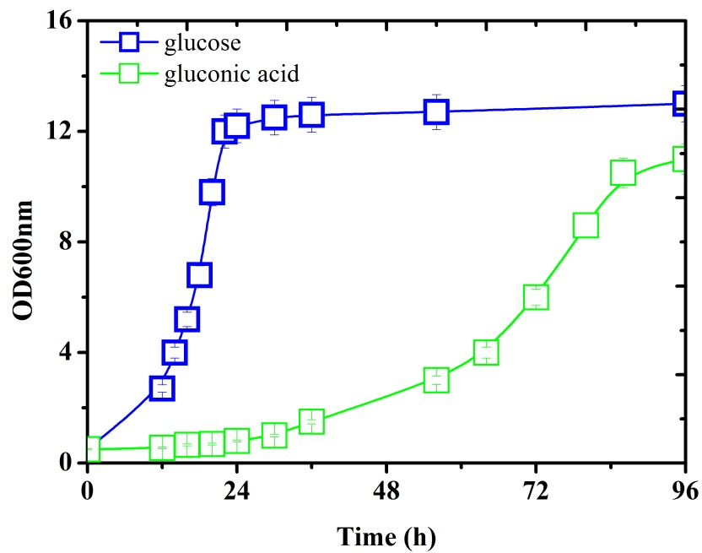
Figure S5 The growth of Y. lipolytica in defined medium containing 10 g/L gluconic acid or 10 g/L glucose.

Table S1 The sequences of the oligonucleotide primers used for PCR verification of Y. lipolytica-transformants
Primer names | Sequence (5’-3’)
VBGL1A | TTGACCCAGTAGCGGACCCAA
VBGL1B | GCCGACATTAGCCCTAACAGCAT
VBGL2A | GGTTGGCGGCGCATTTGT
VBGL2B | TGTCGTCCACTCGGCTTTCATC
V4UASEGIA | CACTTGCCGTTAAGGGCGTAGGGT
V4UASEGIB | CTGGCTGTTGTCGTTCCAAATGCTG
VEGIIA | CTTGCCGTTAAGGGCGTAGGG
VEGIIB | CCATCGAGCATAATTGTGGATGTCG
VCBHIA | TTTGCTTTGTGGTTGGGACTTTAGC
VCBHIB | GGTTCGAGATCCGATGTTAGTGGAGTA
VCBHIIA | TTTGCTTTGTGGTTGGGACTTTAGCC
VCBHIIB | AGGCGTTGGACCAGCCGTGA
V4UASCBHIA | CGCCGCAAGGAATGGTGCA
V4UASCBHIB | GGTTCGAGATCCGATGTTAGTGGAGTA
V4UASCBHIIA | CGCCGCAAGGAATGGTGCA
V4UASCBHIIB | CCGATCCGACTGGAGGTACTCTGGTAG
VXYNA | CCCAAATTGACCCAGTAGCGGACCCA
VXYNB | GAGAAGTAGCCCTCGACGGCGACGATC
VLPMOA | TTGACCCAGTAGCGGACCCAACCC
VLPMOB | TGATCTCGTGGCGGAGCACGTAATT
VSWOA | TTTTGCTTTGTGGTTGGGACTTTAGCC
VSWOB | GGGTGTAGTAGTCGCCGTTGGGAGC

Table S2 Comparison of cellulose utilization and biomass yield of cellulolytic Y. lipolytica grown on different cellulosic substrates for 120h in aerobic cultivation without the addition of ascorbic acidª
Strains | CIMV-cellulose consumed % | Biomass yield % | Cellulose consumed % (wheat straw) | Biomass yield %
YLC9 | 64.9 ± 0.5 | 0.37 ± 0.03 | 16.0 ± 0.6 | 0.16 ± 0.01
YLC11 | 67.2 ± 0.8 | 0.38 ± 0.03 | 17.8 ± 0.5 | 0.15 ± 0.02
^{b}YLC11+ S | 68.5 ± 1.0 | 0.38 ± 0.02 | 20.9 ± 0.7 | 0.16 ± 0.01
ªThe results were calculated from at least three biological replicates, and are given as the mean value ± standard deviation. The initial cellulose content was 25 g/L for all the substrates.
^{b}The cellulose was treated by SWO1 at the dosage of 15 mg/g cellulose for 24 h before enzymatic hydrolysis.

