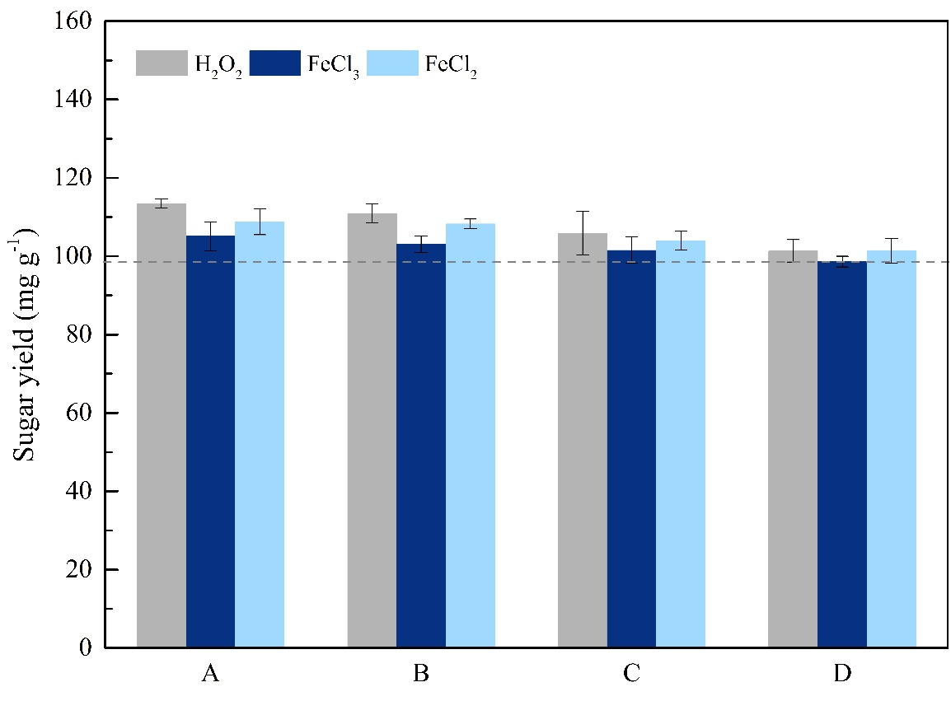
Figure S1 the effects of pretreatment conditions on the enzymatic hydrolysis of the untreated (dashed line) and pretreated RS. The experimental groups were A: 0.04M FeCl₃/0.04M FeCl₂/3M H₂O₂; B: 0.03M FeCl₃/0.03M FeCl₂/2.25M H₂O₂; C: 0.02M FeCl₃/0.02M FeCl₂/1.5M H₂O₂; D: 0.01M FeCl₃/0.01M FeCl₂/0.75M H₂O₂.

The RS pretreated with only H₂O₂ or only Fe(II)/Fe(III) did not obtain effective enzymatic hydrolysis under the same conditions. The oxidability of H₂O₂ was greatly low without Fe(II)/Fe(III). In addition, FeCl₃ solution provided acidic conditions, but sole FeCl₃ pretreatment under low temperature could not effectively promote the enzymatic hydrolysis of the RS.

