Additional file
Microbial biogas production from hydrolysis-lignin - Insight into lignin structural changes
Daniel Girma Mulatª, Janka Dibdiakova^{b} and Svein Jarle Hornª*

ªFaculty of Chemistry, Biotechnology and Food Science, Norwegian University of Life Sciences, P.O.Box 5003, 1432 Ås, Norway.
^{b}Norwegian Institute of Bioeconomy Research, P.O.Box 115, 1432 Ås, Norway
*Correspondence to: Svein Jarle Horn; E-mail: svein.horn@nmbu.no

3 pages, 1 Table and 1 Figure are included in the supporting material.

Table S1
Assignments of ¹³C-¹H correlation signals in the HSQC spectra of the lignin components in birch.
Labelª | δ_{C}/δ_{H} (ppm) | Assignments
B_{β} | 53.6/3.04 | C_{β}−H_{β} in β-β resinol substructures (B)
–OCH₃ | 55.6/3.71 | C−H in methoxyls
A_{γ} | 59.5/3.69 | C_{γ}−H_{γ} in β-O-4' substructures (A)
C_{γ} | 62.3/3.70 | C_{γ}−H_{γ} in β-5 phenylcoumaran substructures (C)
B_{γ} | 71.0/3.88-4.17 | C_{γ}−H_{γ} in β-β resinol substructures (B)
A_{α} | 71.9/4.85 | C_{α}−H_{α} in β-O-4' units (A)
BE_{α} | 81.3/4.65 | C_{α}−H_{α} in benzyl ether (BE) LCC structures
A′_{α} | 83.1/5.21 | C_{α}−H_{α} in γ-acylated β-O-4' substructures (A′)
A_{β(G)} | 83.9/4.33 | C_{β}−H_{β} in β-O-4' linked to G/H unit (A)
B_{α} | 84.9/4.64 | C_{α}−H_{α} in β-β resinol substructures (B)
A_{β(S)} | 85.9/4.11 | C_{β}−H_{β} in β-O-4' linked to a S unit (A)
C_{α} | 87.0/5.45 | C_{α}−H_{α} in β-5 phenylcoumaran substructures(C)
S_{2,6} | 104.0/6.70 | C_{2,6}−H_{2,6} in syringyl units (S)
S′_{2,6} | 106.3/7.31 | C_{2,6}−H_{2,6} in oxidized (C_{α}=O) S units (S′)
G₂ | 111.1/6.98 | C₂−H₂ in guaiacyl units (G)
G₅ | 114.7/6.71 | C₅−H₅ in guaiacyl units (G)
G₆ | 118.9/6.80 | C₆−H₆ in guaiacyl units (G)

ªThe labels refer to the lignin units and substructures shown in Figures 2 and 3 (main text).

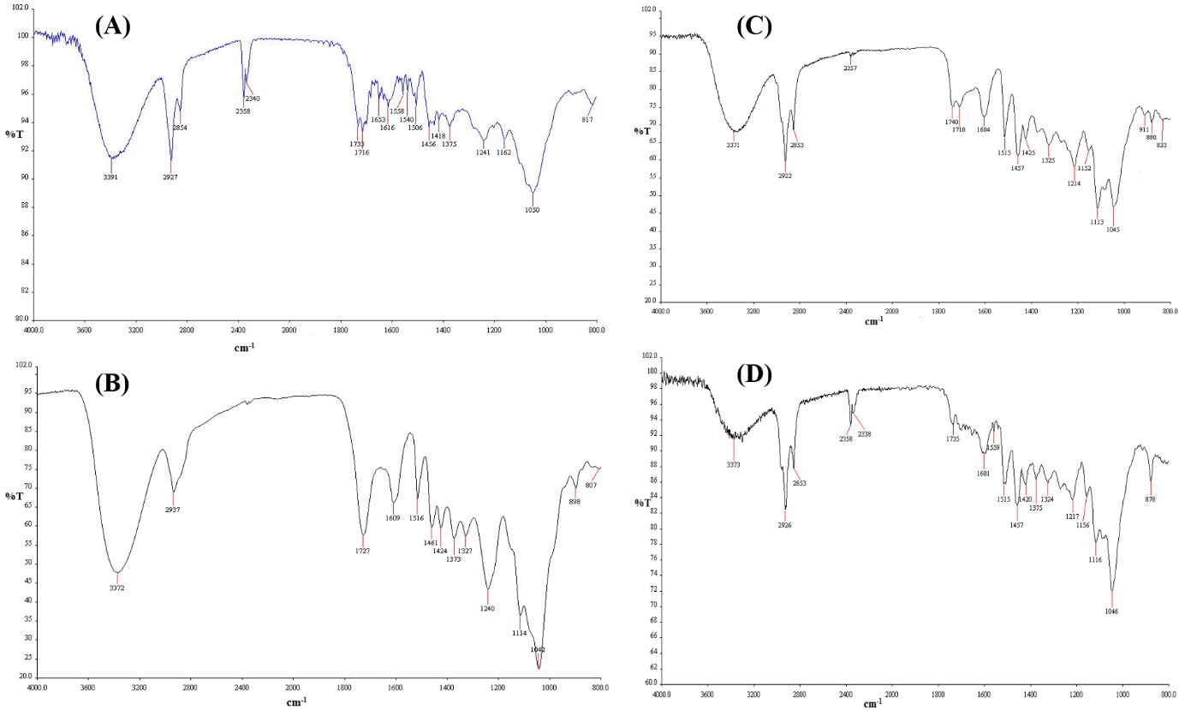

Figure S1 FTIR spectra of untreated (A), steam-exploded (B), HL (C) and HL birch after AD (D).

