Fig. S7 (corresponds to Fig. 1C, D)

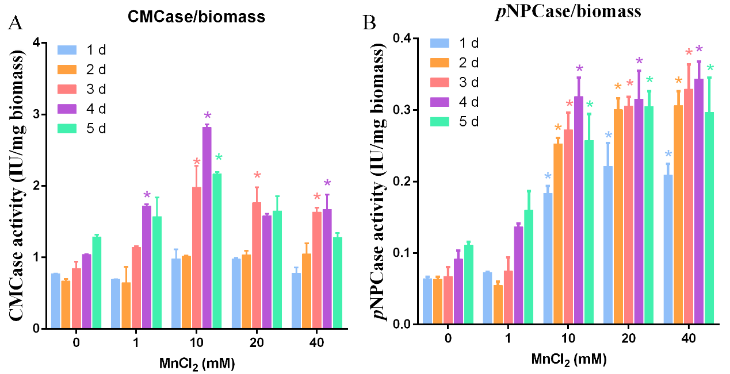
CMCase activity per biomass
pNPCase activity per biomass

Fig. S7 A-B. The effects of different concentrations of Mn²⁺ (final concentration 0, 1, 10, 20 and 40 mM) on CMCase activity per biomass (A) and pNPCase activity per biomass (B) of T. reesei Rut-C30. For every experiment, three biological replicates were performed with three technical replicates each. Values are the means±SD of the results from three independent experiments. Asterisks indicate a significant difference compared to the untreated strain (*p< 0.05, Student’s t test).

Fig. S8 (corresponds to Fig. 3C, D)

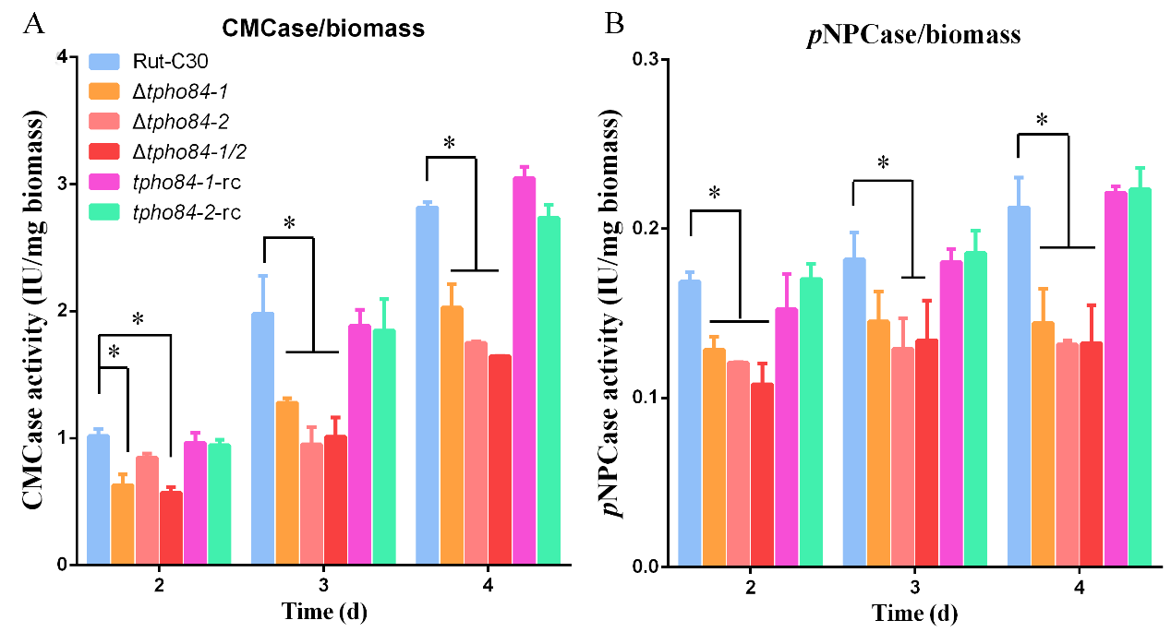
CMCase activity per biomass
pNPCase activity per biomass

Fig. S8 A-B. The CMCase activity per biomass (A) and pNPCase activity per biomass (B) of T. reesei Rut-C30 and its derivative mutant strains were examined after culture in medium containing 0 or 10 mM MnCl₂. For every experiment, three biological replicates were performed with three technical replicates each. Values are the means±SD of the results from three independent experiments. Asterisks indicate significant differences (*p< 0.05, Student’s t test).

Fig. S9 (corresponds to Fig. 5C, D)

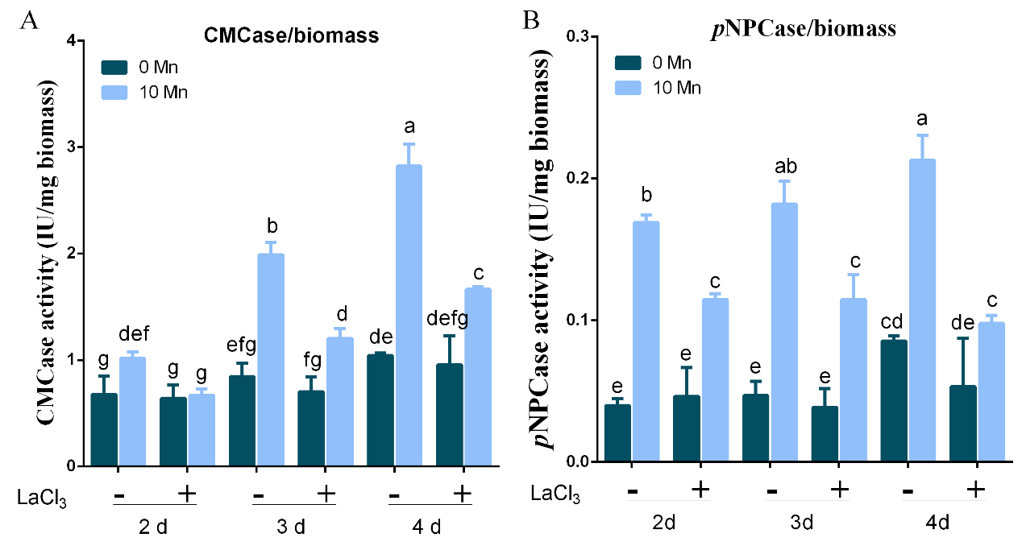
CMCase activity per biomass
pNPCase activity per biomass

Fig. S9 A-B. The CMCase activity per biomass (A) and pNPCase activity per biomass (B) of T. reesei Rut-C30 were examined after culture in medium containing 0 or 10 mM MnCl₂ and with (-) or without (+) 5 mM LaCl₃. For every experiment, three biological replicates were performed with three technical replicates each. Values are the means±SD of the results from three independent experiments. Different letters indicate significant differences between the columns (p< 0.05, according to Duncan’s multiple-range test).

Fig. S10 (corresponds to Fig. 6A, B)

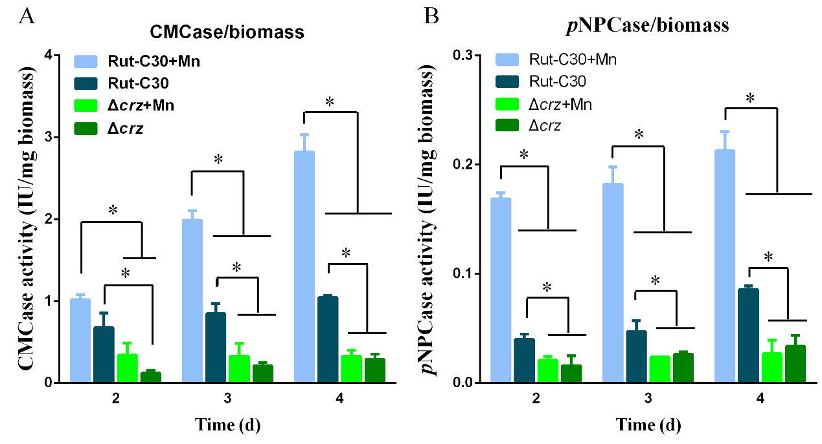
CMCase activity per biomass
pNPCase activity per biomass

Fig. S10 A-B. The CMCase activity per biomass (A) and pNPCase activity per biomass (B) of T. reesei Rut-C30 and Dcrz1 strains supplemented with 0 or 10 mM MnCl₂. For every experiment, three biological replicates were performed with three technical replicates each. Asterisks indicate significant differences (*p< 0.05, Student’s t test).

Fig. S11 (corresponds to Fig. 7C, D)

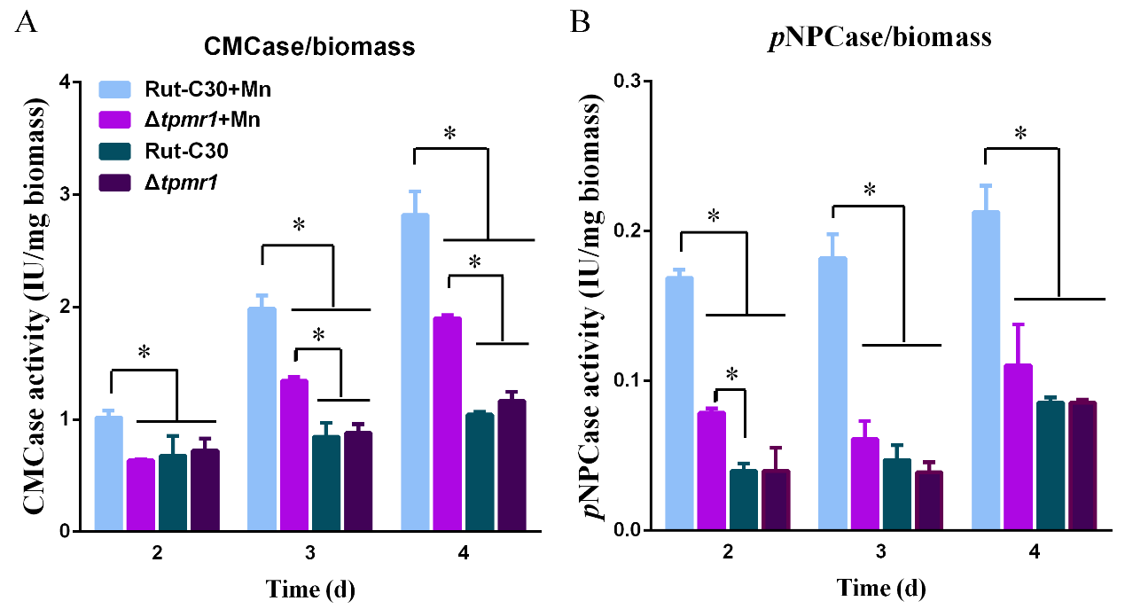
CMCase activity per biomass
pNPCase activity per biomass

Fig. S11 A-B. The CMCase activity per biomass (A) and pNPCase activity per biomass (B) of T. reesei Rut-C30 and Δtpmr1 strains were examined after culture in medium containing 0 or 10 mM MnCl₂. For every experiment, three biological replicates were performed with three technical replicates each. Asterisks indicate significant differences (*p< 0.05, Student’s t test).

