Additional file 10
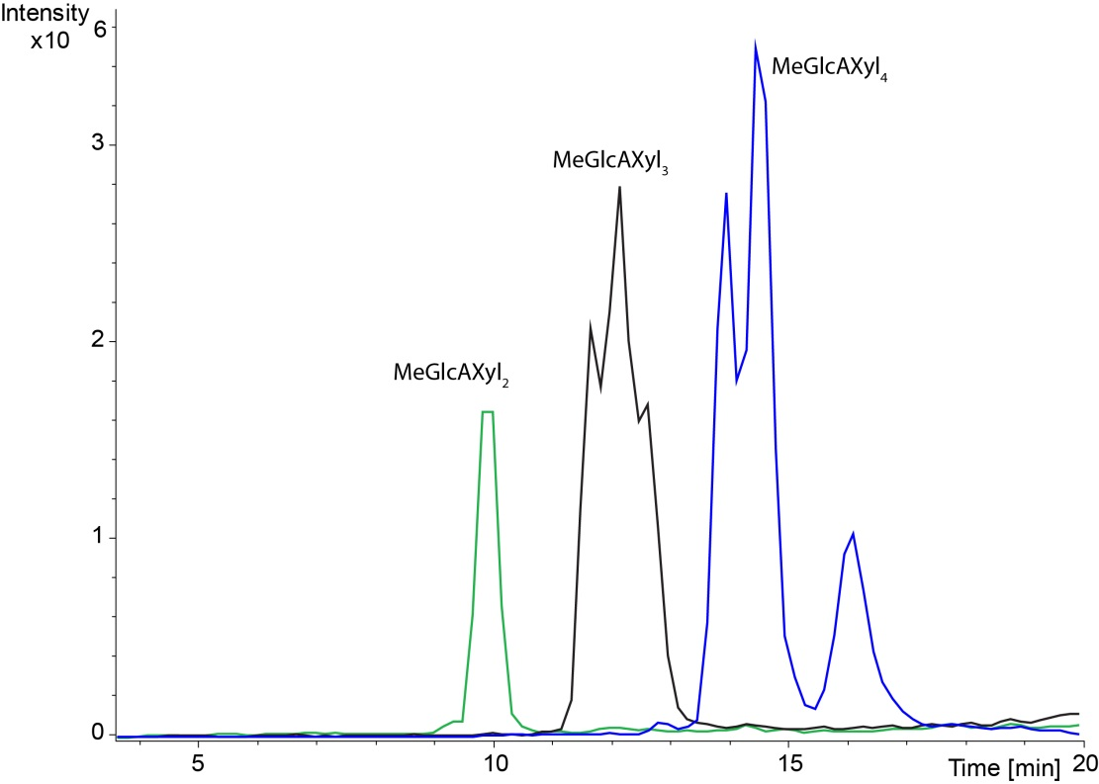
Chromatogram of CuGE hydrolysed LRP. The enzyme hydrolysate was after enzyme treatment saponified with NaOH to remove all acetylations. The chromatogram shows that several peaks appear for each compound mass indicating structural isomers eluting at different retention times. The chromatograms suggest that CuGE can release products with the 4-O-methyl-glucuronoyl substitution in various positions.

