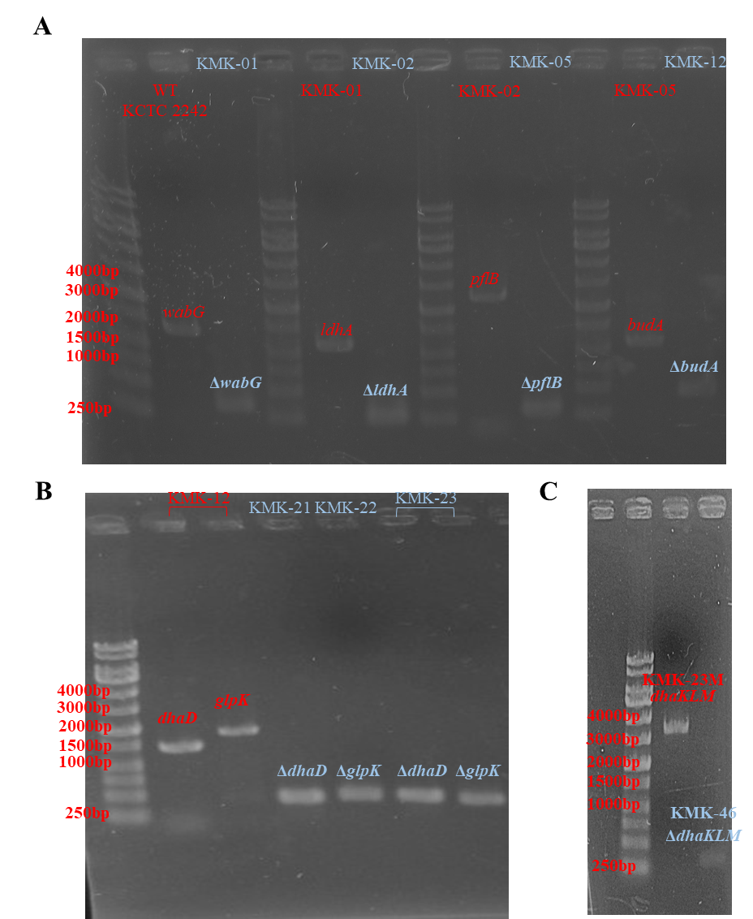

Figure S1. Confirmation PCR experiments for deletion mutants. A. PCR fragments from genomic DNA of K. pneumoniae KCTC 2242, KMK-01, KMK-02 and KMK-05 for wabG, ldhA, pflB, budA sites. B. PCR fragments from KMK-12, KMK-21, KMK-22 and KMK-23 for dhaD and glpK sties. C. PCR fragments from KMK-23M and KMK-46 for dhaKLM site. The genes from control strains are written in red, while ones from deleted strains are written in light blue.

