A
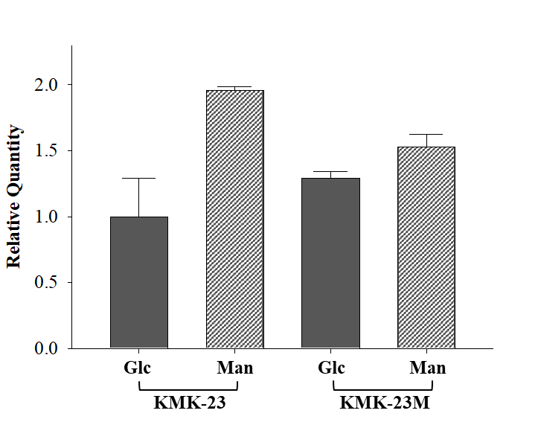

B
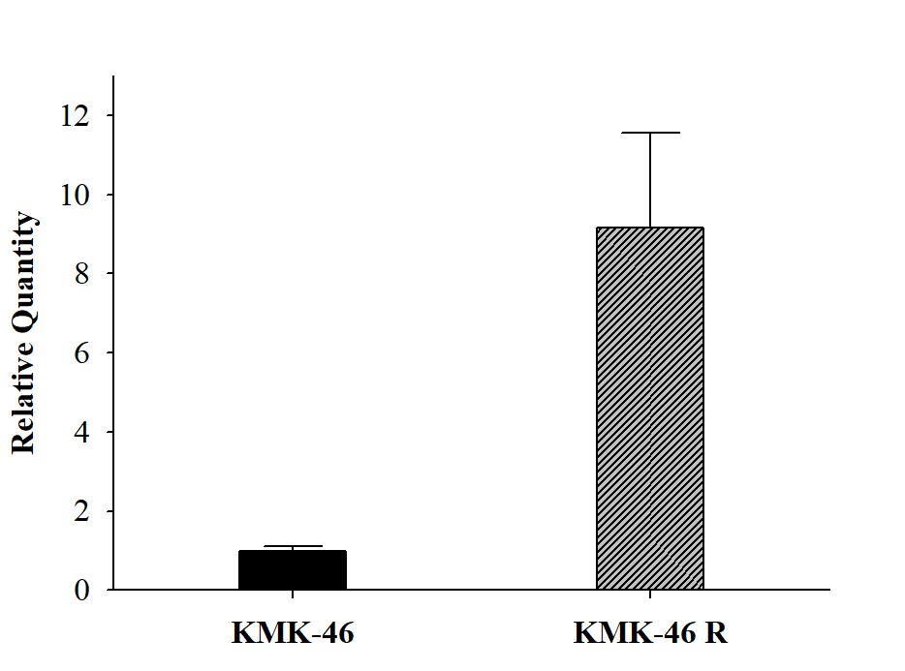

Figure S2. Relatively gene expression levels of A. mtlA in KMK-23 and KMK-23M when glucose or mannitol was used as a co-substrate and B. dhaR when the gene was overexpressed in KMK46 strain. The gene expression levels were detected by quantitative RT-PCR.

