Additional File 3
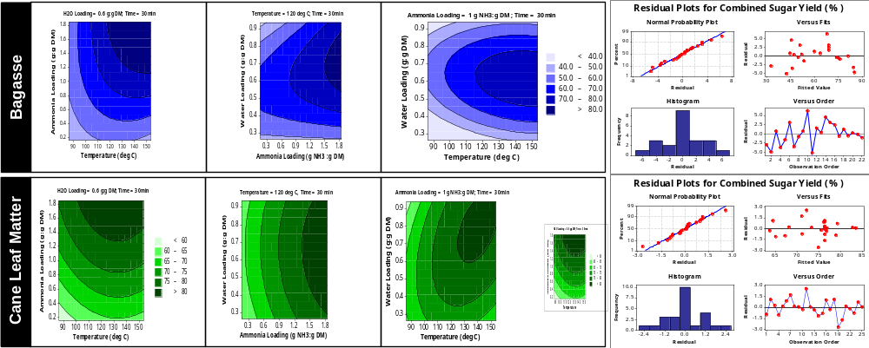
Fig. S1-A: Contour plots illustrating the effect of temperature, ammonia loading and water loading on the combined monomeric sugar (glucose and xylose) yield for sugarcane bagasse and cane leaf matter.
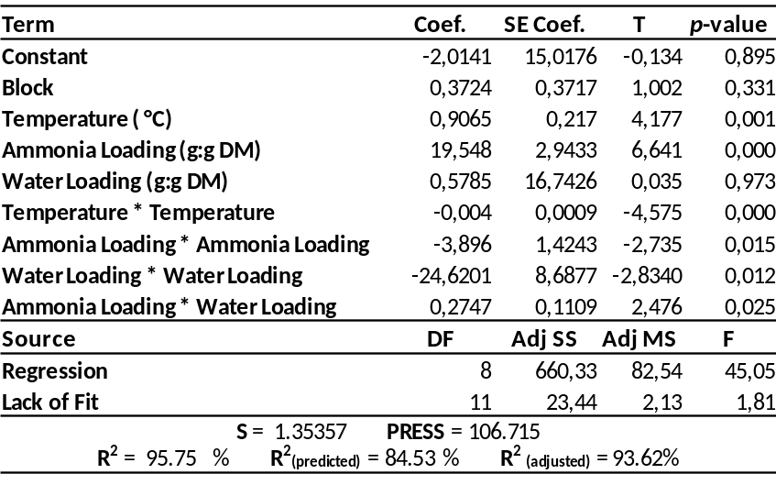
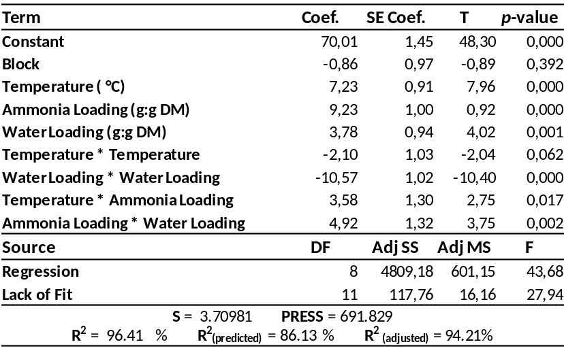
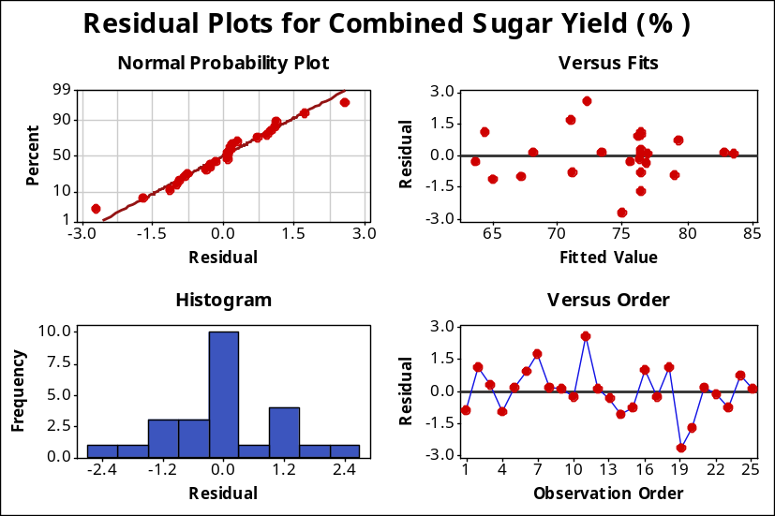
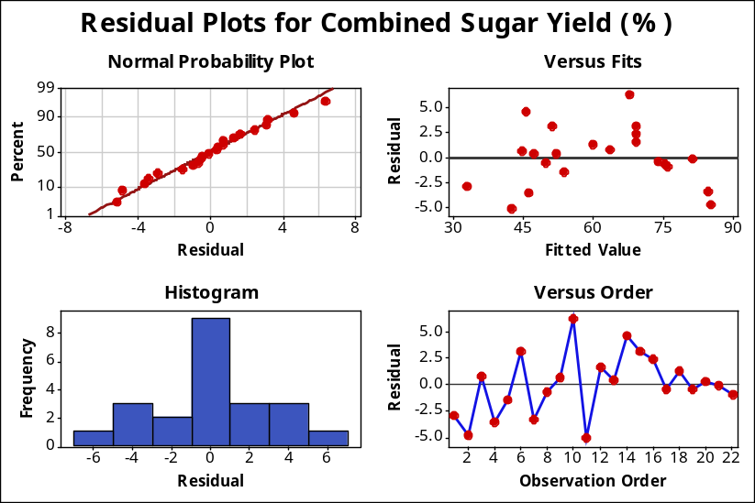
b. AFEXTM-Bagasse: Regression coefficients and p-values
a. AFEXTM-Bagasse: Residual plots for combined sugar yield
d. AFEXTM-CLM: Regression coefficients and p-values
c. AFEXTM-CLM: Residual plots for combined sugar yield
Fig. S1-B: The statistical residual plots and regression coefficients used to validate ANOVA assumptions in evaluating the effect of AFEXTM pretreatment conditions on the monomeric combined sugar yield from sugarcane bagasse and CLM. Abbreviations: S - Standard Error of the Regression, PRESS - Prediction Sum of Squares.

