Additional File 4

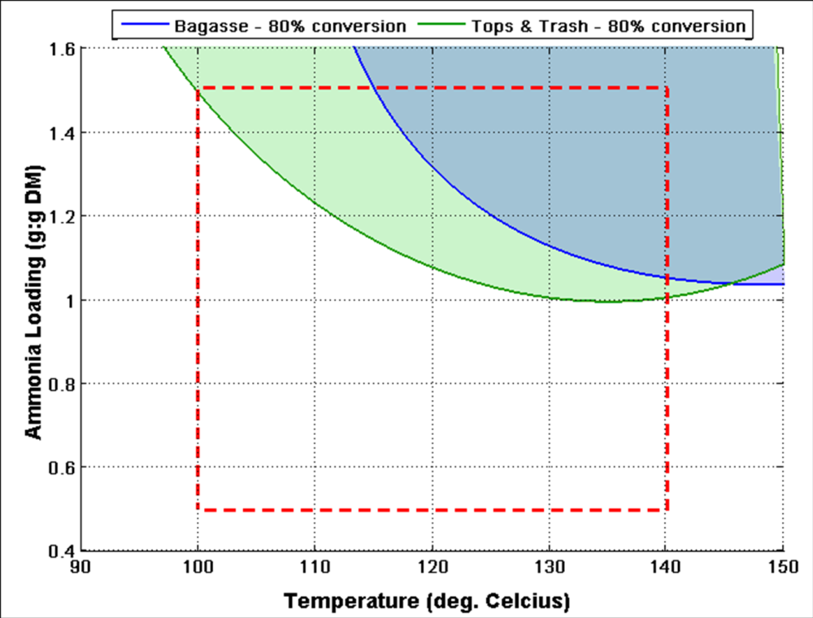
Fig. S2: Profiling the effect of ammonia loading and temperature on the combined glucose and xylose yields for AFEXTM-treated bagasse and cane leaf matter after 1% glucan loading enzymatic hydrolysis with 15mg protein per gram glucan. Pretreatment water loading and residence time were fixed at 0.65 g H₂O per gram DM and 30 minutes, respectively.
Region of
Model validity
Region of
Bagasse-Trash
Co-pretreatment

