Additional File 5

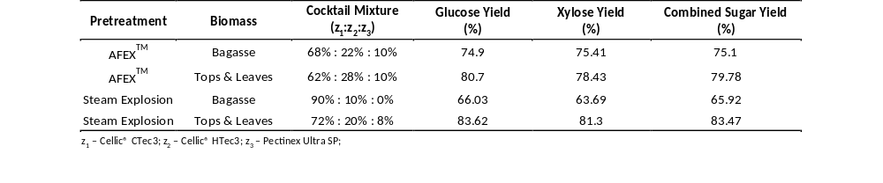
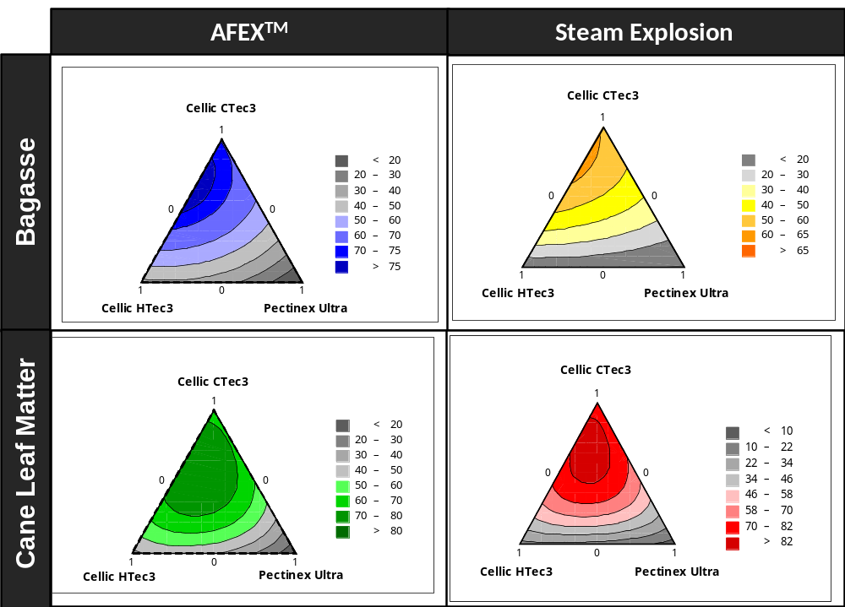
Fig. 3S-A: Quantification of the effect combinations of commercial enzyme mixtures consisting of Cellic CTec3, Cellic HTec3, and Pectinex Ultra SP on the combined sugar yield during 1% glucan loading enzymatic hydrolysis performed at 50 °C, 250 rpm for 72 hrs. The total enzyme dosage was fixed at 15mg/g glucan in pretreated biomass A – Contour profiles of the effect of commercial enzyme mixtures on the combined sugar yields, B – Composition of the optimized cocktail mixtures by ratio and the corresponding glucose, xylose and combined sugar yield.
A
B

Fig. 3B: The statistical residual plots and regression coefficients (coded) used to validate ANOVA assumptions in evaluating the effect of commercial enzyme cocktail mixtures on the monomeric combined sugar yield from AFEXTM-treated sugarcane bagasse and CLM. Abbreviations: S - Standard Error of the Regression, PRESS - Prediction Sum of Squares.
a. AFEXTM-Bagasse: Residual plots for Enzyme Optimization

e. StEx-Bagasse: Residual plots for Enzyme Optimization

e. StEx-Bagasse: Residual plots for Enzyme Optimization

e. StEx-Bagasse: Residual plots for Enzyme Optimization
b. AFEXTM-CLM: Residual plots for Enzyme Optimization

e. StEx-Bagasse: Residual plots for Enzyme Optimization

e. StEx-Bagasse: Residual plots for Enzyme Optimization

e. StEx-Bagasse: Residual plots for Enzyme Optimization
c. AFEXTM-Bagasse: Regression coefficients and p-values

f. AFEXTM-Bagasse: Regression coefficients and p-values

f. AFEXTM-Bagasse: Regression coefficients and p-values

f. AFEXTM-Bagasse: Regression coefficients and p-values
c. AFEXTM-CLM: Regression coefficients and p-values

f. AFEXTM-Bagasse: Regression coefficients and p-values

f. AFEXTM-Bagasse: Regression coefficients and p-values

f. AFEXTM-Bagasse: Regression coefficients and p-values
Fig. 3C: The statistical residual plots and regression coefficients (coded) used to validate ANOVA assumptions in evaluating the effect of commercial enzyme cocktail mixtures on the monomeric combined sugar yield from StEx-treated sugarcane bagasse and CLM. Abbreviations: S - Standard Error of the Regression, PRESS - Prediction Sum of Squares.
f. StEx-Bagasse: Regression coefficients and p-values

f. AFEXTM-Bagasse: Regression coefficients and p-values

f. AFEXTM-Bagasse: Regression coefficients and p-values

f. AFEXTM-Bagasse: Regression coefficients and p-values
e. StEx-Bagasse: Residual plots for Enzyme Optimization

e. StEx-Bagasse: Residual plots for Enzyme Optimization

e. StEx-Bagasse: Residual plots for Enzyme Optimization

e. StEx-Bagasse: Residual plots for Enzyme Optimization
h. StEx-CLM: Regression coefficients and p-values

h. AFEXTM-CLM: Regression coefficients and p-values

h. AFEXTM-CLM: Regression coefficients and p-values

h. AFEXTM-CLM: Regression coefficients and p-values
g. StEx-CLM: Residual plots for Enzyme Optimization

g. StEx-CLM: Residual plots for Enzyme Optimization

g. StEx-CLM: Residual plots for Enzyme Optimization

g. StEx-CLM: Residual plots for Enzyme Optimization

