Additional File 6
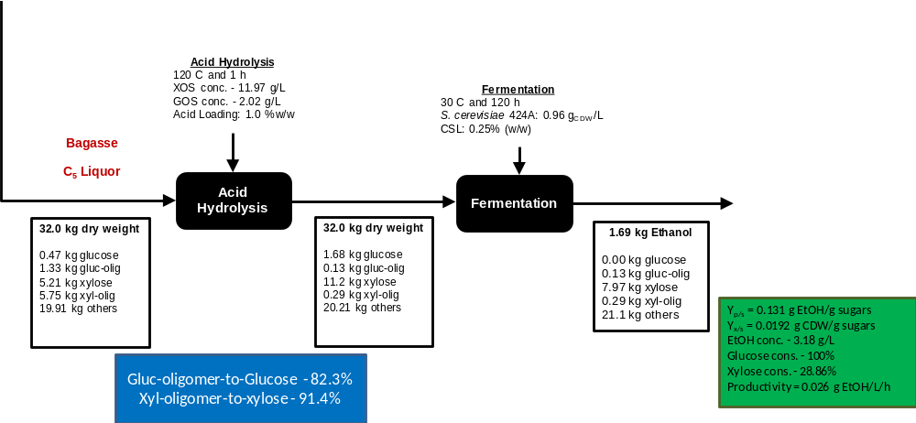
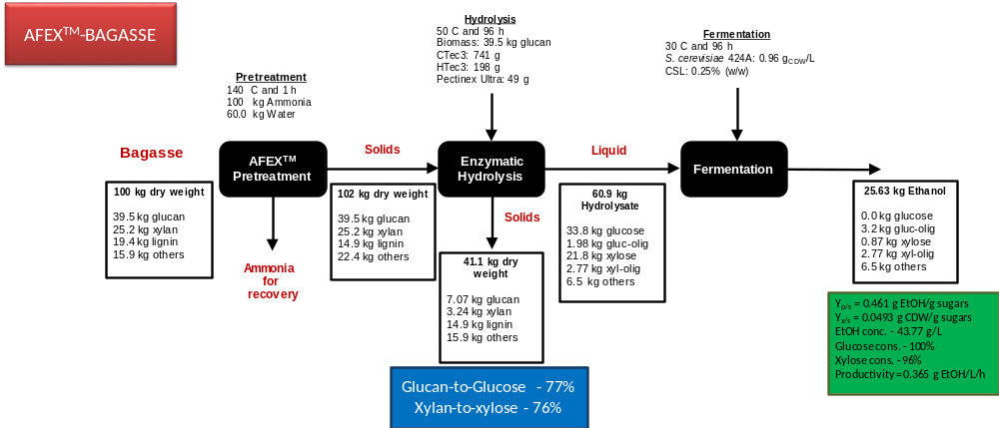
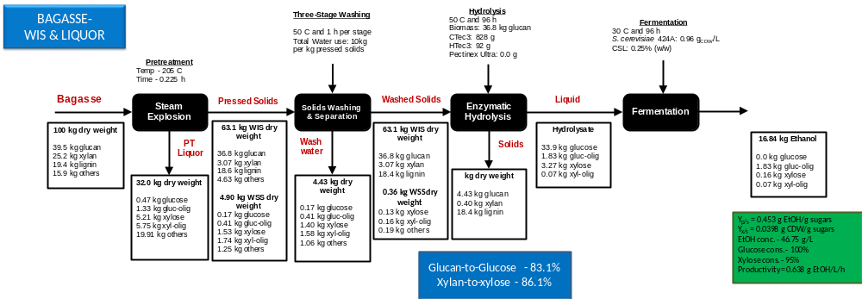
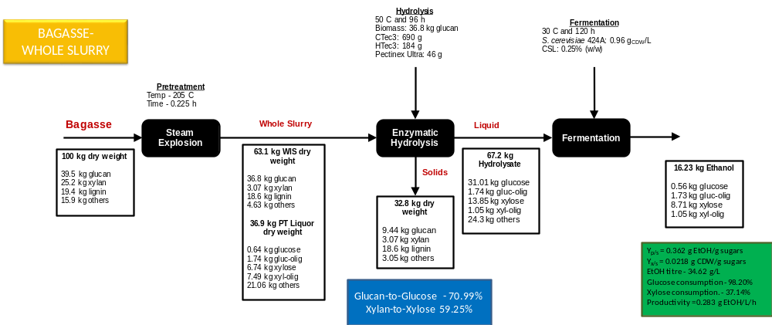
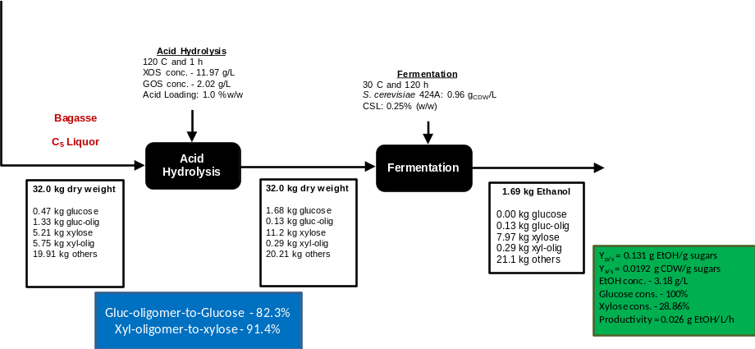
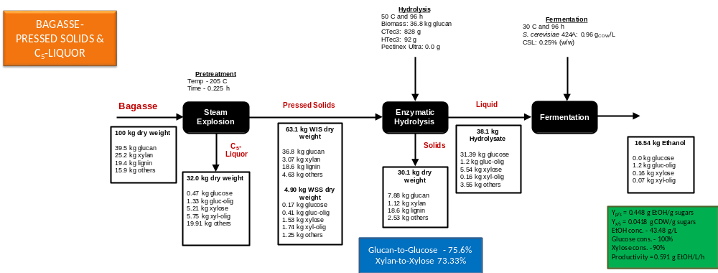
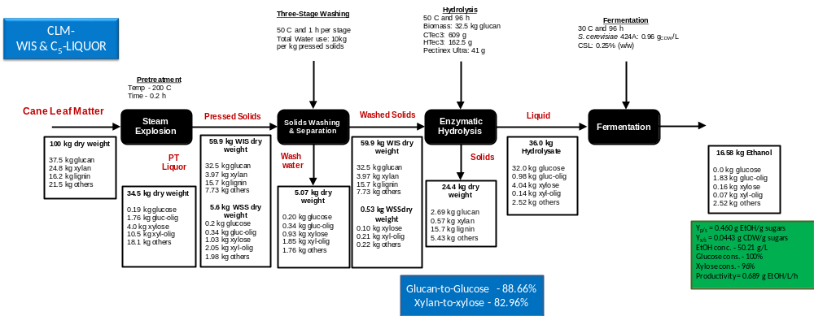
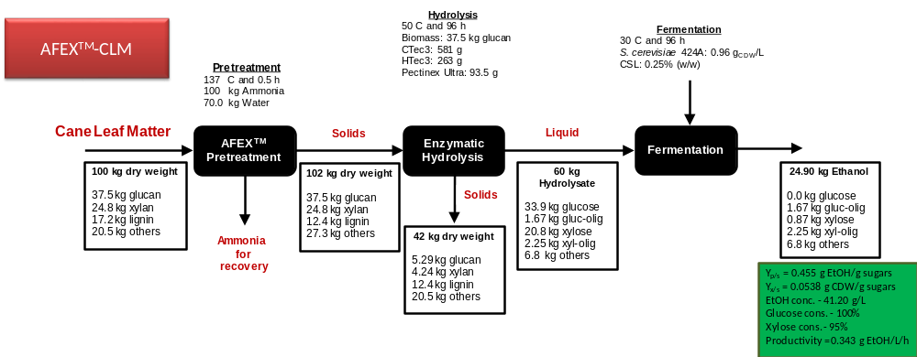
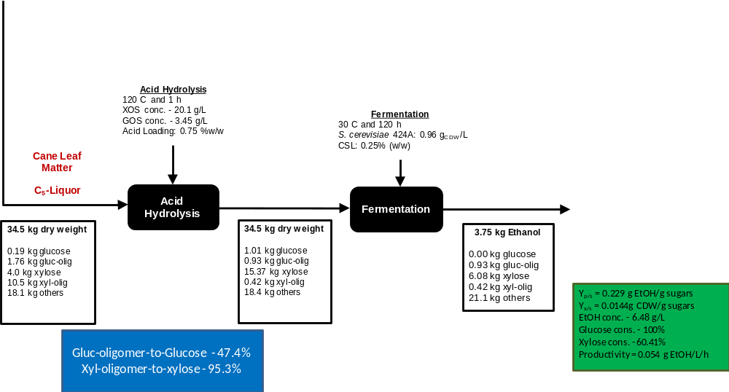
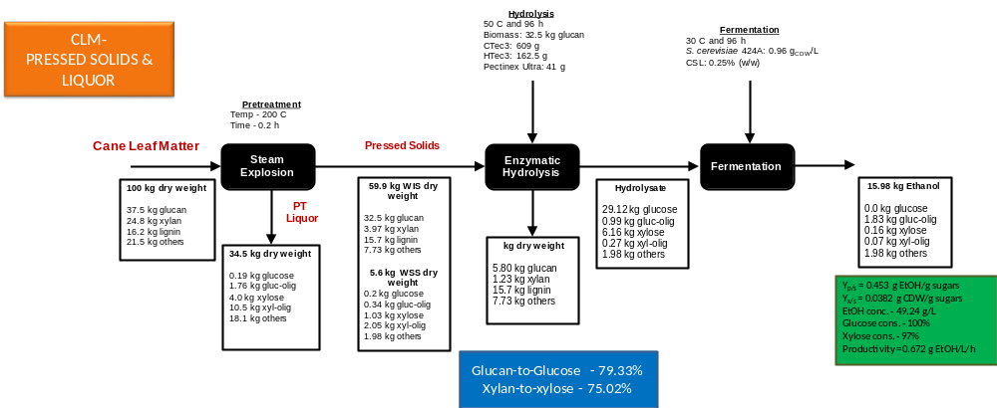
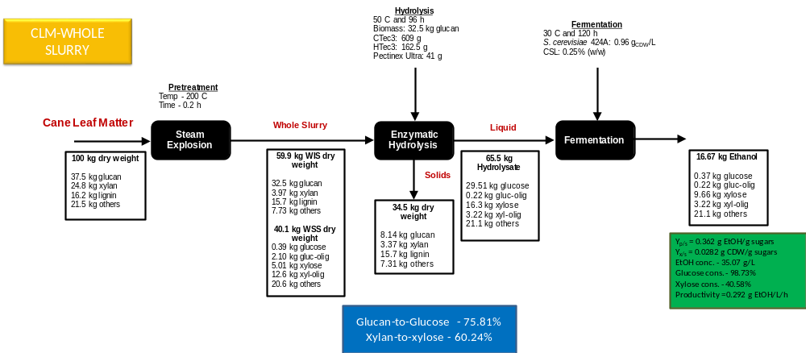
Figure S4: Material balances during pretreatment, washing, hydrolysis and fermentation for Processes I – IV. A – AFEX-bagasse (Process I), B – StEx-bagasse (washed) (Process II), C – StEx-bagasse (unwashed) (Process III), D – StEx-bagasse (whole slurry) (Process IV), E – AFEX-CLM (Process I), F – StEx-CLM (washed) (Process II), G – StEx (unwashed) (Process III), H – StEx (whole slurry) (Process IV). Abbreviations: WIS – water insoluble solids, WSS – water soluble solids.

