Additional file 2

Confirmation of FAD2 (YALIOB10153) deletion:
Deletion was confirmed by the absence of a FAD2-specific PCR product (forward primer NP1888 internal to the FAD2 gene – reverse primer NP1889 internal to the FAD2 gene), the presence of a fad2::hph-specific PCR product (forward primer NP1890 external to the FAD2 locus – reverse primer internal to the hph gene) (Supplementary Figure 1), as well as the absence of linoleic acid in the resulting strain (Figure 1 and Supplementary Figure 2).

Additional Figure S1
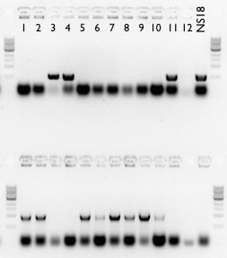

Wild-type FAD2 product (NP1888-NP1889)

Deletion fad2::hph product (NP1890-NP656)

Figure S1. Confirmation of FAD2 deletion. 12 transformants and the parental wild-type strain (NS18) screened for the wild-type (top) and deletion (bottom) products. The first isolate was chosen and used for experiments in this study

Additional Figure S2
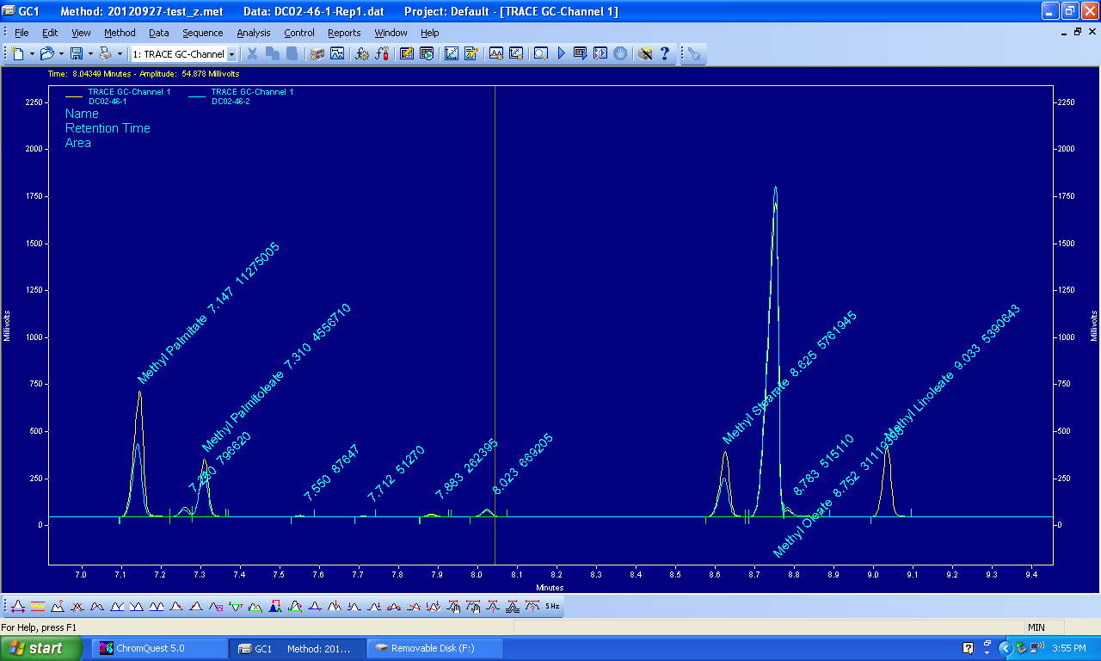
A.

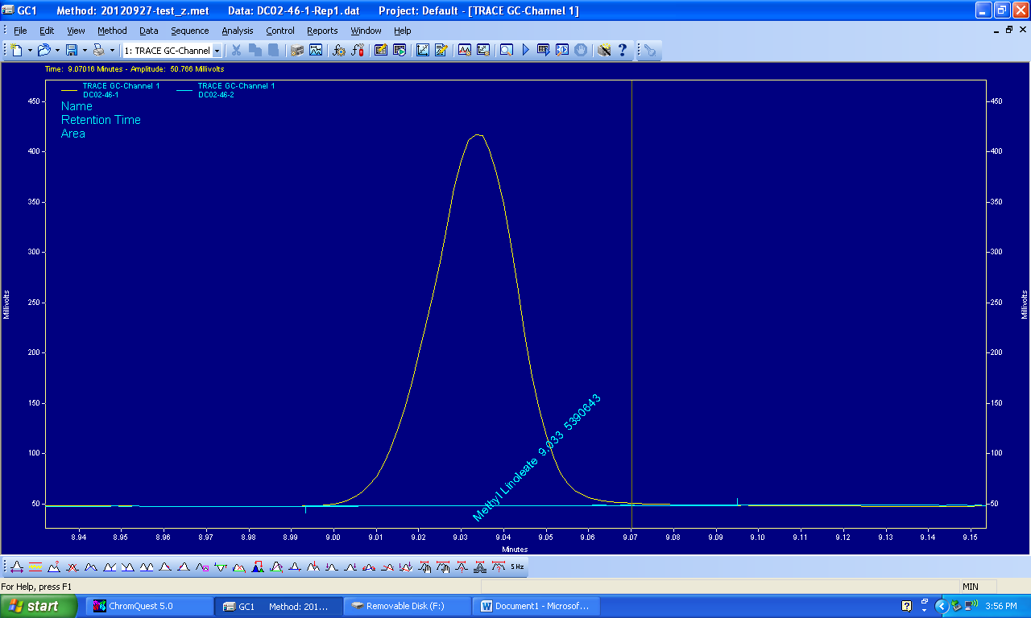
B.

Figure S2. Absence of linoleate in fad2 strain. A. Gas chromatogram of the parental strain (yellow) and the fad2::hph strain (blue). Peaks for the methyl esters of palmitate, palmitoleate, stearate, oleate and linoleate are identified and labeled on the chromatogram by the software based on previously run standards. B. Magnification of the linoleic acid peak for the parental strain (yellow). No detectable linoleic acid is observed for the fad2::hph strain (blue).

Table S1. Primer pairs used to construct targeted integration cassettes.
Targeted modification | 5’ fragment |  | 3’ fragment
Targeted modification | forward | reverse | forward | reverse
YlSCT1::nat | NP2321 | NP356 | NP355 | NP2322
YlOLE1::hph | NP1879 | NP656 | NP655 | NP1880
YlOLE1::AaOLE1 | NP2336 | NP2337 | (single product)
YlOLE1::RtOLE1-1 | NP2338 | NP2339 | (single product)
YlOLE1::RtOLE1-2 | NP2340 | NP2341 | (single product)
YlOLE1::RgOLE1 | NP2342 | NP2343 | (single product)
YlOLE1::MvOLE1 | NP2344 | NP2345 | (single product)
YlOLE1::PgOLE1 | NP2346 | NP2347 | (single product)
YlOLE1::GtOLE1 | NP2348 | NP2349 | (single product)
Ylfad2::hph | NP1881 | NP656 | NP655 | NP1882

Table S2. Primer sequences.
NP355 | AACTTCCGTTCCTGGCGATGCCG
NP356 | TCTCCATCGGAAGCGGTTCCGTC
NP655 | ACCACTTGGCGAGACTTCATCTGT
NP656 | AGCATCGTCAAAGTTGCCATCCAC
NP1879 | GCCGCTTCCCCTACGTAATCGAATACTTGTCTTTCCTCATCTACTAACTACACATTCAACATGAAGAAGCCCGAGCTGACC
NP1880 | GGCTCCGATTATTCCTTGTTTCATGCATTATCTATACGATATTAATAAATATTCTTGACTTACTCCTTAGCTCGAGGTC
NP1881 | TGAGTCCCTTTCTCGTATTCCAACAGACCGACCATAGAAATGAAGAAGCCCGAGCTGACC
NP1882 | TGCTGTTCAGTTAAAACACAATCAAATAACATTTCTAGCTTTACTCCTTAGCTCGAGGTC
NP1888 | TCACCGGATGGGTTCTGCAC
NP1889 | GGGTGAAGTTCCACTGGTCG
NP1890 | TAACCTCGGGTGTGCCTCTG
NP2321 | GCGCCACCCTTTGGTTCTTCCAGCACAACAAAAACACGACACGCTAAATGACCACTCTGGATGACACC
NP2322 | GCGCACAAAGTCCGTTATAATGAATGATACTCTAAATTTCAACTAGTTAGTTAAGGGCAGGGCATCGACA
NP2336 | GCCGCTTCCCCTACGTAATCGAATACTTGTCTTTCCTCATCTACTAACTACACATTCAACATGAACGGTCCCGAAGAGGTG
NP2337 | GGCTCCGATTATTCCTTGTTTCATGCATTATCTATACGATATTAATAAATATTCTTGACTTAAGCAGCGCGGCCAGAGA
NP2338 | GCCGCTTCCCCTACGTAATCGAATACTTGTCTTTCCTCATCTACTAACTACACATTCAACATGACTGCCTCGTCGGCACT
NP2339 | GGCTCCGATTATTCCTTGTTTCATGCATTATCTATACGATATTAATAAATATTCTTGACTTACGCCTTGACCGTCAGGC
NP2340 | GCCGCTTCCCCTACGTAATCGAATACTTGTCTTTCCTCATCTACTAACTACACATTCAACATGACTGCCTCTTCGGCACT
NP2341 | GGCTCCGATTATTCCTTGTTTCATGCATTATCTATACGATATTAATAAATATTCTTGACTTACGCCTTGACCTTCAGGC
NP2342 | GCCGCTTCCCCTACGTAATCGAATACTTGTCTTTCCTCATCTACTAACTACACATTCAACATGCGCCACCCGGACTACTC
NP2343 | GGCTCCGATTATTCCTTGTTTCATGCATTATCTATACGATATTAATAAATATTCTTGACTCATGCCGCCCGTGTTGCCG
NP2344 | GCCGCTTCCCCTACGTAATCGAATACTTGTCTTTCCTCATCTACTAACTACACATTCAACATGTCCGTCACGGCCTCTGC
NP2345 | GGCTCCGATTATTCCTTGTTTCATGCATTATCTATACGATATTAATAAATATTCTTGACCTATTCAAAGAGGGACTGGG
NP2346 | GCCGCTTCCCCTACGTAATCGAATACTTGTCTTTCCTCATCTACTAACTACACATTCAACATGTCCAAACCCTCACCTTC
NP2347 | GGCTCCGATTATTCCTTGTTTCATGCATTATCTATACGATATTAATAAATATTCTTGACTCAAGTATAGATCGGCTTGACTTC
NP2348 | GCCGCTTCCCCTACGTAATCGAATACTTGTCTTTCCTCATCTACTAACTACACATTCAACATGGCGACCTACACGCCGCC
NP2349 | GGCTCCGATTATTCCTTGTTTCATGCATTATCTATACGATATTAATAAATATTCTTGACCTACGCTTCCTTCTCCTCCTTC

Table S3. Strains.
Strain | Genotype | Source
NS18 | Wild type | NRRL #YB-392
NS418 | ole1::hph | this study
NS419 | fad2::hph | this study
NS432 | tgl3::hph nat-RtDGA1 ble-CpDGA2 | Friedlander et al, 2016
NS563 | sct1::nat | this study
NS564 | fad2::hph sct1::nat | this study
NS804 | sct1::nat ble-AaSCT1 | this study
NS808 | sct1::nat ble-AaSCT1 ole1::hph | this study
NS809 | sct1::nat ble-AaSCT1 ole1::PgOLE1 | this study
NS968 | sct1::nat ble-AaSCT1 ole1::PgOLE1 fad2::hph | this study
NS975 | sct1::nat ble-AaSCT1 ole1::PgOLE1 fad2::hph ScSUC2-rELO2 RtDGA1 | this study
NS993 | sct1::nat ble-AaSCT1 ole1::PgOLE1 fad2::hph ScSUC2-rELO2 RtDGA1 ptxD-PgOLE1 CpDGA2 | this study

