Supporting Information

Use of bacteria for improving the lignocellulose biorefinery process: Importance of Pre-erosion
Shengnan Zhuo ^{1,&}, Xu Yan ^{1, 2,&} , Dan Liu ¹, Mengying Si ¹, Kejing Zhang ¹, Mingren Liu ¹, Bing Peng ^{1,2},
Yan Shi ^{1, 2, *}
¹ School of Metallurgy and Environment, Central South University, Changsha 410083, China
² Chinese National Engineering Research Center for Control & Treatment of Heavy Metal Pollution, Changsha 410083, China
& These authors contributed equally to this work.
* Corresponding author: shiyzyrs@csu.edu.cn
Table S1 Main assignments of FTIR bands of CS[1-3]
Wavenumbers (cm⁻¹) | Assignments
1728 | C=O stretching from esters, waxes, fatty acids, and noncellulosic polysaccharides
1655 | Stretching of C=O conjugated to aromatic rings
1632-1636 | Bending caused by absorbed water in cellulose
1613 | Carbonyl group stretching
1594-1609 | Aromatic ring vibrations
1504-1515 | -CH bending in the aromatic rings of lignin
1462-1464 | Asymmetric C-H bending (in CH₃ and -CH₂-) in lignin
1427 | CH₂ bending in cellulose
1421-1424 | Aromatic ring vibrations
1383 | Symmetrical stretching for C=O of COO- groups in
1360 | Aliphatic C-H stretch in the methyl group (not MeO) and the phenolic OH
1320 | C-H in cellulose
1332 | C=O stretching in syringyl derivatives
1266-1270 (shoulder) | Guaiacyl ring stretching vibrations
1247 | Acetate ester C-O stretching from hemicellulose
1234 | Ring breathing with C-O stretching
1226 | Syringyl and guaiacyl ring breathing with C=O stretching
1160-1162 | Asymmetric C-O-C bridge stretching in cellulose
1126 | Aromatic skeletal and C-O stretch
1106-1112 | Anhydroglucose ring in cellulose
1056 | C-O stretch in cellulose and hemicellulose
1037 | Aromatic C-H in-plain deformation for guaiacyl type
899 | C-O-C stretch from glycosidic linkage between glucose units of cellulose
841 | Aromatic C-H out of plane bending
The Table S1 shows the main assignments of FTIR bands of CS, which helps to understand the changes in the chemical structure of CS.
Reference:
1. Filipe Natalio RF, Sidney R. Cohen, Gregory Leitus, Gerhard Fritz-Popovski, Oskar Paris, Michael Kappl, Hans-Jürgen Butt. Biological fabrication of cellulose fibers with tailored properties. Science. 2017;357:1118-1122.
2. Tripathi A, Ferrer A, Khan SA, Rojas OJ. Morphological and Thermochemical Changes upon Autohydrolysis and Microemulsion Treatments of Coir and Empty Fruit Bunch Residual Biomass to Isolate Lignin-Rich Micro- and Nanofibrillar Cellulose. ACS Sustain Chem Eng. 2017; 5:2483-2492.
3. Rangan A, Manchiganti MV, Thilaividankan RM, Kestur SG, Menon R. Novel method for the preparation of lignin-rich nanoparticles from lignocellulosic fibers. Ind Crops Prod. 2017;103:152-160.

Figure S1 Enzymatic digestibility of CS pretreated under different conditions. Error bars shown are standard deviations of triplicate samples.
Figure S1 shows the reducing sugar yield of CS pretreated under different conditions, obviously, the enzymatic digestibility was the best under the condition of 150 ºC, 4 h. As the same, the highest sugar yield occured by B-6 treatement after this condition. So, in the text, we selected a group of samples under this condition as the representative to study.
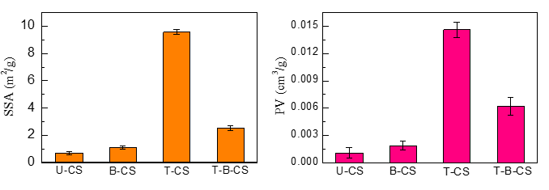
Figure S2 SSA and PV of CS samples. Error bars shown are standard deviations of triplicate samples.
Figure S2 shows the SSA and PV of the representative CS samples. Due to the destruction of CS by THF–H₂O co-solvent system, the SSA and PV of T-CS was much higher than U-CS. The hole collapse of T-B-CS resulted in the decrease of SSA and PV, which was attributed to the further removal of lignin after the modification by B-6. But the enzymatic hydrolysis is still improved.
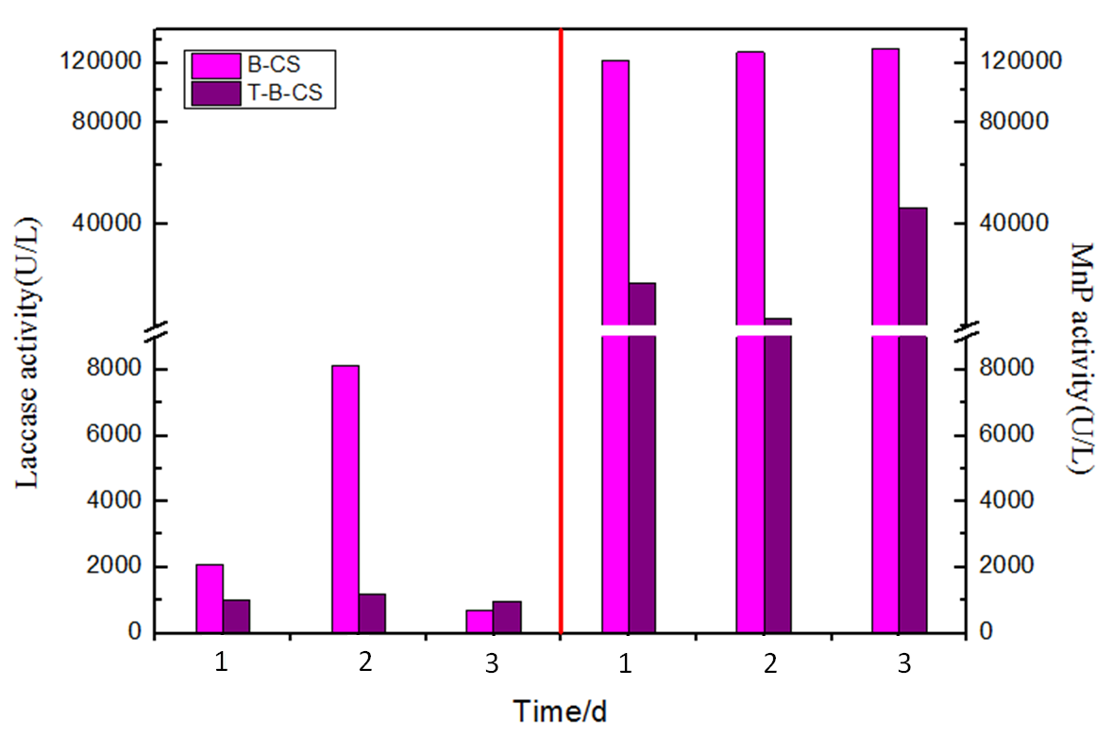

Figure S3 Lac and MnP activity of B-CS and T-B-CS
Figure S3 is a reflection of enzyme activity including MnP and Lac. All the data suggested the activity of B-CS was higher than the T-B-CS, indicating the enzymes producing by B-6 were consumed by the releasing phenols from the T-CS.

