Additional material

Boosting of enzymatic softwood saccharification by fungal GH5 and GH26 endomannanases
von Freiesleben et al.

Table S1 and S2 Ratings from one-way ANOVA analyses of initial reaction rates by endomannanases on pure mannans (Figure 2). A one-way ANOVA analysis was made for all endomannanases on each substrate (top, Table S1) and for each enzyme across all substrates (bottom, Table S2). Ratings are assigned with a 95 % confidence interval with the Turkey-Kramer method in SASjmp. Please consult the manuscript for enzyme abbreviations.

Table S1
Endomannanases | Guar gum | Locust bean gum | Konjac glucomannan | Acetylated GGM ª | Deacetylated GGM ª
YpenMan26A | A | A | A | B | B
Wsp.Man26A | C, D | B | A | A | A
AnidMan26A | B | B | A, B | C | D, E
AstiMan26A | C, D | C | A, B, C, D | B | B, C
PansMan26A | C | C | A, B, C | C, D | B, C, D
PansMan26A core | C, D | C | A, B, C, D | C | C, D, E
NdesMan26A | C, D | C, D | A, B, C, D | C | E
CvirMan26A | C, D | C | A, B, C, D | D, E | E
AnigMan5A | C | C | B, C, D | D, E | F
MtheMan26A | D, E | D, E | B, C, D | E, F | F
TresMan5A core | E | E | C, D | F | G
TresMan5A | E | E | D | F | G

Table S2
Endomannanases | Guar gum | Locust bean gum | Konjac glucomannan | Acetylated GGM ª | Deacetylated GGM ª
YpenMan26A | A, B | A | B | C | C
Wsp.Man26A | C | A | A | B | B
AnidMan26A | B, C | A | B | D | C, D
AstiMan26A | C | A, B | A | B | A, B
PansMan26A | C | B | A | C | B
PansMan26A core | C | B | A | B, C | B
NdesMan26A | A | A | A | A | A
CvirMan26A | A, B | A | A | B | A
AnigMan5A | A, B | A | B, C | C | C
MtheMan26A | A, B | A | A | B | A
TresMan5A core | A | A, B | B, C | D | C
TresMan5A | A | A | B, C | C | B

ª spruce galactoglucomannan (GGM)

Table S3 Ratings from one-way ANOVA analyses of sugar release during softwood saccharification at 30 °C (Figure 3 and Figure S2). A one-way ANOVA analysis was made for each sugar at each time point. Ratings are assigned with a 95 % confidence interval with the Turkey-Kramer method in SASjmp. Please consult the manuscript for enzyme abbreviations.

Samples | 24h |  |  | 48h |  |  | 144h
Samples | Glucose | Mannose | Xylose | Glucose | Mannose | Xylose | Glucose | Mannose | Xylose
+ BM2 + TresMan5A | A | A | A | A | A | A | A | A | A
+ BM2 + CvirMan26A | B | B, C | B, C | B, C | B | A, B | B, C | A, B | A
+ BM2 + NdesMan26A | B | B | A, B | B | B | A, B | B | A, B, C | A, B
+ BM2 + TresMan5A core | B, C | B | B, C | B | B | A, B | B, C, D | B, C, D | B
+ BM2 + PansMan26A | C, D | B, C, D | A, B | B, C, D | B | A | B, C, D, E | B, C, D | A, B
+ BM2 + PansMan26A core | D | D, E | B, C | C, D | B | A, B | B, C, D, E | B, C, D | A, B
+ BM2 + AstiMan26A | D, E | D, E | B, C | D, E | B | A, B | B, C, D | B, C, D | A, B
+ BM2 + MtheMan26A | D, E | C, D, E | B, C | D, E, F | B | A, B | B, C, D, E | B, C, D | A, B
+ BM2 + Wsp.Man26A | D, E | C, D, E | B, C | D, E, F, G | B | A, B | B, C, D, E | B, C, D | A, B
+ BM2 + AnigMan5A | D, E | B, C, D | B, C | D, E, F | B | A, B | C, D, E | B, C, D | A, B
+ BM2 + YpenMan26A | D, E, F | C, D, E | B, C | E, F, G | B | A, B | C, D, E | B, C, D | A, B
+ BM2 + AnidMan26A | E, F | C, D, E | B, C | F, G | B | A, B | D, E | D | A, B
+ BM2 + BSA | F | E | C | G | B | A, B | E | C, D | A, B
CTec3 | G | F | B, C | H | C | B | F | E | A, B

Table S4 Ratings from one-way ANOVA analyses of glucose release during softwood saccharification at 30 and 50 °C (Figure 4). A one-way ANOVA analysis was made for each temperature at each time point. Ratings are assigned with a 95 % confidence interval with the Turkey-Kramer method in SASjmp. Please consult the manuscript for enzyme abbreviations.

Samples | 24 h |  | 48 h |  | 144 h
Samples | 30 °C | 50 °C | 30 °C | 50 °C | 30 °C | 50 °C
+ BM2 + TresMan5A | A | A | A | A | A | A
+ BM2 + CvirMan26A | B | B | B | B | B | B
+ BM2 + TresMan5A core | B | B | B | B | B | B
+ BM2 + BSA | C | C | C | C | C | C
CTec3 | D | C | D | C | D | C
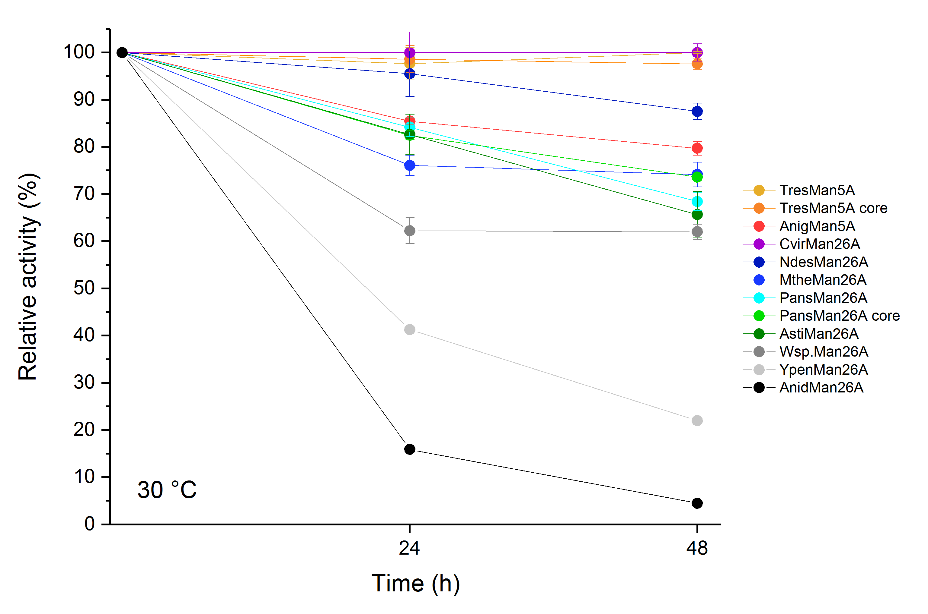
Figure S1 Stability of endomannanases at 30 °C. The relative activity (%) was determined on locust bean gum at 30 °C, pH 5 and are given as mean values ± SD (n=3). Please consult the manuscript for enzyme abbreviations.

Figure S2 Softwood saccharification. Endomannanases or BSA were added in equal molar amounts on top of Cellic ® CTec3 plus an A. niger GH2 β-mannosidase (BM2). Samples were taken after 24, 48 and 144 h saccharification at 30 °C. Glucose (g/l, light grey), mannose (dark grey) and xylose (black) yields are given as mean values ± SD (n=3). One-way ANOVA analyses can be seen in Table S3.

 | 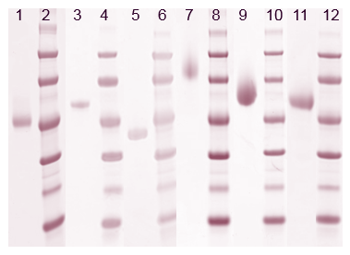
  Lane | Sample
  1 | AnidMan26A – 5µl
  2 | LMW – 10µl
  3 | PansMan26A – 5µl
  4 | LMW – 10µl
  5 | PansMan26A core – 5µl
  6 | LMW – 10µl
  7 | TresMan5A – 5µl
  8 | LMW – 10µl
  9 | TresMan5A core – 5µl
  10 | LMW – 10µl
  11 | AnigMan5A – 5 µl
  12 | LMW – 10µl
 | 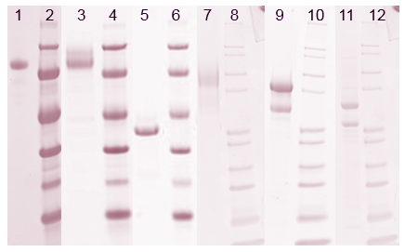 | 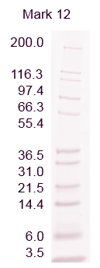
  Lane | Sample
  1 | CvirMan26A – 5µl
  2 | LMW – 10µl
  3 | AstiMan26A – 5µl
  4 | LMW – 10µl
  5 | YpenMan26A – 5µl
  6 | LMW – 10µl
  7 | WspMan26A – 5µl
  8 | Mark 12 – 10µl
  9 | NdesMan26A – 5µl
  10 | Mark 12 – 10µl
  11 | MtheMan5A – 5 µl
  12 | Mark 12 – 10µl

Figure S3 SDS-PAGE gels of the purified enzymes. The protein concentration in the samples was 0.5 mg/ml. Prior to gel loading, samples were diluted 1:1 with loading mix. Loading mix was prepared as a 9:1 mix of Novex ® Tris-Glycine SDS Sample Buffer (2X) (Life Technologies) and Nupage ® Sample Reducing Agent (10X) (Life Technologies). Please consult the manuscript for enzyme abbreviations. Samples with NdesMan26A and MtheMan26A both contain molecules with and without the CBM35.

