Additional file 2
Figure S1
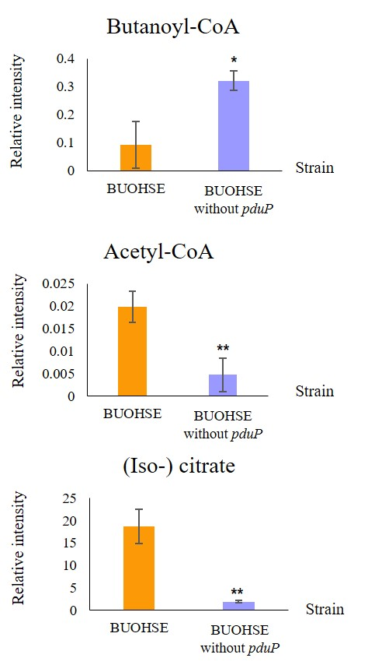
Fig. S1 Relative intensity of intracellular butanoyl-CoA, acetyl-CoA, and (iso-) citrate in BUOHSE and BUOHSE without pduP. Asterisks indicate significant differences in the strains (*: p ≤ 0.05; **: p ≤ 0.01).

Figure S2
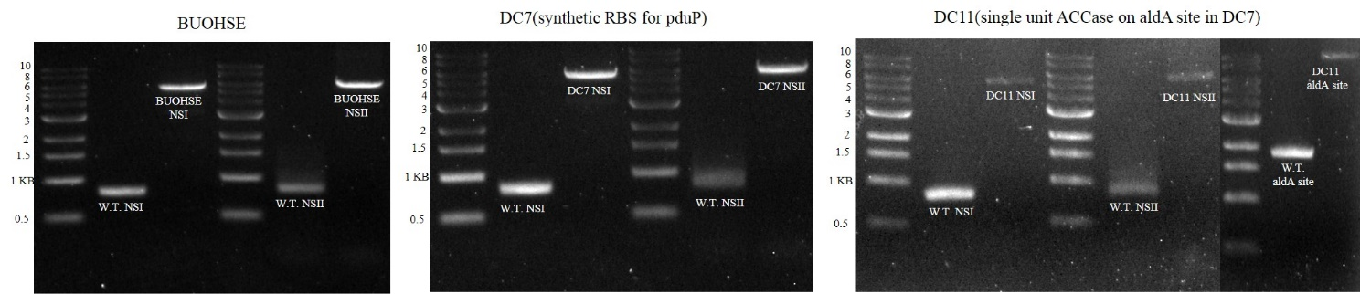
Fig. S2 Colony PCR results for the segregation test in BUOHSE, DC7, and DC11 strain, W. T. (wild type strain), NSI (neutral site I), NSII (neutral site II).

Figure S3
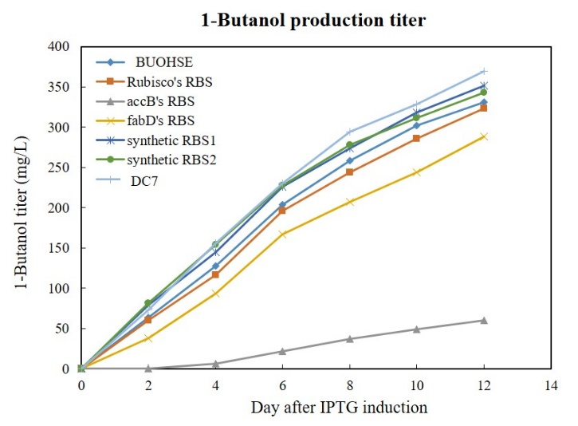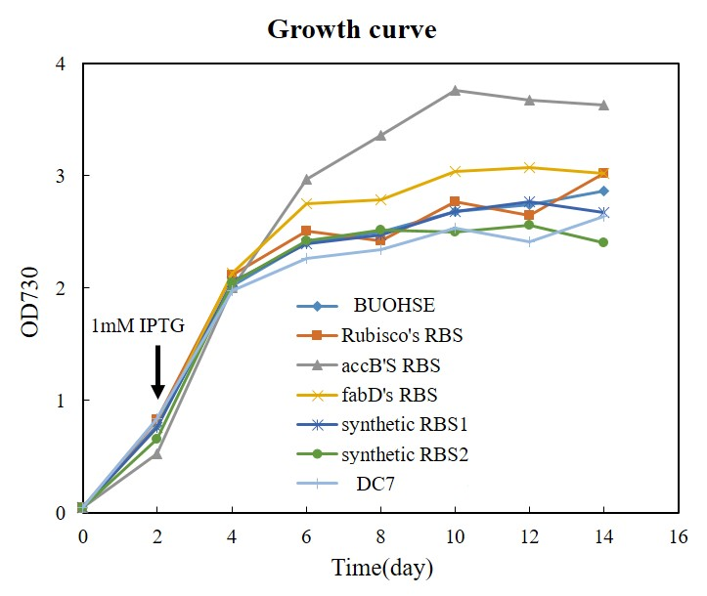
Fig. S3 1-Butanol production and cell density of S. elongatus obtained with the different RBS sequences.

