Enrichment of syngas-converting mixed microbial consortia for ethanol production and thermodynamics-based design of enrichment strategies – Additional file 1.

Table S1. Average apparent biomass yield for enrichment experiments from transfer T3 to T6 and p-values from t-test analysis.
 | Biomass yield  (mg VSS/e-mol) | P-value | HT6 | HT5.5 | HT5.5YE | HT5YE | NT5YE
HT6 | 0.216±0.042 | HT6
HT5.5* | 0.168±0.040 | HT5.5 | 0.121
HT5.5YE | 0.221±0.026 | HT5.5YE | 0.844 | 0.035
HT5YE | 0.279±0.071 | HT5YE | 0.077 | 0.016 | 0.054
NT5YE | 0.262±0.036 | NT5YE | 0.110 | 0.002 | 0.039 | 0.563
*Average apparent biomass yield of enrichment series HT5.5 was calculated using values from transfer T3 to T5.

Table S2. Average production efficiency calculated in Cmol and e-mol recovery, and p-values from t-test analysis.
 |  | Production  efficiency (%) | P-value |  | HT6 | HT5.5 | HT5.5YE | HT5YE | NT5YE
HT6 | Cmol | 83.16±0.70% | HT6 | Cmol
HT6 | e-mol | 92.92±0.54% | HT6 | e-mol
HT5.5 | Cmol | 77.33±2.31% | HT5.5 | Cmol | 0.017
HT5.5 | e-mol | 85.83±2.46% | HT5.5 | e-mol | 0.012
HT5.5YE | Cmol | 93.18±1.69% | HT5.5YE | Cmol | 0.007 | 0.000
HT5.5YE | e-mol | 89.84±1.80% | HT5.5YE | e-mol | 0.128 | 0.090
HT5YE | Cmol | 80.29±0.83% | HT5YE | Cmol | 0.115 | 0.133 | 0.003
HT5YE | e-mol | 88.57±1.77% | HT5YE | e-mol | 0.234 | 0.334 | 0.618
NT5YE | Cmol | 91.60±6.41% | NT5YE | Cmol | 0.203 | 0.077 | 0.764 | 0.126
NT5YE | e-mol | 95.01±3.29% | NT5YE | e-mol | 0.464 | 0.035 | 0.144 | 0.115
*Production efficiency of HT5.5 calculated using data from transfer T4 and T5 of enrichment experiments.

Table S3. Net production/consumption in control experiments and total Cmol (Cmmol) and e-mol (e-mmol) production.
 | Acetate  (mmol) | Propionate  (mmol) | Butyrate  (mmol) | Ethanol  (mmol) | Butanol  (mmol) | Caproate  (mmol) | Total  Cmmol | Total  e-mmol
HT6 | 0.004 | 0.000 | 0.000 | 0.000 | 0.000 | 0.000 | 0.007 | 0.029
HT5.5 | 0.024 | 0.000 | 0.000 | -0.005 | 0.000 | 0.000 | 0.039 | 0.137
HT5.5YE | 0.332 | 0.018 | 0.020 | -0.109 | -0.020 | 0.000 | 0.496 | 1.498
HT5YE | 0.066 | 0.013 | 0.037 | -0.038 | 0.000 | -0.002 | 0.230 | 0.926
NT5YE | 0.324 | 0.027 | 0.024 | -0.110 | -0.019 | 0.013 | 0.606 | 2.088

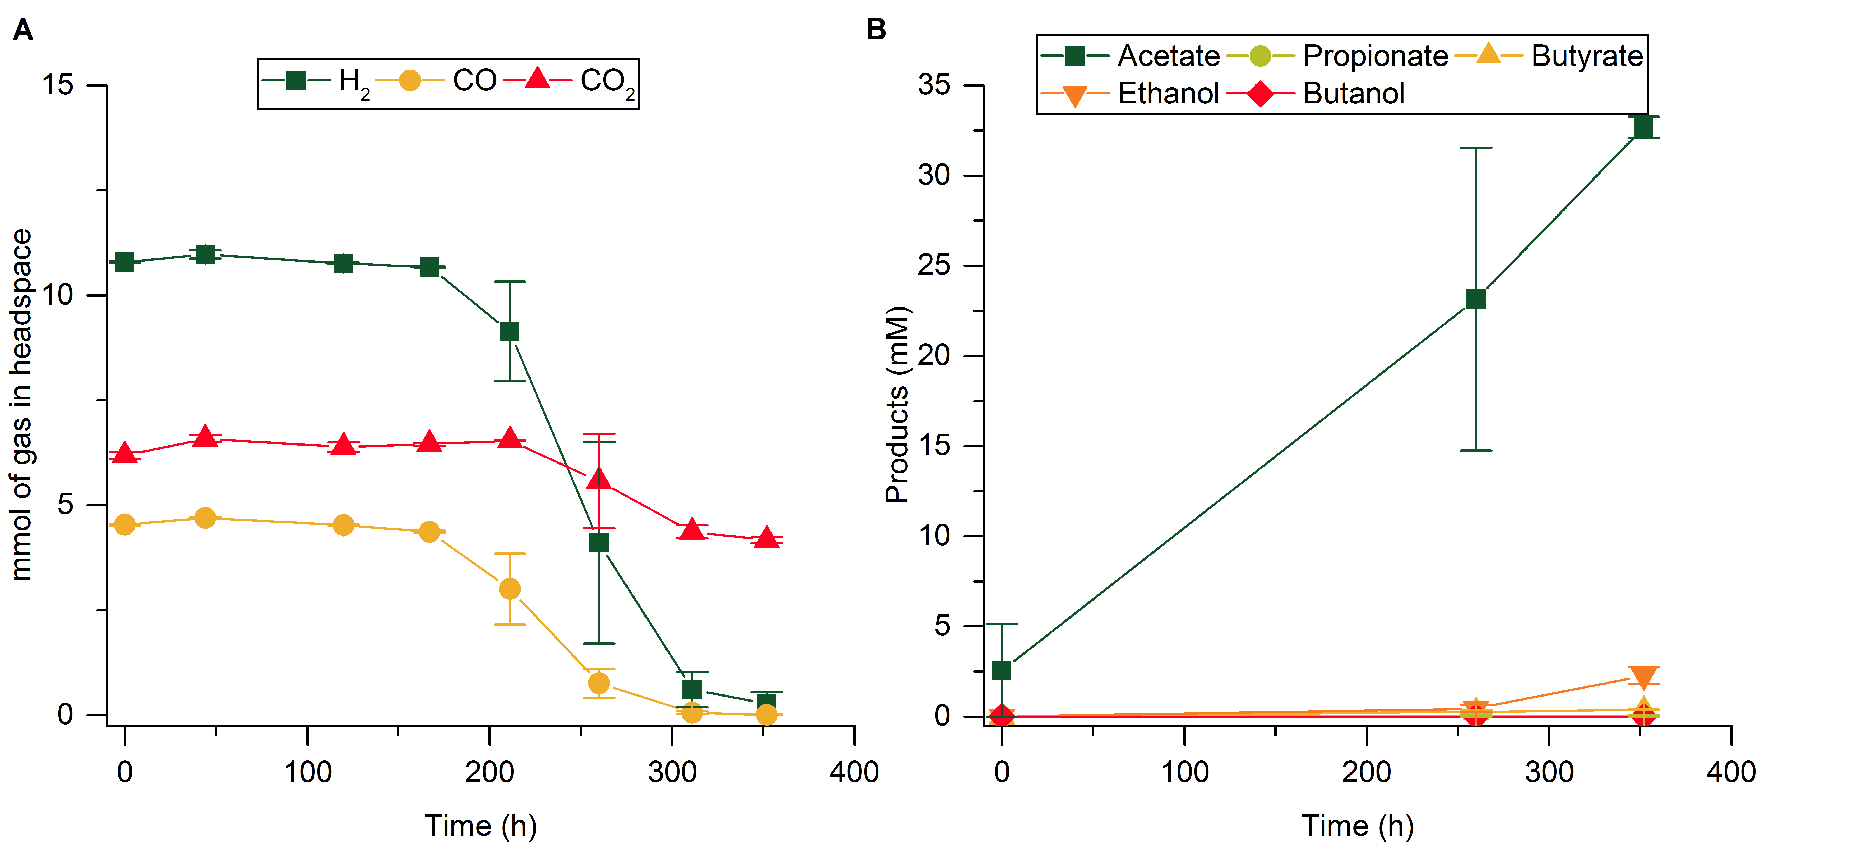
Figure S1. Fermentation profile of enrichment HT5.5 at transfer T1 (average of duplicates). A Gas composition of the headspace (mmol). B Concentration of products in the fermentation broth (mM) and microbial growth (mg VSS/L).
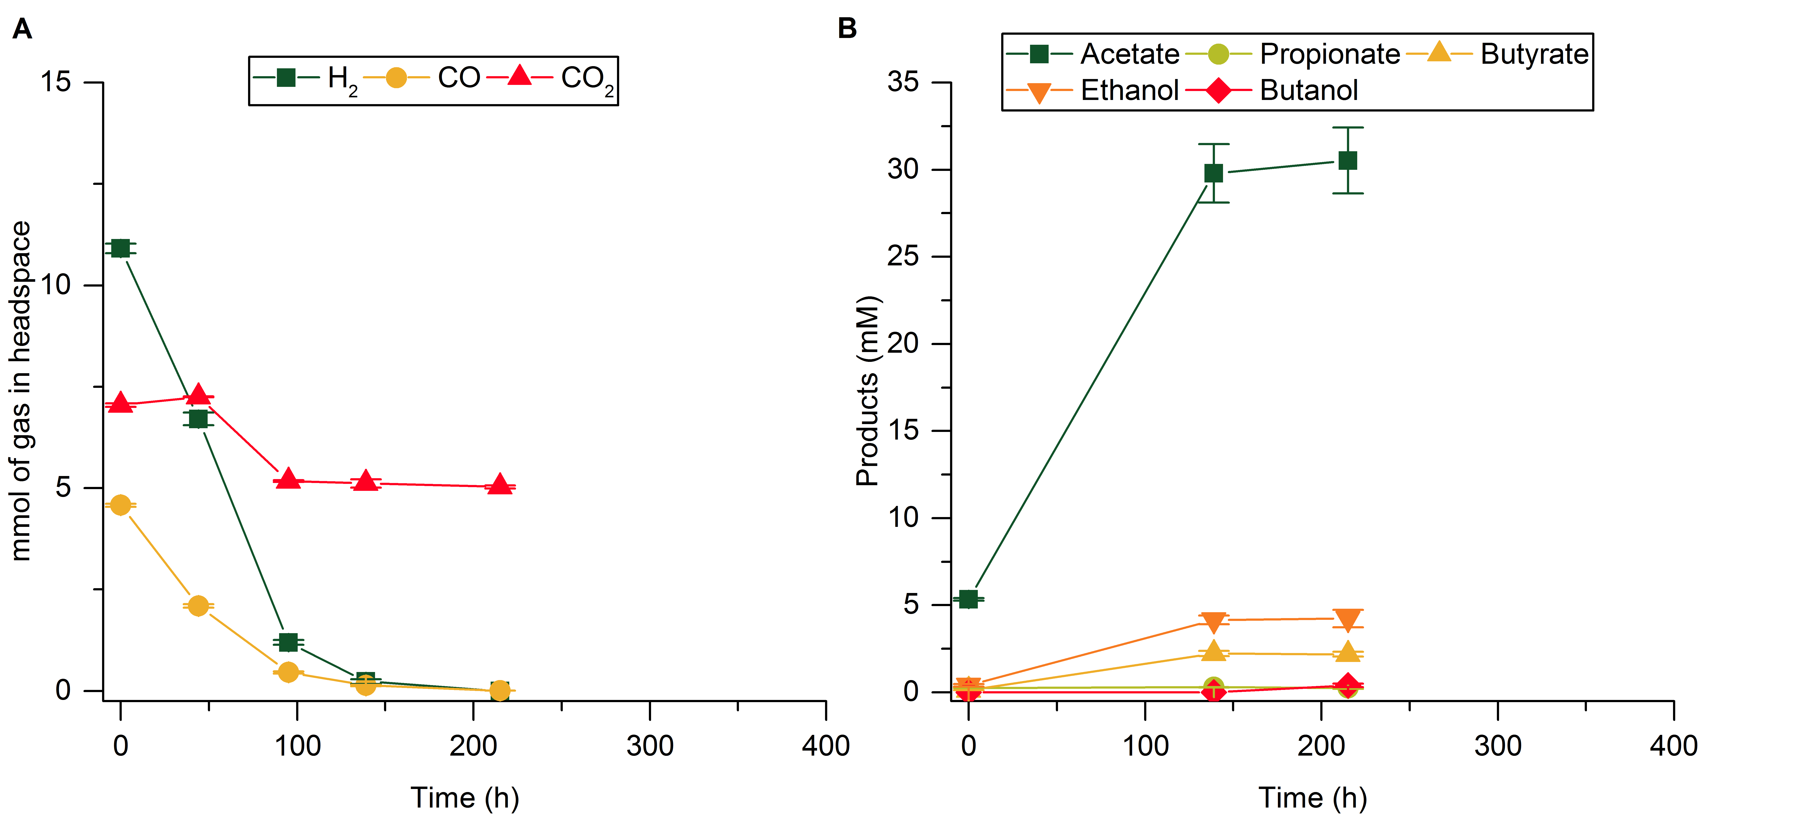
Figure S2. Fermentation profile of enrichment HT5.5YE at transfer T1 (average of duplicates). A Gas composition of the headspace (mmol). B Concentration of products in the fermentation broth (mM) and microbial growth (mg VSS/L).
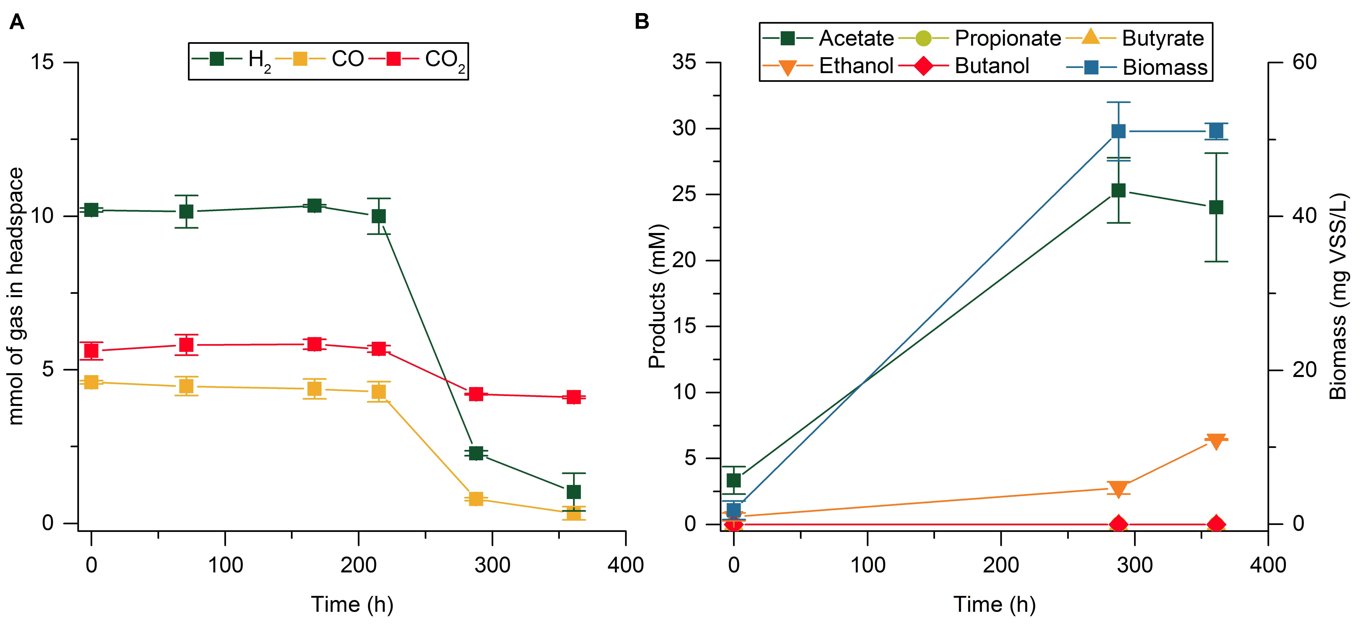
Figure S3. Fermentation profile of enrichment HT5.5 at transfer T4 (average of duplicates). A Gas composition of the headspace (mmol). B Concentration of products in the fermentation broth (mM) and microbial growth (mg VSS/L).
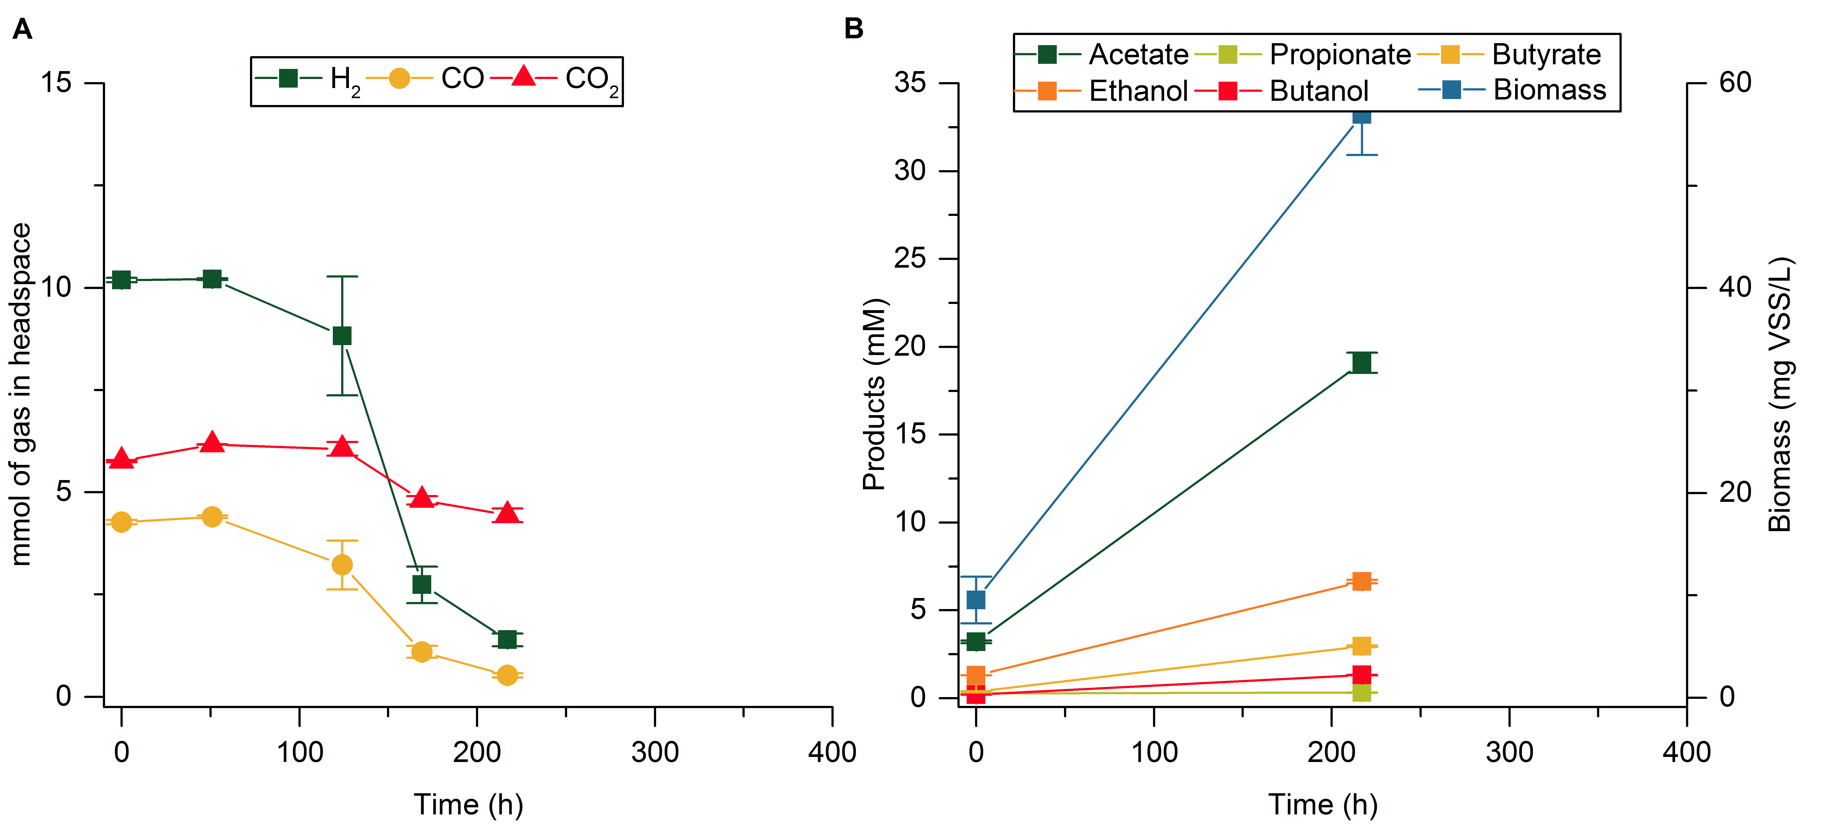
Figure S4. Fermentation profile of enrichment HT5.5YE at transfer T4 (average of duplicates). A Gas composition of the headspace (mmol). B Concentration of products in the fermentation broth (mM) and microbial growth (mg VSS/L).
Figure S5. Apparent biomass yield in enrichment experiments from transfer T3, and percentage of H₂ and CO conversion for each batch experiment. The columns show the values for the fermentation transferred and the error bars indicate the corresponding values of the duplicate experiment. A Enrichment HT6 at an initial pH of 6; B Enrichment HT5.5 at an initial pH of 5.5; C Enrichment HT5.5YE at an initial pH of 5.5 with YE (0.5 g/L); D Enrichment HT5YE at an initial pH of 5 with YE (0.5 g/L); E Enrichment NT5YE at an initial pH of 5 with YE (0.5 g/L).

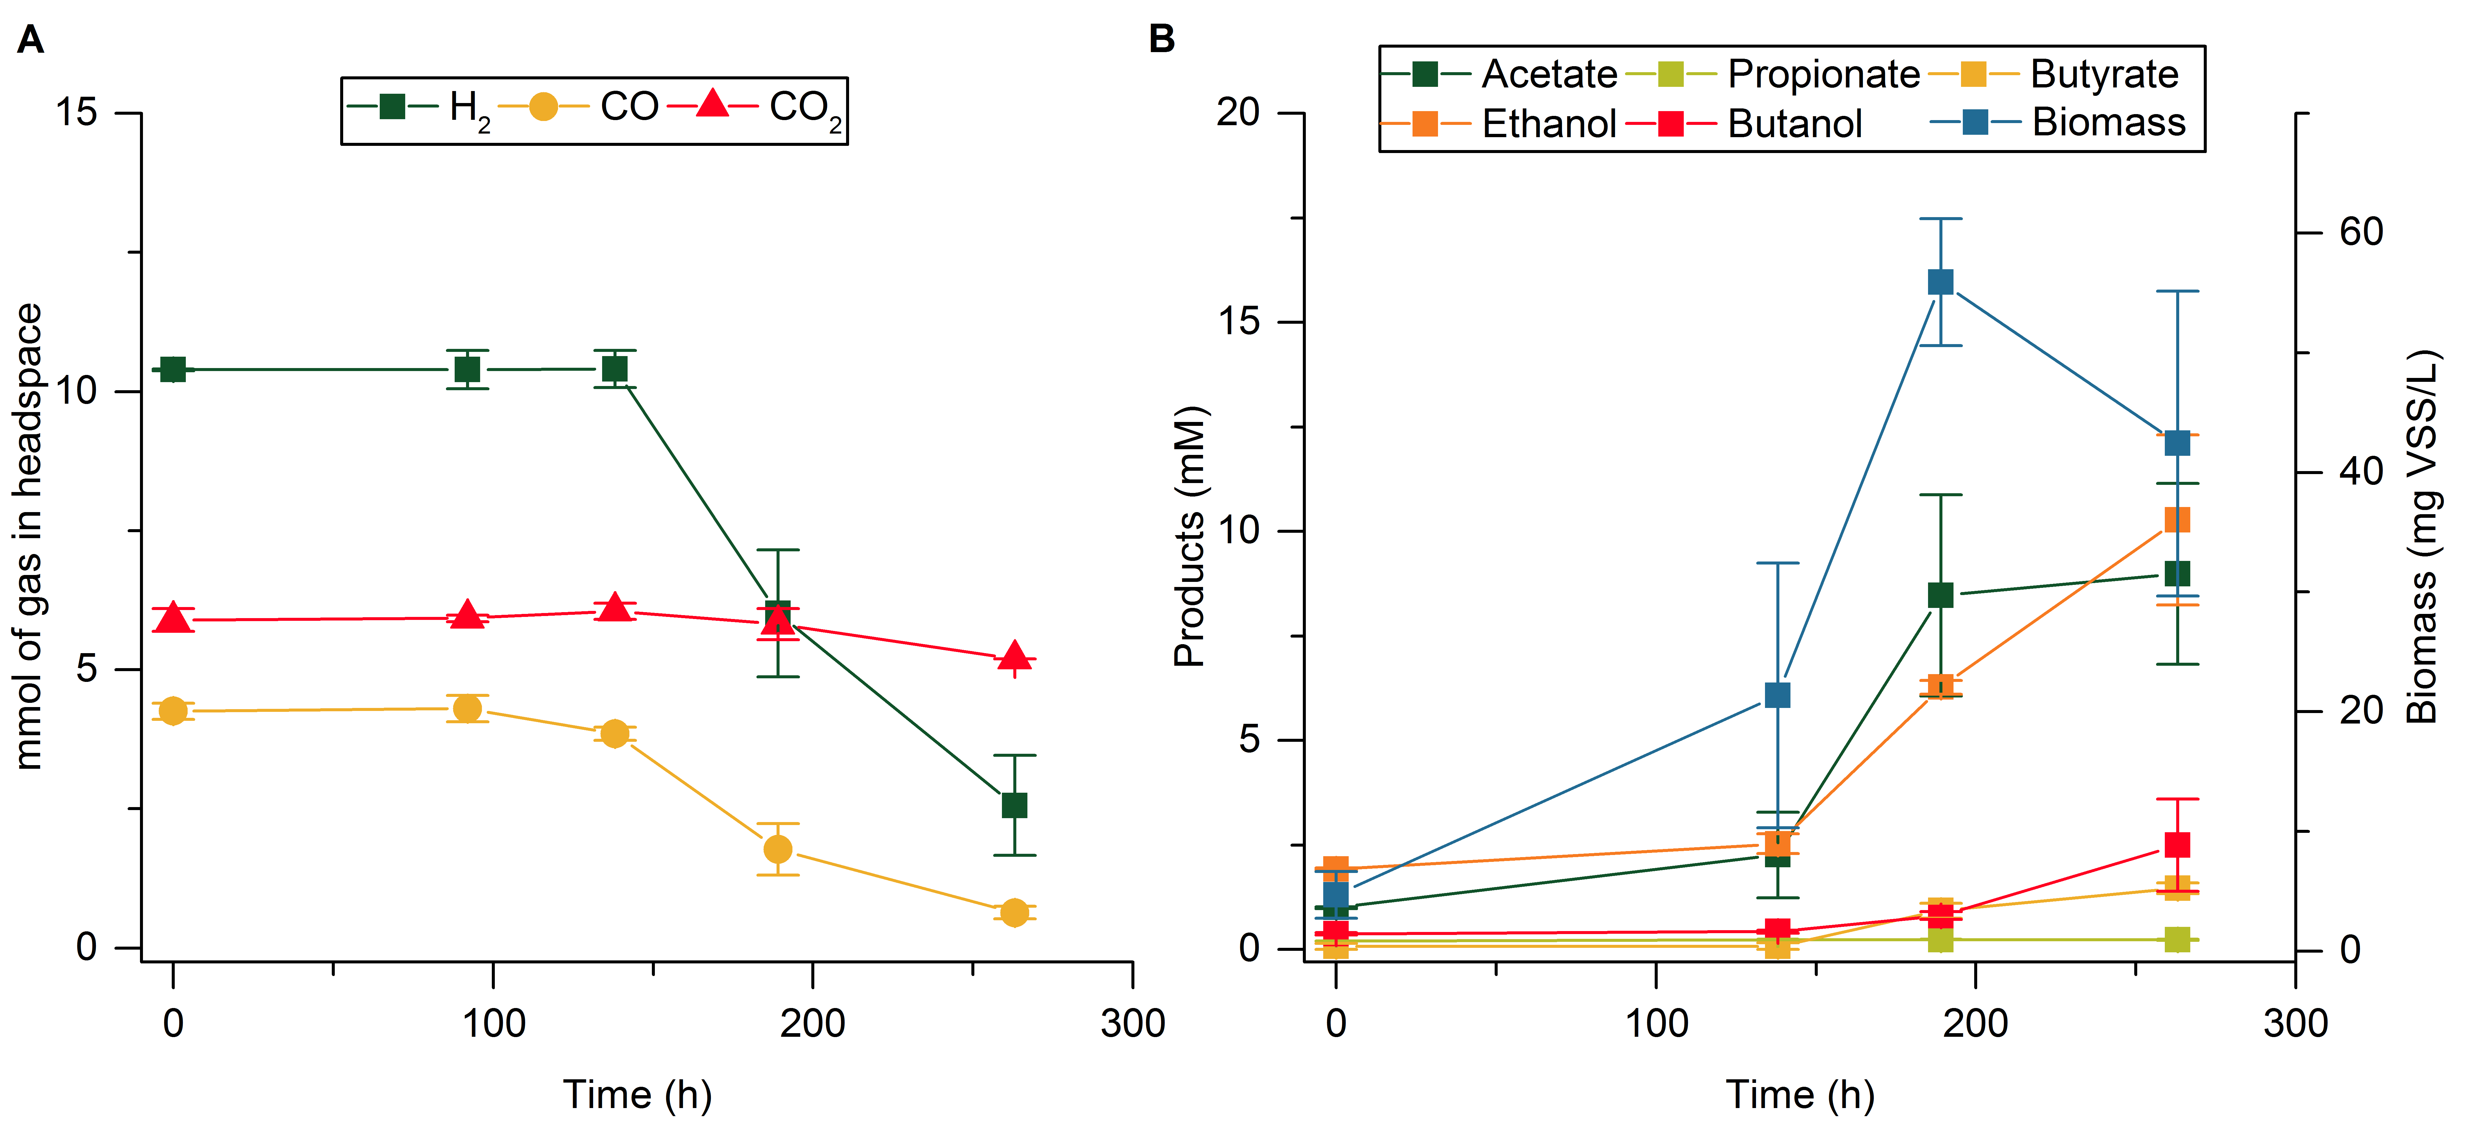
Figure S6. Fermentation profile of enrichment HT5YE at transfer T4 (average of duplicates). A Gas composition of the headspace (mmol). B Concentration of products in the fermentation broth (mM) and microbial growth (mg VSS/L).
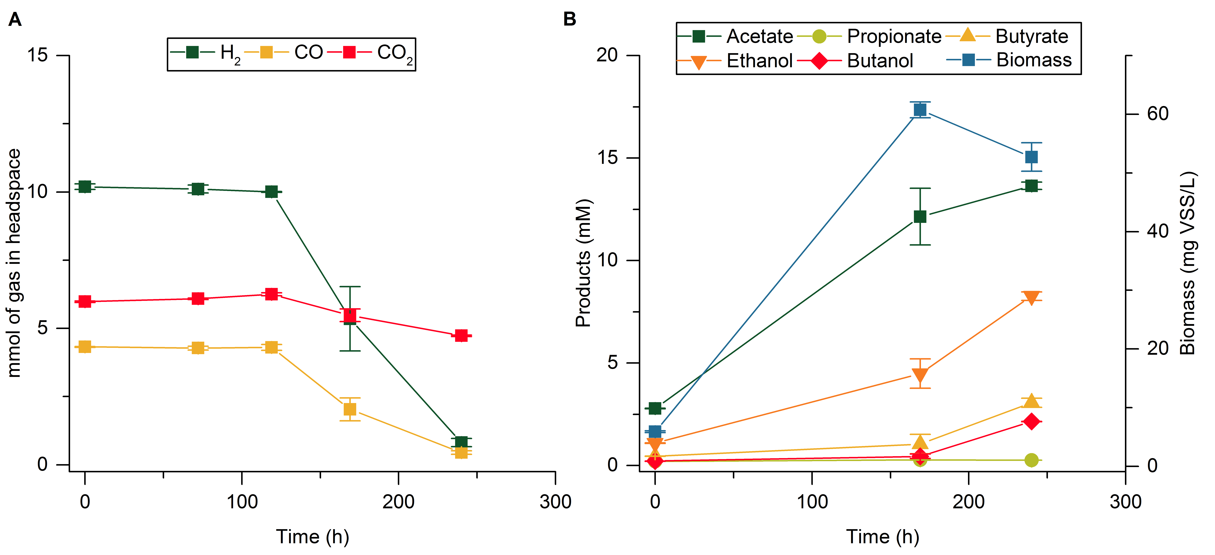
Figure S7. Fermentation profile of enrichment HT5.5YE at transfer T5 (average of duplicates). A Gas composition of the headspace (mmol). B Concentration of products in the fermentation broth (mM) and microbial growth (mg VSS/L).
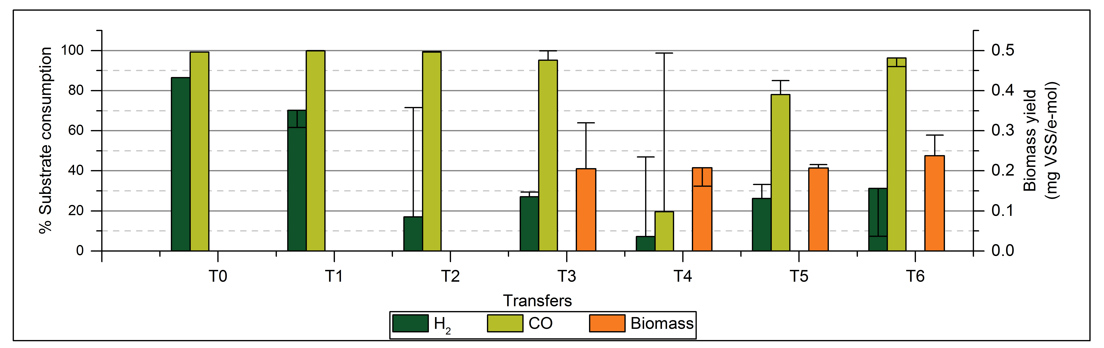
Figure S8. Apparent biomass yield for enrichment HT5YE-Ac from transfer T3, and percentage of H₂ and CO conversion. The columns show the values for the fermentation transferred and the error bars indicate the corresponding values of the duplicate experiment.
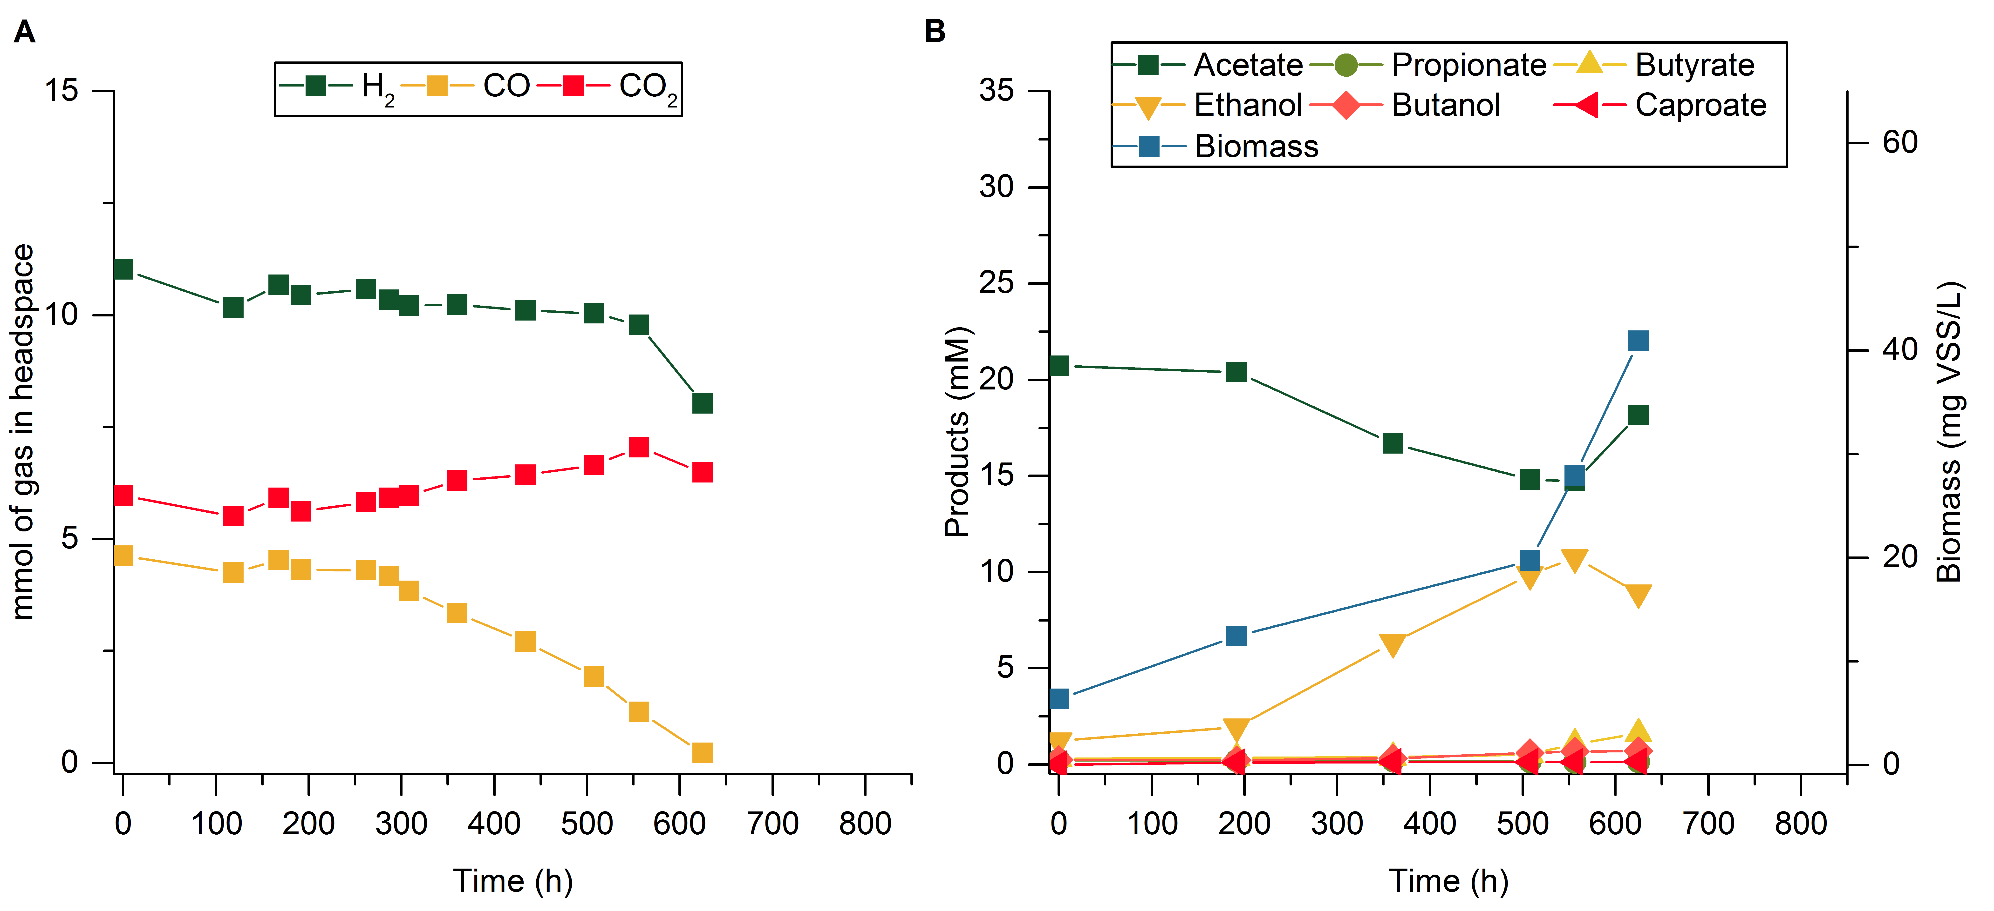
Figure S9. Fermentation profile of enrichment HT5YE-Ac at transfer T3 (replicate 1). A Gas composition of the headspace (mmol). B Concentration of products in the fermentation broth (mM) and microbial growth (mg VSS/L).
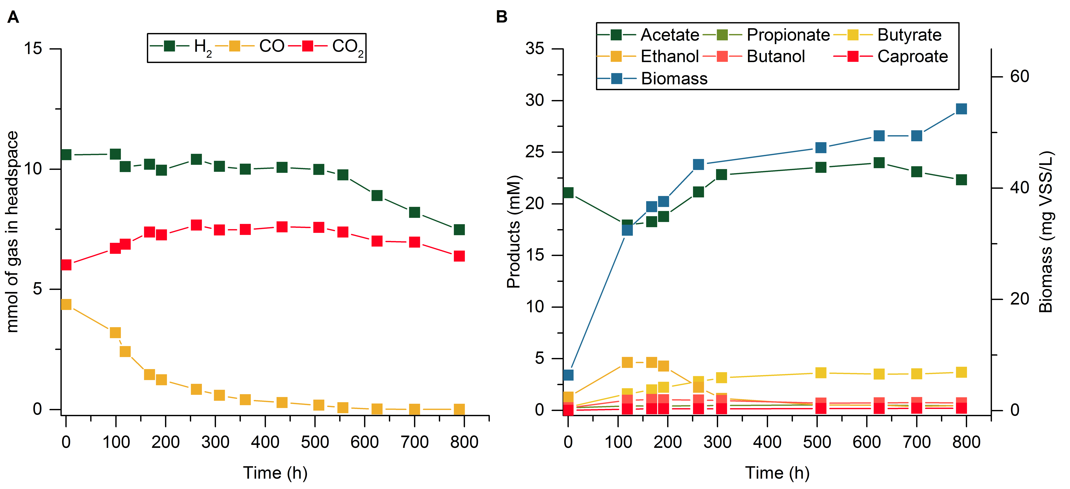
Figure S10. Fermentation profile of enrichment HT5YE-Ac at transfer T3(replicate 2). A Gas composition of the headspace (mmol). B Concentration of products in the fermentation broth (mM) and microbial growth (mg VSS/L).

