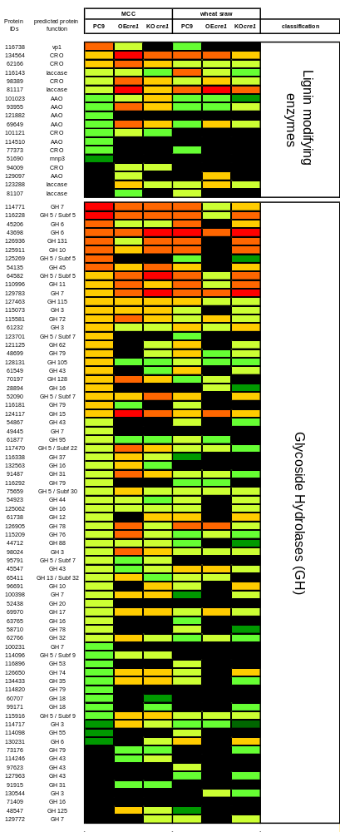Additional file 3.
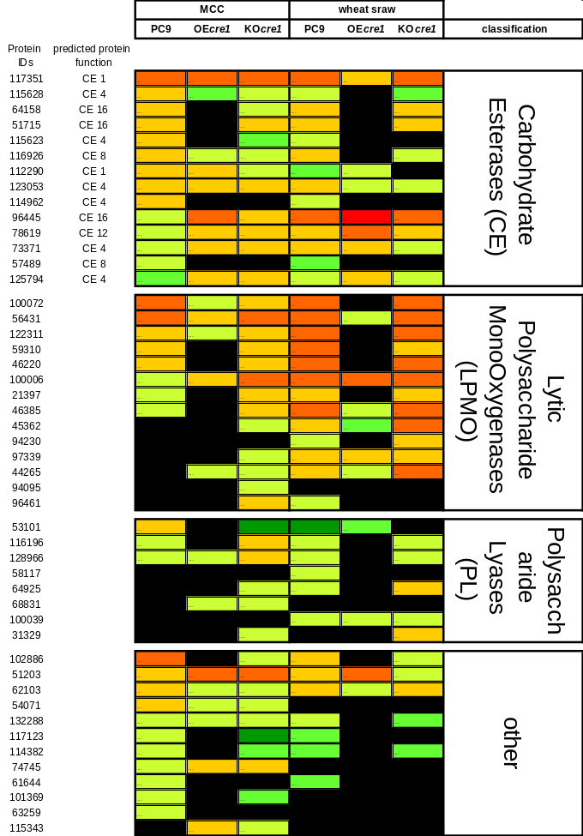

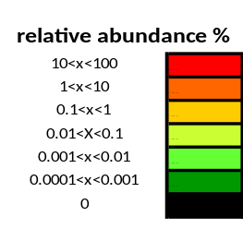

Figure S3. Relative abundance of individual CAZymes. Relative abundance [% of total secreted CAZymes] of the individual detected CAZymes was calculated, revealing the composition of secreted CAZymes in the different secretomes. Relative abundance of the CAZymes was rated by a colored scale as shown in the figure. The JGI ID number and the annotated function are shown in the figure.

