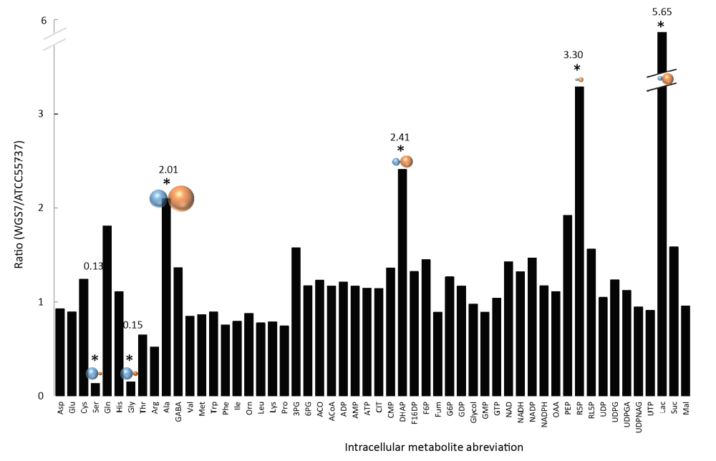
Figure S1. Correlation of intracellular metabolites between the new strain P. acidipropionici WGS7 and the wild type strain P. acidipropionici ATCC 55737. Significant difference p < 0.05 is indicated with (*). The intracellular metabolic data was obtained from two biological replicates. Legend of metabolites: Asp Aspartate , Glu Glutamate, Ser Serine, Gln Glutamine, Thr Threonine, Arg Arginine, Ala Alanine, GABA γ-aminobutyrate, Val Valine, Met Methionine, Phe Phenylalanine, Ile Isoleucine, Orn Ornithine, Leu Leucine, Lys Lysine, Pro Proline, 3PG 3-Phosphoglycerate, 6PG 6-Phosphogluconate, ACO Acetate, ACoA Acetyl-CoA, ADP Adenosine diphosphate, AMP Adenosine monophosphate, ATP Adenosine triphosphate, CIT Citrate, CMP Cytidine monophosphate, DHAP Dihydroxyacetone phosphate, F16DP Fructose 1-6-diphosphate, F6P Fructose-6-phosphate, Fum Fumarate, G6P Glucose-6-phosphate, GDP Guanosine diphosphate, GTP Guanosine triphosphate, NAD Nicotinamide adenine dinucleotide oxidized, NADH Nicotinamide adenine dinucleotide reduced, NADP Nicotinamide adenine dinucleotide phosphate oxidized, NADP Nicotinamide adenine dinucleotide phosphate reduced, OAA Oxaloacetate, PEP Phosphoenolpyruvate, R5P Ribose-5-phsophate, RL5P Ribulose-5-phosphate, UDP Uridine diphosphate, UDPG Uridine diphosphate glucose, UDPGA UDP-α-D-glucuronic acid, UDPNAG UDP-N-Acetyl glucosamine, UTP Uridine triphosphate, Lac Lactate, Suc Succinate, Mal Malate.

Table S2. P-values obtained from metabolomics comparisons
Metabolite | p-value
Ser | 6.88E-07
Lac | 1.23E-0.06
Gly | 2.11E-0.06
R5P | 0.0016
DHAP | 0.0119
Ala | 0.0464
Arg | 0.0527
PEP | 0.0739
RL5P | 0.1303
Suc | 0.1878
3PG | 0.1935
F6P | 0.2014
Gln | 0.2227
Thr | 0.2338
NADP | 0.3002
NAD | 0.3081
G6P | 0.3834
GABA | 0.4056
Pro | 0.4113
CMP | 0.4197
Phe | 0.4394
NADH | 0.4479
F16DP | 0.4621
Leu | 0.4876
Lys | 0.5229
Ile | 0.5236
Cys | 0.5510
ACO | 0.5797
OAA | 0.5945
ADP | 0.5996
AMP | 0.5999
GDP | 0.6369
UDPG | 0.6451
Val | 0.6489
6PG | 0.6660
NADPH | 0.6660
Met | 0.6726
ACoA | 0.6729
Fum | 0.6904
ATP | 0.7116
UDPNAG | 0.7209
Continued Table S2
CIT | 0.7270
UTP | 0.7457
Trp | 0.7500
Orn | 0.7592
Glu | 0.7686
His | 0.7806
UDPGA | 0.7869
Asp | 0.7994
GMP | 0.8207
GTP | 0.9226
UDP | 0.9541
Glycol | 0.9698
Mal | 0.9740

Legend of metabolites: see legend of Figure S1

