Table S1. Putative HDCR gene clusters found in bacterial genomes. Subunits of the HDCR from A. woodii were used to search available completed bacterial RefSeq genomes for similar gene clusters using MultiGeneBlast. If variations to the A. woodii gene cluster are present they are indicated.

Organism | Putative HDCR gene cluster
Acetobacterium woodii DSM 1030 | Awo_RS_04145-04180
Cloacibacillus porcorum strain CL-84¹ | BED41_RS16035-00320
Clostridium beijerinckii strain NCIMB 14988² | LF65_RS20925-20895
Clostridium carboxidivorans P7¹ | Ccar_RS16075-16045
Clostridium difficile 630 | CD630_33170-33130
Clostridium taeniosporum strain 1/k² | BGI42_RS14085-14055
Desulfotalea psychrophila LSv54 | DP_RS02385-02370
Desulfobacterium autotrophicum HRM2 | HRM2_RS00765-00750
Desulfotomaculum nigrificans CO-1-SRB³ | DESCA_RS05360-14360
Desulfovibrio alaskensis G20 | DDE_RS02105-02120
Desulfovibrio magneticus RS-1 | DMR_RS20510-20490
Desulfovibrio salexigens DSM 2638 | DESAL_RS01825-01840
Dehalobacterium formicoaceticum strain DMC⁴ | CEQ75_RS07685-07715
Ilyobacter polytropus DSM 2926⁵ | ILYOP_RS15475-03270
Intestinibacter bartlettii DSM 16795 | CLOBAR_00271-00268
Paenibacillus durus strain DSM 1735 | PDUR_RS13050-13065
Paenibacillus polymyxa SC2 | PPSC2_RS42955-42970
Paenibacillus stellifer strain DSM 14472 | PSTEL_RS12765-12775
Paenibacillus terrae HPL-003 | HPL003_23040- 23055
Pelosinus fermentans JBW45 | JBW_RS18290-18275
Peptoclostridium acidaminophilum DSM 3953⁶ | EAL2_RS02100-15100
Symbiobacterium thermophilum IAM 14863 | STH_RS16410-16395
Thermoanaerobacter kivui strain DSM 2030 | TKV_RS09735-09720
Thermosediminibacter oceani DSM 16646⁵ | TOOE_RS03915-03930
Treponema primitia ZAS-2 | TREPR_RS04760-04785

¹genes annotated as nuoE and nuoF (NADH:Quinone oxidoreductase) between hydA and fdhF
²genes for molybdopterin biosynthesis and fdhD between hydA and fdhF
³no hyc genes, gene annotated as NAD/FAD oxidoreductase with one predicted transmembrane helix after fdhF
⁴genes annotated as nuoE and nuoF (NADH:Quinone oxidoreductase) in front of hydA and fdhF
⁵ no hyc genes
⁶genes annotated as nuoE and nuoF in front of hydA, genes annotated as NADH dehydrogenase in front of fdhF

Table S2. Comparison of purified enzymes catalysing the direct hydrogenation of CO₂ as well as formate oxidation.

 |  | H₂:MV-oxidoreductase  activity [U/mg] | formate:MV-  oxidoreductase  activity [U/mg] | K_{m}  (H₂/ formate)  [mM] | H₂ production  [U/mg]/[h⁻¹] | formate  production  [U/mg] ]/[h⁻¹]
T. kivui | 60 °C | 14,400 | 455 | 0.126/  0.55 | 930/  9,892,000 | 900/  9,556,000
A. woodii¹ | 30 °C | 10,800 | 600 | 0.125/  1.0 | 14/  141,960 | 10/  101,600
E. coli^{2,3,4} | 37 °C | 2.44 ± 0.62# | 0.82 ± 0.04# | 0.034/  26 | 0.1/  1,836 | 0.03/  550.8
# For E. coli FHL, benzylviologen instead of methylviologen was used
¹ Schuchmann K, Müller V. Direct and reversible hydrogenation of CO₂ to formate by a bacterial carbon dioxide
reductase. Science. 2013;342:1382-5.
² McDowall JS, Murphy BJ, Haumann M, Palmer T, Armstrong FA, Sargent F. Bacterial formate hydrogenlyase
complex. Proc Natl Acad Sci USA. 2014;111:E3948-E56.
³ Axley MJ, Grahame DA. Kinetics for formate dehydrogenase of Escherichia coli formate-hydrogenlyase.
J Biol Chem. 1991;266:13731-13736.
⁴ Pinske C, Sargent F. Exploring the directionality of Escherichia coli formate hydrogenlyase: a membrane-
bound enzyme capable of fixing carbon dioxide to organic acid. MicrobiologyOpen. 2016;5:721-37.
ND – not determined

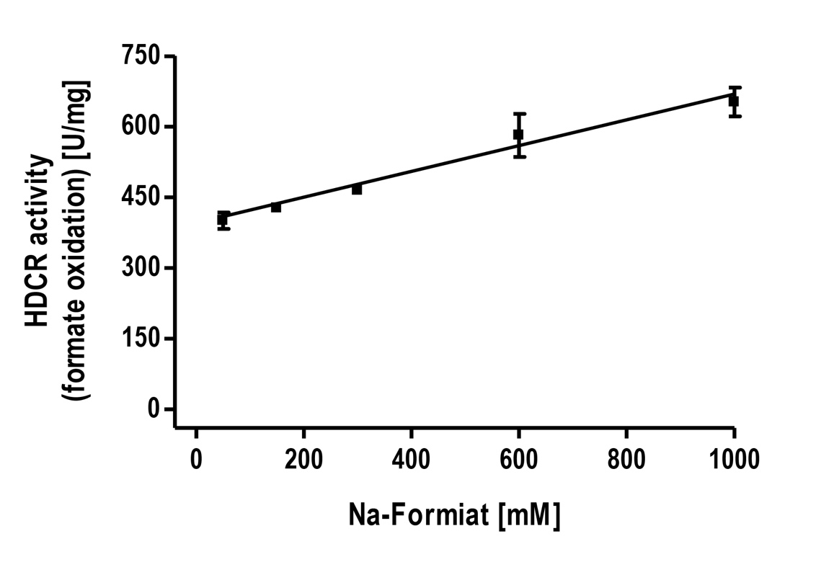

Figure S1. Substrate tolerance of the HDCR from T. kivui. 10 µg isolated enzyme was incubated in 100 mM HEPES/NaOH, 2 mM DTE, pH 7.0 under an atmosphere of 100% N₂ and varying concentrations of Na formate as substrate. H₂ production was measured in the gas phase.

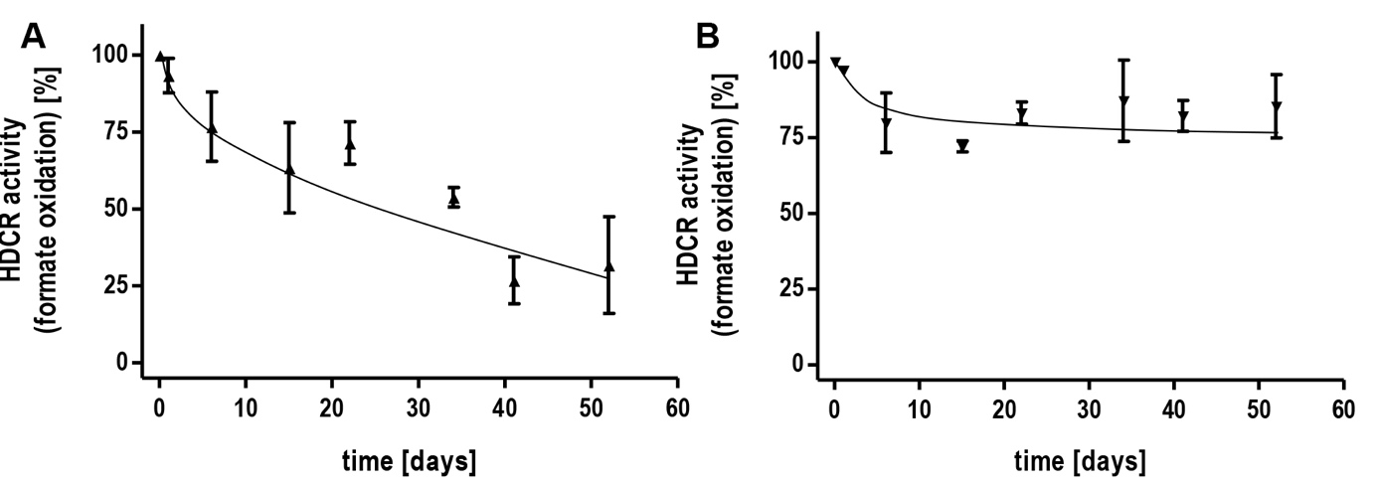

Figure S2. Stability of the HDCR from T. kivui. The enzyme was incubated at 4°C (A) and -20°C (B). Samples were taken and the specific activity determined by measuring H₂ evolution. 10 µg isolated enzyme was incubated in 100 mM HEPES/NaOH, 2 mM DTE, pH 7.0 under an atmosphere of 100% N₂ and 150 mM sodium formate as substrate. H₂ production was measured in the gas phase. The sample incubated at -20°C was thawed each time and frozen afterwards.

