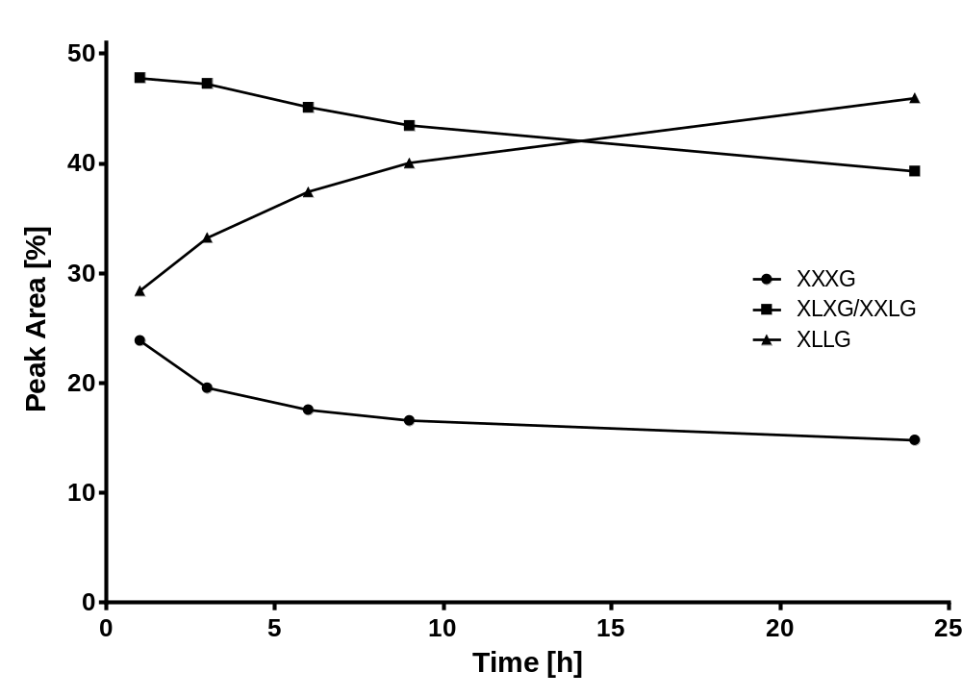
Figure S1 Relative peak areas determined by HPAEC-PAD of the xyloglucan oligosaccharides XXXG, XLXG+XXLG, and XLLG over time during xyloglucan hydrolysis using Cel9D.

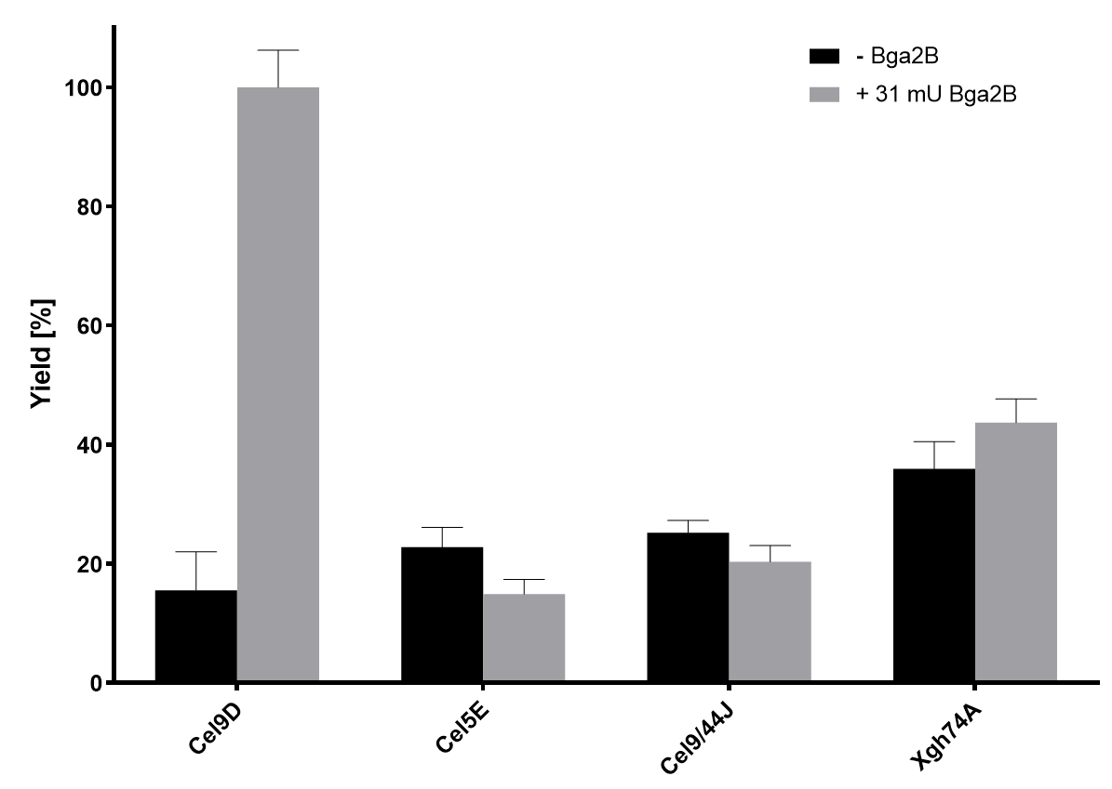
Figure S2 Relative reaction yields determined by HPAEC-PAD with 1 µg Cel9D, Cel5E, Cel9/44J or Xgh74A using standard reaction conditions with (grey) and without (black) the addition of 31 mU Bga2B.

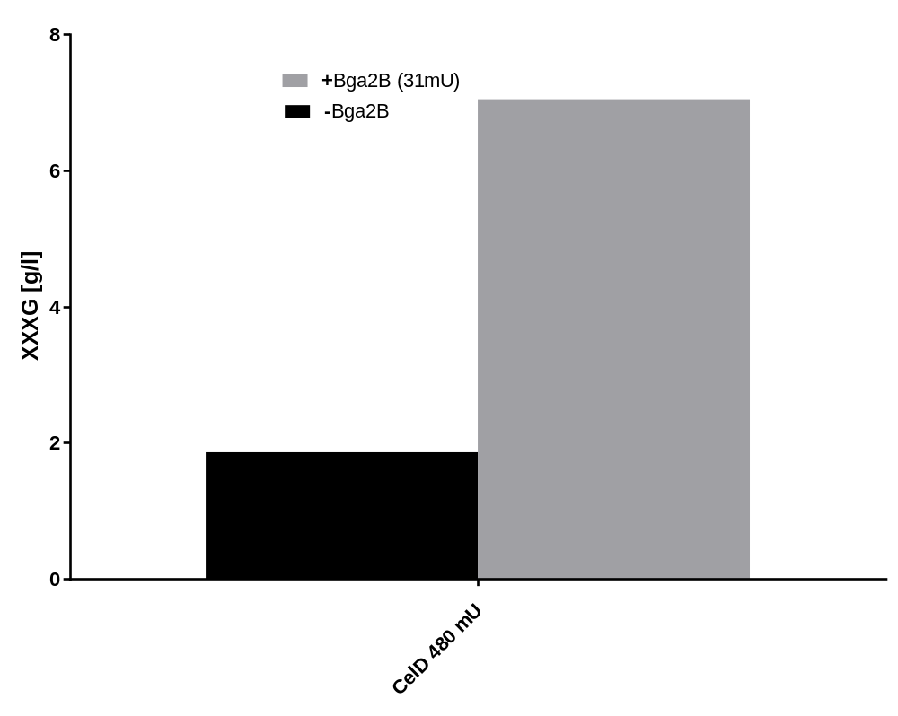
Figure S3 XXXG concentrations determined by HPAEC-PAD after 6h, 60°C incubation of 480 mU Cel9D with (grey) and without (black) the addition of 31 mU Bga2B.

