Additional file 10

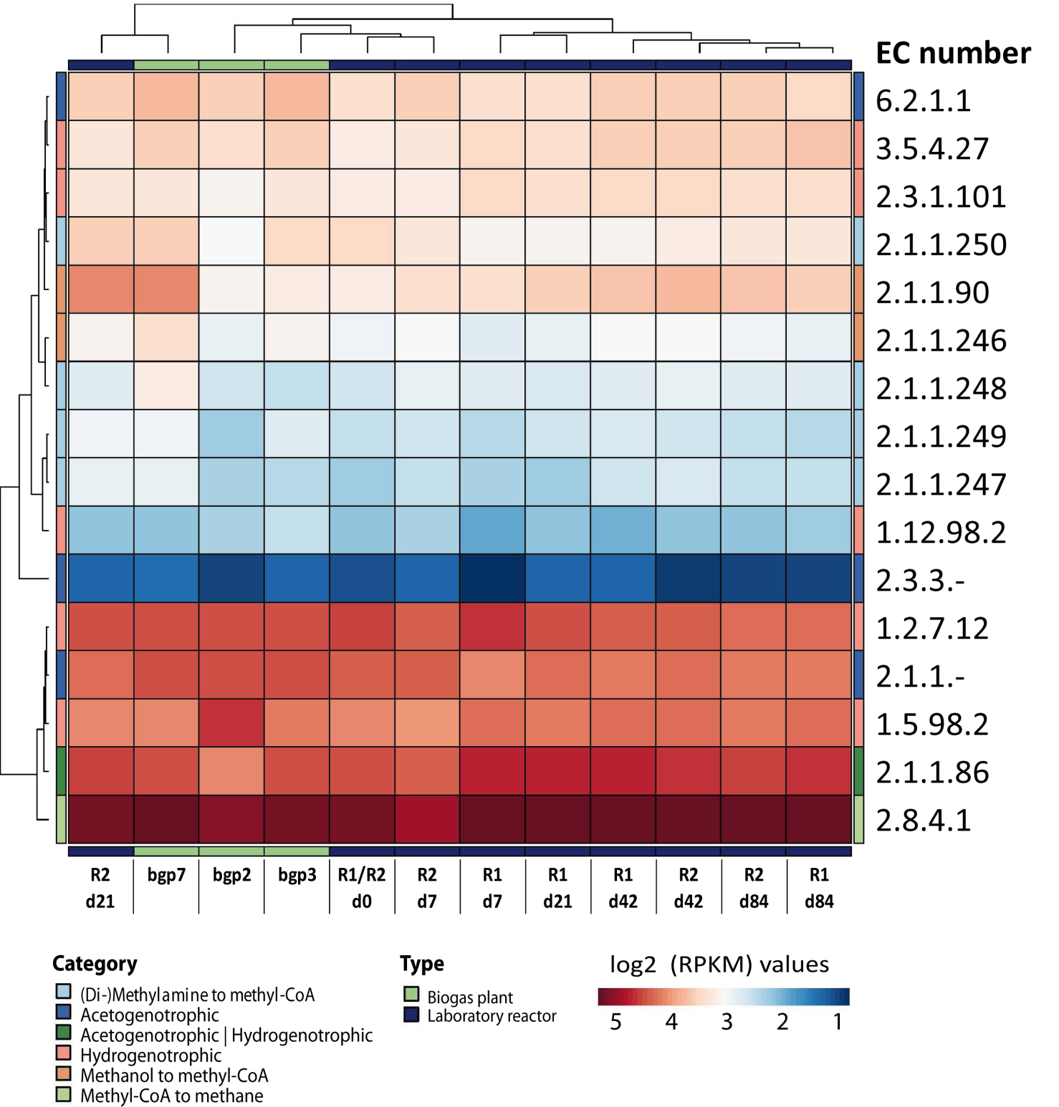
Comparative metatranscriptomic analysis of methanogenesis metabolic module.
Heatmap of log2-transformed RPKM values of enzymes associated with methanogenesis metabolic module.

