Additional file 3

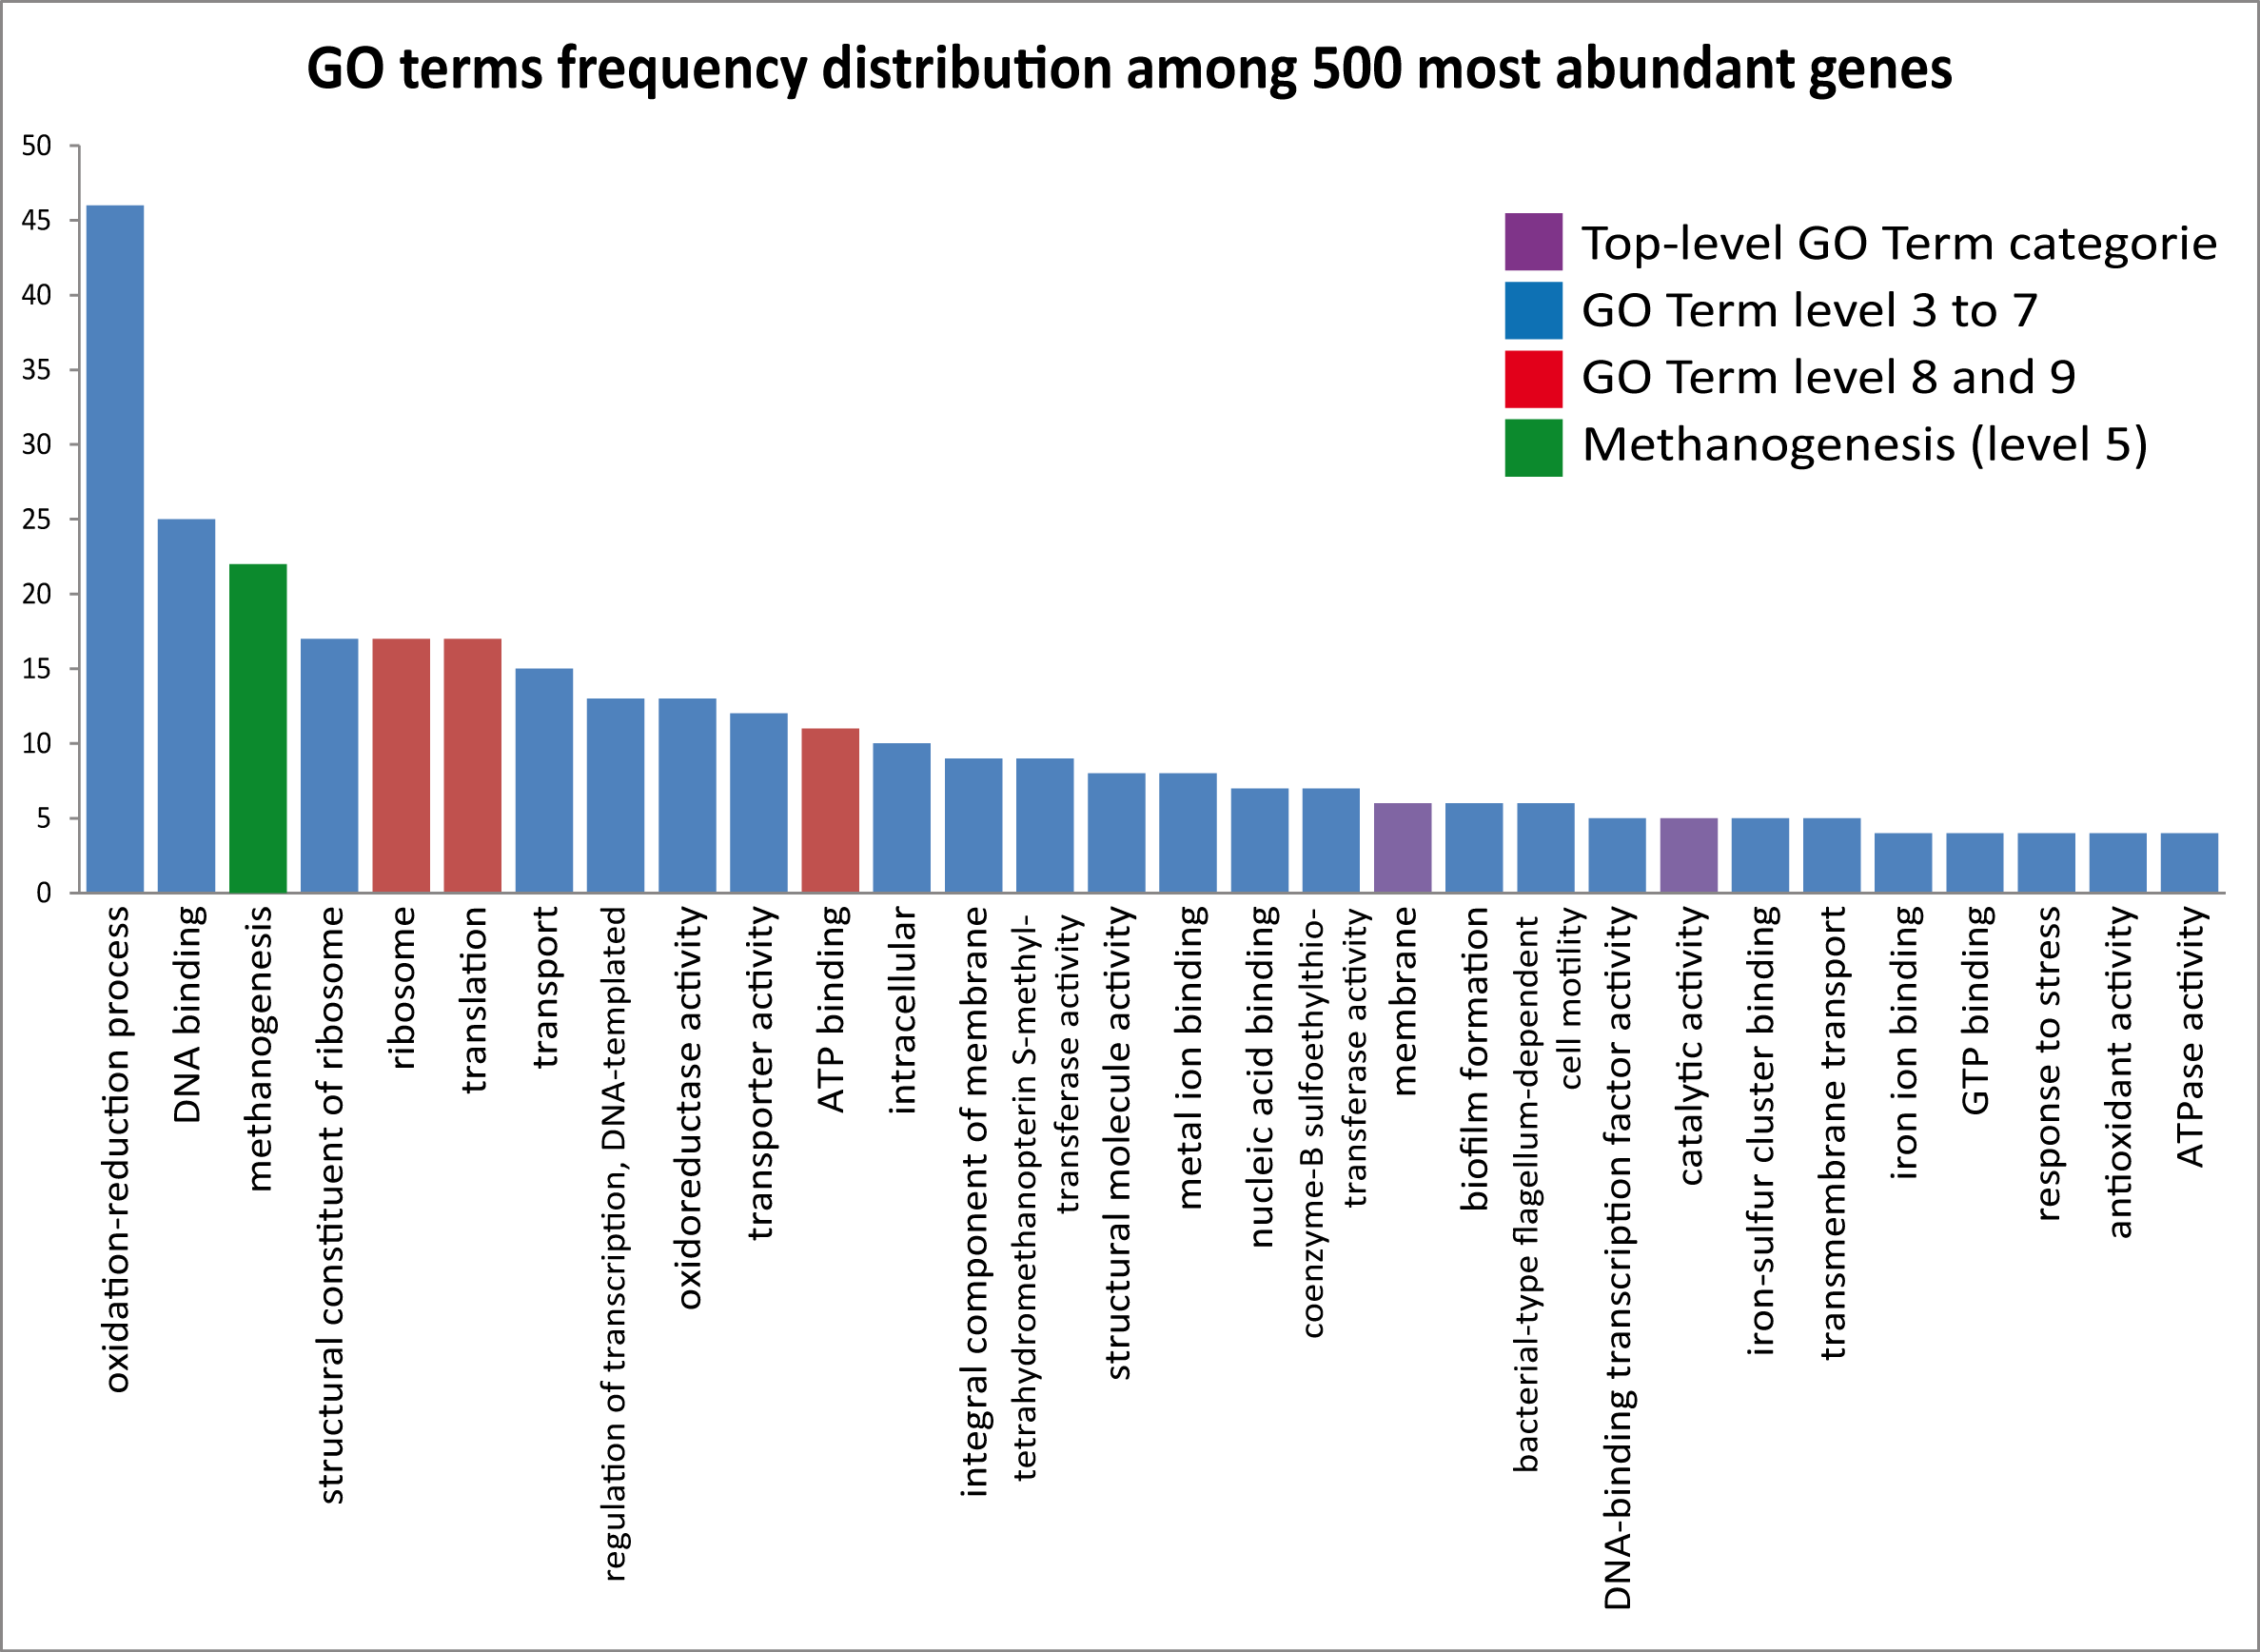
GO terms frequency distribution.
The frequency distribution of GO terms among most abundant genes in methane producing laboratory reactors (R1, R2, time 42, and 48 hours), based on mean log2 RPKM calculations.

