Additional file 5

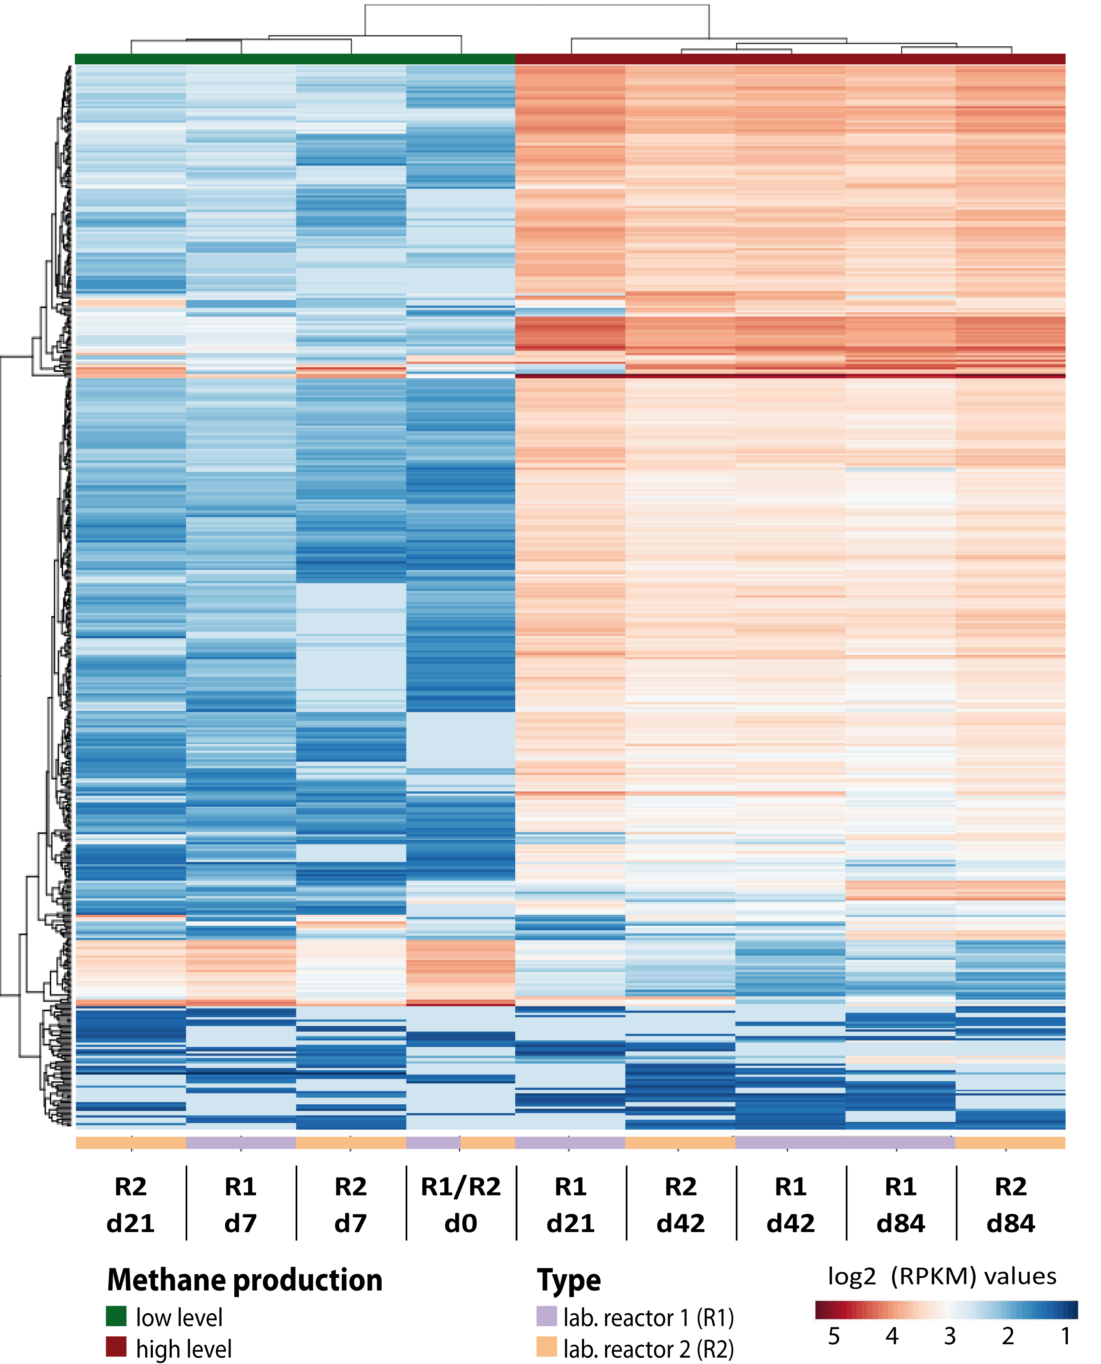
Comparative metatranscriptomic analysis of laboratory reactors.
Heatmap colors representing gene log2 RPM values. Hierarchical clustering was done for samples as well as for genes. Corresponding dendrogram on the top shows clustering of biogas plants and laboratory reactors. The dendrogram on the left demonstrating clustering of genes.

