Additional file 1

Clustered tree and PCoA plot based on weighted-Unifrac distance

Weighted-Unifrac distances were calculated using phyloseq R-package. Clustering was performed using hclust R function with ward.D2 parameter, and PCoA plot was performed using phyloseq ordinate and plot functions.
NSS and SS communities appear to separate with cycles: C1 are well grouped, C2 and C3 begin to be distant and C4 and C5 are well separated. On the PCoA plot, NSS-C5a appear to be close to C1 points, but it is in fact due to its projection according to the 3rd and 4th axes. Its position in the clustered tree and the raw distances confirm that it is distant from SS-C1 and NSS-C1.

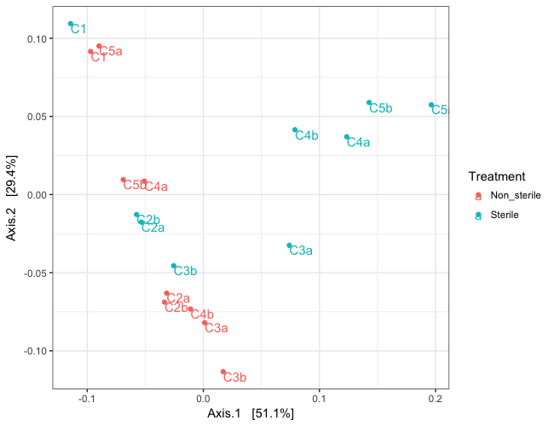
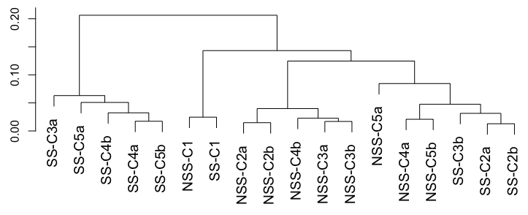

Weighted-Unifrac distances between samples

