Synthesis and Techno-Economic Assessment of Microbial-Based Processes for Terpenes Production
Wenzhao Wu, Christos T. Maravelias*
Dept. of Chemical and Biological Engineering and DOE Great Lakes Bioenergy Research Center, University of Wisconsin-Madison, Madison, WI 53706
Additional File 1
1. VVM^{MIN} calculation
The minimum amount of air required ($q_{air}^{MIN}, L$ air/g glucose) can be calculated based on the stoichiometry of Equations 1-4 in the main text. The result is shown in Equation A1.
$q_{air}^{MIN}=\frac{\left(\frac{η×z\%}{ζ}-\frac{θ×x\%}{ζ}\right)×σ}{{MW}_{O2}×ν}=\frac{\left(\frac{192×z\%}{180}-\frac{38.08×x\%}{180}\right)×24 L/mol}{32g/mol×21\% oxygen in air}=0.0167×(100-y)$ (A1)
where ζ, η and θ represent the stoichiometrically weighted molecular weights of glucose and O₂ (consumed and produced), respectively; MW_{O2} is the molecular weight of O₂; $σ$ is the molar volume of gas at normal conditions; ν is the volumetric percentage of oxygen in air.
VVM^{MIN} is derived as shown in Equation A2 using the definition of VVM, where $q^{IN}$ is the total volumetric flow rate of the feed liquid per unit of glucose flow rate (L/g glucose); $τ$ is fermenter residence time (min); $ρ_{liq}$ is density (g/L) of the feed (glucose-water mixture), which is a fitted function based on known experimental data points (see Additional File 2), i.e., $ρ_{liq}=294.75×glucose concentration (wt\%)+1000$.
${VVM}^{MIN}=\frac{q_{air}^{MIN}}{q^{IN}×τ}=\frac{0.0167×(100-y)}{\frac{1}{glucose concentration×ρ_{liq}}×45h×60min/h}=\frac{(100-y)×glucose concentration×(294.75×glucose concentration+1000)}{161677}$ (A2)
For example, in Case 1 (glucose concentration = 14 wt%, yield = 0.45 %, i.e., y=0.45), ${VVM}^{MIN}=0.090$ min⁻¹, which is satisfied by the 0.1 min⁻¹ VVM in Case 1. The same verification can be performed for Cases 2 and 3, where VVM^{MIN}=0.040 and 0.0079 min⁻¹, respectively.
We can also identify infeasible yield and glucose concentration combinations for a given VVM, as represented by the grey shaded areas in Figures 6 and 10 in the main text, by fixing VVM^{MIN} to the given VVM value in Equation A2. The specific calculations can be found in Additional File 2.
2. Batch-to-chemostat data conversion
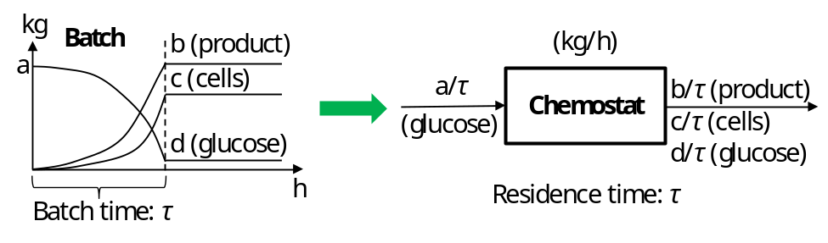
Figure S1. Conversion of data in a batch reactor (kg) to equivalent data in a chemostat (kg/h).
Figure S1 shows how we convert data in a batch reactor to equivalent data in a chemostat.
3. Explanation to “min” functions
The $n_{gas}$ threshold values for Components 1 and 2, where the corresponding component is completely stripped to the vapor phase, are $\frac{n_{1}×(P-f\left(T\right)-g(T) )}{f\left(T\right)}$ and $\frac{n_{2}×(P-f\left(T\right)-g(T) )}{g\left(T\right)}$, respectively, which are calculated with $\frac{f\left(T\right)×n_{gas}}{P-f\left(T\right)-g(T) }=n_{1}$ and $\frac{g\left(T\right)×n_{gas}}{P-f\left(T\right)-g(T) }=n_{2}$ by definition.
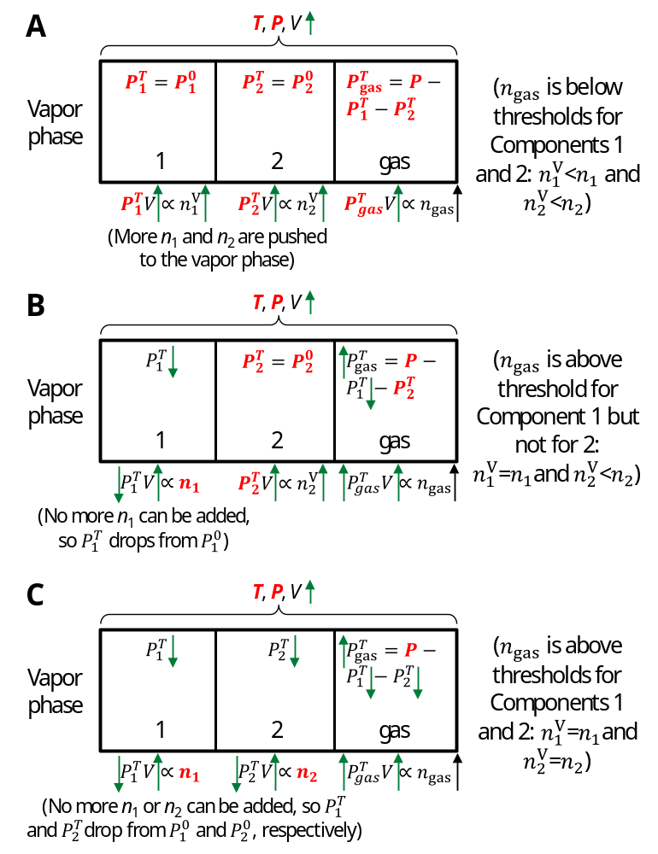
Figure S2. Changes to VLE with increasing n_{gas} in different ranges. (A) n_{gas} is below the threshold values for both Components 1 and 2; (B) n_{gas} is above the threshold value for Component 1 but not for Component 2; (C) n_{gas} is above the threshold values for both Components 1 and 2. It is assumed that the $n_{gas}$ threshold value for Component 1 is lower than that for Component 2, as an example here. Constants are marked bold in red. The change (increase/decrease) for each variable is marked with a green directional arrow. V represents the total volumetric flow rate of the vapor phase. The components are separated into different regions for demonstration purpose only; in reality, they are mixed together.
The qualitative VLE analysis in different n_{gas} ranges is shown in Figure S2. For demonstration purpose, we first assume that the $n_{gas}$ threshold value for Component 1 is lower than that for Component 2; in other words, when Component 1 is completely stripped to the vapor, a portion of Component 2 still exists in the liquid, i.e., $\frac{n_{1}}{f\left(T\right)}<\frac{n_{2}}{g\left(T\right)}$. There are three possible scenarios as follows.
Scenario 1. When n_{gas} is below the threshold values for both Components 1 and 2 (Figure S2-A), the increase of n_{gas} leads to more Components 1 and 2 being pushed to the vapor phase.
Scenario 2. When n_{gas} is above the threshold value for Component 1 but not for Component 2 (Figure S2-B), $n_{1}^{V}$=$n_{1}$, i.e., no more Component 1 is left to be pushed to the vapor phase further, leading to the drop of $P_{1}^{T}$ and increase of $P_{gas}^{T}$.
Scenario 3. When n_{gas} is above the threshold values for both Components 1 and 2 (Figure S2-C), $n_{1}^{V}$=$n_{1}$ and $n_{2}^{V}$=$n_{2}$, leading to drop of $P_{1}^{T}$and $P_{2}^{T}$ as well as increase of $P_{gas}^{T}$
A quantitative analysis for the three scenarios is as follows.
In Scenario 1, $\frac{f\left(T\right)×n_{gas}}{P-f\left(T\right)-g(T) }<n_{1}$, while $\frac{g\left(T\right)×n_{gas}}{P-f\left(T\right)-g(T) }<n_{2}$ is implicit because $\frac{n_{1}}{f\left(T\right)}<\frac{n_{2}}{g\left(T\right)}$. Thus, $n_{gas}<\frac{n_{1}×(P-f\left(T\right)-g(T) )}{f\left(T\right)}$ uniquely describes Scenario 1. We solve Equations 3-8 in the main text to obtain the following.
$n_{1}^{V}=\frac{f\left(T\right)×n_{gas}}{P-f\left(T\right)-g(T) }$ (A3)
$n_{2}^{V}=\frac{g\left(T\right)×n_{gas}}{P-f\left(T\right)-g(T) }$ (A4)
In Scenario 2, $\frac{f\left(T\right)×n_{gas}}{P-f\left(T\right)-g(T) }≥n_{1}$ and $\frac{g\left(T\right)×n_{gas}}{P-f\left(T\right)-g(T) }<n_{2}$, and thus $\frac{n_{1}×(P-f\left(T\right)-g(T) )}{f\left(T\right)}≤n_{gas}<\frac{n_{2}×(P-f\left(T\right)-g(T) )}{g\left(T\right)}$, the following equations hold (as discussed in the last paragraph of Section “VLE analysis” in the main text).
$n_{1}^{V}+n_{1}^{L}=n_{1}$ (A5)
$n_{2}^{V}+n_{2}^{L}=n_{2}$ (A6)
$n_{1}^{V}=n_{1}$ (A7)
$\frac{P_{gas}^{T}}{n_{gas}}=\frac{P_{1}^{T}}{n_{1}^{V}}=\frac{P_{2}^{T}}{n_{2}^{V}}$ (A8)
$P_{2}^{T}=P_{2}^{0}$ (A9)
$P_{1}^{0}=f\left(T\right);P_{2}^{0}=g\left(T\right)$ (A10)
$P_{1}^{T}+P_{2}^{T}+P_{gas}^{T}=P$ (A11)
Solving Equations A5-A11, we obtain the following.
$n_{1}^{V}=n_{1}$ (A12)
$n_{2}^{V}=\frac{g\left(T\right)×{(n}_{gas}+n_{1})}{P-g(T) }$ (A13)
In Scenario 3, $\frac{g\left(T\right)×n_{gas}}{P-f\left(T\right)-g(T) }≥n_{2}$, while $\frac{f\left(T\right)×n_{gas}}{P-f\left(T\right)-g(T) }≥n_{1}$ is implicit because $\frac{n_{1}}{f\left(T\right)}<\frac{n_{2}}{g\left(T\right)}$. Thus, $n_{gas}≥\frac{n_{2}×(P-f\left(T\right)-g(T) )}{g\left(T\right)}$ uniquely describes Scenario 3, and we obtain the following.
$n_{1}^{V}=n_{1}$ (A14)
$n_{2}^{V}=n_{2}$ (A15)
Results for the above three scenarios (Equations A3, A4, and A12-A15) can be summarized as the following.
$n_{1}^{V}=min⁡(\frac{f\left(T\right)×n_{gas}}{P-f\left(T\right)-g(T) }$, $n_{1}$) (A16)
$n_{2}^{V}=min⁡(\frac{g\left(T\right)×n_{gas}}{P-f\left(T\right)-g(T) }$, $\frac{g\left(T\right)×(n_{gas}+n_{1})}{P-g(T) }$, $n_{2}$) (A17)
To verify the validity of Equations A16 and 17, note that in Equation A17, $\frac{g\left(T\right)×n_{gas}}{P-f\left(T\right)-g(T) }-\frac{g\left(T\right)×\left(n_{gas}+n_{1}\right)}{P-g\left(T\right) }=\frac{g\left(T\right)×\{f\left(T\right)×n_{gas}-n_{1}×\left[P-f\left(T\right)-g\left(T\right)\right]\}}{\left[P-f\left(T\right)-g\left(T\right) \right]×\left[P-g\left(T\right)\right]}$. Therefore,
(1) When $\frac{g\left(T\right)×n_{gas}}{P-f\left(T\right)-g(T) }<n_{2}$ and $f\left(T\right)×n_{gas}-n_{1}×\left[P-f\left(T\right)-g\left(T\right)\right]<0$, i.e., $\frac{f\left(T\right)×n_{gas}}{P-f\left(T\right)-g(T) }<n_{1}$, we have $\frac{g\left(T\right)×n_{gas}}{P-f\left(T\right)-g(T) }<\frac{g\left(T\right)×(n_{gas}+n_{1})}{P-g(T) }<n_{2}$, and thus $n_{2}^{V}=\frac{g\left(T\right)×n_{gas}}{P-f\left(T\right)-g(T) }$ and $n_{1}^{V}=\frac{f\left(T\right)×n_{gas}}{P-f\left(T\right)-g(T) }$, which corresponds to Scenario 1.
(2) When $\frac{g\left(T\right)×n_{gas}}{P-f\left(T\right)-g(T) }<n_{2}$ and $f\left(T\right)×n_{gas}-n_{1}×\left[P-f\left(T\right)-g\left(T\right)\right]≥0$, i.e., $\frac{f\left(T\right)×n_{gas}}{P-f\left(T\right)-g(T) }≥n_{1}$, we have $\frac{g\left(T\right)×(n_{gas}+n_{1})}{P-g(T) }≤\frac{g\left(T\right)×n_{gas}}{P-f\left(T\right)-g(T) }<n_{2}$ $n_{2}^{V}=\frac{g\left(T\right)×(n_{gas}+n_{1})}{P-g(T) }$ and $n_{1}^{V}=n_{1}$, which corresponds to Scenario 2.
(3) When $\frac{g\left(T\right)×n_{gas}}{P-f\left(T\right)-g(T) }≥n_{2}$, $\frac{f\left(T\right)×n_{gas}}{P-f\left(T\right)-g(T) }≥n_{1}$ always holds because $\frac{n_{1}}{f\left(T\right)}<\frac{n_{2}}{g\left(T\right)}$. Thus, $n_{2}≤\frac{g\left(T\right)×(n_{gas}+n_{1})}{P-g(T) }≤\frac{g\left(T\right)×n_{gas}}{P-f\left(T\right)-g(T) }$. Therefore, we have $n_{2}^{V}=n_{2}$ and $n_{1}^{V}=n_{1}$, which corresponds to Scenario 3.
With a similar deduction procedure, if we further account for scenarios where the $n_{gas}$ threshold value for Component 2 is lower than that for Component 1, i.e., $\frac{n_{2}}{g\left(T\right)}<\frac{n_{1}}{f\left(T\right)}$, Equations 10-13. in the main text can be obtained, which accounts for all possible scenarios.
4. VLE analysis in the fermenter
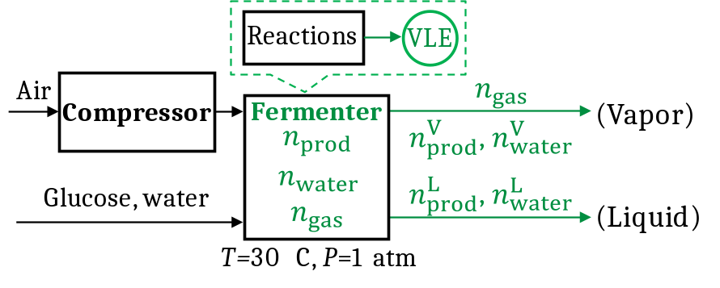
Figure S3. VLE analysis applied in the fermenter. Parts related to the VLE analysis are marked in green.
To apply the VLE analysis in the fermenter, we replace Components 1 and 2 with “product” and “water”, and specify T=30 °C, P=1 atm, as well as f and g (for limonene and water, respectively). Thus, we find that the system (as shown in Figure S3) is uniquely determined by n_{prod}, n_{water} and n_{gas}, which are further expressed as functions (f, g and h) of feed glucose concentration (wt%), product yield (g product/g glucose) and/or VVM (min⁻¹), as shown in Equations A18-A20. Note that n_{gas} is the amount of gas (air and CO₂) present after fermentation, not the initial total air input through the compressor. MW_{prod} and MW_{water} are the molecular weights of product and water; $ρ_{liq}=294.75×glucose concentration+1000$, which is the density of input glucose-water liquid mixture; $τ$ is residence time; $σ$ is gas molar volume; $m_{liq}$ is the total mass flowrate in the liquid feed; $n_{CO2}$/$n_{O2}$/$γ$ is the amount of CO₂/O₂/water generated or consumed during fermentation (functions of yield). Note that the glucose mass flowrate in the feed ($m_{glucose}$) is fixed (40 T/h).
$n_{prod}=\frac{m_{glucose}×yield}{{MW}_{prod}}=f(yield)$ (A18)
$n_{water}=\frac{m_{feed water}+γ}{{MW}_{water}}=\frac{\frac{100×m_{glucose}}{glucose concentration}-m_{glucose}+γ}{{MW}_{water}}=g(glucose concentration, yield)$ (A19)
$n_{gas}=\frac{m_{liq}×τ×VVM}{σ×ρ_{liq}}+n_{CO2}+n_{O2}=\frac{\left(\frac{100×m_{glucose}}{glucose concentration}\right)×τ×VVM}{σ×ρ_{liq}}+n_{CO2}+n_{O2}=h(glucose concentration, yield, VVM)$ (A20)
We further express product split fraction to vapor (α, i.e., $n_{prod}^{V}/n_{prod}$) and liquid product titer (β, e.g., g/L) as functions of n_{prod}, n_{water} and n_{gas} as shown in Equations A21 and A22. Therefore, they are also functions of glucose concentration, yield and VVM. Implementation of the calculations can be found in Additional File 2.
$α=\frac{n_{prod}^{V}}{n_{prod}}=\frac{min⁡(\frac{f\left(T\right)×n_{gas}}{P-f\left(T\right)-g\left(T\right) }, \frac{f\left(T\right)×\left(n_{gas}+n_{water}\right)}{P-f\left(T\right) }, n_{prod})}{n_{prod}}$ (A21)
$β=\frac{m_{prod}^{L}}{Q^{L}}=\frac{{MW}_{prod}×(n_{prod}-min⁡(\frac{f\left(T\right)×n_{gas}}{P-f\left(T\right)-g(T) }\text{,} \frac{f\left(T\right)×\left(n_{gas}+n_{water}\right)}{P-f\left(T\right) }\text{,}n_{prod})}{\frac{{MW}_{prod}×(n_{prod}-min⁡(\frac{f\left(T\right)×n_{gas}}{P-f\left(T\right)-g(T) }\text{,} \frac{f\left(T\right)×\left(n_{gas}+n_{water}\right)}{P-f\left(T\right) }\text{,}n_{prod})}{ρ_{prod}}+\frac{{MW}_{water}×(n_{water}-min⁡(\frac{g\left(T\right)×n_{gas}}{P-f\left(T\right)-g\left(T\right) }\text{,}\frac{g\left(T\right)×\left(n_{gas}+n_{prod}\right)}{P-g\left(T\right) },n_{water}\text{)})}{ρ_{water}}}$ (A22)
5. VLE analysis in the condenser
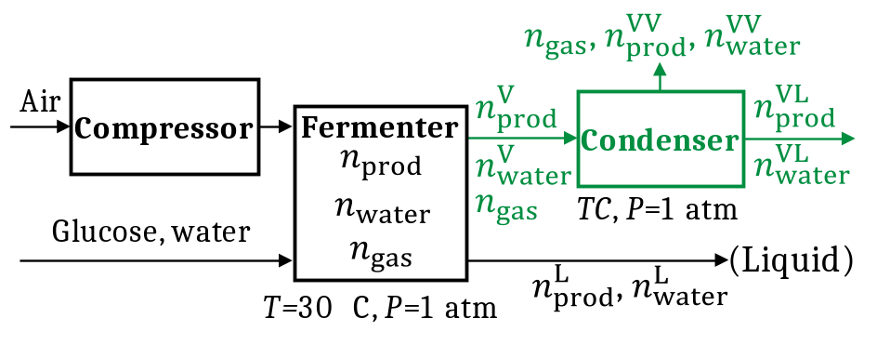
Figure S4. VLE analysis applied in the condenser. Parts related to the VLE analysis are marked in green.
Similarly, we apply the VLE analysis in the condenser (see Figure S4) by replacing n₁ and n₂ with $n_{prod}^{V}$ and $n_{water}^{V}$, and replacing $n_{1}^{V}$, $n_{2}^{V}$, $n_{1}^{L}$ and $n_{2}^{L}$ with $n_{prod}^{VV}$, $n_{water}^{VV}$, $n_{prod}^{VL}$ and $n_{water}^{VL}$ (molar flowrates of product and water in the vapor/liquid phase after condensation), respectively. Note that the “min” functions no longer need to be included here because we operate the condenser at temperature TC that guarantees co-existence of product and water in the condensed liquid. Thus, we find that $n_{prod}^{VV}, n_{water}^{VV}$, $n_{prod}^{VL} and n_{water}^{VL}$ are functions of $n_{prod}^{V}, n_{water}^{V} and n_{gas}$, which are functions of glucose concentration, yield and VVM as explained in Section 4. We further express the fraction of product condensed (λ) and liquid product concentration after condensation ($ω$, e.g., g/L) as functions of $n_{prod}^{V}, n_{water}^{V} and n_{gas}$, as shown in Equations A23 and A24, where TC is the condenser temperature. Therefore, λ and $ω$ are also functions of glucose concentration, yield and VVM. Implementation of this calculation can be found in Additional File 2.
$λ=\frac{n_{prod}^{VL}}{n_{prod}^{V}}=1-\frac{\frac{f\left(TC\right)×n_{gas}}{P-f\left(TC\right)-g(TC) }}{n_{prod}^{V}}$ (A23)
$ω=\frac{m_{prod}^{VL}}{Q^{VL}}=\frac{{MW}_{prod}×(n_{prod}^{V}-\frac{f\left(TC\right)×n_{gas}}{P-f\left(TC\right)-g(TC) })}{\frac{{MW}_{prod}×(n_{prod}^{V}-\frac{f\left(TC\right)×n_{gas}}{P-f\left(TC\right)-g(TC) })}{ρ_{prod}}+\frac{{MW}_{water}×(n_{water}^{V}-\frac{g\left(TC\right)×n_{gas}}{P-f\left(TC\right)-g(TC) })}{ρ_{water}}}$ (A24)
To maximize product recovery, we operate the condenser such that λ=100% (all the product is condensed), and the condenser temperature TC can be calculated by solving Equation A23 by fixing λ=100%, i.e., $f(TC)=0$. Thus, for limonene, TC ≅ 0 °C.
6. Cost distribution by units in Cases 1-3
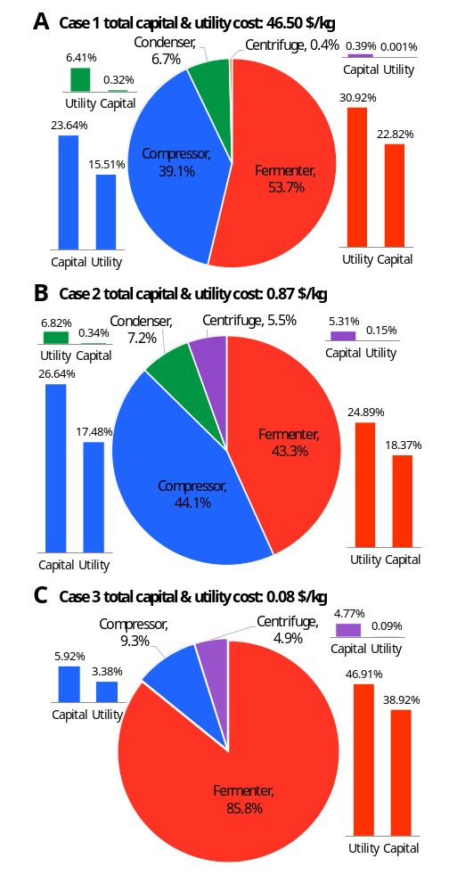
Figure S5. Cost distribution by units (feedstock costs are excluded; only capital and utility costs are included) for the three cases. (A) Case 1; (B) Case 2; (C) Case 3. Capital costs are annualized.
Figure S5 shows the cost distribution by units for the three case studies.
7. Cost distribution by units in Case 4 (use of dodecane solvent)
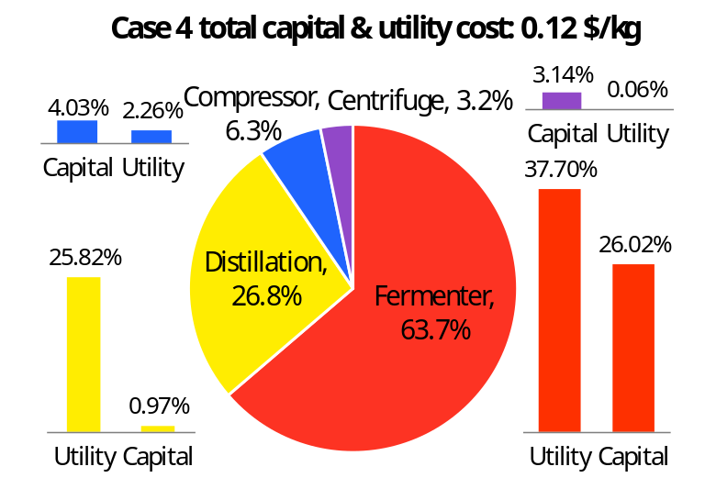
Figure S6. Cost distribution by units for Case 4 (feedstock costs are excluded; only capital and utility costs are included). Capital costs are annualized.
Figure S6 shows the cost distribution by units for Case 4. Note that dodecane price is assumed to be 1.5 $/kg. The Antoine constants for dodecane and limonene used to calculate relative volatility for the distillation simulation in SuperPro are as follows, where units of P and T are mmHg and K, respectively. log₁₀P=A-B/(T+C).
Dodecane: A=6.9979, B=1639.27, C=-91.36
Limonene: A=6.1716, B=1114.54, C=-114.33
8. Techno-economic parameters
Table S1. Parameters for units.
Fermenter |  | Compressor |  | Condenser |  | Centrifuge
Temperature (C) | 30 | Max outlet temperature (C) | 40 | Pressure (atm) | 1 | Limiting oil globule diameter (μm) | 20
Pressure (atm) | 1 | Pressure change (atm) | 2 | Heat transfer coefficient (W/m2-K) | 860 | Bulk liquid density (g/L) | 1000
Specific power (kW/m3) | 0.3 | Efficiency (%) | 70 | Heat transfer efficiency (%) | 90 | Bulk liquid viscosity (cP) | 1.5
Working to vessel volume ratio (%) | 90 | Labor (labor hrs/hr) | 0.05 | Temperature difference factor | 1 | Efficiency (%) | 30
Labor (labor hrs/hr) | 1 |  |  | Labor (labor hrs/hr) | 0 | Product removal (%) | 100
 |  |  |  |  |  | Cells removal (%) | 95
 |  |  |  |  |  | Power dissipation to heat (50%) | 50
 |  |  |  |  |  | Labor (labor hrs/hr) | 1
Table S2. Parameters for capital costs.
 | Fermenter | Compressor | Condenser | Centrifuge
PC (purhcase cost) Base size | 3500 m3 | 2982 KW | 95 m2 | 27 m3/h
PC Base cost ($) | 700000 | 3236000 | 39000 | 258000
PC power law exponent | 0.6 | 0.6 | 0.6 | 0.6
Max size per equipment | 2750 m3 | 3000 KW | 100 m2 | 9000 m3/h
Installation cost (% of PC) | 30 | 50 | 50 | 50
Annual maintenance cost (% of PC) | 10 | 10 | 10 | 10
Table S3. Parameters for feedstock and utility costs, and other parameters.
Parameter | value
Glucose ($/kg) | 0.6
Water ($/m3) | 0.85
Dodecane ($/kg) | 1.5
Chilled water ($/T) | 0.4
Cooling water ($/T) | 0.05
Freon ($/Mcal) | 0.1
Electricity ($/KW-h) | 0.1
Costing year | 2016
Operating days per year | 330
Operating capacity (%) | 100
Capital charge factor (calculated) | 0.188
9. SuperPro screenshot
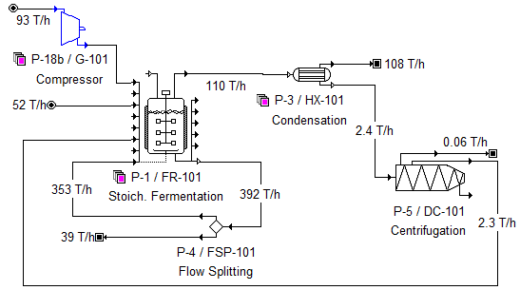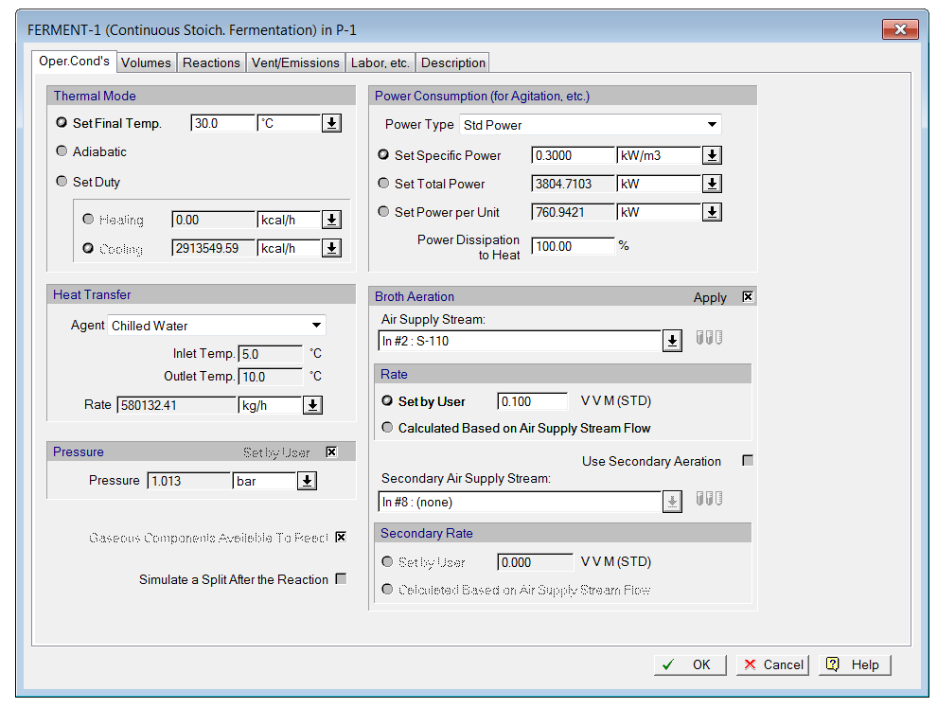
Figure S7. Screenshot from SuperPro for Case 1, including the process flowsheet and the interface for fermentation modeling as an example.
A screenshot from SuperPro for Case 1 is presented in Figure S7, where the total flowrate in each stream is shown. The flowrate for each component can be found in Figure 7 of the main text.

