Additional file 1:
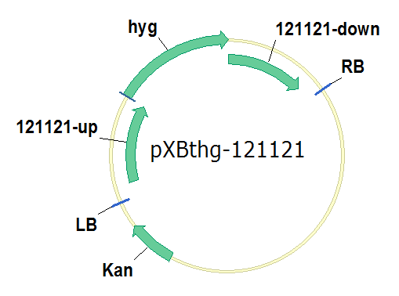
Fig. S1 Schematic illustration of the plasmid pXBthg-121121. hyg: homomycin resistance; LB, left border of binary vector; RB, right border of binary vector; Kan: kanamycin resistance; 121121-up: the 1500 bp upstream of gene 121121; 121121-down: the 1500 bp downstream of gene 121121.

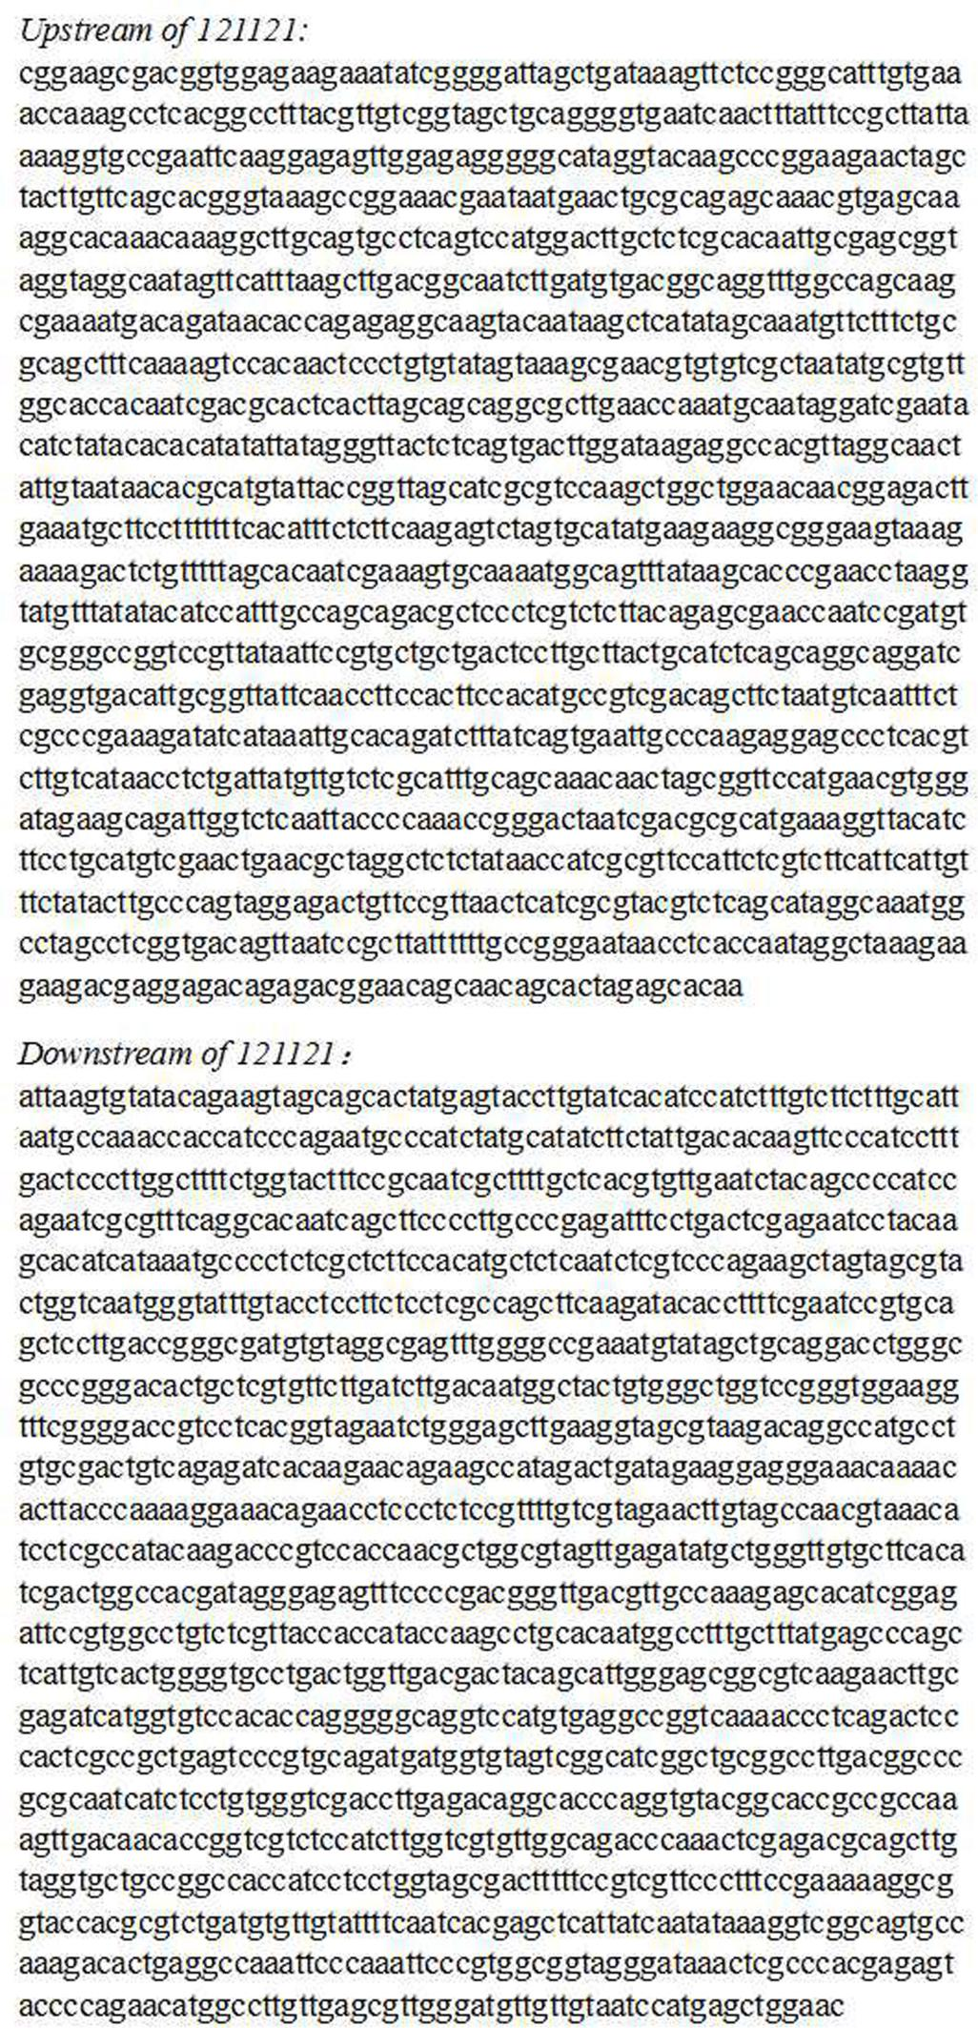
Fig. S2 The 1500-bp upstream and downstream regions of gene 121121
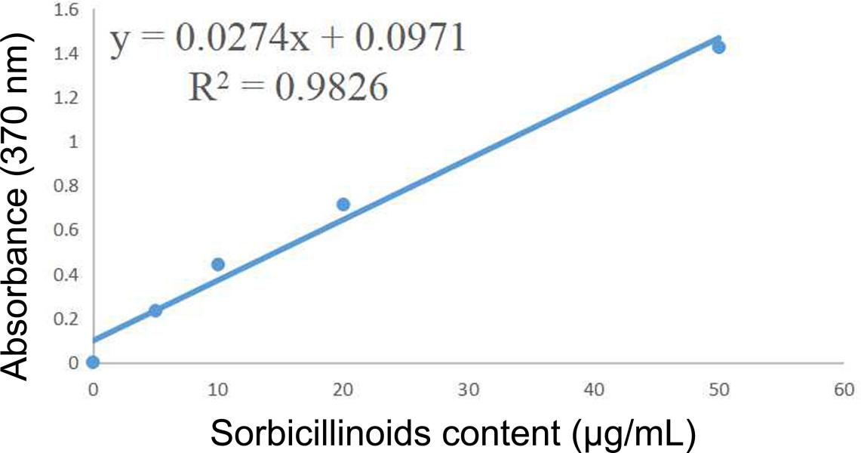
Fig. S3 Thestandard curve of sorbicillinoids.
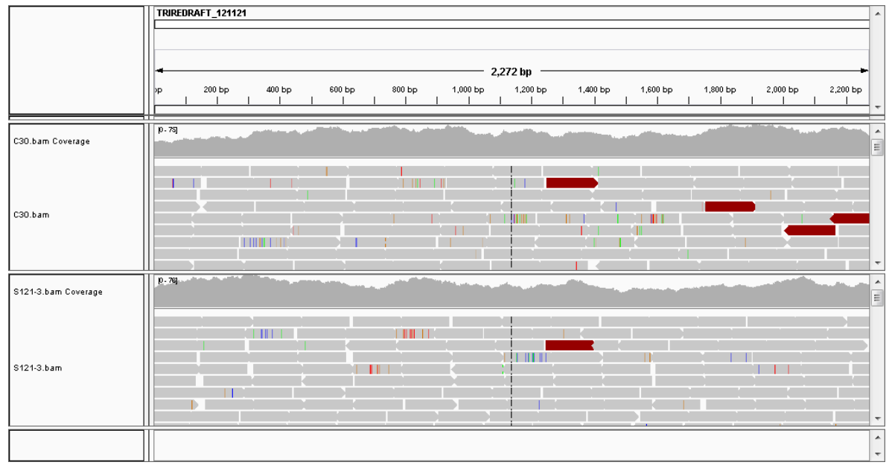
Fig. S4 The whole genome resequencing of strain ZC121 shows the unsuccessful deletion of gene 121121.
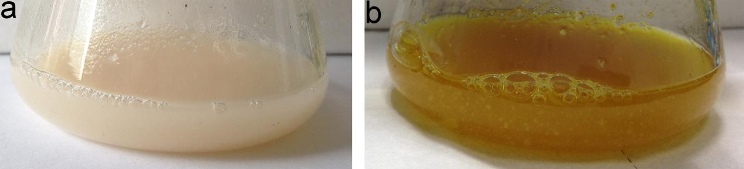
Fig. S5 The color of the culture supernatant of T. reesei RUT-C30 (a) and ZC121 (b) grown on glucose.

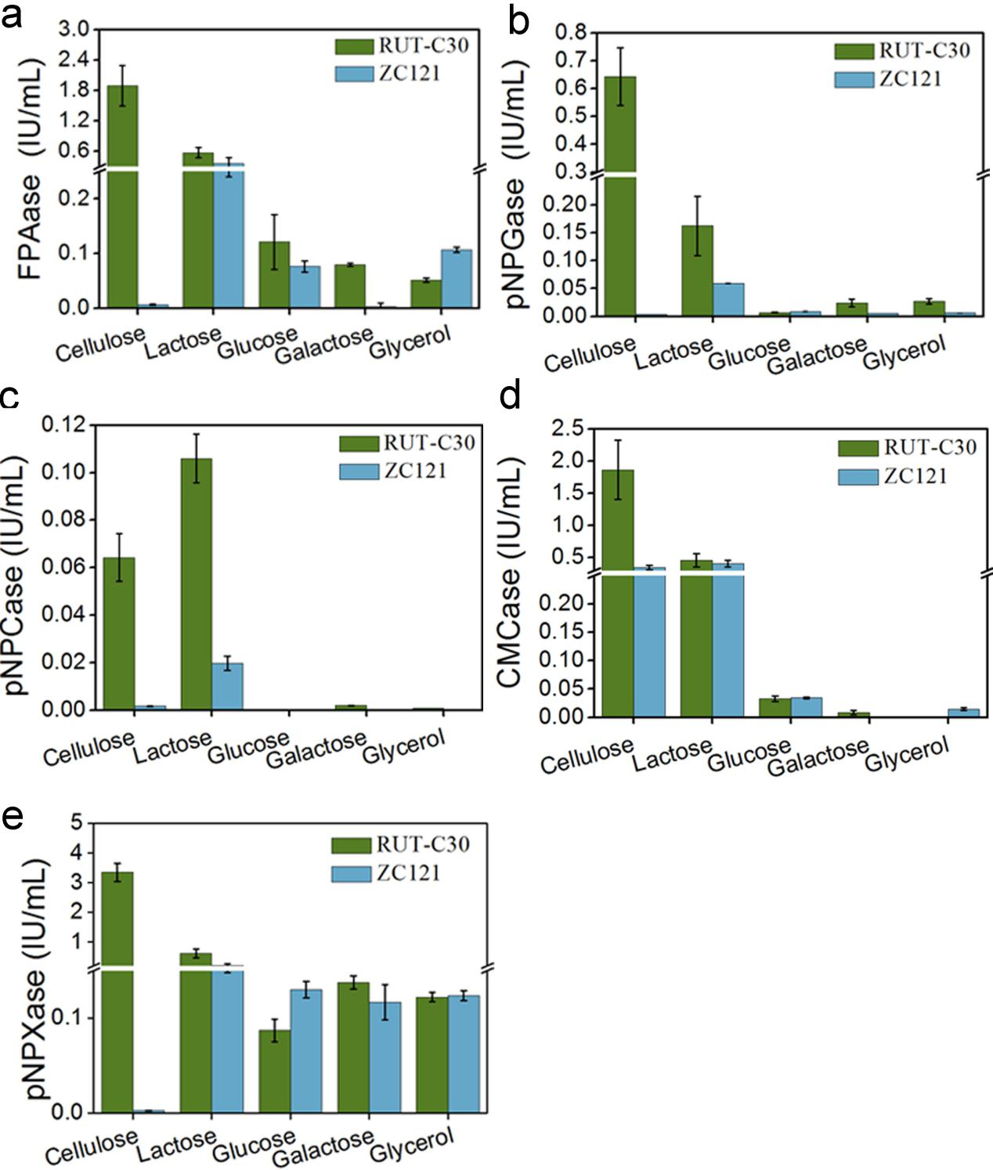
Fig.S6 Cellulolytic enzyme activities in the culture supernatant of T. reesei ZC121 and RUT-C30 grown on 2% cellulose, lactose, glucose, galactose and glycerol were assayed on day 5, including the activities of FPase (the filter paper activity) (a), pNPGase (the BGL activity) (b), pNPCase (the CBH activity) (c), CMCase (the CMC activity) (d) ahd pNPXase (the β-xylosidase activity) (e). The error bars indicate the standard deviations of three biological replicates.

Table S1 Primers used in this study.
Name | Sequence | Description
121121(deletion)up-F | ATTATTATGGAGAAACTCGAGCGGAAGCGACGGTGGAGAAGAAAT | Amplification of the 1500 bp upstream of gene 121121
121121(deletion)up-R | CCGTCACCAGCCCTGCTCGAGTTGTGCTCTAGTGCTGTTGCTGTTCC | Amplification of the 1500 bp upstream of gene 121121
121121(deletion)down-F | ACGTTATCTCGTGCGGATCCATTAAGTGTATACAGAAGTAGCAGCAC | Amplification of the 1500 bp downstream of gene 121121
121121(deletion)down-R | CAGGTCGACTCTAGAGAGGATCCGTTCCAGCTCATGGATTACAA | Amplification of the 1500 bp downstream of gene 121121
121121-(3783bp)-F | ATGGAGACAAACAACAGCGACAGCA | PCR cloning of the 3783 bp fragment as indicated in Figure 1
121121-(3783bp)-R | GTTCCAGCTCATGGATTACAACAACATCCC | PCR cloning of the 3783 bp fragment as indicated in Figure 1
121121- (2075bp)-F | CCGCAGGACATATCCACGCCCTC | PCR cloning of the 2075 bp fragment as indicated in Figure 1
121121- (2075bp)-R | GTTCCAGCTCATGGATTACAACAACATCCC | PCR cloning of the 2075 bp fragment as indicated in Figure 1

Table S2 Comparative transcription levels of the sorbicillinoid gene cluster and its neighboring cellulase-related genes in T. reesei ZC121on cellulose and glucose.
Gene IDª | log2(C121/CC30)  Celluose Glucose |  | p value  Celluose Glucose |  | Gene name | Description
67737 | inf | inf | inf | inf | sor5 | hypothetical protein
93844 | 5.13855 | 7.57345 | 5.00E-05 | 5.00E-05 | sor1 | hypothetical protein
93847 | 7.24352 | 9.79423 | 5.00E-05 | 5.00E-05 | sor2 | hypothetical protein
139626 | 11.3587 | 11.6189 | 0.0041 | 5.00E-05 | sor3 | FAD/NAD(P)-binding domain-containing protein
121436 | 8.76461 | 8.58193 | 5.00E-05 | 5.00E-05 | sor6 (MFS) | MFS general substrate transporter
31634 | 4.84193 | 5.20684 | 5.00E-05 | 5.00E-05 | ypr2 | hypothetical protein
4579 | 6.43464 | 5.79129 | 5.00E-05 | 5.00E-05 | sor4 | putative isoamyl alcohol oxidase
93861 | 4.70987 | 4.77854 | 5.00E-05 | 5.00E-05 | ypr1 | hypothetical protein
69551 | 4.70987 | 0.00140732 | 5.00E-05 | 0.7632 | 69551 | hypothetical protein
139631 | -5.74706 | -0.736928 | 5.00E-05 | 0.1496 | axe1 | acetyl xylan esterase
121449 | -6.30054 | -2.7972 | 5.00E-05 | 0.00025 | cip1 | hypothetical protein
139633 | -5.70598 | -1.33685 | 5.00E-05 | 5.00E-05 | cel61a | endoglucanase-4
a: Gene ID was assigned based on the T. reesei RUT-C30genome database (https://www.ncbi.nlm.nih.gov/genome/323?genome_assembly_id=49799). Inf: the transcript of sor5 was not detected in RUT-C30, but in ZC121.

