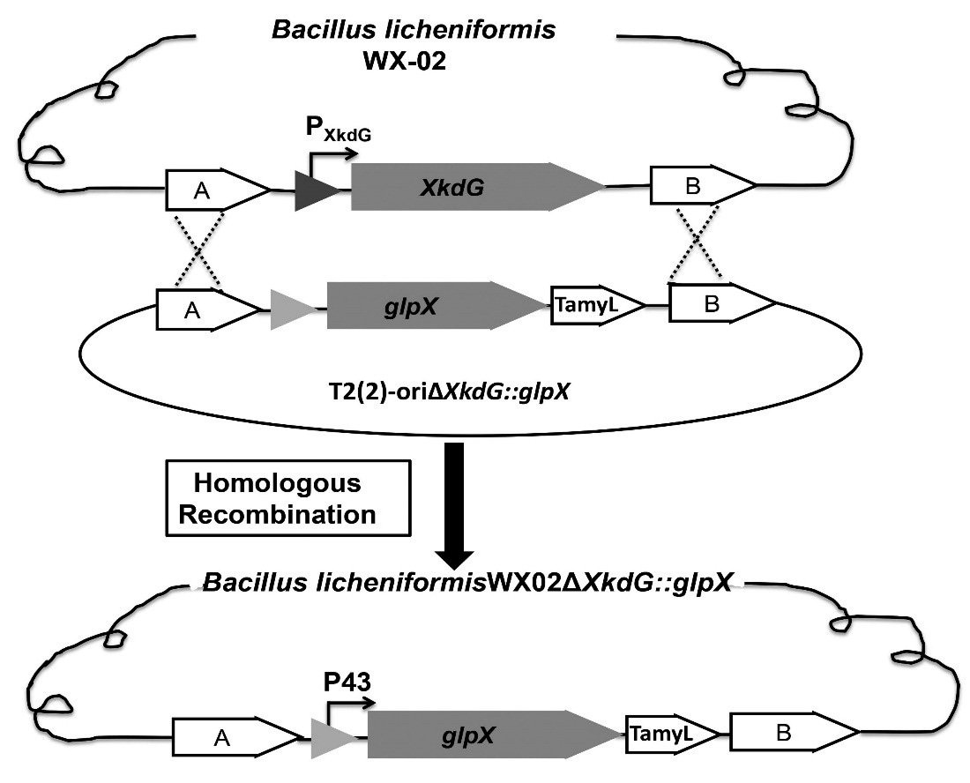

Figure S1 Schematic diagram showing the construction of recombination strains WX02-glpX. Upper panel schematic representation of the genomic organization of xkdG gene coding for phage capsid protein in Bacillus licheniformis WX-02. Lower panel homologous recombination with the plasmid T₂-GglpX replaces the xkdG, leads to the over-expression of glpX under the control of promoter P43.

