Comparative Transcriptome and Metabolome Analysis Suggest Bottlenecks that Limit Seed and Oil Yields in Transgenic Camelina sativa Expressing Diacylglycerol Acyltransferase 1 and Glycerol-3-Phosphate Dehydrogenase

Hesham M. Abdullah^{1,2, ¥}, Sudesh Chhikara^{1 €}, Parisa Akbari¹, Danny J. Schnell³, Ashwani Pareek⁴, and Om Parkash Dhankher^{1*}

¹Stockbridge School of Agriculture, University of Massachusetts Amherst, MA 01003, USA
²Biotechnology Department, Faculty of Agriculture, Al-Azhar University, Cairo 11651, Egypt
³Department of Plant Biology, Michigan State University, East Lansing, MI 48824, USA
⁴Stress physiology and Molecular Biology Laboratory, School of Life Sciences, Jawaharlal Nehru University, New Delhi 100067, India

¥ Current address: Department of Plant Biology, Michigan State University, East Lansing, MI 48824, USA
€ Current address: Centre for Biotechnology, Maharshi Dayanand University, Rohtak 124001, India

*Corresponding Author:
Om Parkash Dhankher
Email: parkash@umass.edu
Tel: 413-545-0062
Fax: 413-545-1058
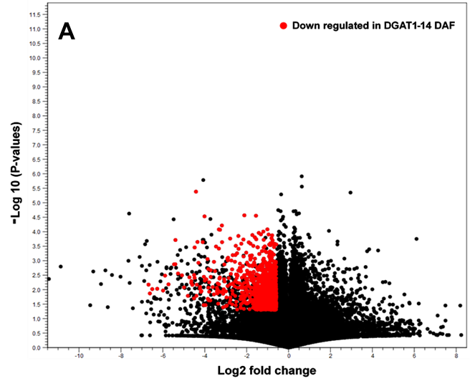
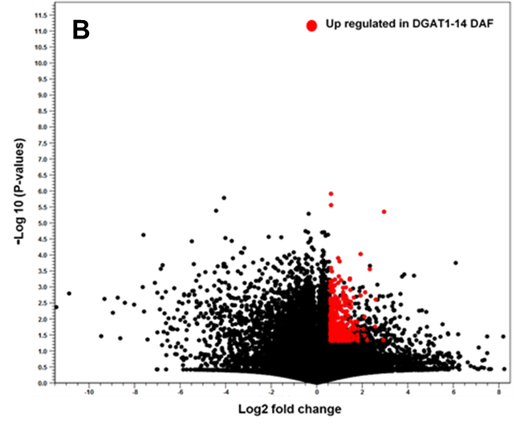
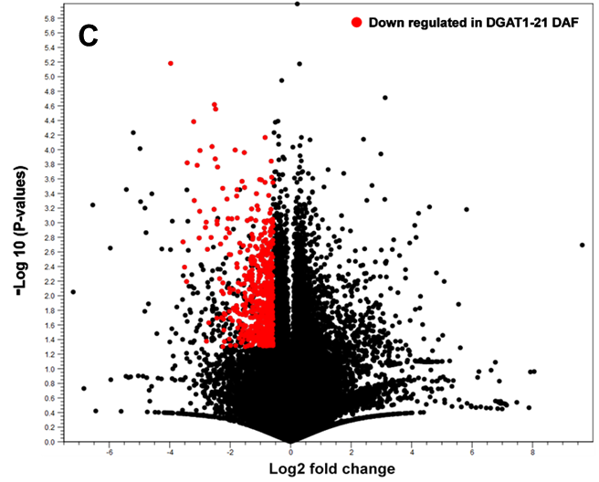
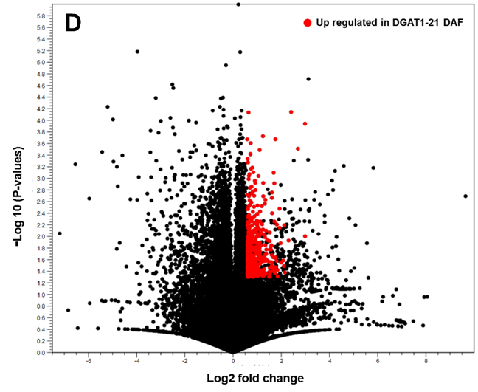
Fig. S1. Volcano plots of the relationship between the P-value of statistical test (y-axis) and the log2 fold change (x-axis) showing the differentially expressed genes between WT and DGAT1 transgenic lines. The genes that showed significant difference (P-value ≤ 0.05) and fold change (log2 fold change ≥ 1.5 or ≤ -1.5) were presented as red spots. A total of 1,057 and 599 genes down regulated in DGAT1 lines at 10-15 DAF (A) and at 16-21 (C), respectively, whereas a total of 448 and 415 genes were up regulated at 10-15 DAF (B) and at 16-21 DAF (D), respectively.

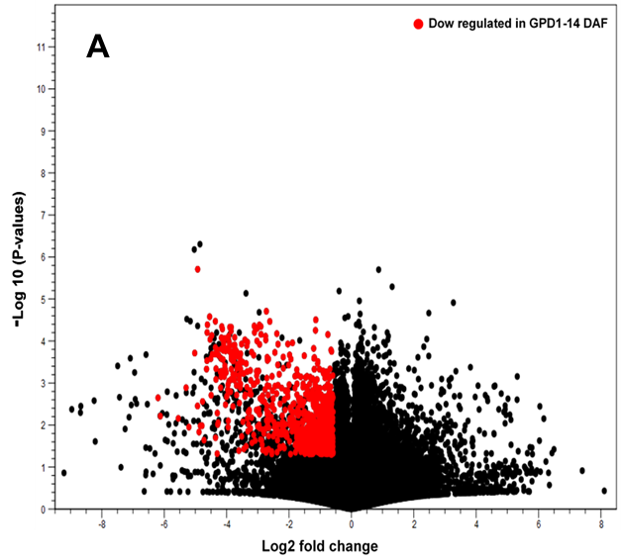
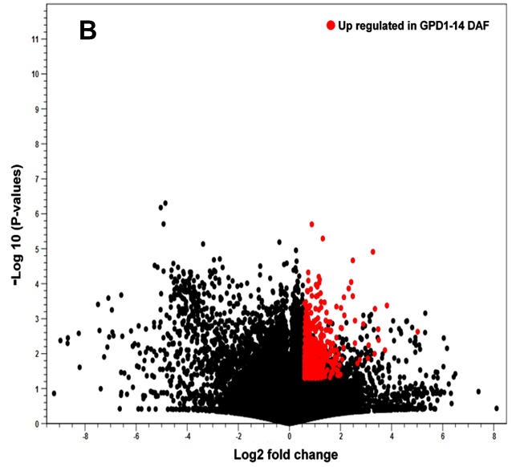
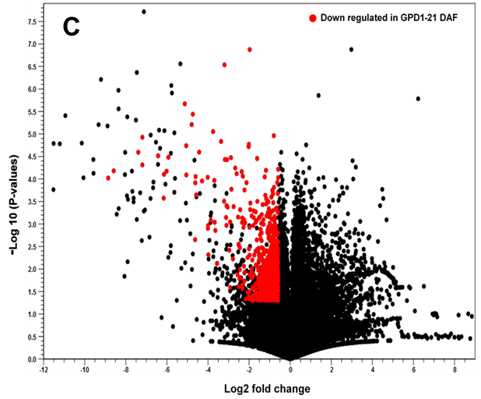
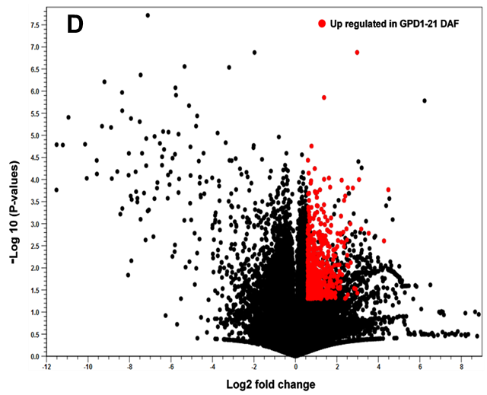
Fig. S2. Volcano plots of the relationship between the P-value of statistical test (y-axis) and the log2 fold change (x-axis) showing the differentially expressed genes between WT and GPD1 transgenic lines. The genes that showed significant difference (P-value ≤ 0.05) and fold change (log2 fold change ≥ 1.5 or ≤ -1.5) were presented as red spots. A total of 981 and 828 genes down regulated in DGAT1 lines at 10-15 DAF (A) and at 16-21 (C), respectively, whereas a total of 617 and 710 genes were up regulated at 10-15 DAF (B) and at 16-21 DAF (D), respectively.

Table S1. RNA-Seq datasets of Camelina developing seeds obtained from transgenic lines and non-transgenic wildtype.
 | WT (10-15 DAF) |  |  | WT (16-21 DAF)
 | B1 | B2 | B3 | B1 | B2 | B3
Number of sequence reads | 53.0 M | 54.8 M | 78.9 M | 62.0 M | 61.7 M | 46.3 M
Number of reads after trimming | 52.0 M | 53.7 M | 76.2 M | 60.7 M | 60.5 M | 45.4 M
Reads mapped in pairs | 44.8 M | 45.6 M | 67.3 M | 50.7 M | 51.1 M | 38.6 M
Reads mapped in broken pairs | 5.9 M | 6.7 M | 8.4 M | 8.4 M | 7.9 M | 5.8 M
Reads not mapped | 210,281 | 241,410 | 372,878 | 319,246 | 286,780 | 184,244
 | DGAT1 #2 (10-15 DAF) |  |  | DGAT1 #2 (16-21 DAF)
 | B1 | B2 | B3 | B1 | B2 | B3
Number of sequence reads | 65.6 M | 46.2 M | 92.0 M | 36.5 M | 44.3 M | 49.1 M
Number of reads after trimming | 64.3 M | 44.7 M | 89.2 M | 35.4 M | 42.9 M | 47.5 M
Reads mapped in pairs | 58.2 M | 38.0 M | 75.5 M | 29.4 M | 35.7 M | 39.3 M
Reads mapped in broken pairs | 4.7 M | 5.0 M | 10.5 M | 4.6 M | 5.5 M | 6.2 M
Reads not mapped | 302,337 | 211,920 | 397,937 | 322,801 | 363,930 | 437,744
 | GDP1 #2 (10-15 DAF) |  |  | GDP1 #2 (16-21 DAF)
 | B1 | B2 | B3 | B1 | B2 | B3
Number of sequence reads | 97.9 M | 47.1 M | 64.4 M | 34.5 M | 41.7 M | 97.9 M
Number of reads after trimming | 95.5 M | 45.6 M | 63.1 M | 33.8 M | 40.5 M | 95.5 M
Reads mapped in pairs | 73.1 M | 38.9 M | 54.4 M | 28.8 M | 33.9 M | 73.1 M
Reads mapped in broken pairs | 9.0 M | 5.0 M | 7.2 M | 3.9 M | 5.1 M | 9.0 M
Reads not mapped | 340,610 | 190,961 | 309,764 | 281,806 | 292,694 | 340,610
Shown are the two stages of camelina seed development RNA-Seq data obtained from Camelina wildtype (WT), Arabidopsis DGAT1-overexpressing line (DGAT1 #2, and Yeast GPD1-overexpressing line (GDP1 #2). Days after flowering (DAF), the number of processed reads obtained from three biological replicates (B1-B3) at different levels of data analysis of RNA sequencing (in millions M).

Table S11. List of selected DEGs showing ≥ 1.5-fold changes in expression between Camelina DGAT1 transgenics and WT plants.

Gene ID | Gene description | Fold change | P-value | RPKMs |  | Regulation
DEGs in DGAT1 vs WT
 |  |  |  | WT | DGAT1
Csa02g065010 | non-specific lipid-transfer 4-like (LTP) | 1.51 | 2.52E-03 | 733.59 | 1105.73 | UP
Csa18g033140 | gibberellin-regulated family | 1.57 | 2.66E-02 | 609.87 | 954.80 | UP
Csa15g038220 | defensin 46 | 1.52 | 1.85E-02 | 62.24 | 94.63 | UP
Csa09g079870 | isoflavone reductase homolog P3-like | 2.43 | 1.04E-03 | 34.58 | 83.98 | UP
Csa08g055270 | merozoite surface CMZ-8-like isoform X5 | 1.60 | 4.67E-03 | 35.60 | 57.09 | UP
Csa09g009250 | low-molecular-weight cysteine-rich 45 | 1.54 | 4.52E-02 | 28.75 | 44.14 | UP
Csa05g007300 | hypothetical protein CARUB_v10024430mg | 1.62 | 1.09E-03 | 21.14 | 34.33 | UP
Csa19g034220 | PREDICTED: uncharacterized protein LOC104766284 | 1.54 | 2.55E-04 | 19.84 | 30.62 | UP
Csa08g049270 | Wound-responsive family | 1.55 | 5.89E-03 | 9.07 | 14.03 | UP
Csa08g055280 | non-specific lipid-transfer At5g64080 | 1.57 | 4.85E-02 | 7.32 | 11.50 | UP
Csa16g051630 | proline-rich extensin EPR1 | 1.77 | 1.27E-02 | 118.80 | 210.34 | UP
Csa07g063460 | UPF0540 At1g62060-like | 1.75 | 6.53E-04 | 29.84 | 52.07 | UP
Csa15g026620 | transmembrane 45A | 1.52 | 4.61E-04 | 26.44 | 40.15 | UP
Csa20g071700 | CASP 1B1 | 1.67 | 6.83E-04 | 22.01 | 36.86 | UP
Csa14g026530 | transmembrane protein | 1.64 | 4.88E-02 | 20.89 | 34.33 | UP
Csa09g075840 | kunitz-type serine protease inhibitor -like | 1.76 | 8.04E-03 | 13.03 | 22.89 | UP
Csa17g013010 | transcription repressor MYB6-like | 1.54 | 5.32E-04 | 9.89 | 15.18 | UP
Csa11g093140 | non-specific lipid-transfer 4-like (LTP) | 1.80 | 4.99E-02 | 6.34 | 11.42 | UP
Csa05g083420 | MORC family CW-type zinc finger 3-like isoform X1 | 1.58 | 4.26E-03 | 4.98 | 7.85 | UP
Csa02827s010 | actin family partial | 1.56 | 1.15E-02 | 4.89 | 7.63 | UP
Csa03g027020 | MLP 28 | 1.65 | 3.77E-04 | 4.51 | 7.43 | UP
Csa00669s010 | mannan endo-1,4-beta-mannosidase 6 isoform X3 | 1.71 | 3.79E-02 | 4.12 | 7.04 | UP
Csa11g070590 | 12S seed storage | -3.21 | 3.08E-04 | 6042.93 | 1882.38 | Down
Csa12g024730 | 2S seed storage | -2.28 | 3.53E-04 | 753.53 | 330.88 | Down
Csa19g001360 | Oleosin 5 | -1.60 | 1.48E-03 | 653.08 | 409.03 | Down
Csa11g057650 | Oleosin 2 | -1.73 | 3.66E-03 | 554.23 | 319.47 | Down
Csa11g043000 | gamma-interferon-inducible-lysosomal thiol reductase-like | -1.71 | 2.71E-03 | 481.49 | 281.14 | Down
Csa07g016060 | cupin family | -1.68 | 2.30E-03 | 323.72 | 193.07 | Down
Csa01g038030 | glycine-rich cell wall structural 2 | -53.14 | 6.56E-03 | 286.62 | 5.39 | Down
Csa12g021990 | cruciferin 3 | -3.44 | 4.31E-04 | 1851.77 | 537.88 | Down
Csa05g012650 | em GEA6 | -15.65 | 6.57E-06 | 111.46 | 7.12 | Down
Csa14g064650 | kDa class III heat shock -like | -1.56 | 5.53E-03 | 86.80 | 55.76 | Down
Csa08g062980 | PEBP (phosphatidylethanolamine-binding ) family | -1.83 | 4.38E-03 | 77.63 | 42.37 | Down
Csa09g061300 | late embryogenesis abundant | -1.96 | 2.67E-02 | 73.05 | 37.33 | Down
Csa20g001350 | aldose reductase-like | -1.53 | 1.40E-02 | 66.77 | 43.78 | Down
Csa18g035930 | HVA22 b | -1.69 | 1.91E-02 | 49.18 | 29.08 | Down
Csa08g057710 | 18 kDa seed maturation -like | -1.67 | 5.43E-03 | 45.07 | 27.02 | Down
Fold change values shown in negatives indicate decreased levels of gene expression in Camelina transgenics compared to the WT plants. DEGs, differentially expressed genes.

Table S12. List of selected DEGs showing ≥ 1.5-fold changes in expression between Camelina GPD1 transgenics and WT plants.

Gene ID | Gene description | Fold change | P-value | RPKMs |  | Regulation
DEGs in GPD1 vs WT
 |  |  |  | WT | GPD1
Csa18g033140 | gibberellin-regulated family | 1.63 | 1.65E-02 | 606.99 | 990.73 | Up
Csa10g017850 | peptide methionine sulfoxide reductase chloroplastic-like | 2.36 | 3.33E-04 | 93.61 | 220.80 | Up
Csa09g079870 | isoflavone reductase homolog P3-like | 5.59 | 2.16E-05 | 34.73 | 194.07 | Up
Csa11g019470 | ---NA--- | 2.05 | 1.08E-04 | 78.81 | 161.85 | Up
Csa12g028100 | peptide methionine sulfoxide reductase chloroplastic-like | 2.25 | 9.37E-05 | 71.69 | 161.11 | Up
Csa05g034910 | tropinone reductase homolog At1g07440-like | 1.52 | 8.73E-03 | 67.58 | 102.50 | Up
Csa08g048840 | peptide methionine sulfoxide reductase B5 | 2.33 | 1.87E-04 | 31.91 | 74.33 | Up
Csa11g077010 | SULFUR DEFICIENCY-INDUCED 1-like | 2.21 | 1.02E-02 | 27.66 | 61.15 | Up
Csa18g021440 | PREDICTED: uncharacterized protein LOC104761060 isoform X2 | 3.07 | 1.27E-03 | 19.15 | 58.72 | Up
Csa16g053900 | 5 -adenylylsulfate reductase chloroplastic | 1.80 | 3.91E-03 | 26.53 | 47.85 | Up
Csa11g059050 | cystinosin homolog | 1.59 | 7.07E-04 | 27.59 | 43.82 | Up
Csa09g075800 | kunitz-type serine protease inhibitor -like | 32.46 | 2.37E-03 | 1.30 | 42.30 | Up
Csa19g058270 | acireductone dioxygenase 3 | 1.84 | 5.34E-03 | 19.99 | 36.88 | Up
Csa05g006880 | defensin 4 | 2.05 | 3.90E-04 | 440.01 | 900.25 | Up
Csa11g017010 | 2S seed storage 2-like | 2.06 | 1.96E-04 | 228.46 | 471.17 | Up
Csa09g086190 | seed maturation | 1.54 | 4.23E-02 | 88.29 | 135.68 | Up
Csa01g035680 | gibberellin-regulated 7-like | 1.58 | 5.46E-04 | 52.46 | 83.00 | Up
Csa15g024360 | phosphoethanolamine N-methyltransferase 1-like | 1.55 | 1.69E-03 | 32.25 | 49.87 | Up
Csa11g070590 | 12S seed storage | -1.72 | 1.23E-03 | 5890.48 | 3423.36 | Down
Csa12g024730 | 2S seed storage | -1.65 | 7.06E-03 | 746.68 | 452.03 | Down
Csa10g035950 | gamma-interferon-inducible-lysosomal thiol reductase-like | -2.23 | 1.13E-03 | 515.09 | 230.53 | Down
Csa01g038030 | glycine-rich cell wall structural 2 | -11.13 | 8.36E-03 | 284.92 | 25.59 | Down
Csa04g015780 | oleosin kDa-like | -2.75 | 2.48E-02 | 240.97 | 87.76 | Down
Csa19g023490 | translationally-controlled tumor homolog | -15.09 | 1.37E-04 | 221.85 | 14.70 | Down
Csa12g021990 | cruciferin 3 | -1.84 | 6.16E-03 | 1943.54 | 1056.56 | Down
Csa19g026450 | 1-aminocyclopropane-1-carboxylate oxidase 5-like | -146.35 | 1.18E-05 | 570.44 | 3.90 | Down
Csa19g023490 | translationally-controlled tumor homolog | -462.46 | 9.55E-05 | 288.02 | 0.62 | Down
Csa15g058410 | glycine-rich cell wall structural -like | -5.38 | 1.58E-02 | 129.08 | 23.99 | Down
Csa05g012650 | em GEA6 | -4.06 | 1.91E-05 | 112.59 | 27.71 | Down
Csa03g033090 | chlorophyll a-b binding chloroplastic | -1.81 | 3.65E-03 | 86.60 | 47.97 | Down
Csa05g020850 | photosystem II type I chlorophyll a b binding | -1.54 | 1.50E-02 | 71.88 | 46.75 | Down
Csa19g025230 | methyl transferase | -146.52 | 4.87E-05 | 66.18 | 0.45 | Down
Csa19g024120 | glutamic acid-rich -like | -15.95 | 1.08E-03 | 57.47 | 3.60 | Down
Csa18g008740 | neurofilament heavy polypeptide-like | -1.68 | 9.74E-04 | 46.87 | 27.93 | Down
Csa12g069790 | glycine-rich cell wall structural -like isoform X5 | -4.99 | 2.69E-02 | 40.36 | 8.09 | Down
Fold change values shown in negatives indicate decreased levels of gene expression in Camelina transgenics compared to the WT plants. DEGs, differentially expressed genes.
Table S13. List of selected lipid-related genes differentially expressed in seeds of Camelina transgenic lines relative to WT.
Gene ID | Gene description | Fold change | P-value | RPKMs
Up-regulated in DGAT1 #2
 |  |  |  | WT | DGAT1 #2
Csa12g026280 | glycerol-3-phosphatase 1 | 1.38 | 4.99E-03 | 1.00 | 1.54
Csa16g038920 | lysophosphatidyl acyltransferase 4 | 1.35 | 1.85E-02 | 0.81 | 1.24
Csa14g001560 | glycerol-3-phosphate acyltransferase 4 | 1.31 | 1.82E-03 | 2.83 | 4.86
Csa12g034280 | Phosphatidic acid phosphatase (PAP2) family protein | 1.31 | 2.74E-02 | 0.93 | 1.31
Csa15g010030 | lipid transfer protein 6 | 1.29 | 1.53E-02 | 4.11 | 7.24
Csa19g005650 | non-specific phospholipase C4 | 1.22 | 2.30E-02 | 0.76 | 1.00
Csa02g059310 | Pyruvate kinase family protein | 1.21 | 3.49E-02 | 2.28 | 3.25
Csa17g007350 | 3-ketoacyl-CoA synthase 2 | 1.20 | 1.92E-02 | 2.99 | 4.27
Csa19g056370 | membrane bound O-acyl transferase (MBOAT) family protein | 1.17 | 7.39E-04 | 13.51 | 21.98
Csa05g013960 | phosphatidylglycerolphosphate synthase 1 | 1.16 | 3.56E-02 | 3.06 | 4.10
Csa03g055310 | long-chain acyl-CoA synthetase 2 | 1.12 | 1.76E-02 | 4.50 | 5.72
Csa19g033960 | Cyclopropane-fatty-acyl-phospholipid synthase | 1.11 | 1.10E-02 | 8.56 | 11.07
Csa08g059940 | 3-ketoacyl-CoA synthase 19 | 1.11 | 8.30E-03 | 3.50 | 4.29
Csa13g011020 | phosphatidylinositol 4-OH kinase beta2 | 1.10 | 3.49E-02 | 1.35 | 1.52
Csa16g027660 | beta-ketoacyl reductase 1 | 1.09 | 1.41E-02 | 16.66 | 21.72
Csa17g028820 | phosphatidylinositol-4-phosphate 5-kinase 1 | 1.09 | 2.10E-02 | 12.20 | 15.41
Csa09g086500 | Lipase/lipooxygenase, PLAT/LH2 family protein | 1.09 | 4.38E-02 | 6.21 | 7.67
Csa19g040900 | Phospholipase A2 family protein | 1.08 | 2.90E-02 | 23.55 | 29.79
Csa14g066150 | acyl-activating enzyme 18 | 1.08 | 4.23E-02 | 6.18 | 7.36
Csa14g049770 | triacylglycerol lipase-like 1 | 1.07 | 2.36E-02 | 102.23 | 137.21
Csa17g039510 | GDSL-like Lipase/Acylhydrolase superfamily protein | 1.07 | 2.33E-03 | 16.91 | 21.21
Csa02g065010 | lipid transfer protein 4 | 1.06 | 1.04E-02 | 680.32 | 903.41
Csa11g064070 | mitochondrial acyl carrier protein 3 | 1.05 | 1.69E-02 | 15.48 | 17.93
Csa16g040270 | enoyl-CoA hydratase 2 | 1.05 | 3.29E-02 | 10.17 | 11.77
Csa19g010510 | acyl-CoA dehydrogenase-related | 1.05 | 1.38E-02 | 7.67 | 8.60
Csa10g043160 | Bifunctional inhibitor/lipid-transfer protein/seed storage 2S albumin superfamily protein | 1.04 | 4.90E-02 | 1341.25 | 1587.17
Csa10g049570 | HXXXD-type acyl-transferase family protein | 1.04 | 2.90E-02 | 52.18 | 59.18
Csa11g065710 | 3-ketoacyl-acyl carrier protein synthase I | 1.04 | 4.61E-02 | 37.41 | 42.04
Csa06g017130 | fatty acid reductase 4 | 1.04 | 1.05E-02 | 36.87 | 41.77
Csa17g016850 | MBOAT (membrane bound O-acyl transferase) family protein | 1.04 | 1.32E-02 | 6.32 | 6.89
Csa14g026690 | Phosphoenolpyruvate carboxylase family protein | 1.04 | 4.88E-02 | 4.68 | 5.05
Csa05g005670 | mitochondrial acyl carrier protein 1 | 1.03 | 2.52E-02 | 58.90 | 63.37
Csa16g008170 | peroxisomal 3-ketoacyl-CoA thiolase 3 | 1.03 | 4.38E-02 | 43.19 | 47.22
Csa06g005440 | 2-oxoacid dehydrogenases acyltransferase family protein | 1.03 | 3.88E-02 | 40.86 | 46.44
Csa07g023540 | acyl carrier protein 3 | 1.02 | 4.75E-02 | 194.51 | 214.97
Csa19g004750 | Plant stearoyl-acyl-carrier-protein desaturase family protein | 1.02 | 4.13E-03 | 67.58 | 70.85
Csa12g079300 | NAD-dependent glycerol-3-phosphate dehydrogenase family protein | 1.02 | 4.00E-02 | 33.89 | 35.54
Down-regulated in DGAT1 #2
 |  |  |  | WT | DGAT1 #2
Csa15g044570 | Cyclopropane-fatty-acyl-phospholipid synthase | -18.24 | 3.91E-03 | 0.89 | 0.03
Csa06g017130 | fatty acid reductase 4 | -4.48 | 3.49E-03 | 5.31 | 0.48
Csa06g040850 | glycerol-3-phosphate acyltransferase 6 | -1.46 | 2.87E-02 | 0.97 | 0.55
Csa19g013410 | phosphatidyl inositol monophosphate 5 kinase | -1.37 | 2.98E-02 | 0.59 | 0.37
Csa04g015780 | oleosin 4 | -1.36 | 1.57E-02 | 214.47 | 51.81
Csa18g042120 | Phosphatidic acid phosphatase (PAP2) family protein | -1.35 | 3.24E-02 | 0.97 | 0.61
Csa03g055310 | long-chain acyl-CoA synthetase 2 | -1.34 | 3.77E-03 | 2.46 | 1.48
Csa19g042120 | Bifunctional inhibitor/lipid-transfer protein/seed storage 2S albumin superfamily protein | -1.22 | 3.61E-02 | 9.67 | 5.99
Csa15g072100 | 3-ketoacyl-CoA synthase 9 | -1.20 | 4.89E-02 | 3.61 | 2.56
Csa10g007610 | 3-ketoacyl-CoA synthase 18 | -1.19 | 8.51E-03 | 11.83 | 7.60
Csa08g008530 | acyl activating enzyme 5 | -1.19 | 1.99E-02 | 1.69 | 1.32
Csa05g011450 | phosphatidylinositol- 4-phosphate 5-kinase 5 | -1.19 | 1.03E-02 | 1.49 | 1.10
Csa08g062980 | PEBP (phosphatidylethanolamine-binding protein) family protein | -1.17 | 3.33E-03 | 70.09 | 36.41
Csa16g014970 | fatty acid desaturase 3 | -1.15 | 3.59E-02 | 75.88 | 43.51
Csa18g010110 | 3-ketoacyl-CoA synthase 20 | -1.15 | 3.42E-02 | 3.22 | 2.47
Csa06g052640 | Fatty acid/sphingolipid desaturase | -1.14 | 4.58E-02 | 6.34 | 4.77
Csa15g002280 | lipid phosphate phosphatase 3 | -1.14 | 2.90E-02 | 2.85 | 2.21
Csa04g024240 | fatty acid reductase 5 | -1.13 | 1.18E-02 | 21.16 | 14.75
Csa20g036130 | fatty acid reductase 1 | -1.13 | 8.53E-03 | 1.19 | 0.95
Csa01g018440 | phosphatidic acid phosphatase-related / PAP2-related | -1.12 | 4.68E-02 | 4.90 | 3.84
Csa10g024840 | Long-chain fatty alcohol dehydrogenase family protein | -1.12 | 1.05E-02 | 3.87 | 3.08
Csa20g037970 | acyl-activating enzyme 17 | -1.10 | 2.60E-02 | 35.75 | 24.99
Csa09g035780 | Lecithin:cholesterol acyltransferase family protein | -1.10 | 2.27E-02 | 14.16 | 10.97
Csa02g033710 | peroxisomal 3-keto-acyl-CoA thiolase 2 | -1.10 | 4.16E-02 | 9.52 | 7.49
Csa06g024860 | esterase/lipase/thioesterase family protein | -1.10 | 3.82E-02 | 5.09 | 4.12
Csa12g011550 | 1-phosphatidylinositol-4-phosphate 5-kinases | -1.10 | 3.61E-02 | 3.40 | 2.83
Csa12g002610 | Lipase/lipooxygenase, PLAT/LH2 family protein | -1.09 | 4.69E-02 | 22.28 | 17.10
Csa19g028170 | trigalactosyldiacylglycerol2 | -1.09 | 1.45E-02 | 5.83 | 4.86
Csa17g092850 | lysophospholipase 2 | -1.09 | 8.71E-03 | 5.40 | 4.54
Csa01g003020 | lecithin:cholesterol acyltransferase 3 | -1.08 | 1.58E-02 | 5.80 | 4.88
Csa12g036760 | Diacylglycerol kinase family protein | -1.07 | 1.66E-02 | 8.45 | 7.13
Csa16g047830 | 3-ketoacyl-CoA synthase 10 | -1.07 | 3.29E-02 | 7.21 | 6.20
Csa17g009720 | acyl-CoA oxidase 3 | -1.07 | 1.45E-02 | 5.05 | 4.37
Csa01g013220 | fatty acid desaturase 2 | -1.06 | 4.02E-02 | 221.46 | 161.02
Csa15g052810 | fatA acyl-ACP thioesterase | -1.06 | 2.27E-02 | 39.31 | 32.50
Csa10g049100 | NAD-dependent glycerol-3-phosphate dehydrogenase family protein | -1.06 | 4.38E-02 | 27.16 | 22.31
Csa03g060560 | phosphoenolpyruvate carboxylase 1 | -1.06 | 4.56E-02 | 7.64 | 6.68
Csa11g014490 | Phospholipase A2 family protein | -1.05 | 3.13E-02 | 13.68 | 12.10
Csa14g016600 | Phosphatidylinositol 3- and 4-kinase family protein | -1.05 | 1.30E-02 | 9.60 | 8.41
Csa17g002220 | Acyl-CoA thioesterase family protein | -1.05 | 3.29E-02 | 5.11 | 4.64
Csa11g006770 | Arabidopsis phospholipase-like protein (PEARLI 4) family | -1.05 | 4.53E-02 | 4.91 | 4.41
Csa07g033170 | beta-ketoacyl reductase 1 | -1.04 | 3.12E-02 | 24.43 | 21.81
Csa12g007640 | phospholipase D delta | -1.04 | 2.43E-02 | 11.61 | 10.51
Csa04g052350 | lipid transfer protein 1 | -1.03 | 2.42E-02 | 235.35 | 193.75
Csa11g085290 | acyl-CoA binding protein 1 | -1.03 | 3.94E-02 | 12.24 | 11.11
Csa12g028090 | oleosin 1 | -1.02 | 1.93E-02 | 2945.32 | 2609.80
Csa11g057650 | oleosin 2 | -1.02 | 4.86E-02 | 1247.51 | 1005.42
Csa11g084730 | plastidic pyruvate kinase beta subunit 1 | -1.02 | 2.50E-02 | 120.16 | 111.02
Csa05g006640 | Plant stearoyl-acyl-carrier-protein desaturase family protein | -1.02 | 1.88E-02 | 86.14 | 78.60
Csa10g042420 | Oleosin family protein | -1.01 | 1.26E-02 | 2355.26 | 2221.56
Csa12g022880 | acyl-CoA binding protein 2 | -1.01 | 1.14E-02 | 24.67 | 23.32
Csa13g010700 | Pyruvate kinase family protein | -1.01 | 9.64E-03 | 19.78 | 19.16
Up-regulated in GPD1 #2
 |  |  |  | WT | GPD1 #2
Csa02g065020 | lipid transfer protein 4 | 2.14 | 4.90E-02 | 1.46 | 5.42
Csa15g019360 | phosphoenolpyruvate carboxylase 3 | 1.94 | 4.93E-02 | 0.30 | 0.64
Csa19g012130 | lipid transfer protein 6 | 1.73 | 3.89E-02 | 0.64 | 1.26
Csa11g092400 | phospholipase C1 | 1.67 | 2.74E-02 | 0.34 | 0.59
Csa01622s010 | acyl-activating enzyme 17 | 1.63 | 1.12E-02 | 2.88 | 7.83
Csa18g024410 | O-acyltransferase (WSD1-like) family protein | 1.62 | 7.52E-03 | 1.06 | 2.09
Csa01g021830 | lysophosphatidyl acyltransferase 5 | 1.62 | 4.34E-03 | 0.48 | 0.82
Csa14g014970 | Bifunctional inhibitor/lipid-transfer protein/seed storage 2S albumin superfamily protein | 1.56 | 4.16E-02 | 1.14 | 2.17
Csa17g007110 | phospholipid sterol acyl transferase 1 | 1.55 | 1.56E-02 | 0.34 | 0.54
Csa03g009940 | glycerol-3-phosphate acyltransferase 1 | 1.52 | 3.71E-02 | 0.81 | 1.40
Csa00441s260 | phospholipase A2-beta | 1.41 | 9.68E-03 | 0.79 | 1.18
Csa18g030890 | Fatty acid hydroxylase superfamily | 1.38 | 4.12E-02 | 0.44 | 0.62
Csa13g049040 | phospholipase D gamma 1 | 1.37 | 1.76E-03 | 1.08 | 1.63
Csa12g011830 | sulfoquinovosyldiacylglycerol 1 | 1.33 | 2.32E-02 | 2.74 | 4.54
Csa02g059310 | Pyruvate kinase family protein | 1.23 | 1.63E-02 | 2.28 | 3.11
Csa16g052740 | Phosphatidylinositol-4-phosphate 5-kinase family protein | 1.20 | 3.26E-02 | 2.69 | 3.67
Csa09g069120 | fatty acid reductase 6 | 1.19 | 1.02E-02 | 9.11 | 13.80
Csa13g025900 | fatty acid reductase 7 | 1.17 | 3.31E-02 | 2.68 | 3.42
Csa19g004730 | lipid phosphate phosphatase 3 | 1.17 | 2.78E-02 | 1.68 | 2.05
Csa09g034350 | fatty acid reductase 4 | 1.16 | 2.80E-02 | 11.61 | 16.86
Csa07g017780 | Lipases | 1.16 | 1.48E-02 | 1.92 | 2.36
Csa17g002080 | glycerol-3-phosphate acyltransferase 4 | 1.15 | 3.04E-02 | 2.10 | 2.57
Csa14g055640 | long-chain acyl-CoA synthetase 2 | 1.14 | 3.95E-02 | 6.88 | 9.03
Csa15g044570 | Cyclopropane-fatty-acyl-phospholipid synthase | 1.13 | 1.46E-02 | 7.37 | 9.52
Csa17g007350 | 3-ketoacyl-CoA synthase 2 | 1.13 | 4.30E-02 | 2.99 | 3.56
Csa16g003620 | Fatty acid/sphingolipid desaturase | 1.13 | 1.65E-02 | 1.31 | 1.50
Csa14g007750 | Fatty acid desaturase family protein | 1.10 | 3.71E-02 | 14.04 | 18.47
Csa13g009890 | diacylglycerol kinase1 | 1.10 | 4.05E-02 | 4.78 | 5.60
Csa17g093650 | phosphoenolpyruvate carboxylase 1 | 1.09 | 3.91E-02 | 9.79 | 11.69
Csa16g043920 | Lipase/lipooxygenase, PLAT/LH2 family protein | 1.09 | 4.92E-02 | 8.33 | 10.14
Csa14g066150 | acyl-activating enzyme 18 | 1.09 | 3.16E-02 | 6.18 | 7.35
Csa10g020840 | cytidinediphosphate diacylglycerol synthase 2 | 1.09 | 2.15E-02 | 3.82 | 4.32
Csa09g050690 | non-specific phospholipase C6 | 1.09 | 1.02E-02 | 2.99 | 3.39
Csa11g088060 | pyruvate decarboxylase-2 | 1.08 | 2.44E-02 | 7.74 | 8.92
Csa10g022650 | fatty acid hydroxylase 2 | 1.08 | 4.74E-02 | 6.03 | 7.08
Csa16g055340 | 3-ketoacyl-acyl carrier protein synthase III | 1.07 | 4.68E-02 | 19.46 | 22.64
Csa12g077540 | HXXXD-type acyl-transferase family protein | 1.07 | 2.10E-02 | 15.76 | 19.31
Csa03g011960 | fatty acyl-ACP thioesterases B | 1.07 | 1.95E-03 | 7.26 | 8.04
Csa17g070600 | Plant stearoyl-acyl-carrier-protein desaturase family protein | 1.06 | 4.78E-02 | 72.66 | 93.82
Csa06g041400 | lipid transfer protein 1 | 1.06 | 2.43E-02 | 74.47 | 89.17
Csa17g028820 | phosphatidylinositol-4-phosphate 5-kinase 1 | 1.06 | 3.94E-02 | 12.20 | 13.63
Csa17g025060 | fatty acid biosynthesis 1 | 1.06 | 1.98E-02 | 11.83 | 13.23
Csa16g040270 | enoyl-CoA hydratase 2 | 1.06 | 3.80E-02 | 10.17 | 11.74
Csa16g017490 | aminophospholipid ATPase 3 | 1.06 | 1.80E-02 | 3.87 | 4.16
Csa16g027640 | beta-ketoacyl reductase 1 | 1.05 | 2.38E-02 | 27.34 | 30.58
Csa19g033920 | fatty alcohol oxidase 3 | 1.05 | 4.62E-02 | 11.74 | 13.34
Csa09g097070 | CDP-diacylglycerol synthase 1 | 1.05 | 4.61E-02 | 5.22 | 5.66
Csa14g049770 | triacylglycerol lipase-like 1 | 1.04 | 4.76E-02 | 102.23 | 123.16
Csa17g050040 | acyl-CoA-binding protein 6 | 1.04 | 2.07E-02 | 81.59 | 89.58
Csa05g059570 | acyl carrier protein 3 | 1.04 | 2.73E-03 | 70.07 | 83.36
Csa11g058960 | NAD-dependent glycerol-3-phosphate dehydrogenase family protein | 1.04 | 8.42E-03 | 26.61 | 28.20
Csa09g087750 | spermidine disinapoyl acyltransferase | 1.04 | 5.00E-02 | 20.69 | 21.95
Csa11g032960 | acyl-CoA oxidase 1 | 1.04 | 2.40E-02 | 11.30 | 12.04
Csa11g003650 | phosphoenolpyruvate carboxykinase 1 | 1.03 | 2.69E-02 | 46.34 | 48.57
Csa17g092830 | lysophospholipase 2 | 1.01 | 2.94E-02 | 152.67 | 163.21
Down-regulated in GPD1 #2
 |  |  |  | WT | GPD1 #2
Csa04g024230 | fatty acid reductase 4 | -41.82 | 1.36E-05 | 4.55 | 0.04
Csa08g062980 | PEBP (phosphatidylethanolamine-binding protein) family protein | -17.43 | 2.31E-03 | 2.79 | 0.07
Csa19g023650 | phospholipase D P1 | -7.43 | 1.27E-02 | 2.17 | 0.16
Csa15g044570 | Cyclopropane-fatty-acyl-phospholipid synthase | -7.17 | 1.76E-03 | 0.89 | 0.08
Csa04g012540 | Esterase/lipase/thioesterase family protein | -4.26 | 1.09E-03 | 1.29 | 0.20
Csa01g003220 | non-specific phospholipase C4 | -2.68 | 1.41E-02 | 0.78 | 0.22
Csa01g021440 | Oleosin family protein | -2.47 | 7.20E-03 | 3.86 | 0.85
Csa01g021080 | Bifunctional inhibitor/lipid-transfer protein/seed storage 2S albumin superfamily protein | -2.37 | 1.89E-02 | 0.98 | 0.31
Csa04g051790 | glycerol-3-phosphate acyltransferase 6 | -1.97 | 2.29E-02 | 0.62 | 0.25
Csa16g028550 | 3-ketoacyl-CoA synthase 6 | -1.66 | 3.48E-02 | 1.04 | 0.51
Csa15g015170 | glycerol-3-phosphate acyltransferase 5 | -1.57 | 1.08E-02 | 1.55 | 0.78
Csa15g002250 | Fatty acid hydroxylase superfamily protein | -1.38 | 2.34E-02 | 19.48 | 7.49
Csa09g034370 | fatty acid reductase 5 | -1.35 | 2.63E-02 | 7.89 | 3.96
Csa18g026810 | MBOAT (membrane bound O-acyl transferase) family protein | -1.28 | 4.13E-02 | 0.95 | 0.64
Csa06g008780 | oleosin 4 | -1.25 | 3.81E-02 | 191.30 | 64.84
Csa10g028850 | phosphatidylserine decarboxylase 1 | -1.25 | 1.43E-03 | 1.20 | 0.83
Csa05g083360 | hydroxypyruvate reductase | -1.23 | 2.78E-02 | 4.47 | 2.84
Csa13g019170 | acyl activating enzyme 5 | -1.16 | 4.36E-02 | 0.82 | 0.63
Csa08g017410 | acyl-activating enzyme 17 | -1.13 | 1.41E-03 | 19.23 | 12.62
Csa09g035780 | Lecithin:cholesterol acyltransferase family protein | -1.13 | 2.66E-03 | 14.16 | 10.01
Csa16g014970 | fatty acid desaturase 3 | -1.12 | 4.89E-02 | 75.88 | 46.71
Csa10g007610 | 3-ketoacyl-CoA synthase 18 | -1.12 | 5.54E-03 | 11.83 | 8.69
Csa14g007700 | acyl-CoA oxidase 3 | -1.11 | 2.58E-02 | 4.30 | 3.31
Csa19g015230 | fatty acid desaturase 7 | -1.11 | 4.47E-02 | 2.41 | 1.92
Csa11g002750 | Lipase/lipooxygenase, PLAT/LH2 family protein | -1.10 | 3.72E-02 | 22.75 | 16.68
Csa11g015010 | O-acyltransferase (WSD1-like) family protein | -1.10 | 2.47E-02 | 5.71 | 4.51
Csa15g020490 | fatty acid desaturase 5 | -1.09 | 3.14E-02 | 10.33 | 7.90
Csa06g052640 | Fatty acid/sphingolipid desaturase | -1.09 | 2.86E-02 | 6.34 | 4.92
Csa11g020530 | acyl-CoA-binding domain 3 | -1.08 | 2.49E-02 | 6.05 | 5.03
Csa01g020470 | Dihydroxyacetone kinase | -1.08 | 3.76E-02 | 5.67 | 4.70
Csa11g057650 | oleosin 2 | -1.07 | 3.20E-02 | 347.98 | 237.69
Csa18g033950 | glycerol-3-phosphate acyltransferase 9 | -1.05 | 4.80E-02 | 13.83 | 11.40
Csa12g007640 | phospholipase D delta | -1.04 | 1.16E-02 | 11.61 | 10.35
Csa03g059760 | lysophospholipase 2 | -1.03 | 4.83E-02 | 40.97 | 36.08
Csa16g017420 | pyruvate dehydrogenase complex E1 alpha subunit | -1.02 | 2.77E-02 | 21.64 | 18.99

Table S14. List of selected genes encode transcription factors which are differentially expressed in seeds of Camelina transgenic lines relative to WT.

Gene ID | Gene description | Fold change | P-value | RPKMs |  | Regulation
Up-regulated in DGAT1m
Csa19g013530 | sequence-specific DNA binding transcription factor | 1.59 | 9.60E-03 | 4.84 | 7.70 | UP
Csa14g027760 | AGAMOUS-like 87 | 1.87 | 2.26E-03 | 2.66 | 4.97 | UP
Csa20g071260 | ethylene-responsive transcription factor 9-like | 1.65 | 1.25E-02 | 1.39 | 2.29 | UP
Csa17g039230 | ethylene-responsive transcription factor 11-like | 1.73 | 6.86E-03 | 0.76 | 1.31 | UP
Csa20g010010 | ethylene-responsive transcription factor ERF106 | 1.99 | 2.94E-03 | 0.46 | 0.91 | UP
Csa11g066870 | dnaJ homolog subfamily C member 2-like | 1.64 | 7.18E-03 | 0.52 | 0.85 | UP
Csa04g051940 | trihelix transcription factor GT-3b-like | 1.52 | 2.64E-02 | 0.50 | 0.76 | UP
Csa01g033020 | transcription factor ABORTED MICROSPORES | 1.71 | 2.86E-02 | 0.35 | 0.60 | UP
Csa07g063560 | WRKY transcription factor 6-like | 2.07 | 1.69E-02 | 0.27 | 0.55 | UP
Csa06g002590 | NAC domain-containing 55-like isoform X2 | 1.75 | 1.94E-03 | 0.31 | 0.54 | UP
Csa17g095950 | NAC domain-containing 21 22-like | 1.50 | 4.41E-02 | 1.16 | 1.74 | UP
Csa04g054530 | ethylene-responsive transcription factor ABI4-like | 1.54 | 1.05E-02 | 0.76 | 1.17 | UP
Csa17g017170 | ethylene-responsive transcription factor ERF088-like isoform X1 | 2.30 | 4.75E-02 | 0.35 | 0.80 | UP
Csa01g012030 | dehydration-responsive element-binding 2B-like | 2.00 | 2.47E-02 | 0.28 | 0.57 | UP
Csa11g003480 | dof zinc finger -like | 1.93 | 2.43E-02 | 0.29 | 0.56 | UP
Csa06g002590 | NAC domain-containing 55-like isoform X2 | 1.80 | 4.59E-02 | 0.30 | 0.55 | UP
Down-regulated in DGAT1m
Csa09g034290 | ABSCISIC ACID-INSENSITIVE 5 1 | -1.54 | 9.47E-03 | 39.65 | 25.70 | Down
Csa02g051710 | heat stress transcription factor A-9-like | -1.91 | 7.04E-03 | 18.21 | 9.51 | Down
Csa14g042020 | pinoresinol reductase 1-like | -2.16 | 6.02E-03 | 11.42 | 5.28 | Down
Csa17g001540 | Homeodomain-like superfamily | -1.87 | 4.10E-03 | 9.45 | 5.04 | Down
Csa05g085820 | Agamous-like MADS-box AGL8 isogeny | -2.87 | 9.53E-03 | 6.91 | 2.41 | Down
Csa17g022060 | myb domain 58 | -1.55 | 5.63E-03 | 6.80 | 4.37 | Down
Csa14g002120 | LHY isoform X1 | -2.03 | 8.08E-03 | 6.36 | 3.13 | Down
Csa14g055680 | B3 domain-containing At1g49475-like | -1.58 | 3.63E-02 | 6.21 | 3.94 | Down
Csa11g086010 | heat stress transcription factor A-9-like | -2.49 | 1.05E-02 | 5.71 | 2.30 | Down
Csa01g030490 | multi -bridging factor 1c | -1.60 | 1.08E-02 | 4.65 | 2.91 | Down
Csa10g004010 | heat stress transcription factor B-1-like | -1.60 | 2.31E-02 | 4.24 | 2.64 | Down
Csa19g036400 | multi -bridging factor 1c | -1.53 | 4.36E-02 | 4.04 | 2.64 | Down
Csa18g025310 | heat stress transcription factor A-9-like | -2.39 | 1.02E-02 | 3.67 | 1.53 | Down
Csa06g025000 | zinc-finger homeodomain 7-like | -1.93 | 1.63E-03 | 3.48 | 1.80 | Down
Csa14g004860 | zinc finger (CCCH-type) family | -1.99 | 2.73E-03 | 3.22 | 1.62 | Down
Csa09g002470 | zinc-finger homeodomain 7-like | -1.99 | 2.18E-02 | 3.00 | 1.51 | Down
Csa12g074610 | REVEILLE 2-like | -1.59 | 8.96E-03 | 2.98 | 1.87 | Down
Csa17g001720 | ethylene-responsive transcription factor ERF023-like | -1.85 | 3.40E-02 | 2.39 | 1.30 | Down
Csa13g007380 | dehydration-responsive element-binding 2A-like | -1.74 | 3.76E-03 | 2.31 | 1.32 | Down
Csa01g018090 | NAC domain-containing 55-like | -2.42 | 1.73E-02 | 2.26 | 0.93 | Down
Csa11g004370 | transcription factor MYB44-like | -1.64 | 2.53E-02 | 2.21 | 1.35 | Down
Csa04g054400 | zinc finger CCCH domain-containing 29-like | -1.54 | 9.93E-03 | 1.92 | 1.25 | Down
Csa18g034940 | ethylene-responsive transcription factor ERF104-like | -2.65 | 3.36E-02 | 1.86 | 0.70 | Down
Csa15g031170 | 2-oxoglutarate (2OG) and Fe(II)-dependent oxygenase superfamily | -2.48 | 8.81E-04 | 1.77 | 0.72 | Down
Csa16g031310 | homeobox-leucine zipper ATHB-13-like | -1.61 | 1.96E-02 | 1.74 | 1.08 | Down
Csa11g078560 | GATA transcription factor 16-like | -1.99 | 4.27E-02 | 1.50 | 0.76 | Down
Csa05g044630 | plant-specific transcription factor YABBY family | -1.92 | 3.29E-03 | 1.47 | 0.77 | Down
Csa09g080130 | dehydration-responsive element-binding 2D-like | -9.58 | 1.20E-02 | 1.43 | 0.15 | Down
Csa15g016690 | myb family transcription factor APL-like isoform X1 | -1.67 | 2.49E-02 | 1.43 | 0.86 | Down
Csa03g020380 | B3 domain-containing At1g16640-like | -2.45 | 4.99E-02 | 1.42 | 0.58 | Down
Csa15g013970 | NAC domain-containing 74-like | -1.64 | 9.55E-03 | 1.36 | 0.83 | Down
Csa09g088620 | CUP-SHAPED COTYLEDON 3-like | -2.33 | 3.76E-03 | 1.21 | 0.52 | Down
Csa04g009910 | AT3g25710 K13N2_1 | -1.69 | 2.47E-02 | 1.19 | 0.70 | Down
Csa11g005420 | SHI RELATED SEQUENCE 2-like | -1.67 | 3.67E-02 | 1.14 | 0.68 | Down
Csa02g055900 | AT5g54630 MRB17_13 | -1.77 | 1.01E-03 | 1.11 | 0.63 | Down
Csa09g058950 | heat stress transcription factor A-7a-like | -2.40 | 4.75E-02 | 1.07 | 0.44 | Down
Csa11g097430 | ethylene-responsive transcription factor ERF104-like | -6.20 | 1.59E-03 | 1.06 | 0.17 | Down
Csa14g005070 | G-box-binding factor 4-like | -2.07 | 1.60E-02 | 1.00 | 0.48 | Down
Csa02g068570 | ethylene-responsive transcription factor ERF104-like | -6.94 | 9.84E-04 | 0.99 | 0.14 | Down
Csa22397s010 | zinc finger (C2H2 type) family | -3.00 | 3.74E-02 | 0.79 | 0.27 | Down
Csa06g029500 | AP2-like ethylene-responsive transcription factor SMZ | -2.70 | 8.20E-03 | 0.77 | 0.29 | Down
Csa05g001300 | zinc finger CONSTANS-LIKE 13-like | -1.92 | 4.69E-02 | 0.65 | 0.34 | Down
Csa06g005270 | transcription factor AIG1-like | -2.97 | 4.70E-02 | 0.61 | 0.21 | Down
Csa05g017850 | ABSCISIC ACID-INSENSITIVE 5-like | -2.72 | 2.13E-02 | 0.61 | 0.22 | Down
Csa08g062200 | dof zinc finger -like | -1.78 | 3.93E-02 | 0.61 | 0.34 | Down
Csa02g035390 | GATA transcription factor 16-like | -2.64 | 3.68E-02 | 0.56 | 0.21 | Down
Csa04g043660 | Agamous-like MADS-box AGL16 | -1.86 | 1.69E-02 | 0.52 | 0.28 | Down
Up-regulated in GPD1
Csa17g050420 | pinoresinol reductase 1-like | 1.57 | 1.79E-03 | 13.96 | 21.93 | Up
Csa05g094340 | phytochrome interacting factor 3-like 2 | 1.52 | 1.01E-02 | 4.33 | 6.61 | Up
Csa15g024960 | NAC domain-containing 100-like | 1.54 | 1.11E-02 | 2.86 | 4.42 | Up
Csa08g054480 | ETHYLENE INSENSITIVE 3-like 4 | 1.64 | 3.27E-02 | 2.36 | 3.86 | Up
Csa04g002510 | homeobox-leucine zipper ATHB-17-like isoform X1 | 1.59 | 3.11E-02 | 2.36 | 3.75 | Up
Csa07g053360 | probable WRKY transcription factor 15 | 1.59 | 9.15E-03 | 1.49 | 2.37 | Up
Csa04g063650 | AGAMOUS-like 20 | 1.56 | 7.25E-03 | 1.31 | 2.04 | Up
Csa05g002800 | probable WRKY transcription factor 46 | 3.38 | 9.90E-03 | 0.40 | 1.34 | Up
Csa03g028490 | homeobox-leucine zipper ATHB-23 | 1.63 | 1.67E-03 | 0.77 | 1.26 | Up
Csa15g021160 | ethylene-responsive transcription factor ERF036-like | 2.88 | 4.84E-02 | 0.37 | 1.06 | Up
Csa06g052800 | ethylene-responsive transcription factor CRF5 | 1.54 | 6.66E-03 | 0.64 | 0.99 | Up
Csa02g072750 | NAC domain-containing 78-like | 1.89 | 1.05E-02 | 0.50 | 0.94 | Up
Csa17g034300 | C2H2-like zinc finger | 1.72 | 4.48E-02 | 0.55 | 0.94 | Up
Csa18g005870 | dnaJ homolog subfamily C member 2-like | 1.97 | 2.91E-02 | 0.47 | 0.93 | Up
Csa04g051940 | trihelix transcription factor GT-3b-like | 1.64 | 2.08E-02 | 0.51 | 0.83 | Up
Csa02g004650 | NAC domain containing 69 | 2.14 | 2.29E-02 | 0.38 | 0.81 | Up
Csa20g010010 | ethylene-responsive transcription factor ERF106 | 1.64 | 2.19E-03 | 0.46 | 0.75 | Up
Csa01g033020 | basic helix-loop-helix (bHLH) DNA-binding superfamily | 2.01 | 2.45E-02 | 0.36 | 0.71 | Up
Csa04g051380 | zinc-finger 10 | 2.39 | 4.45E-02 | 0.29 | 0.69 | Up
Csa04330s010 | ethylene-responsive transcription factor CRF5- partial | 1.68 | 2.02E-02 | 0.41 | 0.68 | Up
Csa09g095630 | NAC domain containing 25 | 1.66 | 1.01E-03 | 0.39 | 0.65 | Up
Csa07g063560 | WRKY transcription factor 6-like | 2.71 | 7.04E-04 | 0.23 | 0.62 | Up
Csa04g030640 | transcription factor PRE4-like | 2.11 | 3.17E-02 | 0.29 | 0.61 | Up
Csa06g024450 | dof zinc finger -like | 1.69 | 2.73E-02 | 0.36 | 0.61 | Up
Csa06g002590 | NAC domain containing 35 | 1.89 | 1.37E-03 | 0.31 | 0.59 | Up
Csa17g033710 | Homeobox-leucine zipper family | 1.80 | 2.15E-02 | 0.31 | 0.56 | Up
Csa12g048260 | homeobox-leucine zipper HAT1 (hd-zip 1) | 1.94 | 2.38E-02 | 0.29 | 0.56 | Up
Csa09g002490 | GATA transcription factor 18-like | 1.52 | 4.84E-02 | 0.36 | 0.55 | Up
Down-regulated in GPD1
Csa19g023630 | AP2 domain containing | -14.72 | 1.81E-04 | 117.74 | 8.00 | Down
Csa19g026420 | AP2 B3-like transcriptional factor family | -5.57 | 4.30E-03 | 18.34 | 3.30 | Down
Csa02g051710 | heat stress transcription factor A-9-like | -1.63 | 2.63E-02 | 18.30 | 11.23 | Down
Csa14g042020 | pinoresinol reductase 1-like | -1.54 | 2.57E-02 | 11.47 | 7.44 | Down
Csa19g023770 | GATA transcription factor 17 | -19.65 | 5.18E-03 | 11.13 | 0.57 | Down
Csa05g085820 | Agamous-like MADS-box AGL8 isogeny | -1.95 | 2.62E-02 | 6.95 | 3.57 | Down
Csa11g086010 | heat stress transcription factor A-9-like | -2.62 | 3.36E-03 | 5.70 | 2.17 | Down
Csa18g034930 | ethylene-responsive transcription factor ERF107-like | -1.88 | 3.77E-02 | 5.57 | 2.96 | Down
Csa11g004520 | heat stress transcription factor B-1-like | -1.69 | 3.43E-02 | 4.89 | 2.90 | Down
Csa20g024330 | zinc finger (C2H2 type) family | -1.72 | 1.92E-02 | 4.36 | 2.54 | Down
Csa10g004010 | heat stress transcription factor B-1-like | -1.65 | 1.11E-02 | 4.27 | 2.59 | Down
Csa14g004860 | zinc finger (CCCH-type) family | -1.78 | 2.79E-03 | 3.21 | 1.81 | Down
Csa11g041340 | pinoresinol reductase 2 | -1.55 | 8.31E-03 | 2.86 | 1.85 | Down
Csa11g089590 | probable WRKY transcription factor 2 | -1.51 | 1.46E-02 | 2.72 | 1.80 | Down
Csa07g053370 | ethylene-responsive transcription factor ERF008-like | -1.67 | 1.44E-02 | 2.51 | 1.51 | Down
Csa01g018090 | NAC domain-containing 55-like | -2.23 | 1.38E-02 | 2.27 | 1.02 | Down
Csa03g001950 | ethylene-responsive transcription factor ERF023-like | -1.60 | 1.79E-02 | 2.13 | 1.33 | Down
Csa05g088940 | myb-like transcription factor family | -1.74 | 1.09E-05 | 1.99 | 1.14 | Down
Csa18g034940 | ethylene-responsive transcription factor ERF104-like | -3.01 | 2.00E-02 | 1.85 | 0.61 | Down
Csa15g031170 | 2-oxoglutarate (2OG) and Fe(II)-dependent oxygenase superfamily | -2.15 | 1.38E-03 | 1.76 | 0.82 | Down
Csa02g067810 | dof zinc finger -like | -1.73 | 2.69E-02 | 1.58 | 0.91 | Down
Csa19g022270 | NAC domain-containing 55-like | -6.54 | 3.46E-03 | 1.57 | 0.24 | Down
Csa15g020040 | NAC domain-containing 55-like | -4.56 | 8.58E-03 | 1.52 | 0.33 | Down
Csa02g021670 | HMG (high mobility group) box | -1.59 | 4.54E-02 | 1.45 | 0.91 | Down
Csa09g080130 | dehydration-responsive element-binding 2D-like | -9.39 | 1.22E-02 | 1.44 | 0.15 | Down
Csa20g049180 | GATA transcription factor 12-like | -1.62 | 4.02E-02 | 1.44 | 0.89 | Down
Csa09g088620 | CUP-SHAPED COTYLEDON 3-like | -1.67 | 1.74E-02 | 1.22 | 0.73 | Down
Csa15g071680 | C2H2-like zinc finger | -1.71 | 2.72E-02 | 1.14 | 0.66 | Down
Csa11g005420 | SHI RELATED SEQUENCE 2-like | -1.70 | 0.016442 | 1.12 | 0.66 | Down
Csa02g055900 | zinc finger | -1.51 | 0.011396 | 1.10 | 0.72 | Down
Csa09g058950 | heat stress transcription factor A-7a-like | -2.70 | 3.37E-02 | 1.06 | 0.39 | Down
Csa11g097430 | ethylene-responsive transcription factor ERF104-like | -3.86 | 4.80E-04 | 1.06 | 0.27 | Down
Csa02g068570 | ethylene-responsive transcription factor ERF104-like | -4.75 | 8.07E-04 | 0.98 | 0.21 | Down
Csa34454s010 | DOF zinc finger -like | -7.58 | 2.58E-02 | 0.95 | 0.13 | Down
Csa06g029500 | AP2-like ethylene-responsive transcription factor SMZ | -1.90 | 9.68E-03 | 0.78 | 0.41 | Down
Csa19g024040 | transcription factor bHLH147-like | -7.15 | 3.95E-02 | 0.77 | 0.11 | Down
Csa18g025650 | C2H2 and C2HC zinc fingers superfamily | -3.10 | 2.82E-02 | 0.73 | 0.23 | Down
Csa07g007510 | squamosa promoter-binding 3 | -2.33 | 3.18E-02 | 0.69 | 0.30 | Down
Csa13g011890 | flowering locus C | -1.91 | 3.81E-02 | 0.65 | 0.34 | Down
Csa04g053240 | AP2-like ethylene-responsive transcription factor SNZ | -3.23 | 9.23E-03 | 0.63 | 0.20 | Down
Csa08g053000 | B3 domain-containing transcription factor NGA4-like | -1.93 | 8.81E-03 | 0.63 | 0.32 | Down
Csa05g017850 | ABSCISIC ACID-INSENSITIVE 5-like | -2.33 | 3.75E-02 | 0.62 | 0.26 | Down
Csa11g031260 | homeobox-leucine zipper HAT1-like | -1.95 | 4.57E-02 | 0.59 | 0.30 | Down
Csa01g018970 | ethylene-responsive transcription factor ERF036-like | -2.10 | 5.08E-03 | 0.57 | 0.27 | Down
Csa20g066710 | ABSCISIC ACID-INSENSITIVE 5 8 | -4.71 | 1.32E-03 | 0.54 | 0.11 | Down

Table S15. Comparative Quantification of transcript levels measured by qRT-PCR and RNA-Seq

ID | Gene name | Gene symbol | RNA-Seq  FC | qRT-PCR  FC
DEGs in DGAT1#2 line relative to WT
Csa02g065010 | Non-specific lipid transfer 4-like | NSLT-L | 1.51 | 1.75
Csa03g009940 | Glycerol-3-phosphate sn-2-acyltransferase 1 | GPAT1 | 1.77 | 0.83
Csa19g001360 | Oleosin 5 | OLE5 | 0.60 | 1.17
Csa11g007400 | 3-Ketoacyl-synthase 18-like | FAE1-L | 0.56 | 1.01
Csa13g016990 | TAG-lipase 2-like | TAGL2-L | 1.77 | 1.427
Csa05g034090 | Acyl CoA thioesterase 13-like | ACOT13-L | 0.51 | 0.812
Csa12g021990 | Cruciferin 3 | CRU3 | 0.244 | 0.203
Csa01g042590 | Acyl-CoA:diacylglycerol acyltransferase 1 | DGAT1 | 1.00 | 1.01
Csa12g028090 | Oleosin 1 | OLE1 | 0.99 | 1.13
Csa02g067560 | glycerol-3-phosphate acyltransferase 9 | GPAT9 | 0.99 | 0.90
Csa06g033410 | lysophosphatidyl acyltransferase 2 | LPAT2 | 1.03 | 1.38
DEGs in GPD1#2 line relative to WT
Csa09g047740 | Glycerol-3-phosphate transporter 1 | GLPT1 | 1.51 | 1.217
Csa01g021830 | Lysophosphatidyl acyltransferase 5 | LPAT5 | 1.95 | 0.64
Csa11g021150 | Glucose-6-phosphate l-epimerase | G6Pe | 1.98 | 2.56
Csa19g024920 | Diacylglycerol kinase 3-like isoform X1 | DAGK | 0.266 | 0.342
Csa16g028550 | 3-Keto acyl-synthase 6 | KCS6 | 0.86 | 0.356
Csa19g023810 | Acyl-activating enzyme 7 | Acylae7 | 0.049 | 0.381
Csa15g015170 | Glycerol-3-phosphate acyltransferase 5 | GPAT5 | 0.125 | 0.69
Csa01g042590 | Acyl-CoA:diacylglycerol acyltransferase 1 | DGAT1 | 0.99 | 0.795
Csa12g028090 | Oleosin 1 | OLE1 | 0.99 | 0.988
Csa02g067560 | glycerol-3-phosphate acyltransferase 9 | GPAT9 | 0.99 | 0.972
Csa06g033410 | lysophosphatidyl acyltransferase 2 | LPAT2 | 1.45 | 1.898
The relative gene expression analysis for the selected candidate genes showing differential regulation in Camelina transgenic lines as compared to non-transgenic WT. Data are the fold changes (FC) in expression measured by using both RNA-Seq and qRT-PCR techniques. DGAT1 #2, the line overexpressing AtDGAT1; GPD1 #2, the line overexpressing ScGPD1; WT, non-transgenic wildtype. WT data was used as a reference. Red arrows indicate increased levels of gene expression, while green arrows indicate decreased levels of gene expression.

Table S16. List of selected genes used in qRT-PCR analysis. Gene IDs, gene names, gene symbols, primer sequences, and size of amplification products are shown.
ID | Gene name | Gene symbol | Forward/reverse primers | Amplicon size
Csa02g065010 | Non-specific lipid transfer 4-like | NSLT | 5’ GTTGAACGGTATGGCTCAAAC 3’  5’ GGGTAGGGAATGCTAACACC 3’ | 132 bp
Csa03g009940 | GPAT1-like | GPAT1 | 5’ TGAGCTGACGGAAGACATTG 3’  5’ GAGACAATAAACCGGCCTAGG 3’ | 133 bp
Csa19g001360 | Oleosin 5 | OLE5 | 5’ CTAGCTATGACCGGATTCTTGG 3’  5’ CCTTTGTCCCACGTACTCAG 3’ | 165 bp
Csa11g007400 | 3-Ketoacyl-synthase 18-like | KCS-18 | 5’ ATCAAGCACTATTACGTCCCG 3’  5’ CGTTGATCTAGATGCCTCCAC 3’ | 138 bp
Csa13g016990 | TAG-lipase 2-like | TAGL2 | 5’ AACTATGGAAGCAGTGATCGG 3’  5’ ACTCCACGTCTTTCACATCG 3’ | 145 bp
Csa05g034090 | Acyl CoA thioesterase 13-like | ACT13-L | 5’ TGTGGATGAAGTTGGTGGAG 3’  5’ CCTCTCACGCCTAACAATCTC 3’ | 138 bp
Csa12g021990 | Cruciferin 3 | CRU3 | 5’ TTGCAGTACATCAGGCTCAG 3’  5’ ACACATTCTGTCCGTTGTCG 3’ | 151 bp
Csa01g042590 | Acyl-CoA:diacylglycerol acyltransferase 1 | DGAT1 | 5’ AAGATACCAAAGACACTCGCC 3’  5’ TGAGCCGAACCTTTCTTGTAG 3’ | 171 bp
Csa12g028090 | Oleosin 1 | OLE1 | 5’ GTTGGGAGAGGAAGATAAACCG 3’  5’ GTAGAAGTACTTGGGCCGTAAC 3’ | 195 bp
Csa02g067560 | glycerol-3-phosphate acyltransferase 9 | GPAT9 | 5’ AGGGATTGAGTTTGCCGAG 3’  5’ AATCTTGCCAGGATCGACTC 3’ | 156 bp
Csa06g033410 | lysophosphatidyl acyltransferase 2 | LPAT2 | 5’ TGACTTTCCTCGACCTTTCTG 3’  5’ TGGCTGGGACAAATGAACG 3’ | 185 bp
Csa09g047740 | Glycerol-3-phosphate transporter 1 | G3PT1 | 5’ CTCATGTTCCTAACCGGGATG 3’  5’ GATTATAGCCGTTACCGTAGCC 3’ | 132 bp
Csa01g021830 | Lysophosphatidyl acyltransferase 5 | LPAT5 | 5’ AGGTTTCGTCTCCTGCTTG 3’  5’ GGGATTTGGGTTAGTTTGATACG 3’ | 165 bp
Csa11g021150 | Glucose-6-phosphate l-epimerase | G6Pe | 5’ CTTTGCCATTGCCTATCACAC 3’  5’ TCAAAGGTTAGTGCATCGCC 3’ | 141 bp
Csa19g024920 | Diacylglycerol kinase 3-like isoform X1 | DAGK | 5’ GCGTCGAAGGAGAAATTTGTG 3’  5’ CATAGCTAGACGGAAATACTCAGG 3’ | 162 bp
Csa16g028550 | 3-Keto acyl-synthase 6 | KCS6 | 5’ CCTCTTCCTCTTGTCCTTAATCG 3’  5’ CCTCAACGTGTTCTCCTGATAG 3’ | 167 bp
Csa19g023810 | Acyl-activating enzyme 7 | Acylae7 | 5’ TGGCGGTGAGAATATAAGCAG 3’  5’ TTCTGGTCTTGCTTCTCGTAAC 3’ | 159 bp
Csa15g015170 | Glycerol-3-phosphate acyltransferase 5 | GPAT5 | 5’ CGAGAGGCTGGAAAGGTTTAG 3’  5’ CCGCCAAGATTCTCTGAACATAG 3’ | 156 bp
Csa15g026420 | Beta-actin | β-Actin | 5’ ACAATTTCCCGCTCTGCTGTTGTG 3’  5’ AGGGTTTCTCTCTTCCACATGCCA 3’ | 220 bp

