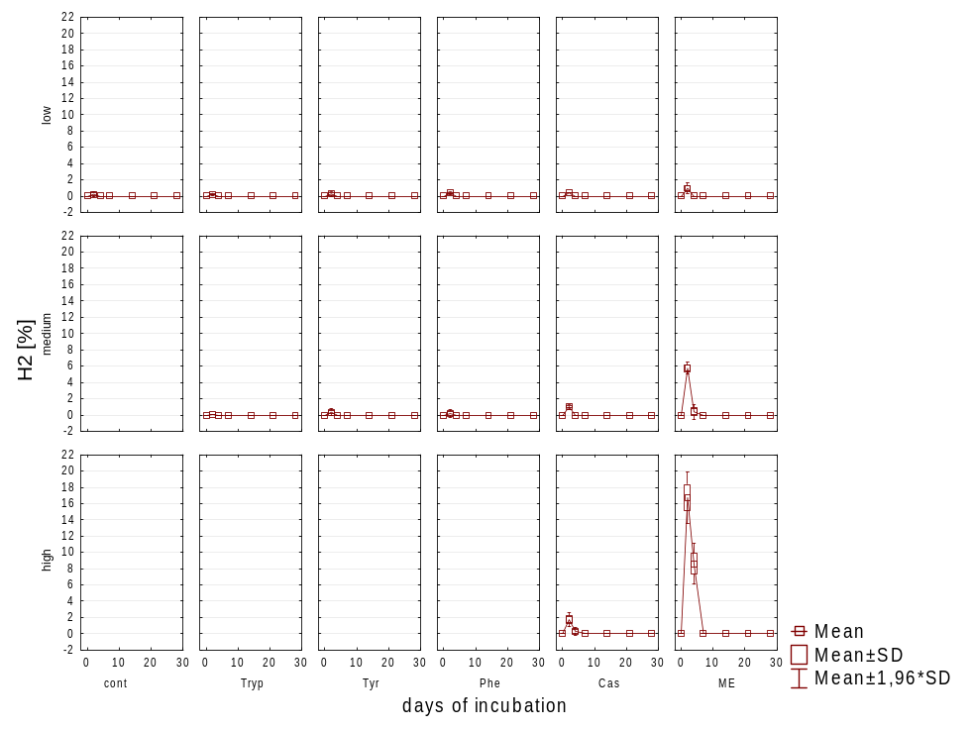
Additional Figure S1. Hydrogen concentration in the headspace [%] during 28 days of mesophilic incubation from flasks reflecting different overload conditions (low, medium, high). Cont: control; Tryp: tryptophan; Tyr: tyrosine; Phe: phenylalanine; FE: meat extract; Cas: casein.
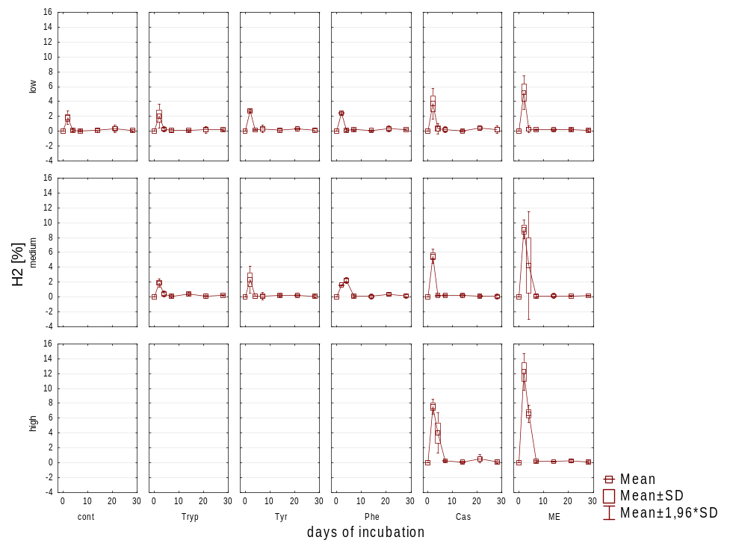
Additional Figure S2. Hydrogen concentration in the headspace [%] during 28 days of thermophilic incubation from flasks reflecting different overload conditions (low, medium, high). Cont: control; Tryp: tryptophan; Tyr: tyrosine; Phe: phenylalanine; FE: meat extract; Cas: casein.
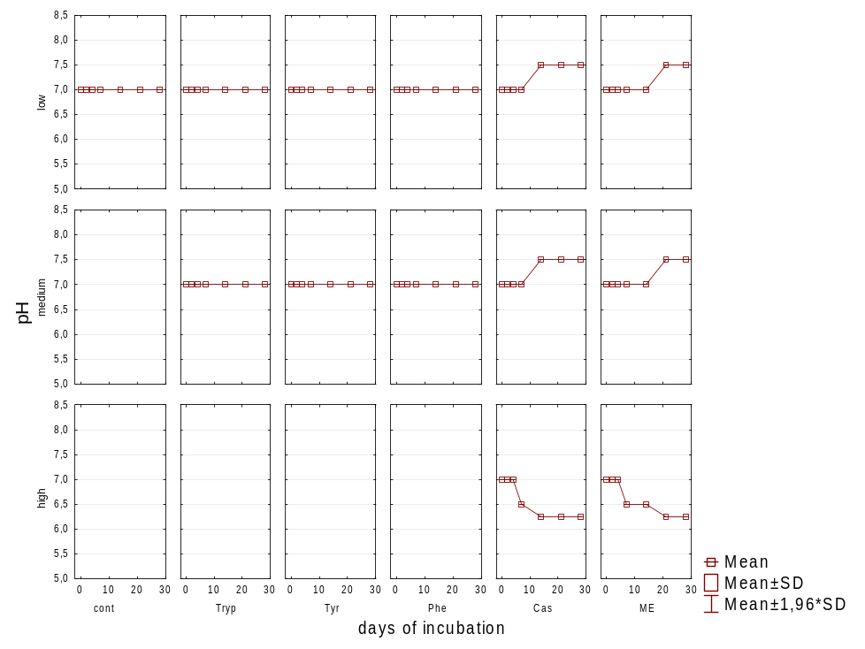
Additional Figure S3. pH measured via indicator strips (Dosatest, VWR, Germany) during 28 days of mesophilic incubation from flasks reflecting different overload conditions (low, medium, high). Cont: control; Tryp: tryptophan; Tyr: tyrosine; Phe: phenylalanine; FE: meat extract; Cas: casein.
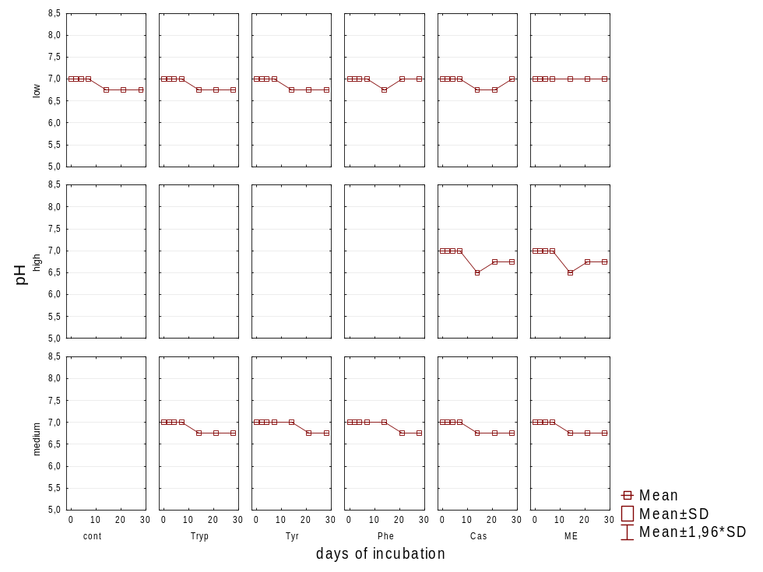
Additional Figure S4. pH measured via indicator strips (Dosatest, VWR, Germany) during 28 days of thermophilic incubation from flasks reflecting different overload conditions (low, medium, high). Cont: control; Tryp: tryptophan; Tyr: tyrosine; Phe: phenylalanine; FE: meat extract; Cas: casein.

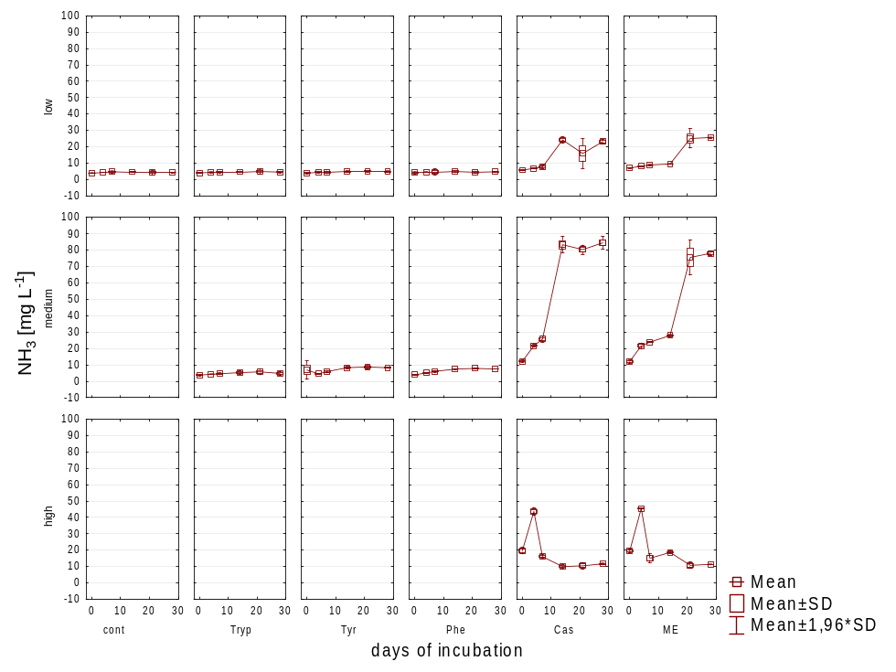
Additional Figure S5. NH₃ concentration during 28 days of mesophilic incubation from flasks reflecting different overload conditions (low, medium, high). Cont: control; Tryp: tryptophan; Tyr: tyrosine; Phe: phenylalanine; FE: meat extract; Cas: casein.
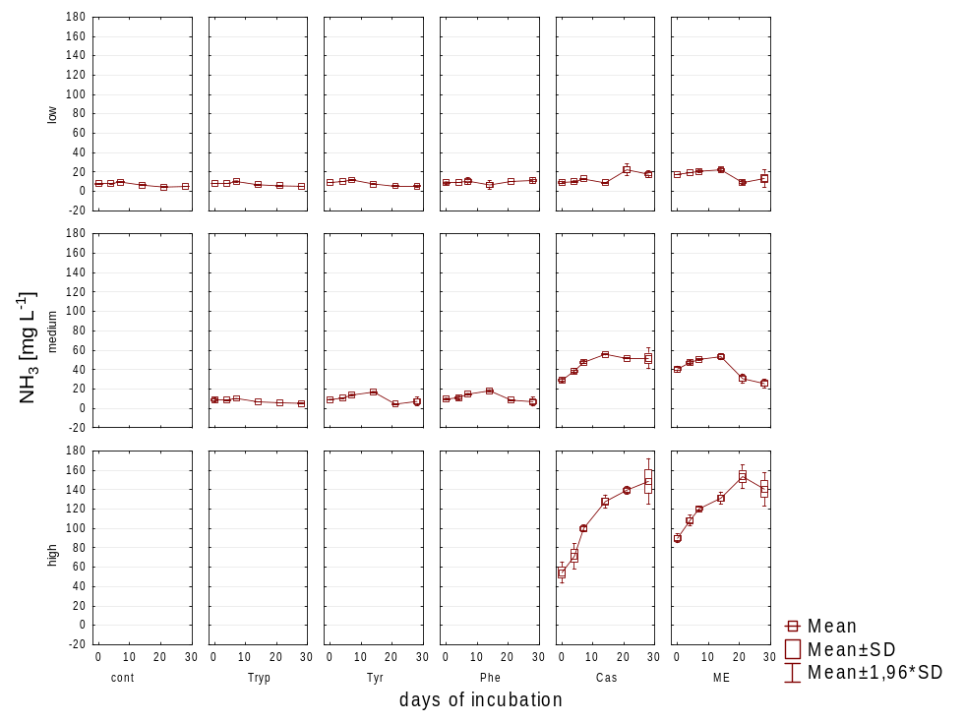
Additional Figure S6. NH₃ concentration during 28 days of thermophilic incubation from flasks reflecting different overload conditions (low, medium, high). Cont: control; Tryp: tryptophan; Tyr: tyrosine; Phe: phenylalanine; FE: meat extract; Cas: casein.

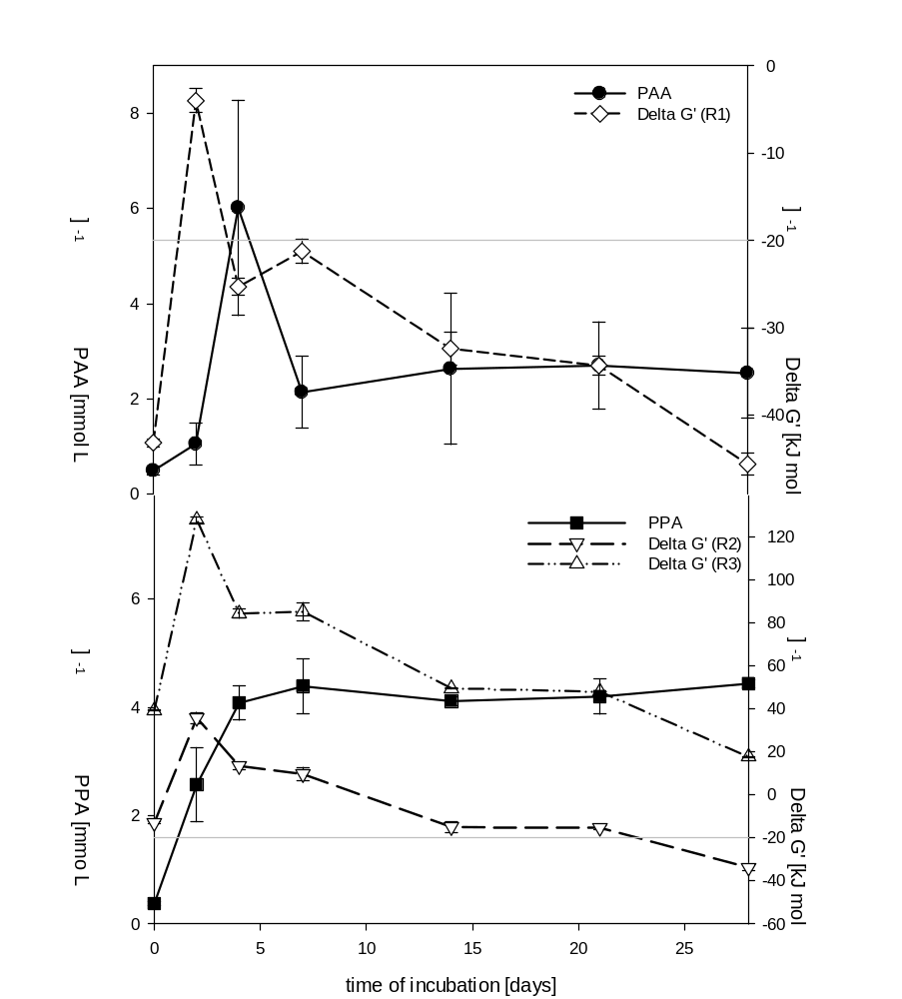
B
A
Additional Figure S7. PAA degradation during the first days of thermophilic incubation (A) and PPA accumulation (B) with ∆G’ values for reaction 1 (A) and reactions 2, 3 according to Table 3. A minimum of -20 kJ mol⁻¹ was considered necessary to make a microbial reaction thermodynamically feasible [70].

Additional Table S1. Total carbon [g L⁻¹], total nitrogen [g L⁻¹], and C/N ratio after 28 days of mesophilic incubation from flasks reflecting different overload conditions (low, medium, high). Cont: control; Tryp: tryptophan; Tyr: tyrosine; Phe: phenylalanine; FE: meat extract; Cas: casein.
substrate | overload | TC (+/- SD)  [g L⁻¹] | TN (+/- SD)  [g L⁻¹] | C/N ratio (+/- SD)
control |  | 2.8 (0.37) | 0.4 (0.01) | 7.7 (0.72)
tryptophan | low | 3.1 (0.43) | 0.4 (0.05) | 7.1 (0.52)
tryptophan | medium | 7.0 (0.25) | 1.0 (0.09) | 7.2 (0.42)
tyrosine | low | 3.5 (0.25) | 0.4 (0.02) | 8.3 (0.97)
tyrosine | medium | 5.5 (0.23) | 0.8 (0.09) | 6.9 (0.85)
phenylalanine | low | 3.3 (0.23) | 0.4 (0.02) | 8.4 (0.35)
phenylalanine | medium | 8.9 (0.10) | 1.0 (0.02) | 9.1 (0.16)
meat extract | low | 3.3 (0.56) | 0.8 (0.08) | 4.2 (0.34)
meat extract | medium | 6.4 (0.47) | 2.1 (0.09) | 3.1 (0.2)
meat extract | high | 17.7 (1.89) | 5.2 (0.08) | 3.4 (0.41)
casein | low | 3.0 (0.53) | 0.7 (0.10) | 4.4 (0.16)
casein | medium | 7.3 (0.10) | 2.2 (0.04) | 3.3 (0.1)
casein | high | 17.3 (2.37) | 5.3 (0.05) | 3.3 (0.47)

Additional Table S2. Total carbon [g L⁻¹], total nitrogen [g L⁻¹], and C/N ratio after 28 days of thermophilic incubation from flasks reflecting different overload conditions (low, medium, high). Cont: control; Tryp: tryptophan; Tyr: tyrosine; Phe: phenylalanine; FE: meat extract; Cas: casein.
substrate | overload | TC (+/- SD)  [g L⁻¹] | TN (+/- SD)  [g L⁻¹] | C/N ratio (+/- SD)
control |  | 1.9 (0.08) | 0.4 (0.02) | 5.4 (0.23)
tryptophan | low | 2.2 (0.16) | 0.4 (0.01) | 5.3 (0.23)
tryptophan | medium | 3.7 (0.05) | 0.9 (0.02) | 4.1 (0.06)
tyrosine | low | 2.0 (0.19) | 0.3 (0.03) | 5.8 (0.04)
tyrosine | medium | 4.1 (0.21) | 0.8 (0.08) | 5.1 (0.28)
phenylalanine | low | 2.3 (0.27) | 0.4 (0.03) | 5.7 (0.23)
phenylalanine | medium | 4.3 (0.02) | 0.8 (0.01) | 5.1 (0.03)
meat extract | low | 2.4 (0.22) | 0.7 (0.05) | 3.5 (0.09)
meat extract | medium | 4.4 (0.69) | 1.9 (0.29) | 2.4 (0.02)
meat extract | high | 8.3 (0.73) | 4.6 (0.31) | 1.8 (0.24)
casein | low | 2.6 (0.25) | 0.7 (0.08) | 3.5 (0.01)
casein | medium | 5.1 (0.11) | 2.0 (0.20) | 2.6 (0.28)
casein | high | 8.5 (0.16) | 5.1 (0.63) | 1.7 (0.17)

