Assessing the Stability and Techno-Economic Implications for Wet Storage of Harvested Microalgae to Manage Seasonal Variability
Lynn M. Wendt^{1†*}, Christopher Kinchin^{2†}, Bradley D. Wahlen¹, Ryan Davis², Thomas Dempster³, Henri Gerken³
¹ Idaho National Laboratory, Biological and Chemical Processing Department, Idaho Falls, ID 83415
² National Renewable Energy Laboratory, Golden, CO 80401
³ Arizona State University, Mesa, AZ 85212

†These authors contributed equally to the manuscript.

*Corresponding author:
Lynn.Wendt@inl.gov
Idaho National Laboratory
P.O. Box 1625
Idaho Falls, Idaho 83415
Phone: 208-526-0479
Facsimile: 208-526-3150

Additional file 1: Figure S1. Storage performance of Scenedesmus acutus biomass after 30 or 180 days of wet anaerobic storage. Error bars represent lower and upper bounds of approximate 95% confidence intervals. Points represent the observed mean in each category.

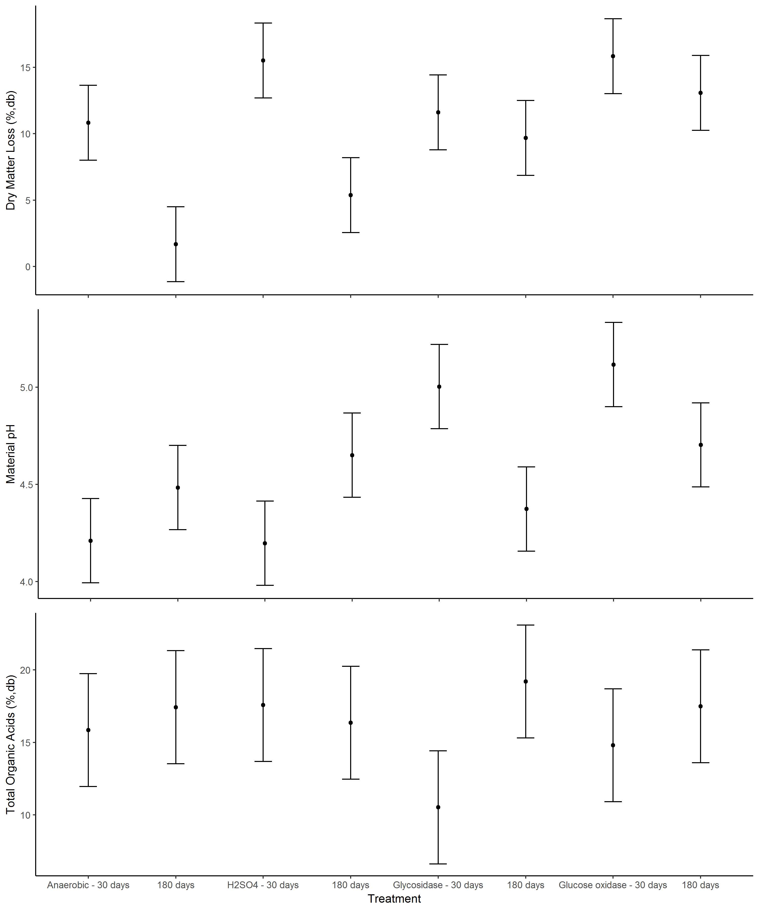

Additional file 1: Figure S2. Fatty acid composition of Scenedesmus acutus algae biomass (20% solids) after 30 or 180 days of wet anaerobic storage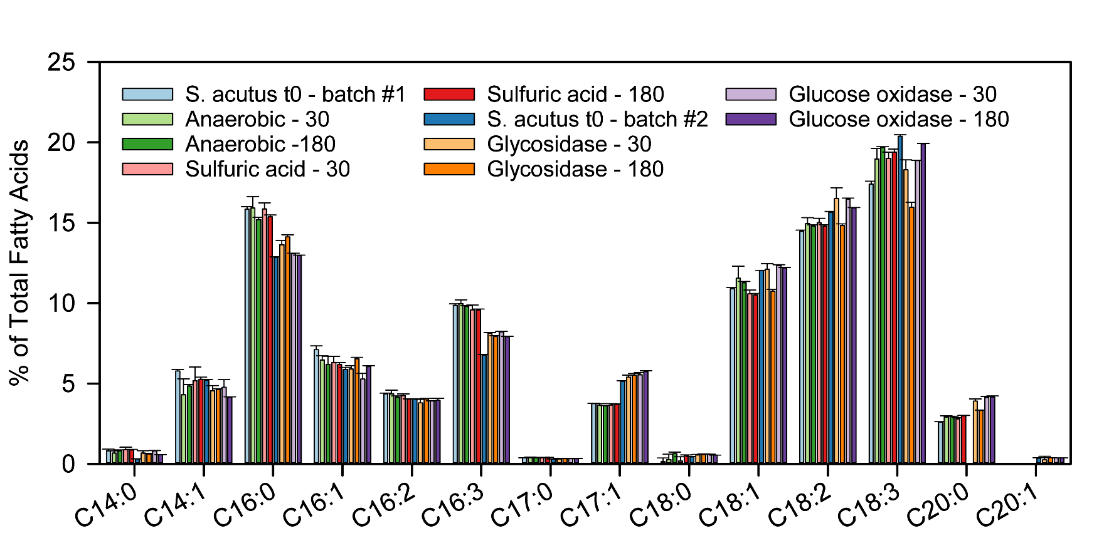
Additional file 1: Table S1. Proximate and ultimate analysis of Scenedesmus acutus algae biomass (20% solids) after 30 or 180 days of wet anaerobic storage
Experimental Condition | Length of Storage | Carbon  (%, db) | Hydrogen  (%, db) | Nitrogen  (%, db) | Oxygen  (%, db) | Sulfur  (%, db) | Volatiles  (%, db) | Ash  (%, db) | Fixed Carbon  (%, db) | HHV (BTU/g)
S. acutus – t₀¹ | 0 | 51.31 ± 0.07 | 7.22 ± 0.03 | 6.72 ± 0.02 | ND | ND | ND | ND | ND | 10003 ± 13
Anaerobic | 30 | 51.05 ± 0.06 | 7.28 ± 0.03 | 6.57 ± 0.22 | ND | ND | ND | ND | ND | 10010 ± 6
Anaerobic | 180 | 53.05 ± 0.07 | 7.14 ± 0.03 | 6.72 ± 0.03 | 29.31 ± 0.11 | 0.27 ± 0.02 | 85.88 ± 0.20 | 3.50 ± 0.06 | 10.62 ± 0.19 | 10154 ± 24
Sulfuric Acid 0.5% (db) | 30 | 52.57 ± 0.24 | 7.05 ± 0.06 | 7.04 ± 0.01 | 29.32 ± 0.30 | 0.26 ± 0.02 | 86.35 ± 0.30 | 3.75 ± 0.02 | 9.89 ± 0.32 | 10230 ± 54
Sulfuric Acid 0.5% (db) | 180 | 53.22 ± 0.05 | 7.19 ± 0.02 | 7.19 ± 0.01 | 28.21 ± 0.05 | 0.30 ± 0.01 | 85.86 ± 0.06 | 3.89 ± 0.04 | 10.25 ± 0.09 | 10260 ± 4
S. acutus – t₀² | 0 | 52.45 ± 0.09 | 6.90 ± 0.03 | 6.85 ± 0.02 | 30.01 ± 0.12 | 0.28 ± 0.01 | 84.62 ± 0.10 | 3.50 ± 0.08 | 11.87 ± 0.15 | 10099 ± 42
Glycosidase | 30 | 54.89 ± 0.38 | 7.10 ± 0.05 | 7.51 ± 0.06 | 26.37 ± 0.48 | 0.31 ± 0.01 | 85.73 ± 0.14 | 3.81 ± 0.06 | 10.46 ± 0.19 | 10731 ± 56
Glycosidase | 180 | 56.40 ± 0.58 | 7.35 ± 0.10 | 8.26 ± 0.10 | 23.34 ± 0.78 | 0.29 ± 0.02 | 85.40 ± 0.14 | 4.36 ± 0.04 | 10.24 ± 0.15 | 10943 ± 37
Glucose oxidase | 30 | 56.53 ± 0.05 | 7.19 ± 0.03 | 7.95 ± 0.01 | 24.05 ± 0.07 | 0.27 ± 0.01 | 85.49 ± 0.22 | 4.01 ± 0.07 | 10.50 ± 0.20 | 11093 ± 19
Glucose oxidase | 180 | 56.94 ± 0.08 | 7.32 ± 0.02 | 8.58 ± 0.02 | 22.65 ± 0.07 | 0.25 ± 0.01 | 85.68 ± 0.13 | 4.27 ± 0.02 | 10.05 ± 0.14 | 11242 ± 22
HHV-Higher Heating Value
^{1, 2} Harvest 1 and 2

Additional file 1: Table S2. Capital and operating costs utilized for dryers and dry and wet storage vessels.

Capital Costs, MM$
Above-ground storage vessels (304SS) | $46.6
In-ground storage pits (plastic lined) | $4.3
Cover for in-ground storage pit (plastic cover) | $0.4
Rotary drum dryer | $7.2
Contact drum dryer | $20.4
Operating Costs, MM$/yr
Rotary drum dryer | $1.6
Contact drum dryer | $1.6
MM-Million; SS-Stainless steel

Additional file 1: Table S3. Discounted cash flow analysis parameters for the TEA.

Plant life | 30 years
Discount rate | 10%
General plant depreciation | 200% declining balance
General plant recovery period | 7 years
Steam (turbine) plant depreciation | 200% declining balance
Steam (turbine) plant recovery period | 7 years
Federal tax rate | 35%
Financing | 40% equity
Loan term | 10-yr loan at 8% APR
Construction period | 3 years
First 12 months’ expenditures | 8%
Second 12 months’ expenditures | 60%
Third 12 months’ expenditures | 32%
Working capital | 5% of fixed capital investment
Start-up time | 6 months
Revenues during start-up | 50%
Variable costs incurred during start-up | 75%
Fixed costs incurred during start-up | 100%

