Production of xylooligosaccharides and monosaccharides from poplar by a two-step acetic acid and peroxide/acetic acid pretreatment

Peiyao Wen¹, Tian Zhang¹, Jinye Wang¹, Zhina Lian², Junhua Zhang^{1, 2}*
Corresponding author. Tel.: +86-13892883052; fax: +86-29-87082216.
E-mail address: junhuazhang@nwafu.edu.cn (J. Zhang)

Peiyao Wen, e-mail address: wenpeiyao@nwafu.edu.cn
Tian Zhang, e-mail address:15002906131@163.com
Jinye Wang, e-mail address: wjy6520@nwafu.edu.cn
Zhina Lian, e-mail address: zhinalian@163.com

Table S1 The AC concentration of AC pretreatment liquor.

AC concentration before pretreatment ( mg/mL) | Treatment time | AC concentration after pretreatment (mg/mL)
0.0 | 10 min | 0.21±0.00
5.2 | 10 min | 3.49±0.08
10.5 | 10 min | 7.60±0.11
0.0 | 30 min | 0.22±0.04
5.2 | 30 min | 4.68±0.23
10.5 | 30 min | 8.41±0.21
0.0 | 50 min | 0.23±0.09
5.2 | 50 min | 4.70±0.14
10.5 | 50 min | 8.41±0.16

\
Figure S1 XRD analysis of raw and two steps pretreated poplar.

Figure S2 FT-IR spectrum of raw and two steps pretreated poplar.

First step pretreatment
Second step pretreatment

Figure S3 XPS analysis of raw and two steps pretreated poplar.

Figure S4 Hydrophobicity of raw and two steps pretreated poplar.

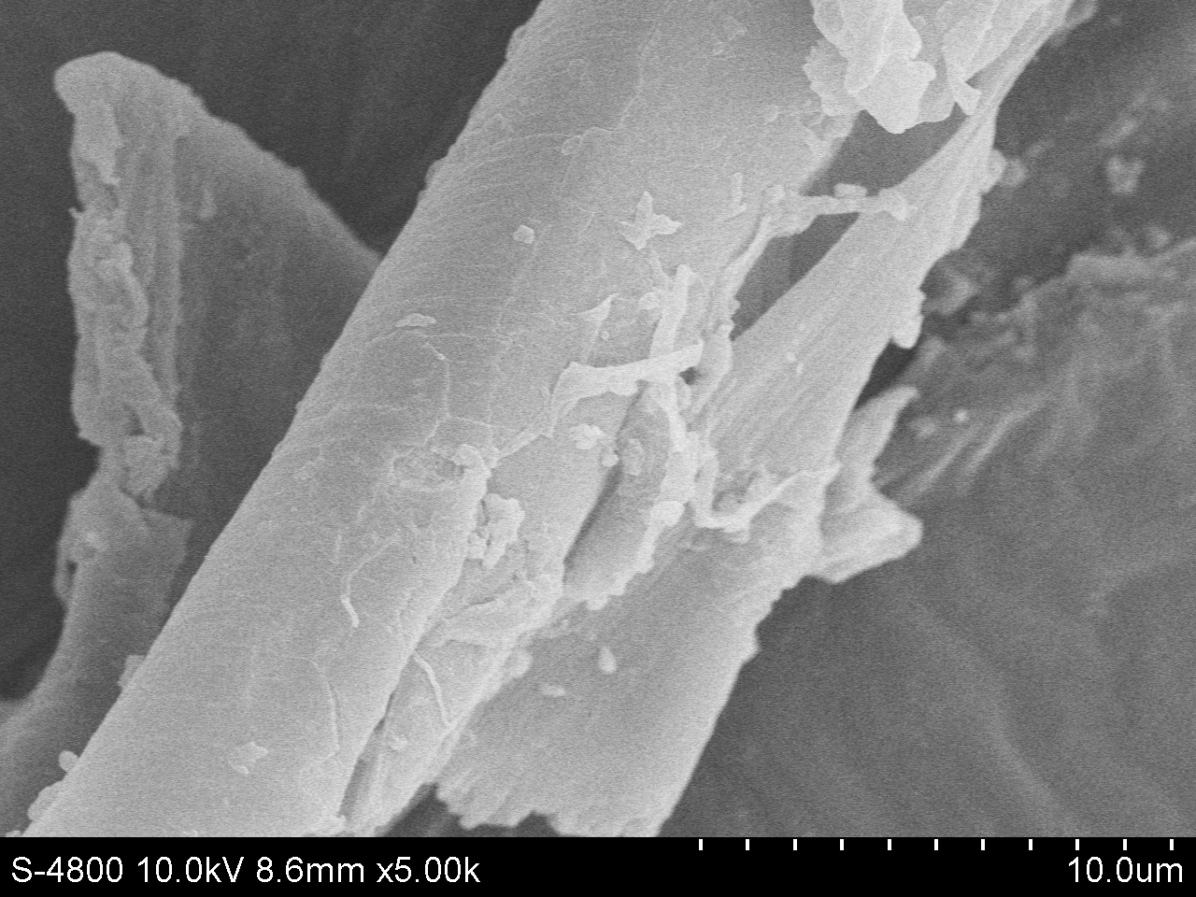
Raw

The first step pretreatment
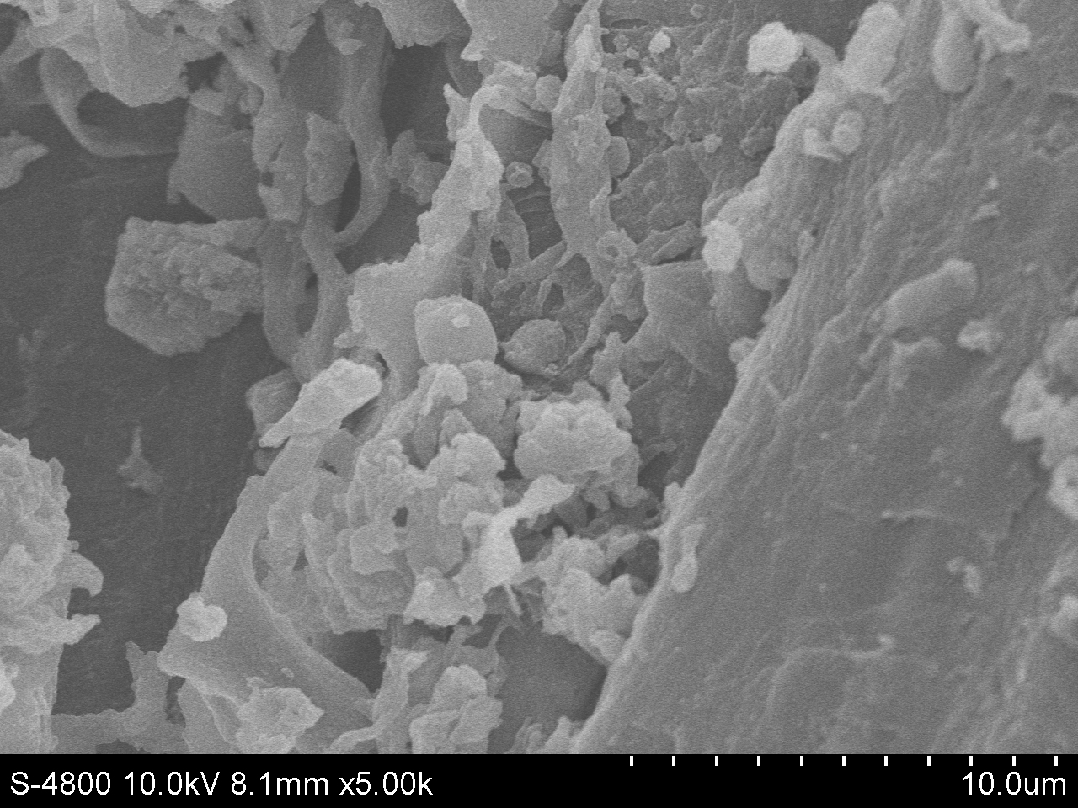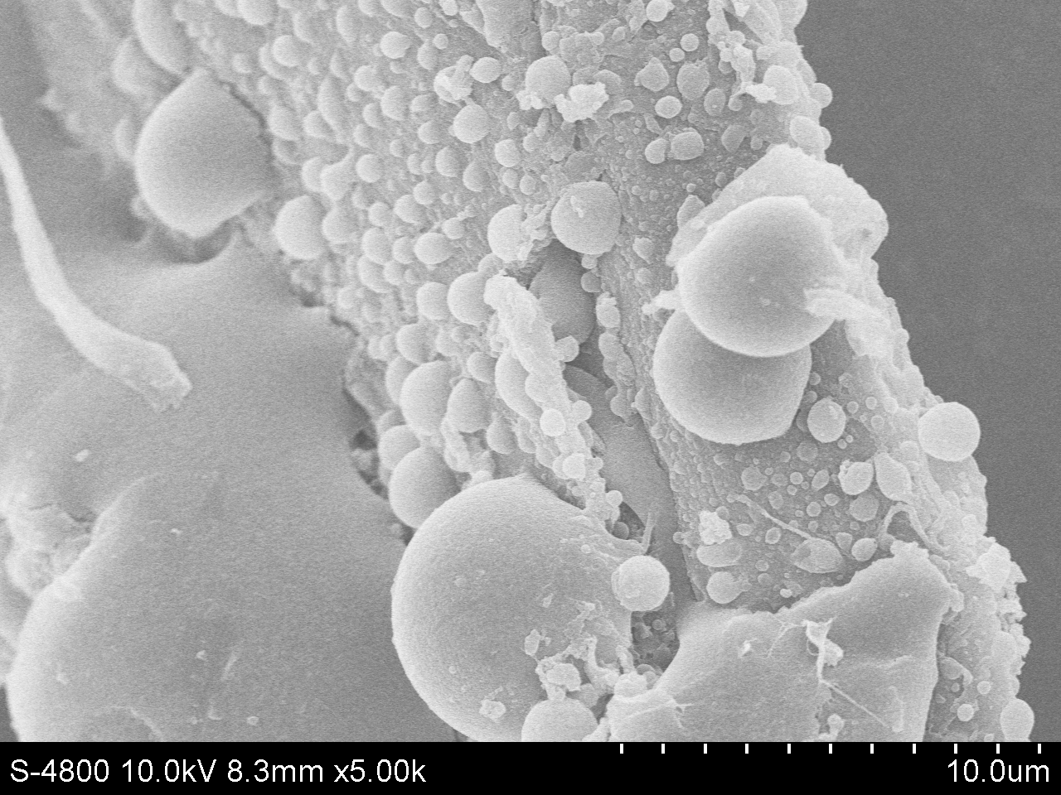
0% AC, 30 min
5% AC, 30 min
10% AC, 30 min

The second step pretreatment
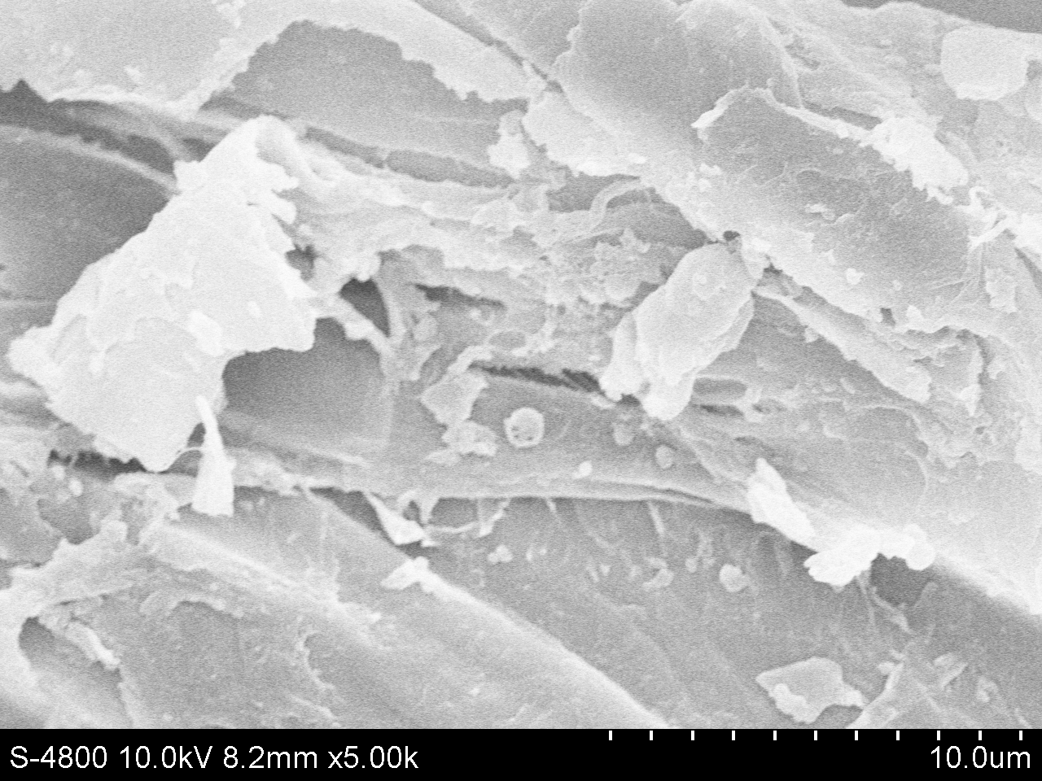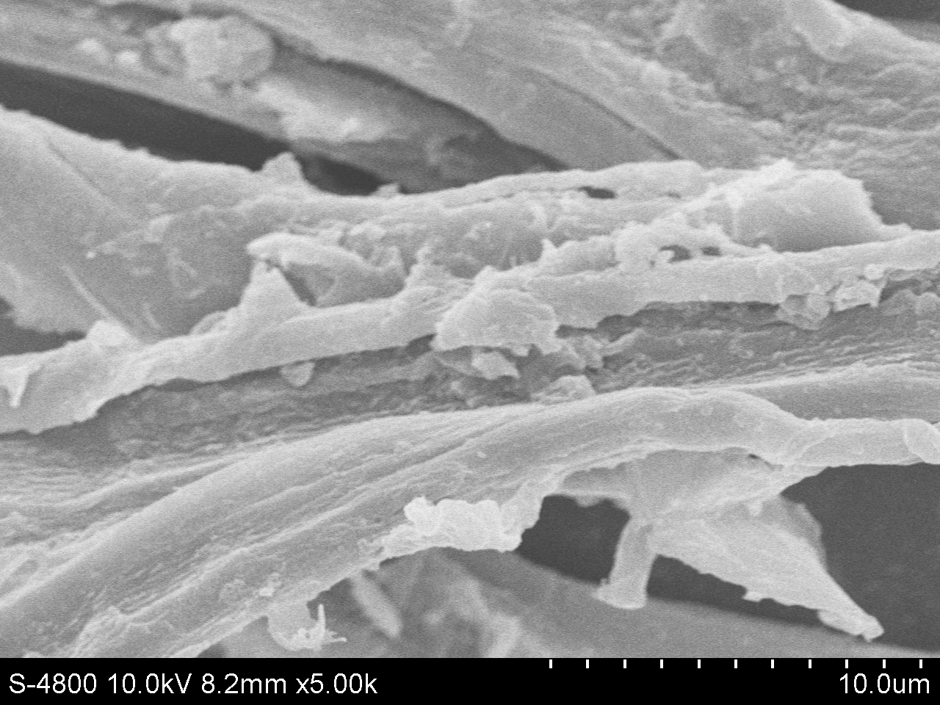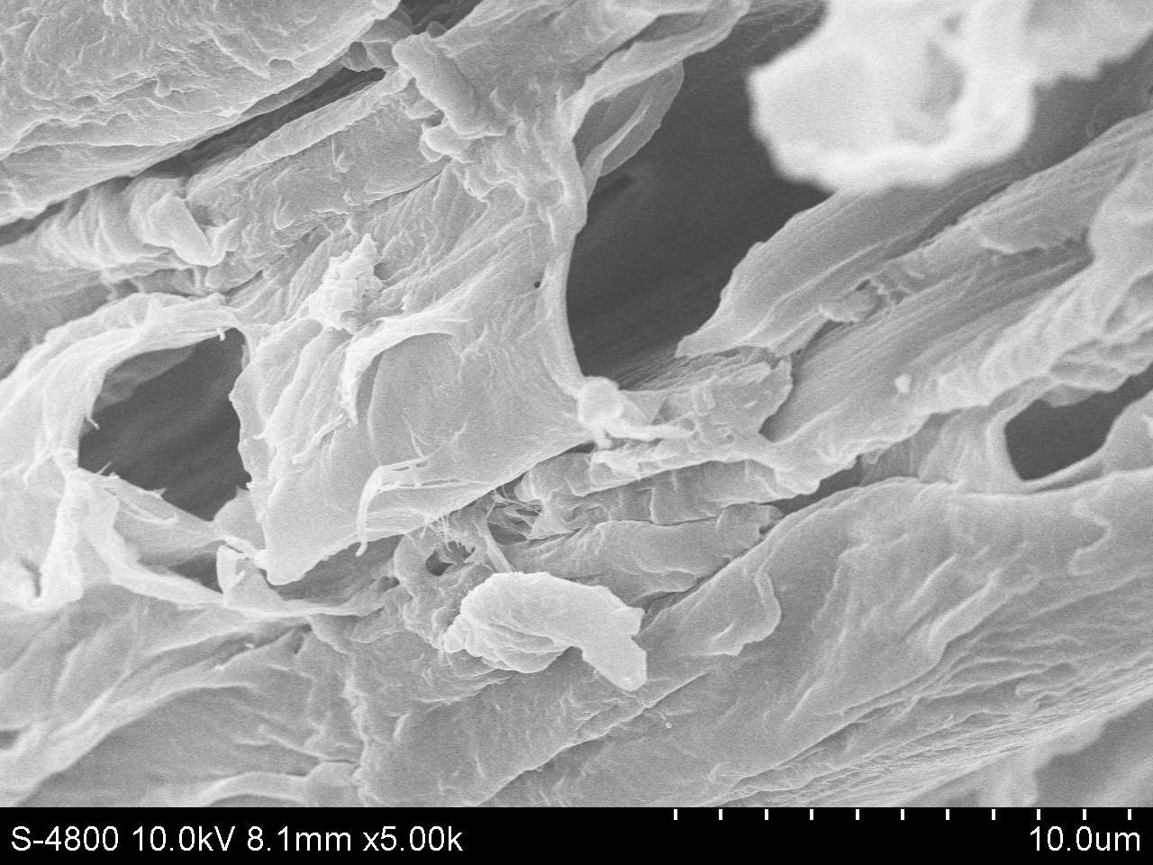
40% HPAC, 60 °C

80% HPAC, 60 °C

60% HPAC, 60 °C

Figure S5 SEM analysis of raw and two steps pretreated poplar.

Figure S6 Effect of CTec2 loading on the hydrolysis of poplar (2%) pretreated by AC (5%, 170°C, 30 min) for 48 h.

