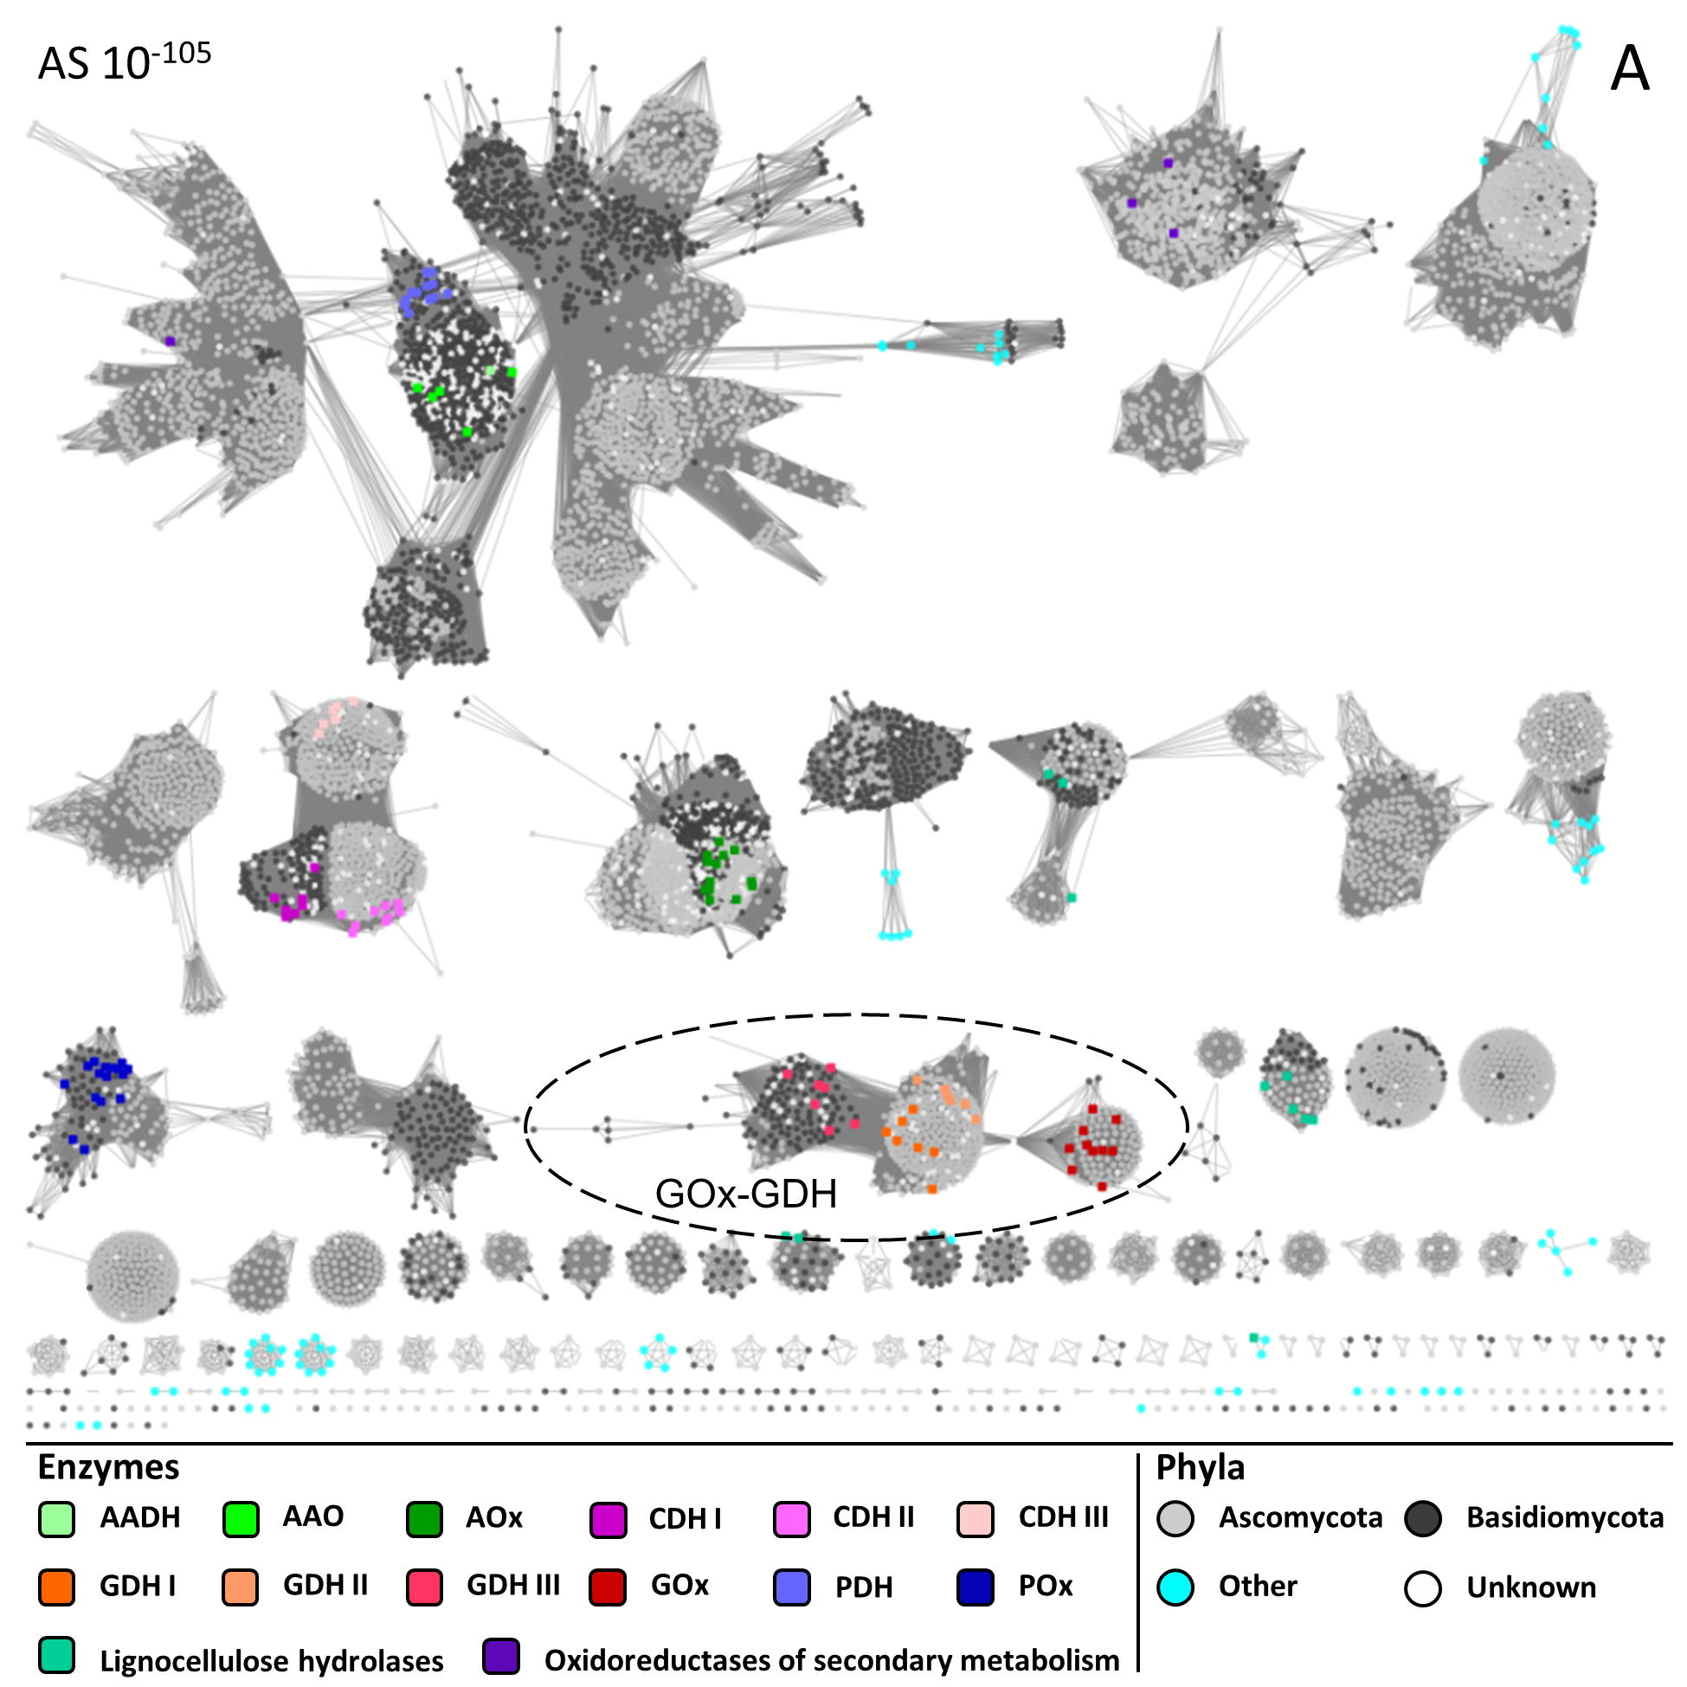

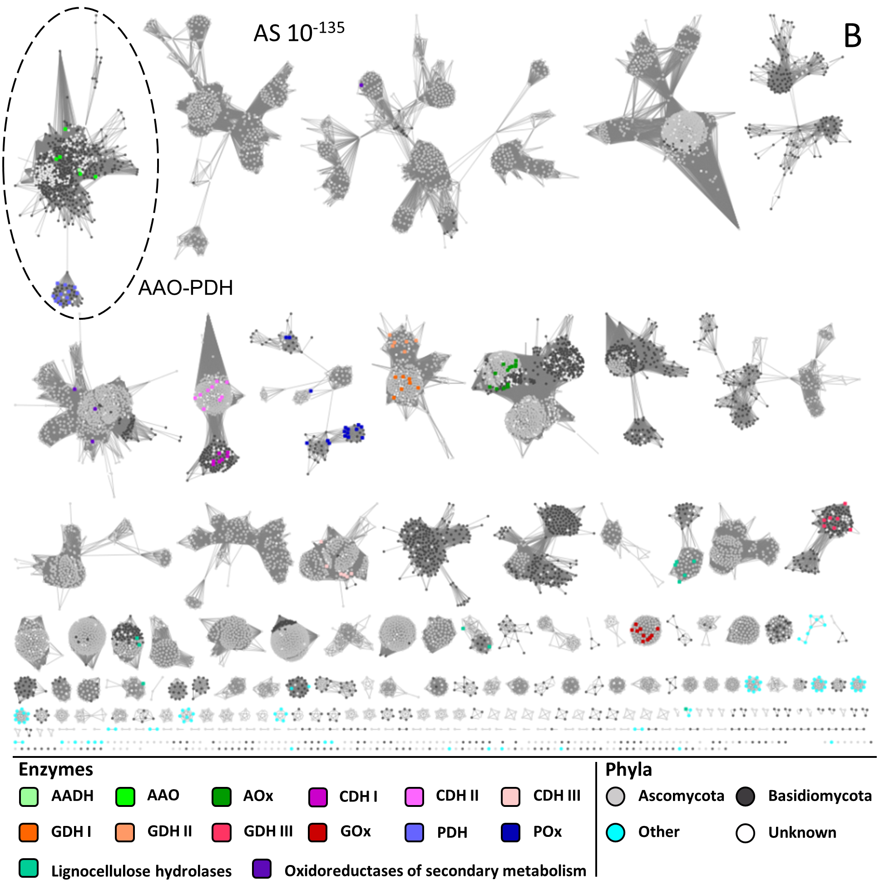

Figure S1. A: Sequence similarity network at an alignment score cut-off of 10⁻¹⁰⁵. B: Sequence similarity network at an alignment score cut-off of 10⁻¹³⁵.
Clusters extracted at this cut-off are indicated by dashed circles. Annotated sequences are coloured according to their functionality ('Enzymes'). All other sequences are coloured according to the fungal phyla they occur in ('Phyla').

