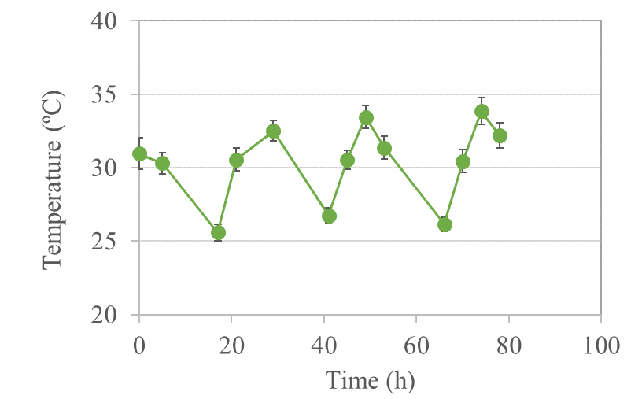
Fig. S1. Temperature variations in the culture of A. platensis in industrial-scale open raceway ponds under nitrogen-limited conditions.

Fig. S2. Gas chromatography analysis of monosaccharide composition of polysaccharide from nitrogen-limited A. platensis. a, rhamnose; b, fucose; c, arabinose; d, xylose; e, mannose; f, galactose; g, glucose; h, glucuronic acid; I, galacturonic acid.

Fig. S3. FTIR analysis of polysaccharide from nitrogen-limited A. platensis.

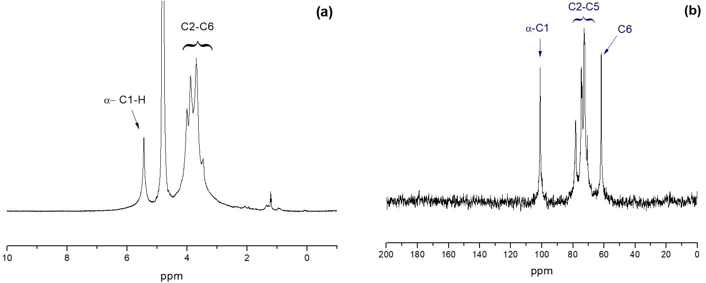
Fig. S4. ¹H NMR and ¹³C NMR spectrum of polysaccharide from nitrogen-limited A. platensis.

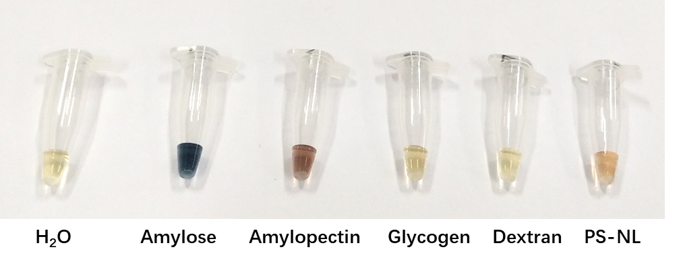
Fig. S5. Iodine-staining analysis of different polysaccharides and comparison with the polysaccharide from nitrogen-limited A. platensis (PS-NL). 20 μL 0.25 g/L glucan+4 μL 0.01N I₂-KI solution.

