Additional Information

Adaptively evolved Escherichia coli for improved ability of formate utilization as a carbon source in sugar-free conditions

Seung-Jin Kim¹, Jihee Yoon¹, Dae-Kyun Im¹, Yong Hwan Kim², Min-Kyu Oh^{1,}*

¹ Department of Chemical and Biological Engineering, Korea University, Seongbuk-gu, Seoul 02841, Republic of Korea.
²School of Energy and Chemical Engineering, UNIST Ulsan, 44919, Republic of Korea

*Corresponding author. M.-K. Oh. mkoh@korea.ac.kr
First Author. S.J. Kim. tmdwls7526@naver.com
Co-author. J.Yoon. yoonz19@daum.net
Co-author. D.K. Im. meganti@korea.ac.kr
Co-author. Y.H. Kim. metalkim@unist.ac.kr

Table S1. Oligonucleotides used for gene cloning in this study
Primers | Sequence
ftfL_fw | 5’- attaaagaggagaaaggtacTGAGAGAAATGCCCTCAG
ftfL_rv | 5’- acatgattcccctcctGAGAGCAGCGGCTAGAAC
mtdA and fch_fw | 5’- cgctgctctcaggaggGGAATCATGTCCAAGAAGC
mtdA and fch_rv | 5’- gctcatcctttcctcctCGATCGGCTCAGTTTACC
glyA_fw | 5’- gagccgatcgaggaggaaaggATGAGCGCCGGAACTGCG
glyA_rv | 5’- ctcgagggggggcccggtacTCAGGCGTAGATCGGGAACC
sga_fw | 5’- tcgagctcggcgcgcctgcaaggaggAAATTCTCATGGCGGCAAC
sga_rv | 5’- cgcaagcttgtcgacctgcaAAAGAATGAGGCCCCAAG
hpr_fw | 5’- actttaataaggagatatacGGGGTCCAGAATGACAAAG
hpr_rv | 5’- ccttgatgcgcctcctGTTTCTTACGCCTCGACG
gck_fw | 5’- cgtaagaaacaggaggCGCATCAAGGTGGTCGAG
gck_rv | 5’- tgatggtgatggctgctgccCTGCATGAAGGGTCAGAC
pdc_fw | 5’-atgtcaaacaaaccctttatctaccaggcacctttcccgatggggaaagacaataccgaagtgtaggctggagctgcttcg
pdc_rv | 5’-ttacttagtgcagttcgcgcactgtttgttgacgatttgctggaagaagtcgttacctttattccggggatccgtcgacc
adhA_fw | 5’-tataaatgcactttgcgtgccg
adhA_rv | 5’-gcaagcgtgaaattacaatcgc
fimCD_fw | 5’- attaaagaggagaaaggtacTGATAACAGGAACAGGACAG
fimCD_rv | 5’- gctgcaggaattcgatatcaCTCATCACGCCCCCTTAAC
ydeH_fw | 5’- attaaagaggagaaaggtacaaaATGATCAAGAAGACAACG
ydeH_rv | 5’- ctcgagggggggcccggtacTCAATGAATGTTAAACGGAG
htrE_fw | 5’-attaaagaggagaaaggtacGCAGGAAGCATAGCGTGAC
htrE_rv | 5’-ctcgagggggggcccggtacTTACTGAATCTGACACCGAATTC
csgD_fw | 5’-attaaagaggagaaaggtacAAAAAGCGGGGTTTCATC
csgD_rv | 5’-ctcgagggggggcccggtacGGCTTTATCGCCTGAGGTTATC

Table S2. Oligonucleotides used for gene deletion in this study
Primers | Sequence
△gcvP_fw | 5’-  aacatatccgccgtgagaaagcgaactccaacatttgtacttcccaggta gtgtaggctg gagctgcttc
△gcvP_rv | 5’-CTGTTCCGCTTTCGCGCGCAGATCAGTCAGATCGATGTTGCCGTTTTTATGTCCATATGAATATCCTCCT
△purU_fw | 5’- ATGCATTCACTCCAACGTAAAGTTCTGCGTACTATTTGTCCGGACCAAAAGTGTAGGCTG GAGCTGCTTC
△purU_rv | 5’- TAATCGTCCGATTACCGTAAACAAAGACGCGCTGTGCCAGTACTTTGTAT GTCCATATGAATATCCTCCT
△purT_fw | 5’- TGGACGCGTGAAGACCCTGCATCCGAAAGTACATGGTGGCATTCTG  GGCCGTGTAGGCTGGAGCTGCTTC
△purT_rv | 5’- ACCCTGAACCTGGGTTGCGGTAGCAACGGAGGCTTCTTTCACATTCTCTTGTCCATATGAATATCCTCCT
△purN_fw | 5’- AAATTAAAGGCACCGTACGGGCAGTTTTCAGCAATAAGGCCGACGCGTTCGTGTAGGCTGGAGCTGCTTC
△purN_rv | 5’- CCAGAAAAGGGGGAAAAAAACTGCTGGAGCTTGCGATTTACAGGTGAATTGTCCATATGAATATCCTCCT
△metF_fw | 5’- TGCACAACACAACATATAACTACAAGCGATTGATGAGGTAAGGTATGAGCGTGTAGGCTGGAGCTGCTTC
△metF_rv | 5’- TTCACAAAAGCCACACTATTTATAAACCAGGTCGAACCCCCAGCGTATGGGTCCATATGAATATCCTCCT
ΔhycA_fw | 5’- CATCGCACAGCGGCATCGTCGCCTACAGGACCAGTGGCACATCTACTGCA GTGTAGGCTG GAGCTGCTTC
ΔhycA_rv | 5’- GCCTCAGCTCATGCTGCCGGGCTTTGTCCCTTTACCAGTTGGCTTAAATT GTCCATATGAATATCCTCCT
Δfnr_fw | 5’- gaaaagcgaattatacggcgcattcagtctggcggttgtgctatccattg gtgtaggctg gagctgcttc
Δfnr-rv | 5’- agcgcatcgttattttcgatggtgatgtatttacctttgactgccagcat gtccatatgaatatcctcct

Table S3. Mutations in the EMK02A2 strain compared to EMK02
Position | Reference | Alternate | Mutation Type | Genes | Residue change
87220 | G | A | synonymous | leuO | K16K
145903 | T | C | synonymous | yadG | G107G
152354 | G | GT | frameshift | panB | R18fs*
272929 | T | C | intergenic
352886 | A | G | non-synonymous | tauC | H12R
355632 | T | C | intergenic
573197 | T | C | intergenic
592514 | G | C | intergenic
601413 | A | G | synonymous | uspG | V93V
689755 | A | T | synonymous | rhsC | I102I
768867 | G | T | non-synonymous | nu1 | G70V
812571 | A | G | non-synonymous | ybhF | R133G
850458 | G | A | intergenic
1211439 | C | T | non-synonymous | ymgJ | A8V
1247163 | T | C | synonymous | ychH | R77R
1275980 | G | C | non-synonymous | purU | S144T
1384023 | T | C | synonymous | fnr | G222G
1384350 | T | G | synonymous | fnr | V113V
1417424 | C | T | non-synonymous | ldhA | P325S
1440176 | G | T | synonymous | bhsA | A23A
1573618 | A | C | non-synonymous | ydeI | N57T
1616189 | T | A | intergenic
1877133 | G | A | non-synonymous | purT | E179K
2137719 | T | C | intergenic
2239728 | T | C | synonymous | InaA | C36C
2487189 | A | T | non-synonymous | purN | T161S
2528862 | G | A | synonymous | trmJ | P87P
2558910 | T | C | synonymous | purL | P817P
2677075 | G | C | synonymous | hypF | P104P
2690002 | T | C | non-synonymous | hycA | I132T
2742929 | T | C | non-synonymous | mazG | C114P
2745583 | T | C | synonymous | relA | L218L
2746742 | T | G | non-synonymous | rlmD | L281W
2808596 | G | A | synonymous | mutH | A220A
2988396 | C | T | intergenic
3400181 | C | A | intergenic
3463600 | C | T | synonymous | ftsX | L288L
3481772 | C | G | non-synonymous | rhsB | A68G
3486919 | T | C | non-synonymous | yhhI | L55P
3512536 | A | G | non-synonymous | arsB | I408V
3512652 | C | T | synonymous | arsC | C12C
3514641 | A | G | non-synonymous | yhiS | K324R
3515361 | G | T | non-synonymous | slp | V74L
3517392 | C | T | synonymous | hdeB | L28L
3684918 | G | A | non-synonymous | dinD | R125K
3750787 | T | C | synonymous | glvA | L24L
3769514 | C | T | synonymous | recF | R192R
3797199 | C | T | intergenic
3903913 | T | C | intergenic
4022076 | G | C | non-synonymous | fpr | D105H
4041158 | T | TT | frameshift | metF | M1fs*
4123296 | C | A | intergenic
4261979 | C | T | intergenic
4275717 | T | A | intergenic
* fs: frameshift

Table S4. Mutations in the EMK02A5 strain compared to EMK02A2
Position | Reference | Alternate | Mutation Type | Genes | Residue change
157875 | A | G | non-synonymous | htrE | K133E
168830  170169 | T  G | C  GA | synonymous  intergenic | mrcB | L814L
347564  355805  689379 | T  C  A | C  A  C | non-synonymous  non-synonymous  intergenic | frmB  ykiB | L46L  P64Q
740253 | TC | C | intergenic
747017 | G | A | intergenic
766431  788230 | A  G | C  C | non-synonymous  non-synonymous | borD  orf_401 | K97Q  V38L
891018 | C | T | synonymous | tfaE | V20V
1097421 | A | T | non-synonymous | ycdT | K90I
1105297 | T | C | non-synonymous | CsgD | V154A
1143039  1170003  1478490 | C  G  C | A  T  T | non-synonymous  intergenic  intergenic | flgL | A149D
1545542 | C | A | non-synonymous | fimD | P393T
1572602 | C | T | non-synonymous | ydeH | T180I
1582513 | A | C | non-synonymous | ydfK | K62T
1823035 | T | C | non-synonymous | yeaP | V317A
1910305  2017589 | G  C | A  A | non-synonymous  intergenic | flhA | V220I
2198184 | T | C | intergenic
2802210  2998771 | T  C | C  T | non-synonymous  stop gained | ppdA  yghQ | V81A  E356sg
3105615 | A | T | synonymous | alx | G320G
3325817  3482641  3482984 | G  C  A | A  T  G | non-synonymous  non-synonymous  non-synonymous | gspO  rhsB  rhsB | G16D  R358C  N472S
3622828  3934181 | A  A | G  C | non-synonymous  intergenic | aldB | T23A
4233361  4451962 | G  A | T  C | Intergenic  intergenic
4453737 | T | A | non-synonymous | fimC | V54E

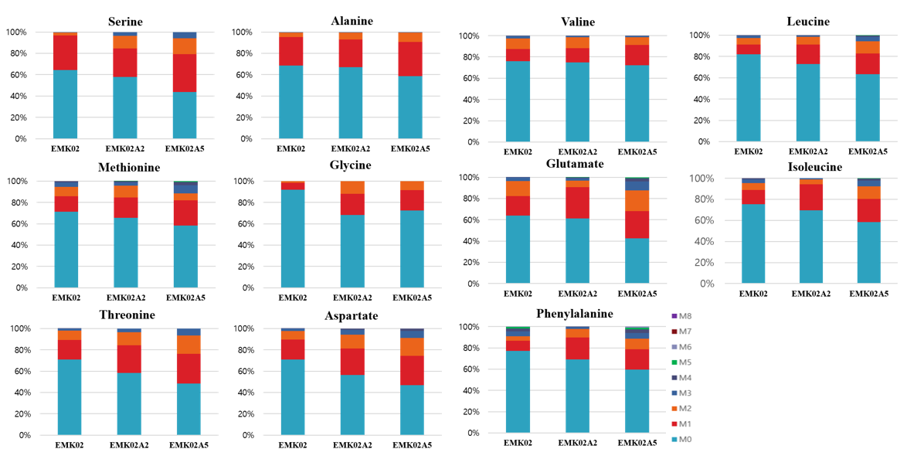
Figure S1. The proportion of labelled amino acids in evolved mutant strains at 8 hours after the addition of ¹³C-labelled formate in formate minimal medium supplied with 1 g/L glycine with initial OD of 0.7. M0-M8 denotes incorporating number of carbon isotope atom in proteinogenic amino acids.

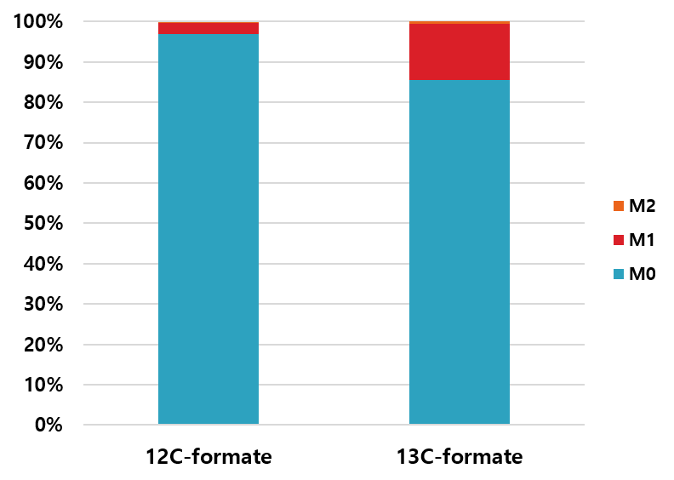
Figure S2. The proportion of labelled ethanol in the EMK02A5 strain after 24-h incubation with unlabeled formate or ¹³C-labelled formate in M9 minimal medium supplied with 1g/L glycine and 0.2g/L yeast extract at iOD of 0.1. M0-M2 denotes incorporating number of carbon isotope atom in ethanol.

