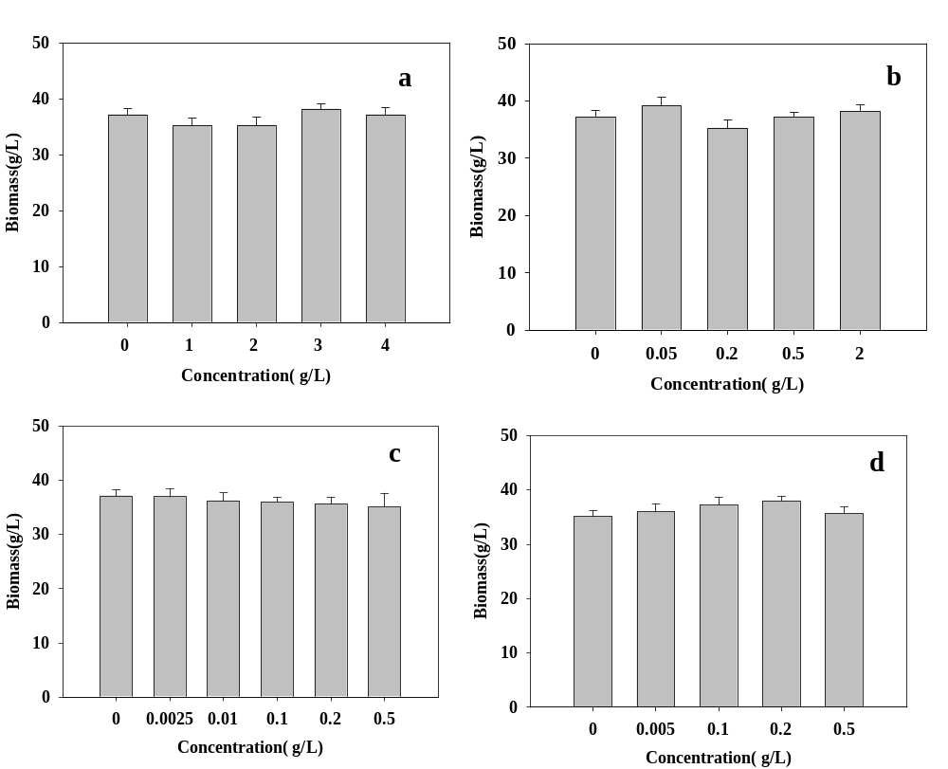
Fig. S1 Biomass of Schizochytrium limacinum SR21 supplemented with various concentrations (a) BA (b) MBA (c) FA (d) ABA

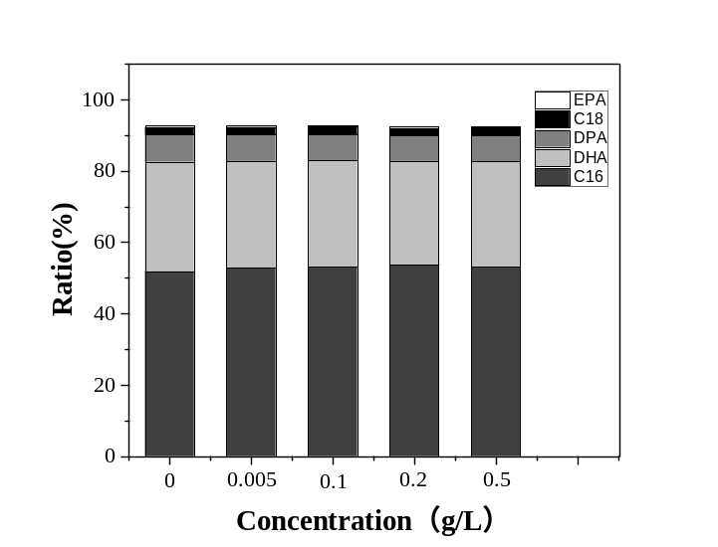
Fig. S2 The lipid profiles in Schizochytrium limacinum SR21 under different concentrations of ABA
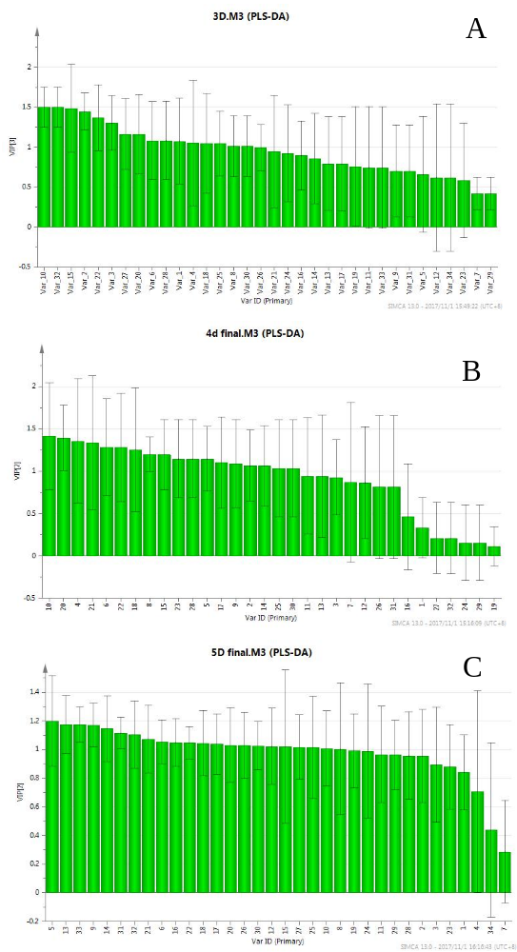

Fig. S3 The VIP value of specific metabolites.(A)-(C): 72nd -120th h
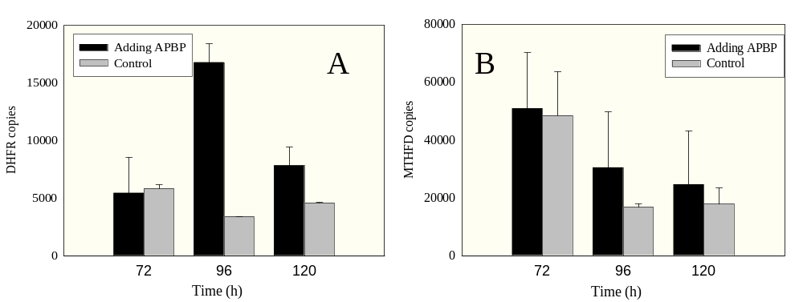
Fig.S4 Quantitative RT-PCR of the gene expression (A) dihydrofolate reductase (DHFR) gene and (B) tetrahydrofolate dehydrogenase (MTHFD)

Table S1 RT-PCR primers used in this study
Gene | Primer name | Primer sequence(5'-3')
DHFR | DH-F | AACACCCAGCTACTGCCATACC
 | DH-R | CCTCCACTGCCAATCTTTG
MTHFD1 | MT1-F | CGAGAAGGGCTACCAGGTTC
 | MT1-R | GAGACCACAGGTACGGATGG
MTHFD2 | MT2-F | AGCCTCGTCGTAGCCCATCT
 | MT2-R | TGCAGCCAGCTCCTCAAGAT

