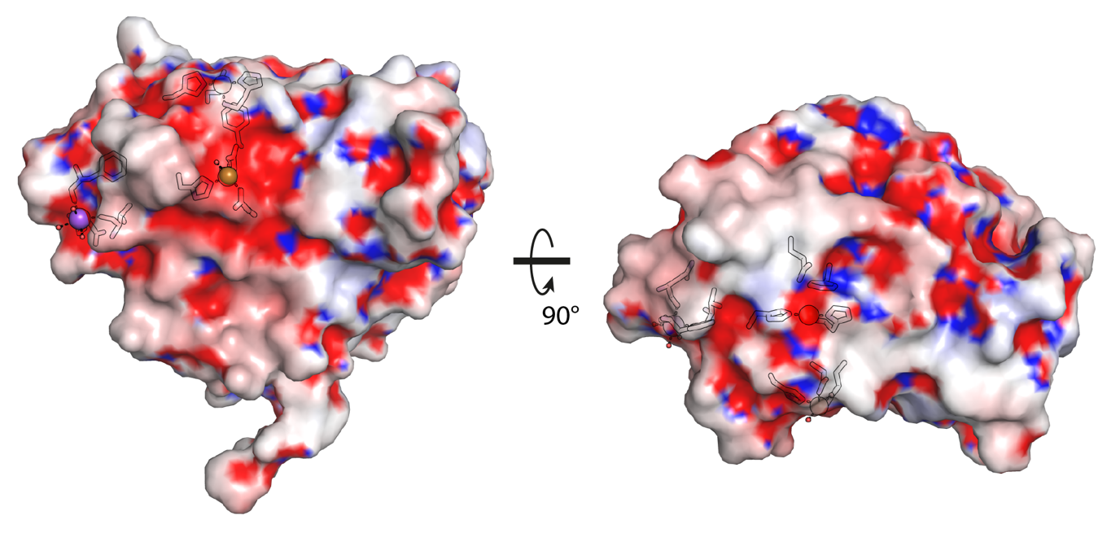
Additional File 5, Figure S4. Electrostatic Surface Potential for TtAA10A. The electrostatic charge distribution for TtAA10 has been mapped onto the protein surface using the APBS plug-in for PyMol at ±10 KBT/e. The histidine brace, secondary copper binding site and sodium binding site are outlined with black lines showing the negatively charged areas to which the ions bind.

