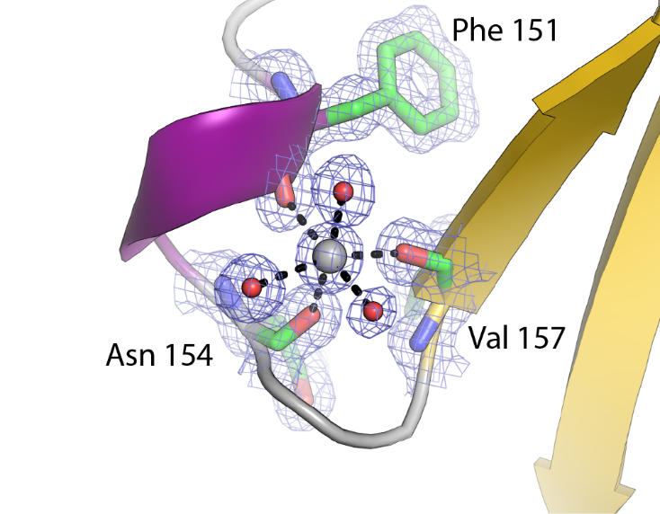
Additional File 7, Figure S6. The Na⁺ Site on the TtAA10A Surface. The modelled sodium ion is shown as a grey sphere with the groups that coordinate it shown as sticks coloured by atom type. The 2F_{obs}-F_{calc} map is shown as a blue wire mesh contoured at 1σ. The sodium ion is octahedrally coordinated with three main chain carbonyl groups and three water molecules. Sodium was assigned at this site based on the coordinating bond lengths and this was the ion that gave a B-factor following refinement closest to the surrounding protein atoms.

