Figure S1: Design of acl1 and acl2 expression cassette.

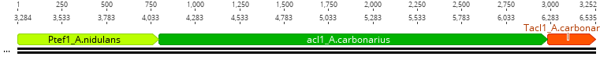

Figure S2: Shake flask cultivation of CitB#99 ACL G1 Z.

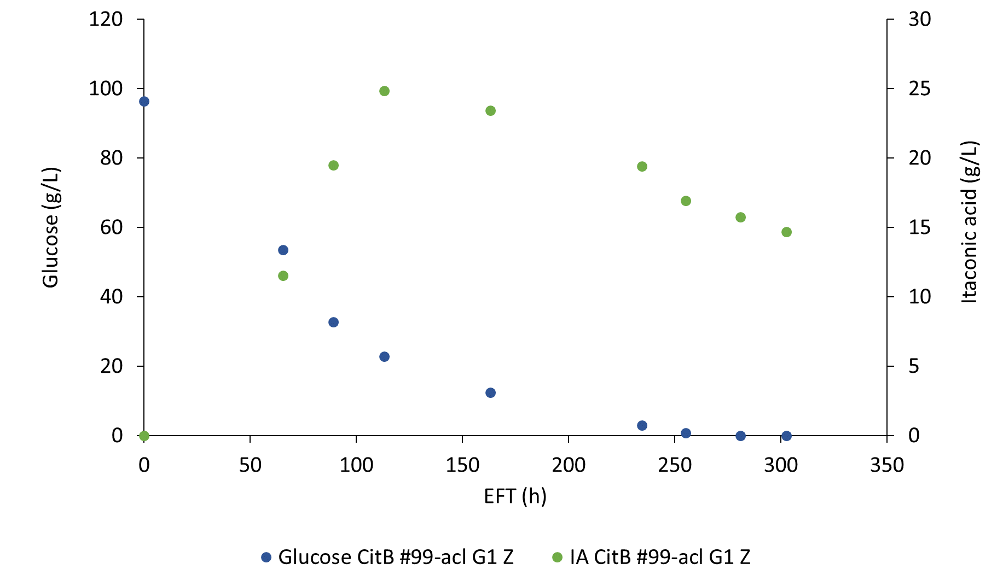

Table S1: Relative copy numbers of introduced acl12 and IA titers achieved in shake flask cultivations. Results are from a single representative experiment.
Strain of A. niger | Max. IA titer (g/L) | Southern blot results
Strain of A. niger | Max. IA titer (g/L) | (rel. gene copy no.)
Strain of A. niger | Max. IA titer (g/L) | acl1 | acl2
CitB#99 | 15.6 | 0 | 0
CitB#99-acl A9 G | 17.9 | 2 | 4
CitB#99-acl B11 G | 18.0 | 1 | 4-5
CitB#99-acl E11 Z | 18.4 | 8-10 | 10
CitB#99-acl D9 R | 18.4 | 3 | 2
CitB#99-acl G1 Z | 20.6 | 1 | 3

Figure S3: Southern-Blot results of selected CitB#99-acl transformants.

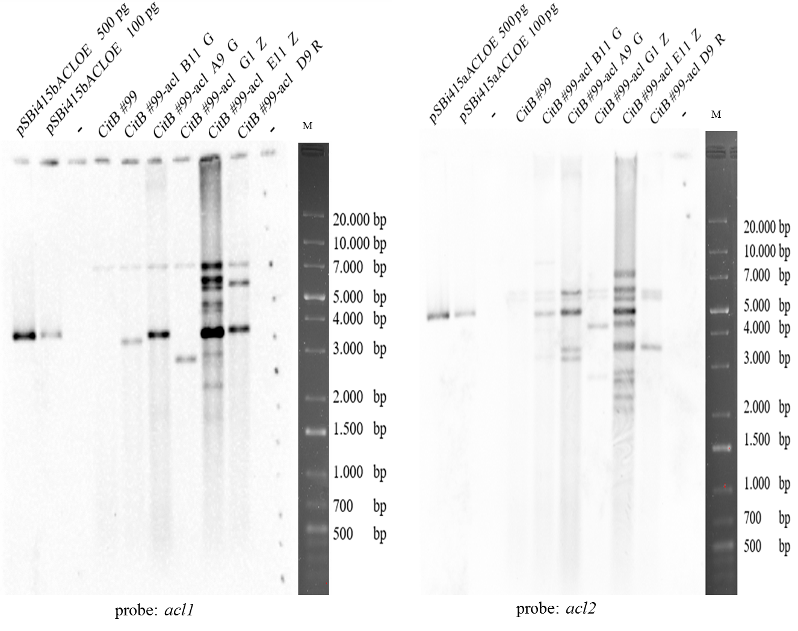
Note that the single fragment present for CitB#99 upon hybridization with the acl1 probe corresponds to a hybridization event with the native acl1 gene of A. niger and is excluded in the estimation of relative gene copy numbers for all CitB#99-acl transformants. Also note that the two fragments present for CitB#99 upon hybridization with the acl2 probe correspond to a hybridization event with the native acl2 gene of A. niger (on the lower fragment) and with the promoter region of the tef1 gene of A. niger (on the upper fragment).

Table S2: Carbon balance of 10L fed-batch bioreactor cultivation of ACL G1 Z. IA: itaconic acid; CA: citric acid.

mmol C/fermentor (percentage of the total)
Total C added | CO₂ produced | IA produced | CA produced | Biomass produced | Remaining glucose | Others
71936 (100%) | 22300 (31%) | 19209 (26,7%) | 3546 (4,9%) | 7849 (10,9%) | 6888 (9,7%) | 4848(6,7%)

Figure S4: (A) pH profile during fed-batch cultivation of strain CitB#99- ACL G1 Z. (B) Dissolved oxygen (DO) profile during fed-batch cultivation.
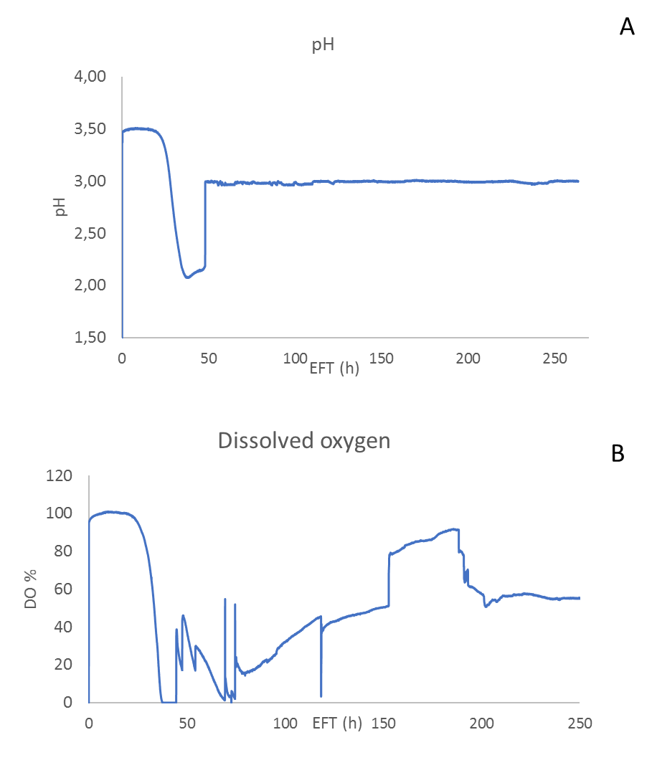

Figure S5: Total nitrogen concentration during 10L controlled fed-batch cultivation of ACL G1 Z.
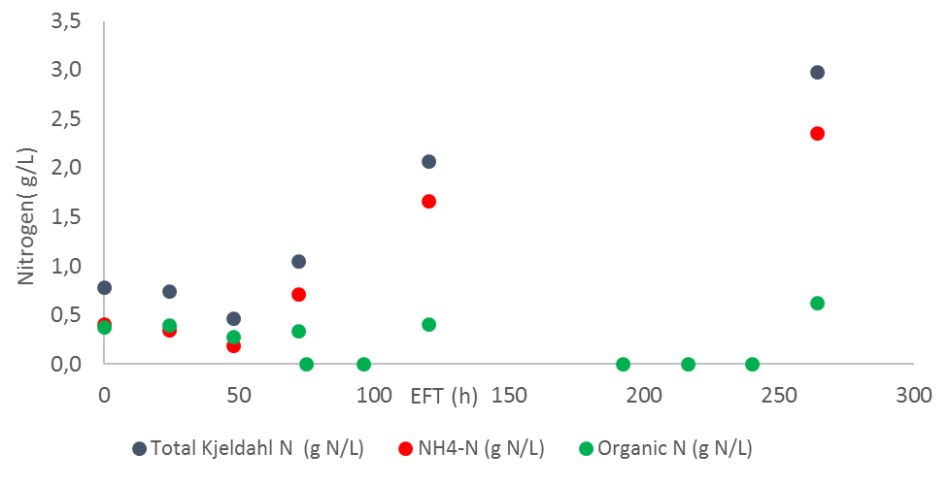

Figure S6: Repeat fed-batch cultivation of ACL G1 Z performed in 5L BioFlo 320 (Eppendorf) controlled bioreactors. (A) Glucose consumption and IA production of CitB#99 ACL G1 Z. (B) pH profile during repeat fed-batch cultivation. (C) DO profile during repeat fed-batch cultivation.

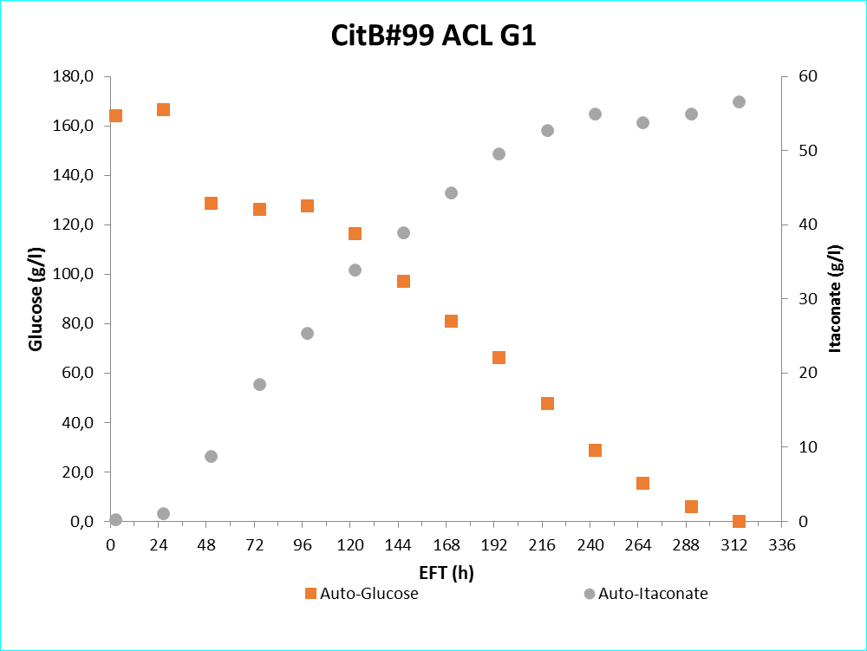
B
C

Table S3: Carbon balance of repeat fed-batch 5L bioreactor cultivation of ACL G1 Z. IA= Itaconic acid.
mmol C/fermentor (percentage of the total)
Total C added | CO₂ produced | IA produced | Biomass produced | Others
33737 (100%) | 13183 (39,1%) | 10878 (32,2%) | 4585 (13,6%) | 3965 (11,8%)

