Additional file 1:
The liquid fraction from hydrothermal pretreatment of wheat straw provides lytic polysaccharide monooxygenases with both electrons and H₂O₂ co-substrate

Table S1. PCR primers used for screening of T. reesei transformants
 | 5’ primer | 3’ primer
cbh1 5’ integration | TO95 GCTGTTCCTACAGCTCTTTC | SO3 CCAGTAGCCACCGCCAGTGC
cbh1 3’ integration | TO47 CCTATGAGTCGTTTACCCAGA | TO08 GGTTGACTTACTCCAGATCG
cbh1 ORF | T1720 CCTGACGCTATCTTCTTGTTGG | T1721  CGCGCATGTTTGTCCATCAAAC

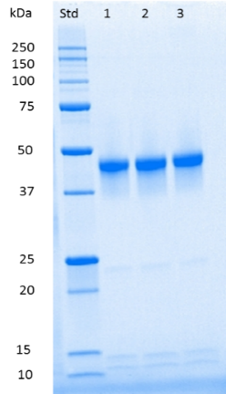

Fig. S1. SDS-PAGE analysis of purified TrLPMO9A. SDS-PAGE analysis was performed using 4-20 % Criterion Stain Free precast gel and BioRad Stain Free Imaging System (BioRad, California, USA). Purified TrLPMO9A is on lines 1-3. “Std” denotes molecular weight standard.

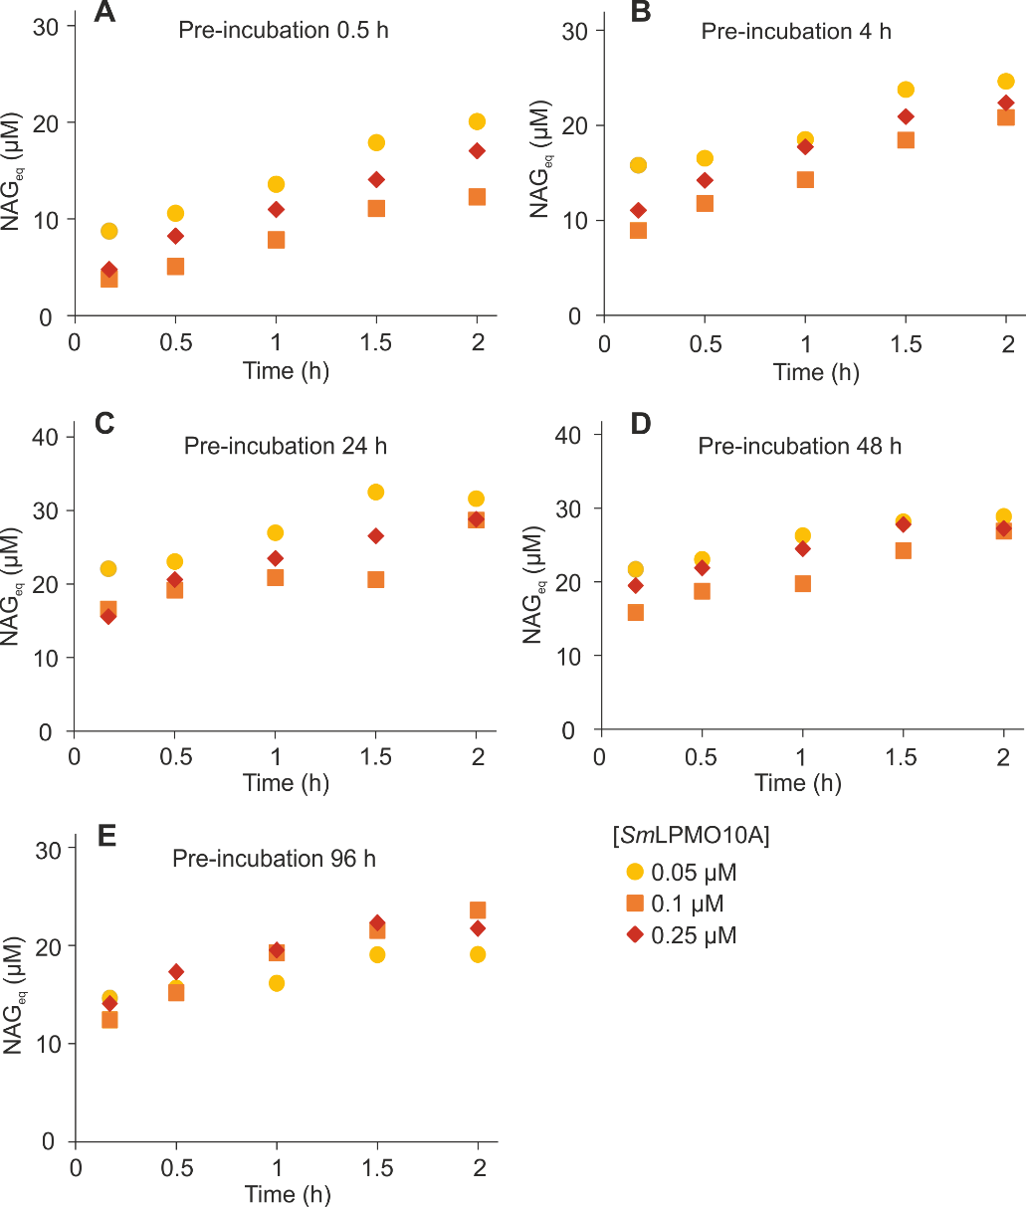
Fig. S2. Time curves of NAG_{eq} formation at different concentrations of SmLPMO10A in reactions with LF pre-incubated at 25 ºC. Reactions were made in 50 mM sodium acetate (pH 5.0) at 25 ºC. The concentration of CNWs was 1.0 g L⁻¹ and that of LF was 10% (v/v). The concentration of SmLPMO10A was 0.05 µM, 0.1 µM, or 0.25 µM (as defined in the plot). Before setting up the reactions the LF was pre-incubated at 25 ºC in aerobic conditions for (A) 0.5 h, (B) 4 h, (C) 24 h, (D) 48 h, or (E) 96 h.

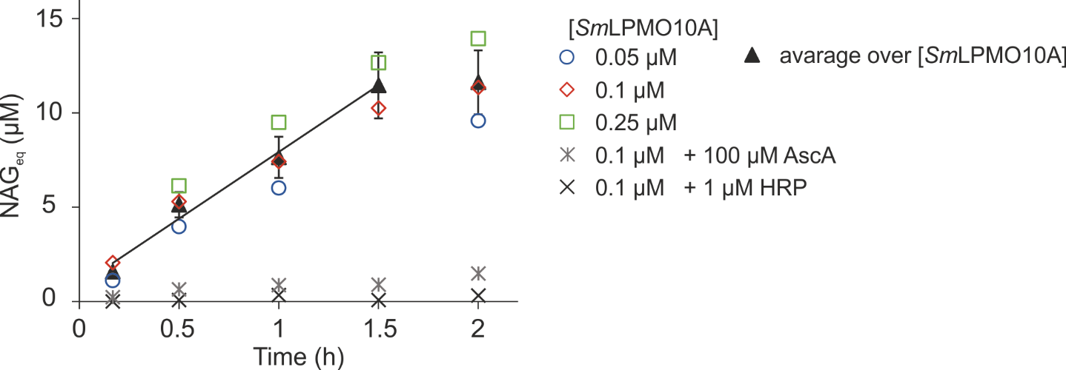
Fig. S3. Solid fraction (SF) from hydrothermal pretreatment of wheat straw supports the degradation of chitin (CNWs) by SmLPMO10A. Reactions were made in 50 mM sodium acetate (pH 5.0) at 25 ºC. The concentration of CNWs was 1.0 g L⁻¹ and that of SmLPMO10A was 0.05 µM, 0.1 µM, or 0.25 µM (as defined in the plot). The concentration of SF was 10 g L⁻¹ and before use in the LPMO experiment, the SF was pre-incubated at 25 ºC overnight. Control experiments show the results obtained with 0.1 µM SmLPMO10A but in the presence of 1 µM horseradish peroxidase. In another control experiment the concentration of SmLPMO10A was 0.1 µM but the SF was replaced with an equivalent amount (on a volume basis) of the supernatant obtained after centrifugation of the SF stock suspension. In this experiment ascorbic acid was added (to 100 µM) to ensure efficient priming reduction. Solid line represent linear regression of the data (up to the 1.5 h time point).

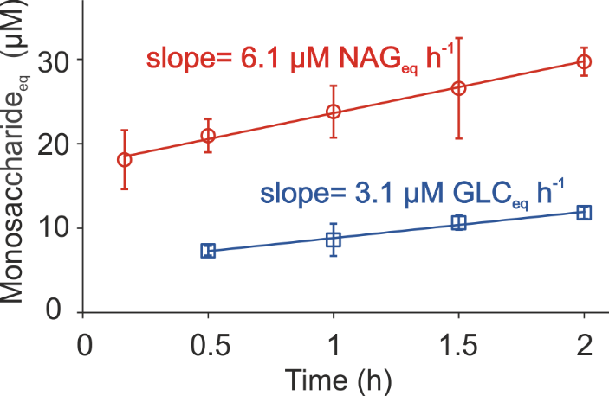
Fig. S4. Stoichiometry of the TrLPMO9A reaction at 25 ºC. Reactions were made in 50 mM sodium acetate (pH 5.0) at 25 ºC. The concentration of LF was 10% (v/v), and, before use in the LPMO reaction, the LF was pre-incubated at 25 ºC for 24 h. In the experiments with chitin (red circles), the concentration of CNWs was 1.0 g L⁻¹ and that of SmLPMO10A was 0.05 µM, 0.1 µM, or 0.25 µM. In the experiments with cellulose (blue squares), the concentration of BMCC was 0.6 g L⁻¹ and that of TrLPMO9A was 0.1 µM, 0.2 µM, or 0.5 µM. Time curves show the formation of soluble products expressed in NAG_{eq} (for the experiments with chitin) or Glc_{eq} (for the experiments with cellulose). Error bars represent S.D. and are from three independent measurements each made in single parallel but at different concentration of LPMO (product formation was essentially independent of the LPMO concentration). Solid lines show linear regression of the data. The rate of H₂O₂ formation (1.5 ± 0.2 µM h⁻¹) was calculated from the rate of the SmLPMO10A reaction (6.1 ± 0.7 µM NAG_{eq} h⁻¹) and a previously determined stoichiometry of 4 NAG_{eq}/H₂O₂ (Kuusk et al. 2018). The stoichiometry of the TrLPMO9A reaction (2.1 ± 0.3 Glc_{eq}/H₂O₂) was calculated from the rate of TrLPMO9A reaction (3.1 ± 0.3 µM NAG_{eq} h⁻¹) and the rate of H₂O₂ formation (1.5 ± 0.2 µM h⁻¹).

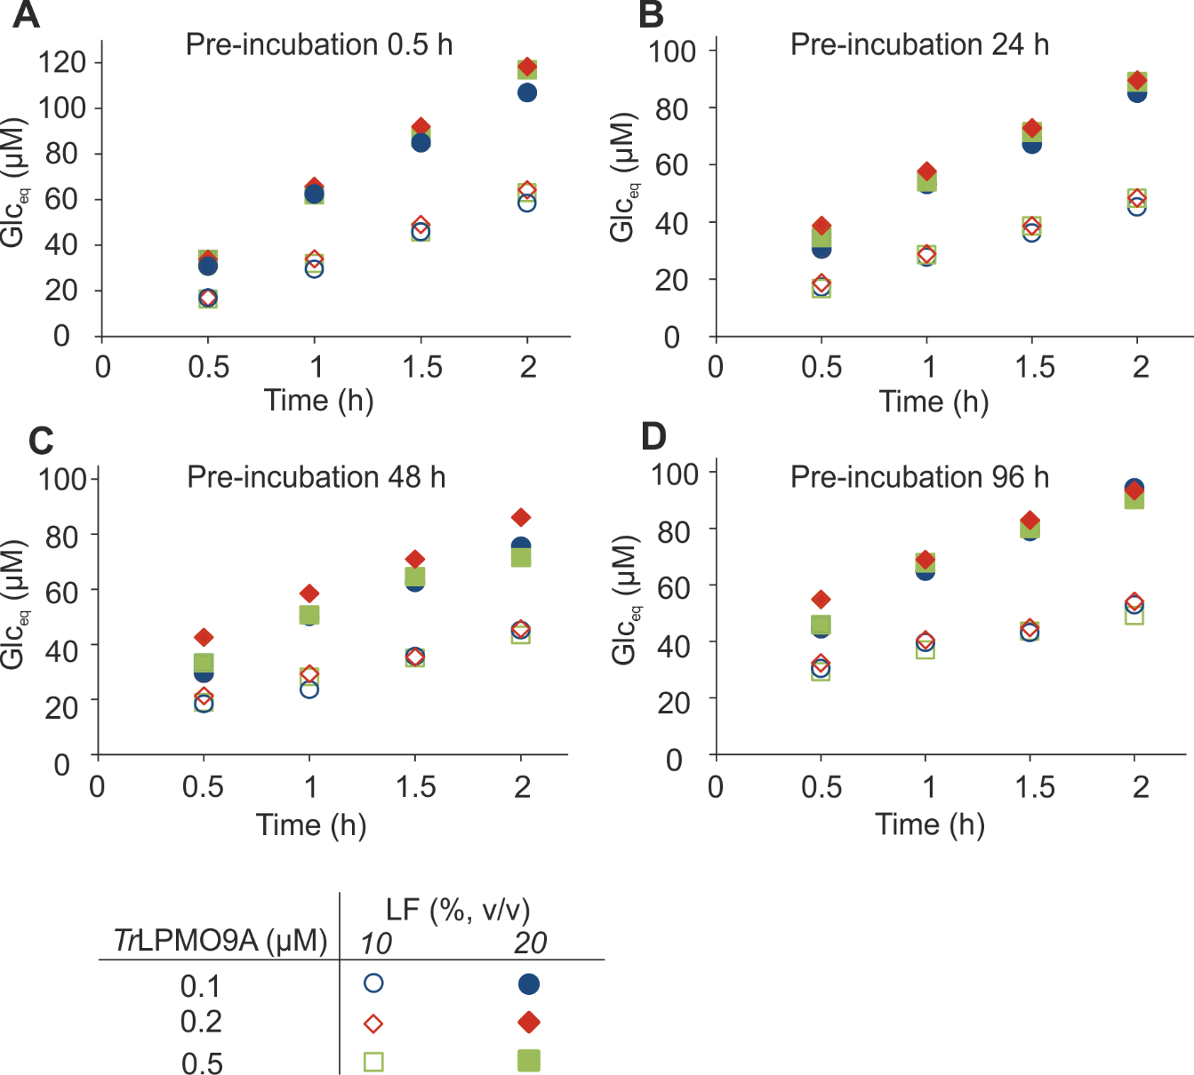
Fig. S5. Time curves of Glc_{eq} formation at different concentrations of TrLPMO9A, LF and the time period of pre-incubation of LF at 50 ºC. Reactions were made in 50 mM sodium acetate (pH 5.0) at 50 ºC. The concentration of BMCC was 0.6 g L⁻¹ and that of LF was 10% or 20% (v/v) as indicated in the plot. The concentration of TrLPMO9A was 0.1 µM, 0.2 µM, or 0.5 µM (as indicated in the plot). Before starting the TrLPMO9A reaction the LF was pre-incubated at 50 ºC in aerobic conditions for (A) 0.5 h, (B) 24 h, (C) 48 h, or (D) 96 h.

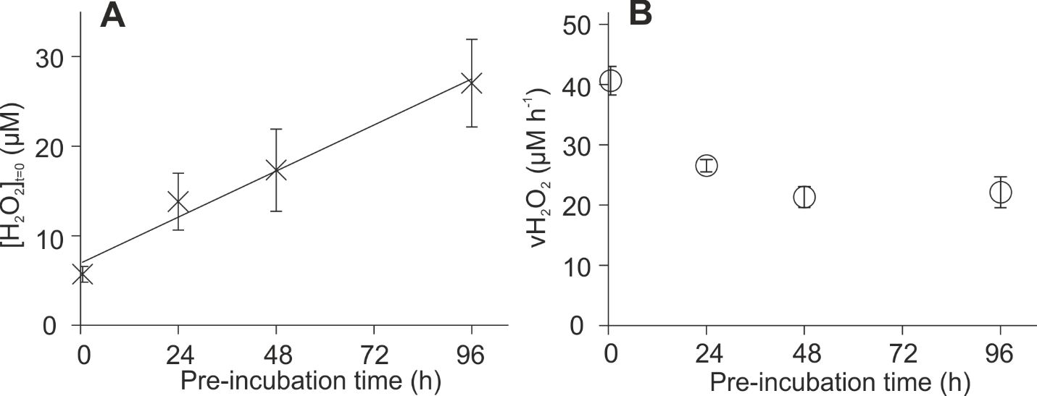

Fig. S6. Dependence of the concentration of H₂O₂ ([H₂O₂]_{t=0}), and the rate of its formation (v_{H2O2}) in the liquid fraction (LF) on the time period of pre-incubation of LF at 50 ºC. Reactions were made in 50 mM sodium acetate (pH 5.0) at 50 ºC. The concentration of BMCC was 0.6 g L⁻¹ and that of LF was 20% (v/v) (data for 10 % (v/v) LF appear in Fig. 5 of the main paper). The panels show the dependence of (A) the [H₂O₂]_{t=0} and (B) the v_{H2O2}, on the pre-incubation time of LF at 50 ºC. The values of [H₂O₂]_{t=0} and v_{H2O2} were found by fitting rates derived from Fig. S5 to Eq 2 by linear regression, using a stoichiometry (n) of 1.32 Glc_{eq}/H₂O₂. Error bars represent S.D. and are from three independent measurements each made in single parallel but at different concentration of TrLPMO9A (Fig. S5).

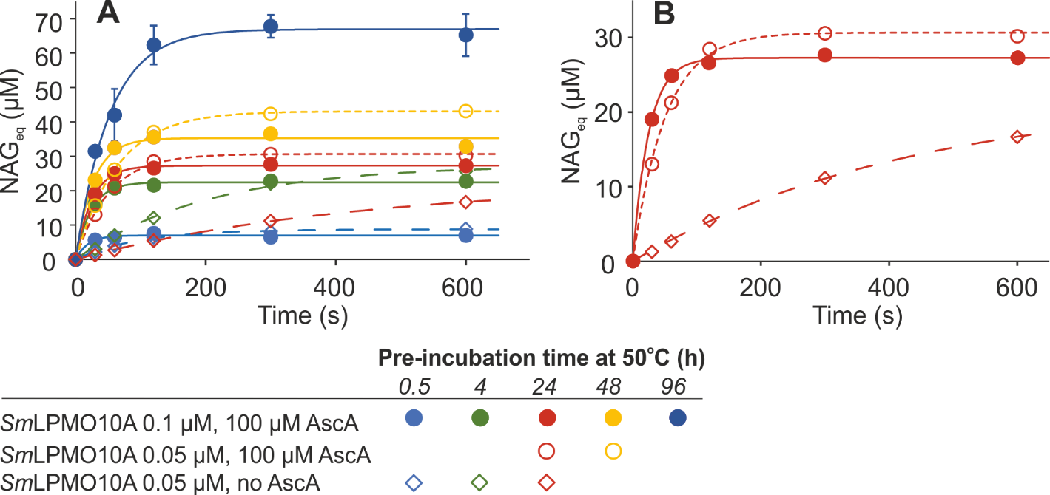
Fig. S7. Measuring of [H₂O₂]_{t=0} after different times of pre-incubation of LF at 50 ºC using SmLPMO10A. SmLPMO10A reactions were made in 50 mM sodium acetate (pH 5.0) at 25 ºC. The concentration of CNWs was 1.0 g L⁻¹ and that of LF was 10% (v/v). The concentration of SmLPMO10A was 0.05 µM or 0.1 µM. Where indicated, the reactions were supplied with 100 µM ascorbic acid to ensure efficient priming reduction. Before starting the SmLPMO10A reaction, the LF was pre-incubated at 50 ºC for the time period indicated in the plot. Solid lines show best-fits of non-linear regression analysis according to Eq 3. The values of [H₂O₂]_{t=0} were found from the n[H₂O₂]_{t=0} values obtained from the non-linear regression analysis using the value of n = 4 NAG_{eq}/H₂O₂. Panel A shows all time curves. For clarity, the data obtained with LF that was pre-incubated for 24 h are also shown in panel B. Two conclusions can be drawn from the data in panel B. (i) The efficiency of the priming reduction decreases with pre-incubation of LF at 50 ºC as evidenced by the slower reaction in the absence of added ascorbic acid (see Kuusk et al 2019). (ii) Increasing the SmLPMO10A concentration increases the initial rate of NAG_{eq} formation.

Additional references
Kuusk S, Bissaro B, Kuusk P, Forsberg Z, Eijsink VGH, Sørlie M, Väljamäe P. Kinetics of H₂O₂-driven degradation of chitin by a bacterial lytic polysaccharide monooxygenase. J. Biol. Chem. 2018;293:523-31.
S. Kuusk, R. Kont, P. Kuusk, A. Heering, M. Sørlie, B. Bissaro, V. G. H. Eijsink and P. Väljamäe, J. Biol. Chem., 2019, 294, 1516-1528.

