Additional file 1 (supporting results)
Sulfide level in municipal sludge digesters affects microbial community response to long-chain fatty acid loads
Sepehr Shakeri Yekta^{1,*}, Tong Liu², Mette Axelsson Bjerg¹, Luka Šafarič¹, Anna Karlsson³, Annika Björn¹, Anna Schnürer^{1,2}
¹Department of Thematic Studies-Environmental Change and Biogas Research Center, Linköping University, 581 83 Linköping, Sweden
²Department of Molecular Sciences, Swedish University of Agricultural Sciences, Uppsala BioCenter, 75007 Uppsala, Sweden
³Scandinavian Biogas Fuels AB, Stockholm, Sweden.
*Correspondence: sepehr.shakeri.yekta@liu.se; Tel.: +46-13-282-294

Table S1 First-order Hill’s diversity (¹D) and evenness (¹E) of the bacterial community in samples collected in different operational phases of digesters F1-F6 (n=3, mean ± standard deviation)
 |  |  | Bacteria
Day | F1-¹D | F2-¹D | F3-¹D | F4-¹D | F5-¹D | F6-¹D
0 | 77±14 | 70±3.4 | 65±2.6 | 78±5.4 | 72±15 | 66±7.0
72 | 25±4.2 | 24±1.6 | 24±2.8 | 26±4.0 | 26±2.6 | 27±4.5
100 | 23±2.3 | 25±0.5 | 24±2.1 | 21±2.5 | 21±4.2 | 23±4.0
128 | 23±1.4 | 26±0.5 | 20±2.3 | 25±9.5 | 18±2.8 | 27±6.8
163 | 24±0.5 | 20±0.1 | 26±4.3 | 15±1.2 | 15±2.3 | 16±1.2
177 | 23±0.6 | 21±1.7 | 22±0.4 | 17±1.9 | 16±1.1 | 20±1.8
205 | 27±5.1 | 34±4.8 | 34±5.1 | 16±1.4 | 23±1.5 | 12±1.5
218 | 28±0.9 | 47±5.2 | 32±1.9 | 50±3.3 | 17±3.2 | 19±3.6
225 | 18±0.6 | 47±3.8 | 30±1.2 | 43±1.6 | 13±2.6 | 8±0.2
233 | 21±3.4 | 46±8.2 | 25±4.4 | 45±0.3 | 14±2.6 | 12±1.4
254 | 24±3.2 | 35±1.5 | 29±1.4 | 41±1.6 | 19±3.3 | 11±1.7
261 | 25±0.5 | 35±1.4 | 30±3.8 | 42±0.9 | 16±0.9 | 11±1.1
278 | 28±0.9 | 33±10 | 34±3.6 | 63±3.2 | 20±1.6 | 12±0.3
Day | F1-¹E | F2-¹E | F3-¹E | F4-¹E | F5-1E | F6-¹E
0 | 0.37±0.06 | 0.37±0.02 | 0.37±0.01 | 0.40±0.01 | 0.41±0.01 | 0.37±0.03
72 | 0.18±0.01 | 0.17±0.01 | 0.15±0.01 | 0.15±0.01 | 0.15±0.01 | 0.15±0.00
100 | 0.15±0.02 | 0.17±0.02 | 0.18±0.02 | 0.14±0.03 | 0.14±0.01 | 0.13±0.01
128 | 0.14±0.01 | 0.17±0.00 | 0.18±0.02 | 0.13±0.01 | 0.12±0.00 | 0.14±0.01
163 | 0.13±0.01 | 0.11±0.01 | 0.14±0.00 | 0.09±0.01 | 0.09±0.00 | 0.09±0.01
177 | 0.13±0.01 | 0.16±0.01 | 0.17±0.01 | 0.11±0.01 | 0.11±0.02 | 0.11±0.01
205 | 0.18±0.01 | 0.20±0.02 | 0.15±0.01 | 0.07±0.01 | 0.10±0.01 | 0.11±0.00
218 | 0.13±0.01 | 0.27±0.01 | 0.17±0.01 | 0.28±0.00 | 0.09±0.01 | 0.11±0.01
225 | 0.14±0.01 | 0.24±0.01 | 0.18±0.03 | 0.29±0.02 | 0.08±0.00 | 0.08±0.00
233 | 0.13±0.00 | 0.23±0.02 | 0.17±0.01 | 0.33±0.03 | 0.08±0.01 | 0.07±0.00
254 | 0.14±0.03 | 0.25±0.02 | 0.22±0.02 | 0.29±0.02 | 0.12±0.02 | 0.06±0.01
261 | 0.21±0.02 | 0.23±0.04 | 0.20±0.02 | 0.31±0.02 | 0.13±0.01 | 0.08±0.00
278 | 0.24±0.03 | 0.30±0.02 | 0.25±0.01 | 0.47±0.02 | 0.16±0.01 | 0.12±0.01

Table S2 Indicator bacteria^{a)} in five clusters of samples, distinguished based on relative ASV read counts and frequency of occurrence
Cluster 1 | Cluster 2 | Cluster 3 | Cluster 4 | Cluster 5
Taxonomic level | Taxonomic level | Taxonomic level | Taxonomic level | Taxonomic level
r value | r value | r value | r value | r value
Aegiribacteria | Saccharofermentans | LNR_A2.18 | Sporanaerobacter | W27
P | G | G | G | F
0.80 | 0.42 | 0.63 | 1.0 | 0.64
Family XIII | Spirochaetaceae | Oligosphaera | Lactobacillus | Lentimicrobiaceae
F | F | G | G | F
0.64 | 0.39 | 0.57 | 0.93 | 0.61
W5 | Syntrophorhabdus | Ruminiclostridium | Syntrophomonas | Candidatus Cloacimonas
G | G | G | G | G
0.58 | 0.36 | 0.54 | 0.93 | 0.51
Gracilibacter | Syntrophaceae | Marinimicrobia SAR406 clade | Ruminococcaceae NK4A214 group | Sphingobacteriales
F | F | P | G | O
0.52 | 0.34 | 0.52 | 0.86 | 0.48
M2PB4 65 termite group | Gracilibacter | Prolixibacteraceae | dgA.11 gut group | Smithella
F | F | F | G | G
0.51 | 0.32 | 0.52 | 0.85 | 0.48
Sedimentibacter | Armatimonadetes | p-251-o5 | Proteiniphilum | SBR1031
G | P | F | G | O
0.47 | 0.29 | 0.51 | 0.83 | 0.43
Peptoclostridium | Candidatus Caldatribacterium | GZKB124 | Fastidiosipila | Chloroflexi
G | G | F | G | P
0.41 | 0.29 | 0.51 | 0.82 | 0.42
Prolixibacteraceae | Leptolinea | Anaerosporobacter | Tetrasphaera | ADurb.Bin063.1
F | G | G | G | G
0.36 | 0.26 | 0.46 | 0.82 | 0.40
DMER64 | WCHB1.41 | Z20 | Syner 01 | Bellilinea
G | O | G | G | G
0.35 | 0.23 | 0.44 | 0.8 | 0.35
Saccharofermentans | p-251-o5 | GWE2-42-42 | Herbinix | Spirochaetaceae
G | F | G | G | F
0.33 | 0.21 | 0.41 | 0.78 | 0.35
a) The 10 bacteria with the highest degree of significant association to each cluster are presented. When genus (G) name could not be assigned to the sequences, the closest classified taxonomic level is listed: Phylum (P), Order (O), Family (F). The indicator values, r, for the assigned taxa represent the degree of association to each cluster (max = 1). Samples associated to each cluster, digester name (sampling day):
- Cluster 1: F1 (72-233), F2 (72-205), F3 (72-233), F4 (72-100), F5 (72-100), F6 (72-100)
- Cluster 2: F1-F6 (inoculum)
- Cluster 3: F4 (128-205), F5 (128-233), F6 (128-278).
- Cluster 4: F4 (218-275)
- Cluster 5: F1 (254-278), F2 (218-278), F3 (254-278), F5 (254-278).

Table S3 First-order Hill’s diversity (¹D) and evenness (¹E) of the archaeal community in samples collected at different operational phases of digesters F1-F6 (n=3, mean ± standard deviation)
 |  |  | Archaea
Day | F1-¹D | F2-¹D | F3-¹D | F4-¹D | F5-¹D | F6-¹D
0 | 7.7±0.4 | 7.6±0.2 | 7.2±0.4 | 7.4±0.4 | 7.3±0.1 | 7.2±0.1
72 | 4.0±0.2 | 4.1±0.1 | 3.9±0.1 | 4.1±0.1 | 3.9±0.1 | 3.8±0.1
100 | 4.0±0.2 | 4.5±0.3 | 4.5±0.1 | 5.2±0.2 | 5.3±0.3 | 4.8±0.3
128 | 4.3±0.3 | 4.1±0.2 | 4.3±0.1 | 5.2±0.2 | 5.6±0.1 | 5.6±0.1
163 | 3.6±0.1 | 3.6±0.1 | 3.7±0.3 | 5.3±0.1 | 5.2±0.0 | 5.3±0.1
177 | 3.8±0.3 | 4.0±0.0 | 4.0±0.1 | 5.3±0.2 | 5.2±0.2 | 5.4±0.2
205 | 3.4±0.1 | 4.0±0.2 | 3.4±0.0 | 4.1±0.1 | 4.2±0.2 | 4.9±0.3
218 | 3.8±0.1 | 4.1±0.1 | 3.8±0.1 | 4.1±0.1 | 5.0±0.1 | 4.6±0.2
225 | 2.9±0.2 | 4.0±0.2 | 3.9±0.2 | 4.8±0.3 | 4.7±0.1 | 4.0±0.2
233 | 3.3±0.1 | 4.1±0.0 | 3.3±0.1 | 4.5±0.5 | 3.7±0.1 | 4.4±0.1
254 | 3.2±0.1 | 3.4±0.1 | 3.2±0.0 | 4.6±0.1 | 3.2±0.2 | 4.1±0.3
261 | 2.6±0.1 | 3.7±0.0 | 3.1±0.1 | 2.6±0.2 | 2.6±0.3 | 3.2±0.1
278 | 2.6±0.2 | 3.6±0.2 | 3.1±0.1 | 2.8±0.2 | 2.7±0.0 | 3.5±0.2
Day | F1-¹E | F2-¹E | F3-¹E | F4-¹E | F5-1E | F6-¹E
0 | 0.49±0.08 | 0.51±0.03 | 0.49±0.05 | 0.55±0.08 | 0.53±0.04 | 0.50±0.05
72 | 0.31±0.04 | 0.29±0.03 | 0.25±0.00 | 0.26±0.02 | 0.25±0.02 | 0.26±0.01
100 | 0.28±0.00 | 0.29±0.03 | 0.31±0.02 | 0.39±0.00 | 0.39±0.05 | 0.35±0.01
128 | 0.29±0.02 | 0.33±0.05 | 0.35±0.02 | 0.36±0.03 | 0.41±0.01 | 0.41±0.01
163 | 0.28±0.02 | 0.26±0.04 | 0.29±0.02 | 0.36±0.01 | 0.37±0.06 | 0.34±0.04
177 | 0.31±0.02 | 0.35±0.02 | 0.39±0.03 | 0.36±0.02 | 0.36±0.00 | 0.38±0.04
205 | 0.26±0.03 | 0.40±0.02 | 0.23±0.02 | 0.24±0.02 | 0.26±0.01 | 0.31±0.02
218 | 0.24±0.01 | 0.38±0.04 | 0.32±0.04 | 0.31±0.03 | 0.33±0.01 | 0.29±0.02
225 | 0.26±0.01 | 0.33±0.02 | 0.34±0.02 | 0.39±0.07 | 0.34±0.02 | 0.25±0.01
233 | 0.28±0.01 | 0.40±0.06 | 0.36±0.09 | 0.34±0.04 | 0.26±0.02 | 0.28±0.03
254 | 0.24±0.01 | 0.39±0.08 | 0.34±0.04 | 0.44±0.03 | 0.26±0.03 | 0.26±0.00
261 | 0.28±0.03 | 0.37±0.04 | 0.40±0.09 | 0.25±0.05 | 0.27±0.05 | 0.25±0.02
278 | 0.31±0.02 | 0.44±0.03 | 0.39±0.09 | 0.26±0.01 | 0.34±0.04 | 0.29±0.03

Table S4 Indicator archaea in six clusters of samples, distinguished based on relative ASV read counts and frequency of occurrence
^{a)}Cluster number | 1 | 2 | 3 | 4 | 5 | 6
^{a)}Cluster number | r
Candidatus Methanofastidiosum | 0.30 | 0.24 | 0.20 | 0.10 |  | 0.15
Candidatus Methanomethylicus |  |  |  | 1.0
Candidatus Nitrocosmicus |  |  |  | 0.09
Methanobacterium | 0.15 | 0.10 | 0.10 |  | 0.20 | 0.41
Methanobrevibacter | 0.08 | 0.12 | 0.09 | 0.26 | 0.35 | 0.05
Methanocorpusculum | 0.15 | 0.29 | 0.45
Methanoculleus | 0.07 |  | 0.08 |  | 0.57 | 0.06
Methanolinea |  |  | 0.09 | 0.79
Methanomassiliicoccus | 0.09 | 0.16 | 0.14 | 0.52
Methanomethylovorans | 0.15 | 0.06 | 0.12
Methanosaeta | 0.13 | 0.22 | 0.15 | 0.28 | 0.09 | 0.13
Methanosarcina |  |  |  |  | 0.97
Methanosphaera |  | 0.14 |  |  | 0.25
Methanospirillum |  | 0.07 |  | 0.27 | 0.28 | 0.24
RumEn M2 | 0.07 |  |  |  | 0.62 | 0.05
Methanomassiliicoccaceae | 0.20 | 0.11 | 0.37 | 0.21
Iainarchaeales | 0.06 | 0.10 | 0.05
Methanomicrobiales | 0.18 | 0.19 | 0.17 |  | 0.11 | 0.29
Bathyarchaeia | 0.36 | 0.07 | 0.26 | 0.17 |  | 0.07
Odinarchaeia |  |  |  | 0.89
Woesearchaeia | 0.05 | 0.08 | 0.43 | 0.43
a) The indicator values, r, for the assigned taxa represent the degree of association to each cluster (max = 1). Samples associated to each cluster, digester name (sampling day):
- Cluster 1: F1 (205-278), F3 (205-218), F4 (205), F5 (205-218), F6 (218), F6 (225-278).
- Cluster 2: F1 (72-100, 163-177), F2 (72, 163-233), F3 (72-177), F4 (72, 218), F5 (72), F6 (72).
- Cluster 3: F1 (128), F2 (100-128), F4 (100 -177), F5 (100-177), F6 (100-205).
- Cluster 4: F1-F6 (inoculum)
- Cluster 5: F4 (254-278).
- Cluster 6: F2 (233-278), F3 (225-278), F4 (225), F4 (233), F5 (225-278).

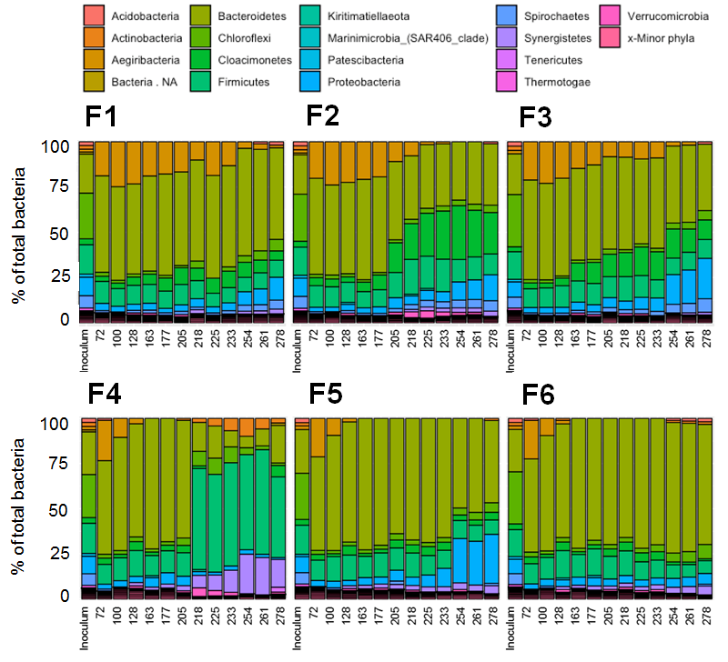
Fig. S1 Relative abundances of 16S rRNA genes of bacterial phyla based on the average ASV reads from triplicate samples collected at different days from digesters F1, F2, F3, F4, F5, and F6 digesters. NA stands for not assigned.

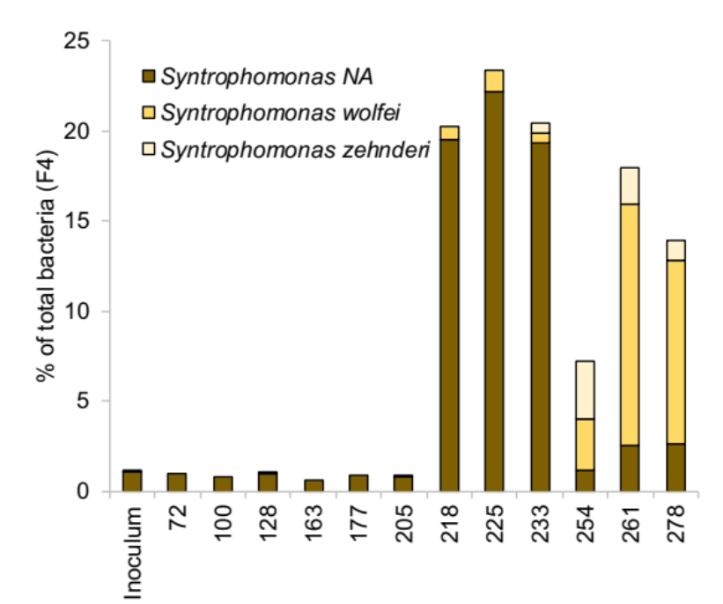
Fig. S2 Relative abundances of 16S rRNA genes assigned to unidentified species of the genus Syntrophomonas (NA) and the species S. wolfei and S. zehnderi based on the average ASV reads from triplicate samples collected at different days from digester F4. Basic local alignment search for the unidentified members of Syntrophomonas gene sequences revealed 99.6% sequence similarity to Syntrophomonas sapovorans (strain OM).

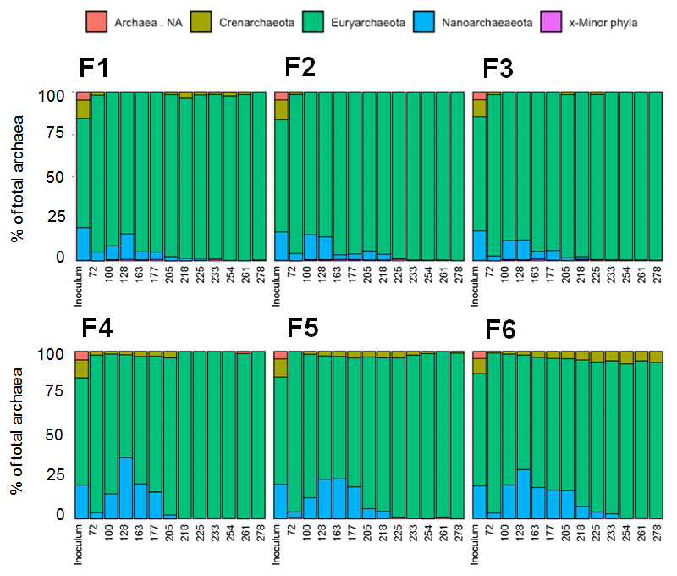
Fig. S3 Relative abundances of 16S rRNA genes of archaeal phyla based on the average ASV reads from triplicate samples collected at different days from digesters F1, F2, F3, F4, F5, and F6 digesters. NA stands for not assigned.

