Additional file 2

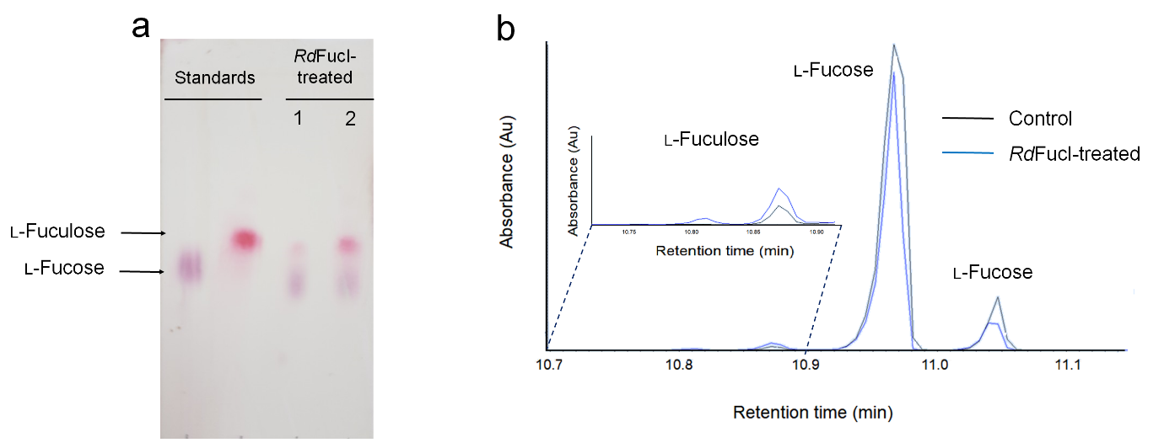

Fig. S2 TLC and GC/MS analyses for the identification of products synthesized by RdFucI. (a) TLC analysis for the identification of products from forward reaction (Lane 1: l-fucose to l-fuculose) and from reverse reaction (Lane 2: l-fuculose to l-fucose). (b) GC/MS analysis for the identification of l-fuculose synthesized from l-fucose by RdFucI. The inset is the expanded chromatogram for l-fuculose peak

