Additional file

Genome Shuffling Enhances Stress Tolerance of
Zymomonas mobilis to Two-Inhibitors

Weiting Wang^{1, 2†}, Bo Wu^{1†}, Han Qin¹, Panting Liu^{1, 2}, Yao Qin^{1, 3} ,
Guowei Duan^{1, 2}, Guoquan Hu^{1, 2} and Mingxiong He^{1, 2}*

¹ Biomass Energy Technology Research Centre, Key Laboratory of Development and Application of Rural Renewable Energy (Ministry of Agriculture and Rural Affairs), Biogas Institute of Ministry of Agriculture and Rural Affairs, Section 4-13, Renmin Rd. South, Chengdu 610041, P. R. China.
² Graduate School of Chinese Academy of Agricultural Science, Beijing 100081, P. R. China.
³ College of Pharmacy and Biological Engineering, Chengdu University, Chengdu 610041, P. R. China.

†These authors contributed equally to this work.

*Corresponding author (Fax: +86-28-85242281; E-mail: hemingxiong@caas.cn; hemxion@hotmail.com)
Additional Table S1 Result of range analysis of orthogonal experiments.

No. | Orthogonal Design |  |  | Fusion rate
No. | A(field density(V/cm)) | B(time/us) | C(number) | Fusion rate
1 | 1 | 1 | 1 | 0.003
2 | 2 | 1 | 2 | 0.163
3 | 3 | 1 | 3 | 0.052
4 | 1 | 2 | 2 | 0.003
5 | 2 | 2 | 3 | 0.239
6 | 3 | 2 | 1 | 0.001
7 | 1 | 3 | 3 | 0.004
8 | 2 | 3 | 1 | 0.003
9 | 3 | 3 | 2 | 0.002
K1 | 0.003 | 0.0727 | 0.002
K2 | 0.135 | 0.081 | 0.056
K3 | 0.0183 | 0.003 | 0.098
R | 0.132 | 0.078 | 0.096
The best levels | A2 | B2 | C3
Order | A>C>B
Additional Figure S1
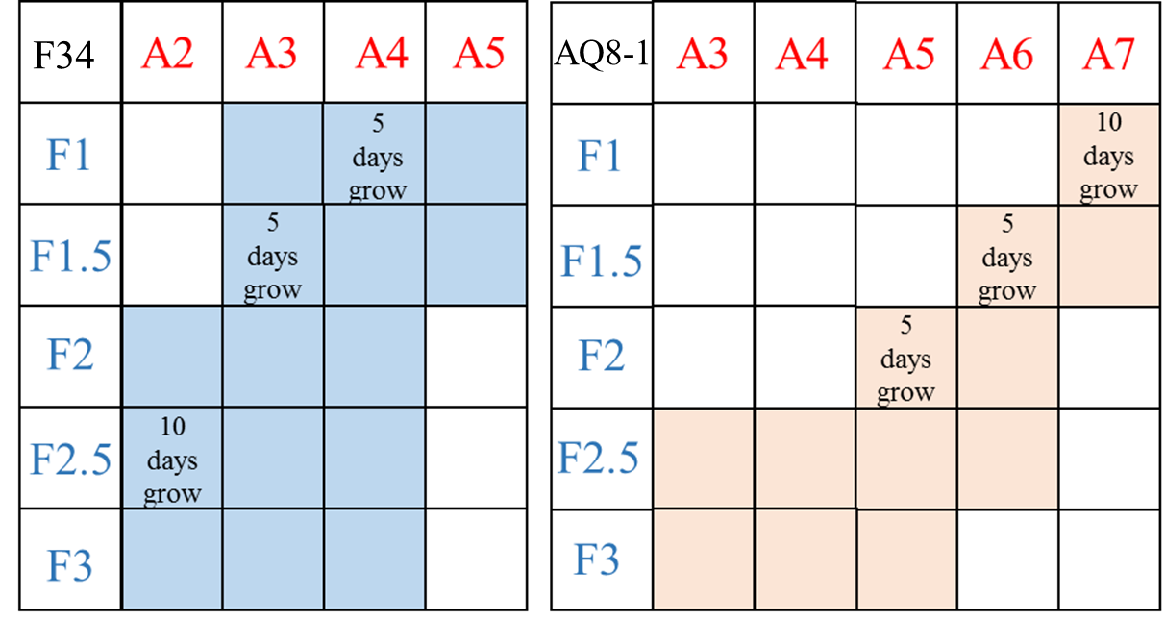
Parental strains AQ8-1 and F34 resistant to acetic acid and furfural.
Red area indicates the test combination of AQ8-1; Blue area indicates the test combination of F34.
(“An” indicates n g/L acetic acid, “Fn” indicates n g/L furfural)

