Additional file 1

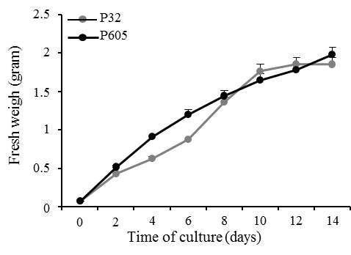

Fig. S1. Dissimilation growth curve of P32 and P605 cell suspension cultures.
Growth characteristics of P32 (gray circles graph) and P605 (black circles graph) cell suspension cultures as evaluated by loss weigh by dissimilation (LWD) over time of the culture. Experiments were done in triplicate. Error bars represent the mean ± standard error (SE).

