Additional file 6
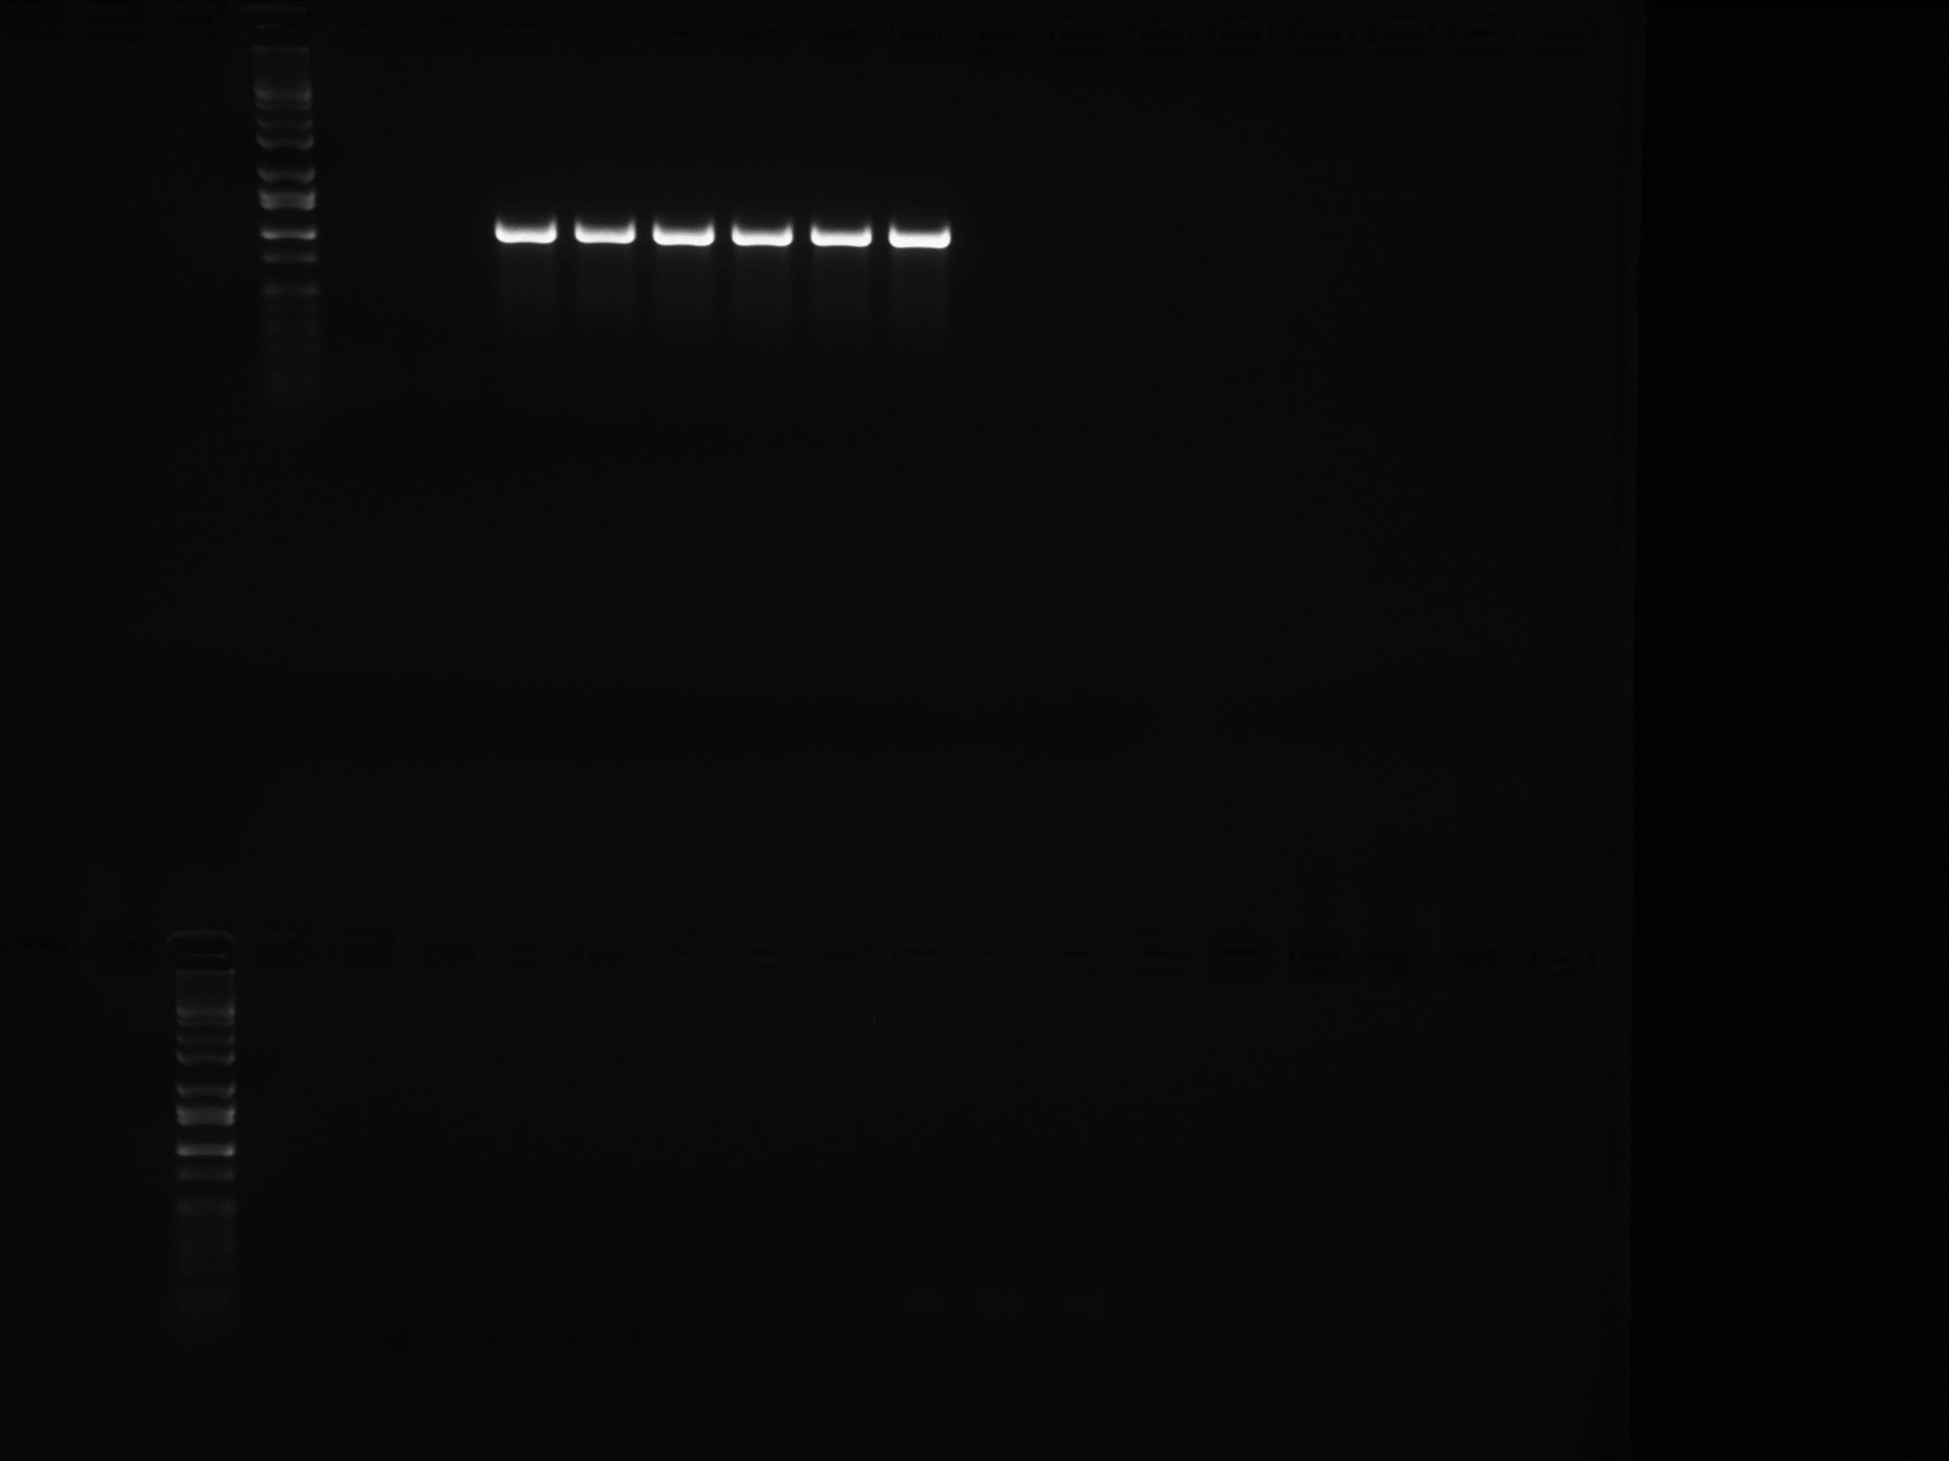
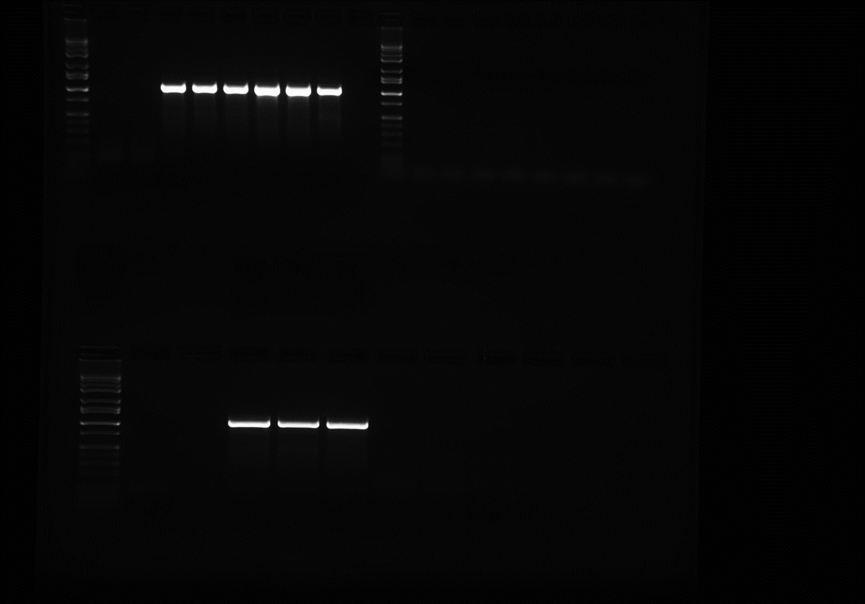
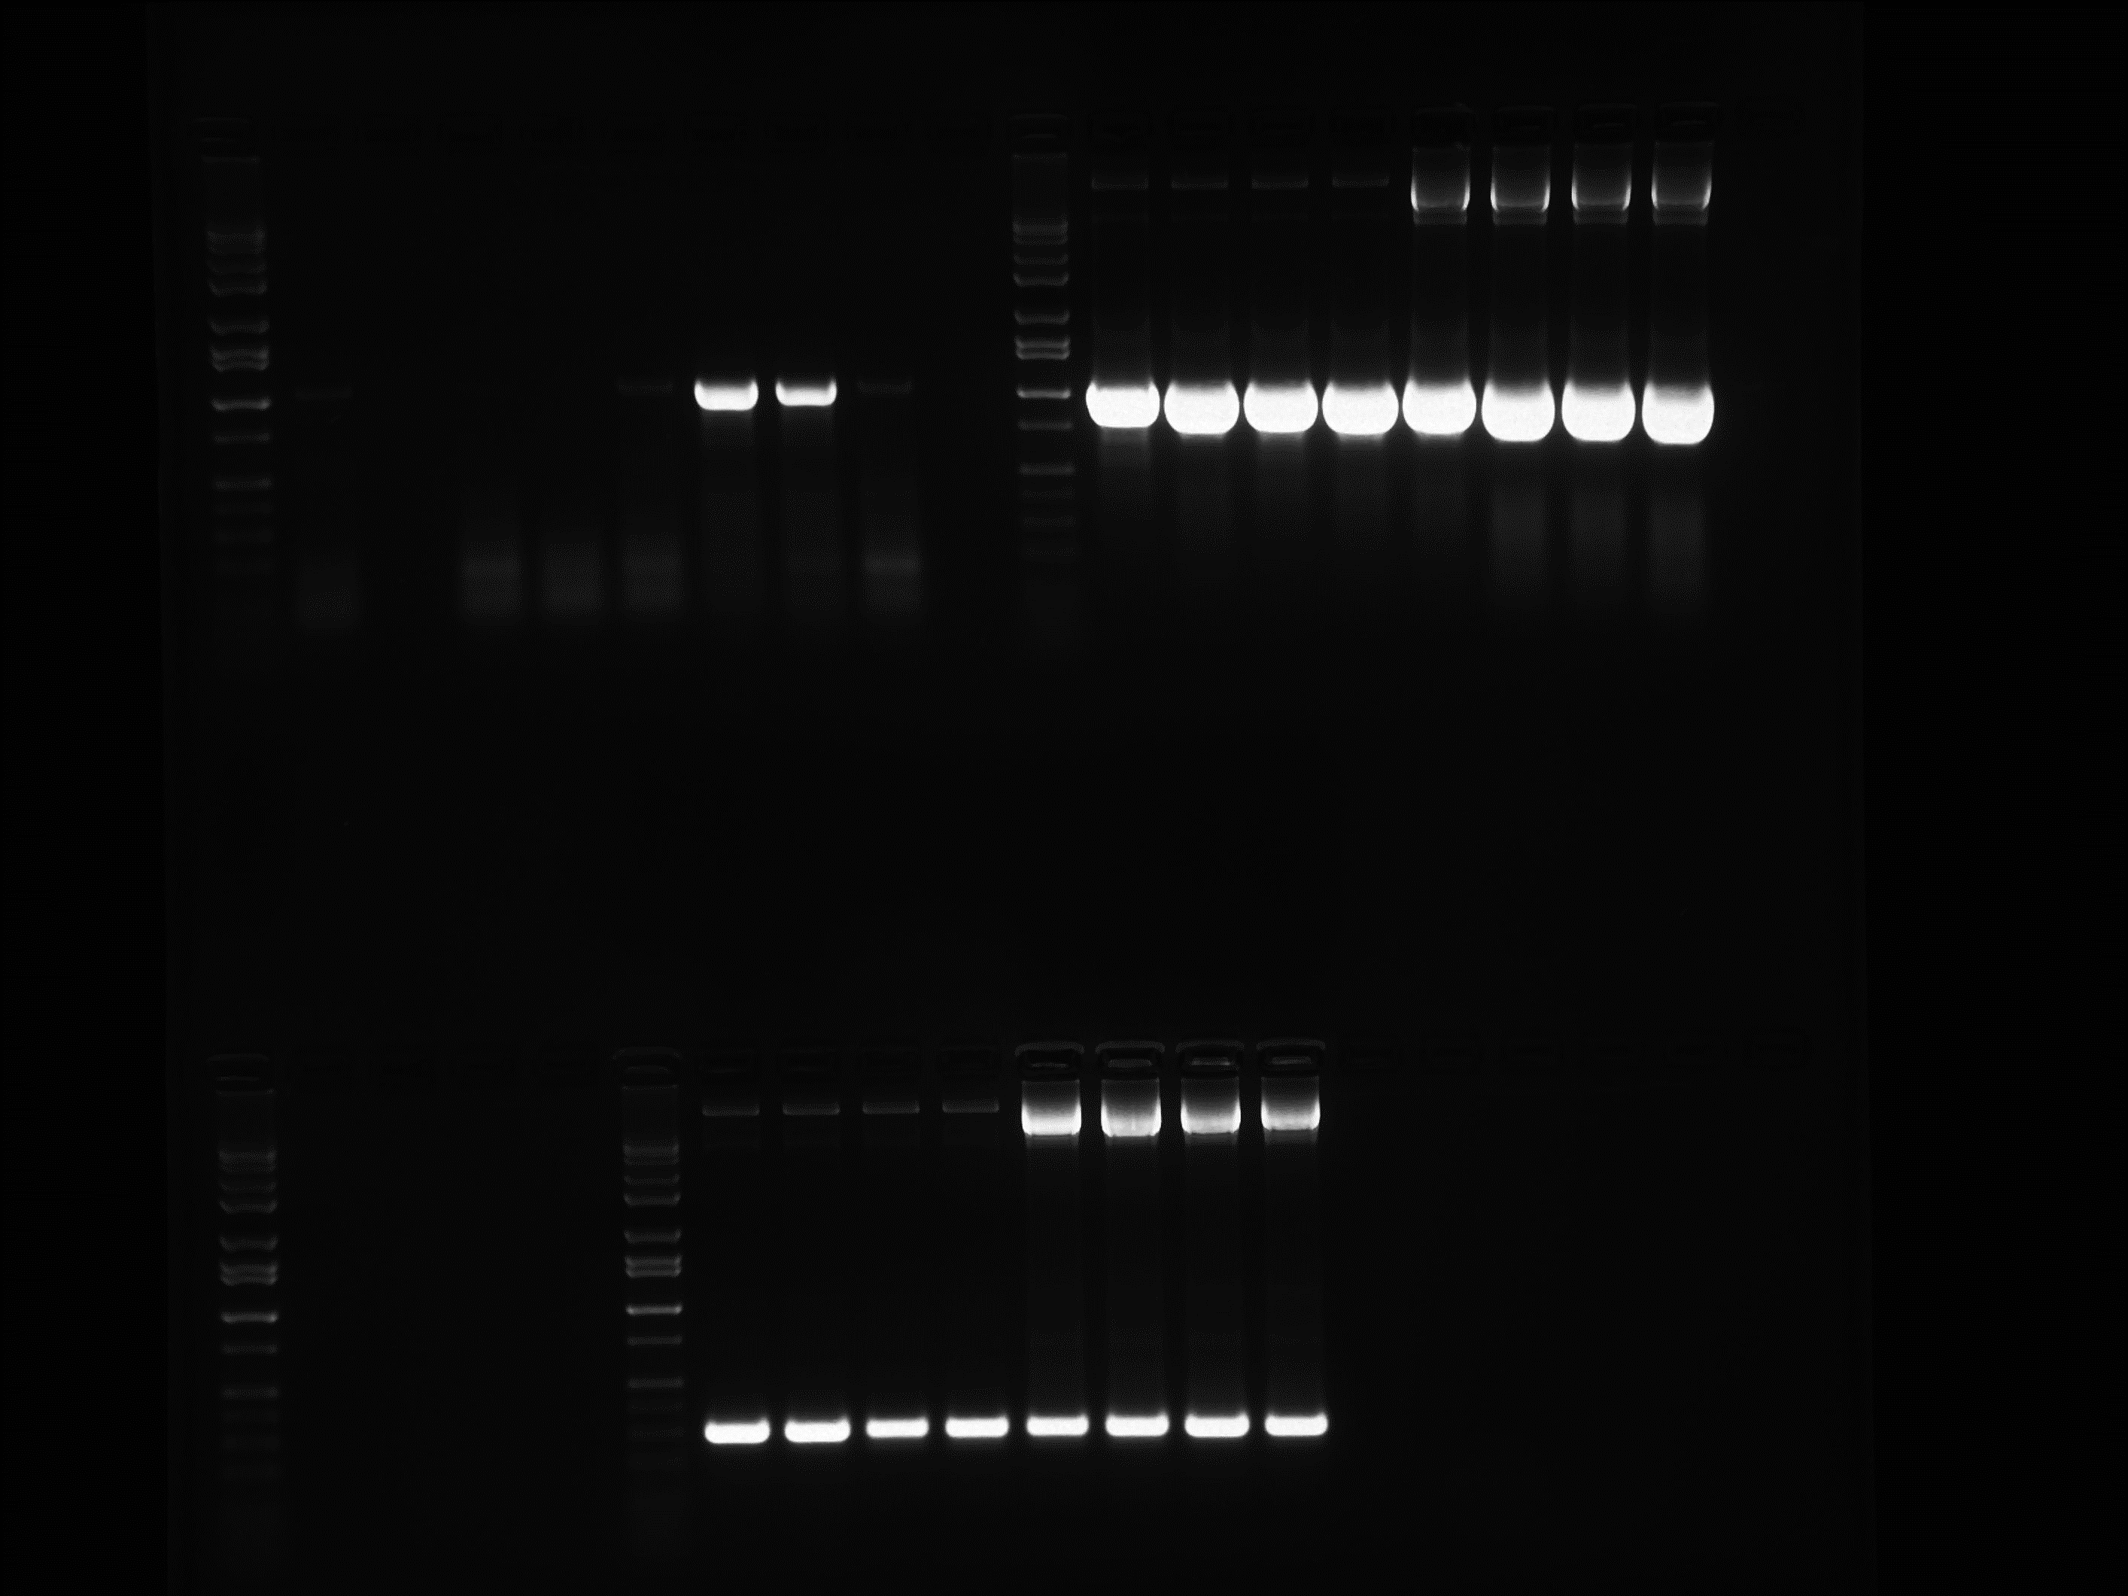
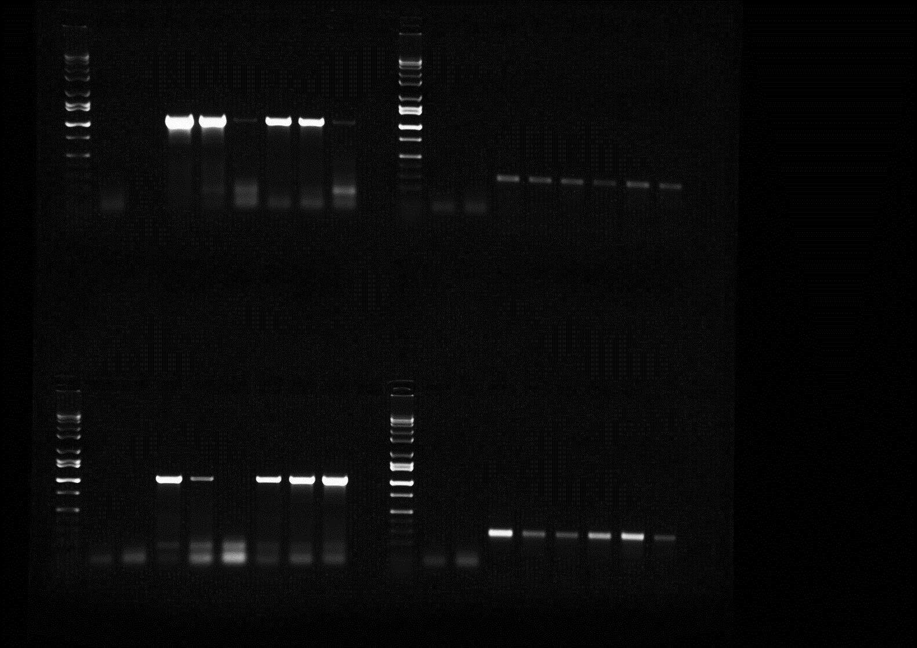
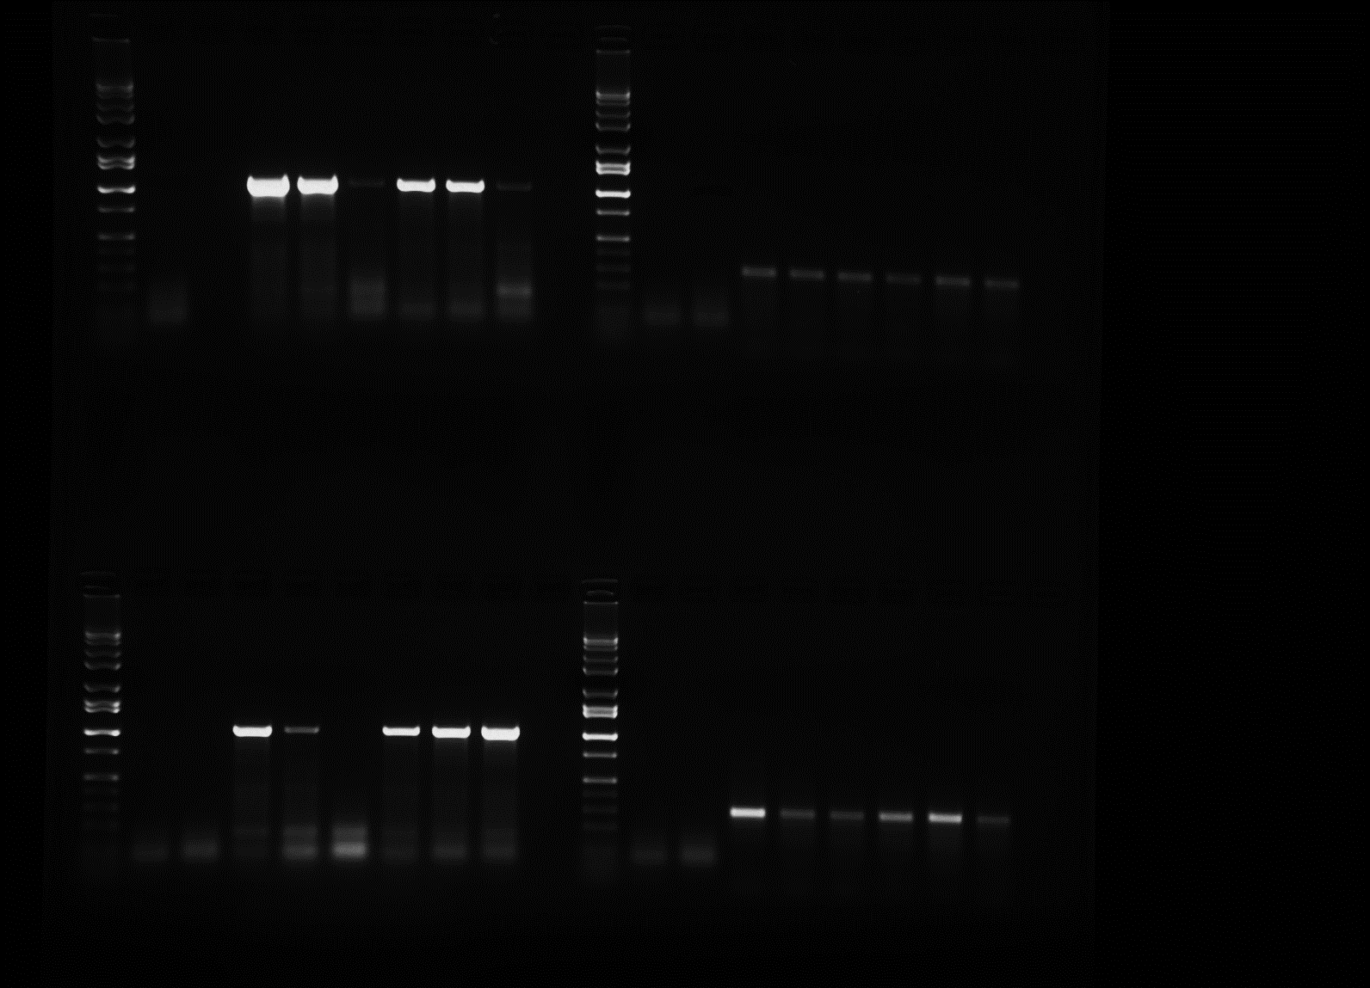
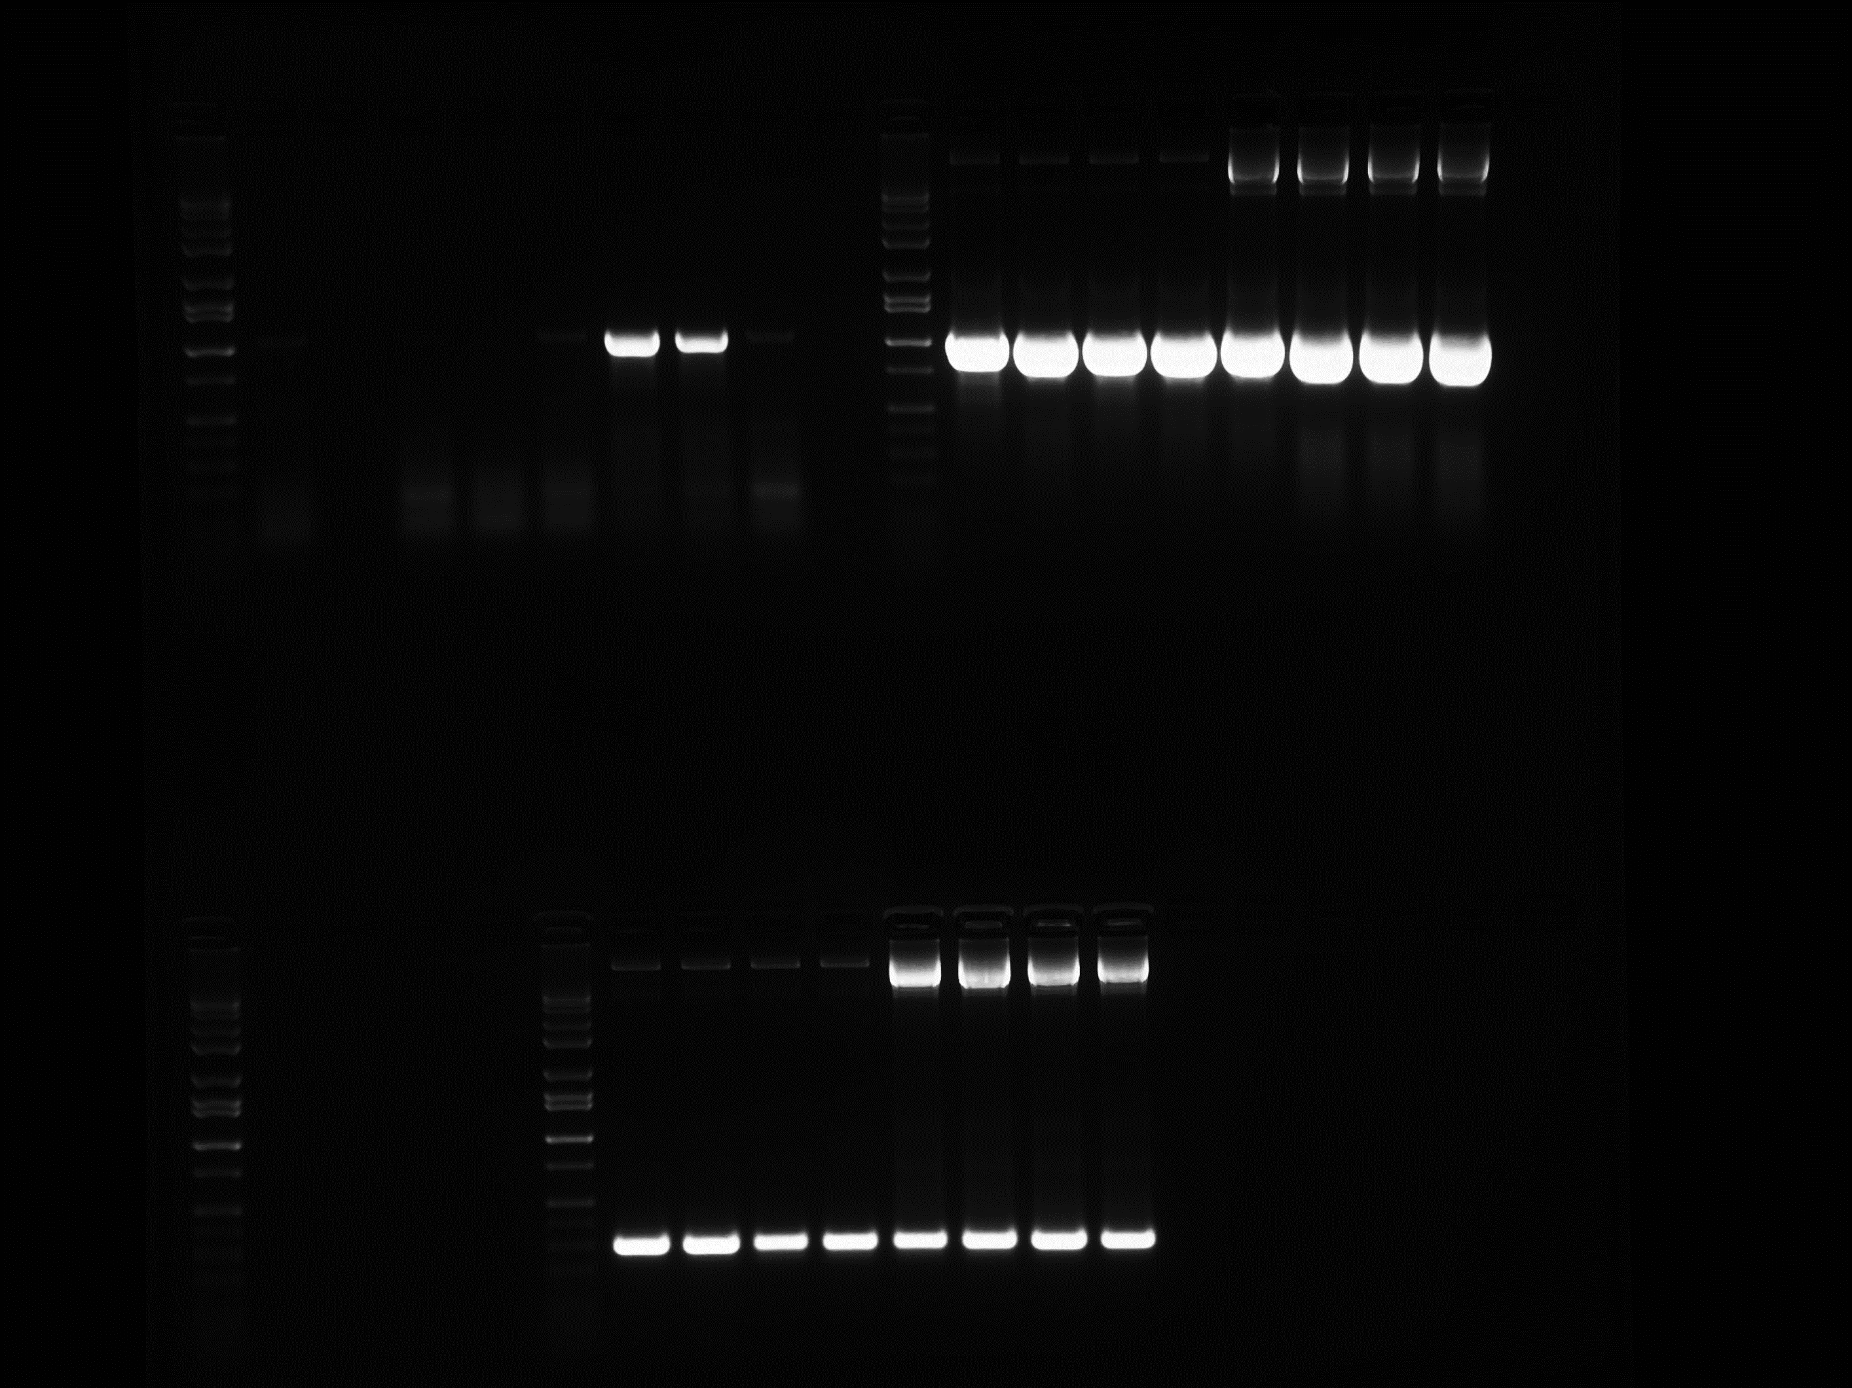
Mk NC₁ NC₂
P32
P605
pANIC 10A
HYG
pporRFP
1 2 3 4 5 6 ^{NC'}₁ ^{NC'}₁ ^{1'}
2' 3' 4'
5' 6' PC1 PC2
P605
P32
a
b
c
d
e
C2 C4 T1 T2 T3 T4 T5 T6

Fig. S6. Phenotype and PCR analysis of regenerated T₀ transgenic and non-transgenic P32 and P605 plants. a to d Images of healthy 2-month-old regenerated T₀ transgenic and non-transgenic P32 (a and b) and P605 (c and d) plants growing on soil. e PCR analysis of transgenic and non-transgenic P32 and P605 plants showing the presence of HYG and pporRFP genes. Mk. Hi-LoTM DNA marker, NC and NC' are negative controls of the genomic DNA (gDNA) extracted from T₀ non-transgenic P32 and P605 plants respectively (NC₁ and NC₂ or NC'₁ and NC'₂ are two set of four individual controls plant of P32 and P605 transformed with A. tumefaciens alone respectively), PC1 and PC2 are positive controls of two different concentrations (50 and 100 ng) of pANIC 10A plasmid DNA, 1-6 and 1'-6' are amplified gDNAs extracted from six individual T₀ transgenic plants of each P32 and P605 line respectively. Amplicon sizes (indicated by the arrows) are 1 kb and 0.35 kb for HYG and pporRFP genes respectively.

