ADDITIONAL INFORMATION

The H₂O₂-dependent activity of a fungal lytic polysaccharide monooxygenase investigated with a turbidimetric assay

Frantisek Filandr^{1,2,3}, Petr Man¹, Petr Halada¹, Hucheng Chang³, Roland Ludwig³ and Daniel Kracher^{3,4}

¹ BioCeV – Institute of Microbiology, The Czech Academy of Sciences, Prumyslova 595, 252 50 Vestec, Czech Republic
²Faculty of Science, Charles University, Hlavova 2030/8, Praha 2, 128 43, Czech Republic
³ Biocatalysis and Biosensing Research Group, Department of Food Science and Technology, BOKU - University of Natural Resources and Life Sciences, Muthgasse 18, 1190 Vienna, Austria
⁴The University of Manchester, Manchester Institute of Biotechnology, M1 7DN Manchester, U.K.

Running title: H₂O₂-dependent activity of LPMO

To whom the correspondence should be addressed: Daniel Kracher (E-mail: danielkracher@boku.ac.at; Telephone: +43 1 47654-75251)

Keywords: lytic polysaccharide monooxygenase, cellobiose dehydrogenase, glucose oxidase, hydrogen peroxide, cellulose, Neurospora crassa

Figure S1. Incubation of 3 µM LPMO and 0.8 mg mL⁻¹ PASC with CDH at concentrations of 0.5 µM (red), 1 µM (blue) or 3 µM (green) in absence of cellobiose. Black line: 3 µM CDH and 10 mM cellobiose in absence of LPMO. All reactions were carried out under constant stirring at 30 °C in 50 mM sodium phosphate buffer, pH 6.0.

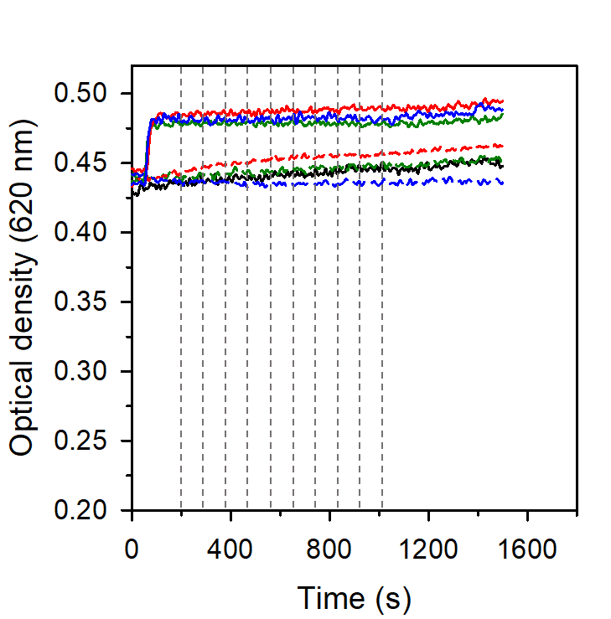
Figure S2. Titration of oxidized LPMO (3 µM) and 0.8 mg mL⁻¹ PASC with 20 µM (green), 40 µM (red) or 80 µM (blue) H₂O₂ (solid lines). Dashed, coloured lines show the titration of 2 mM ascorbate and 0.8 mg mL⁻¹ PASC with 20 µM (green), 40 µM (red) or 80 µM (blue) H₂O₂. The vertical dashed lines indicate the addition of H₂O₂. The arrow indicates the addition of LPMO (solid lines) or 2 mM ascorbate (dashed lines). All reactions were carried out under constant stirring at 30 °C in 50 mM sodium phosphate buffer, pH 6.0.

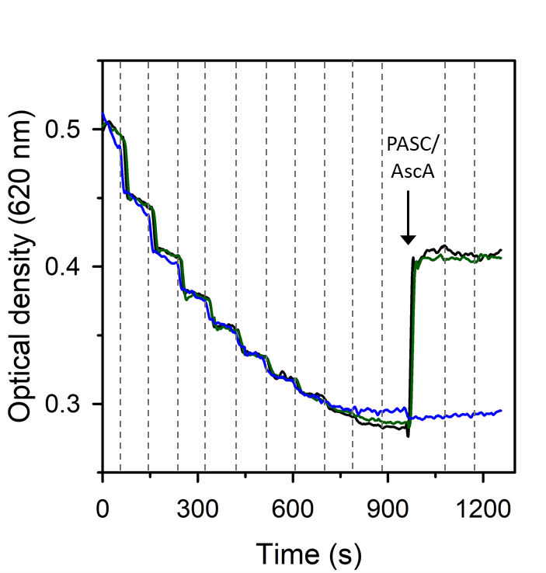
Figure S3. Titration of LPMO (3 µM) and 0.8 mg mL⁻¹ PASC with 40 µM H₂O₂. The vertical dashed lines indicate the addition of H₂O₂. The arrow indicates the addition of fresh PASC which was either added alone (green line) or simultaneously with 1 mM ascorbate (AscA, black line). The blue line indicates the addition of ascorbate (1 mM). All reactions were carried out under constant stirring at 30 °C in 50 mM sodium phosphate buffer, pH 6.0.

