Supplementary data

Fig. S1 Cell density of E. coli BL21(DE3) grown with different concentrations of sabinene. The figure shows the cell density curve of BL21(DE3) after 24 h of cultivation under different concentrations of sabinene stress. The growth of BL21(DE3) was completely inhibited under 3.5 g/L sabinene. The experiments were carried out in triplicate. Error bars represent the standard deviation from the mean.
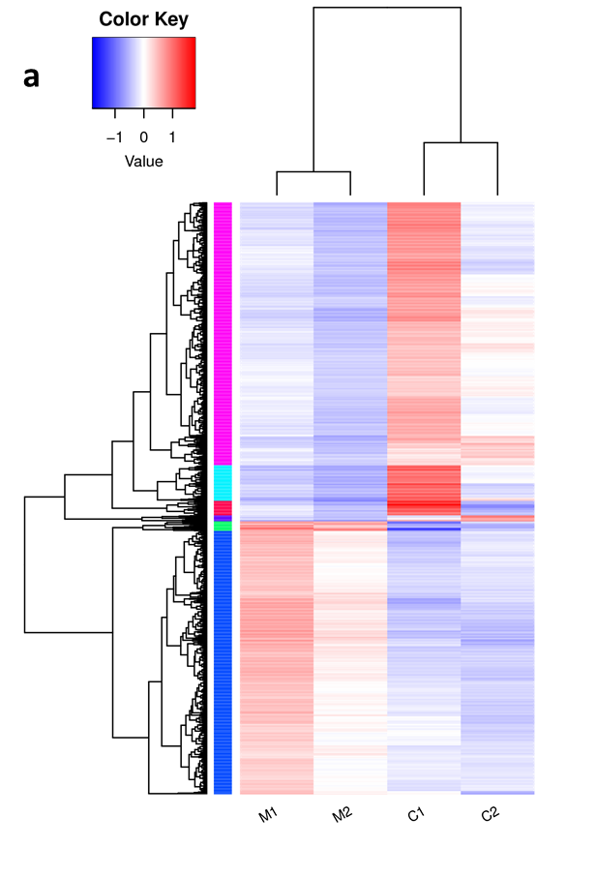
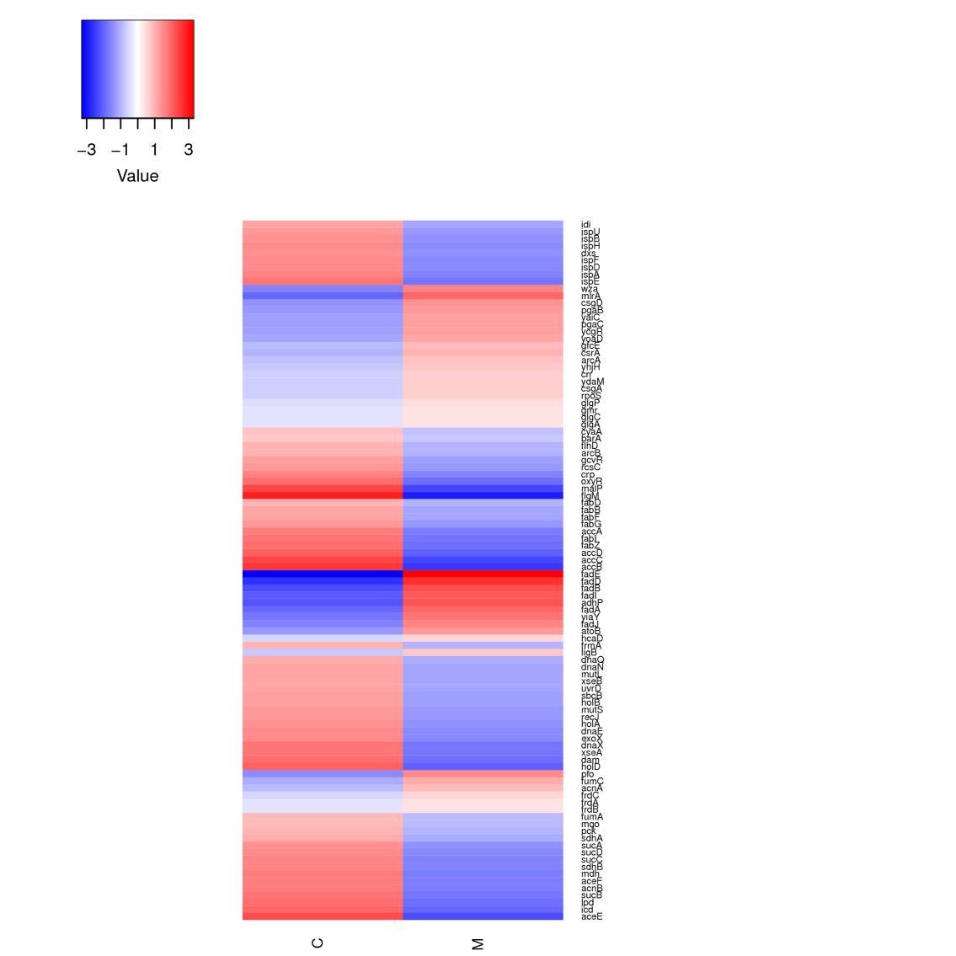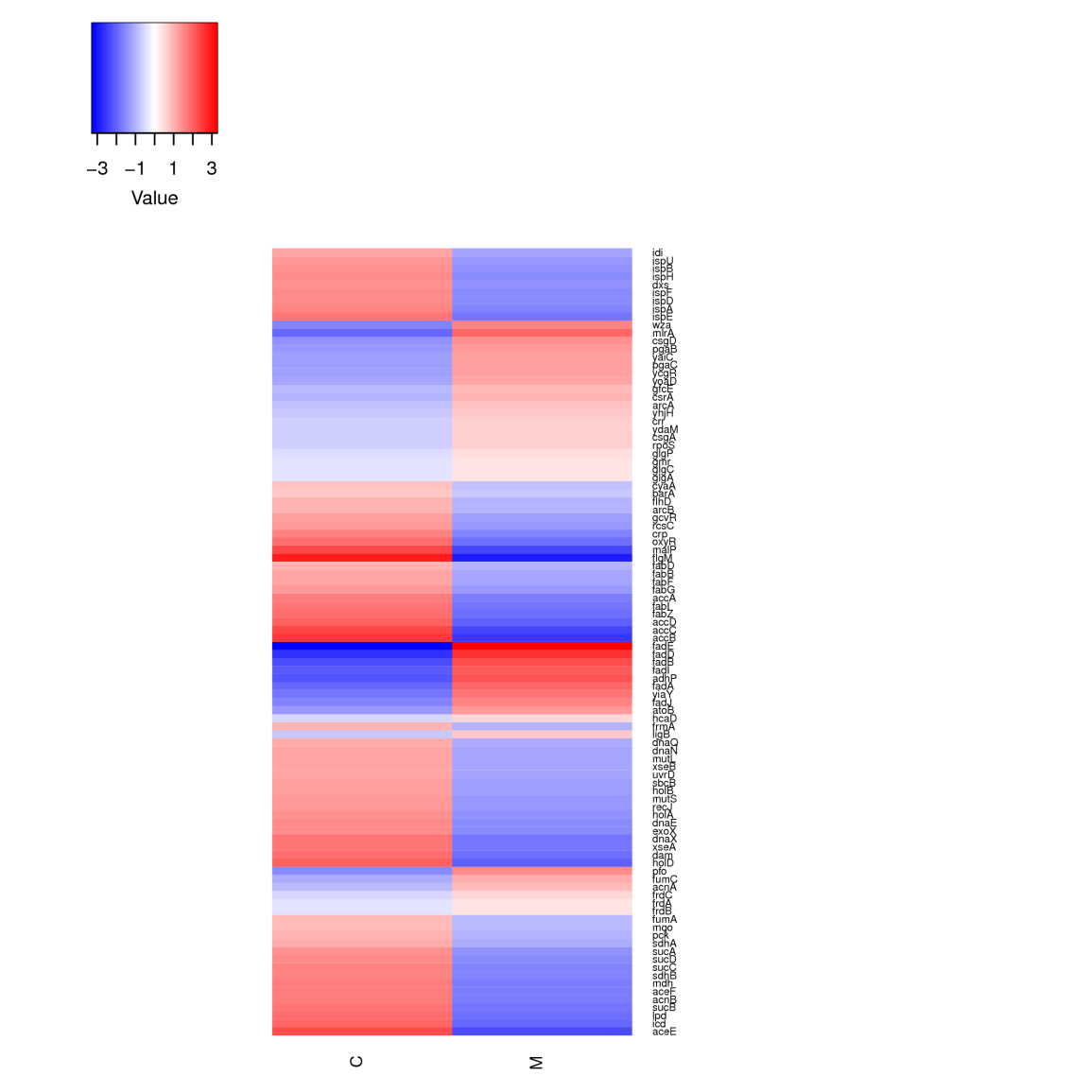
b
Terpenoid backbone biosynthesis(ko00900)
Biofilm formation (ko02026)
Fatty acid biosynthesis (ko00061)
Fatty acid degradation (ko00071)
Mismatch repair (ko03430)

Fig. S2 Hierarchical clustering. a Differential expression gene cluster analysis. Log10 (RPKM+1) were used for clustering, high expression genes are in red and low expression are in blue. Color ranges from blue to red, indicating a higher amount of gene expression. b Cluster analysis of significant differential pathway genes. Red bars represent a relative up-regulation of the gene, while blue represents a relative down-regulation of the gene. The figure shows five paths, terpenoids backbone biosynthesis, biofilm formation, fatty acid biosynthesis, fatty acid degradation and mismatch repair. The differentially expressed genes in each pathway are arranged according to the Log2 Fold Change value of the differential expression.
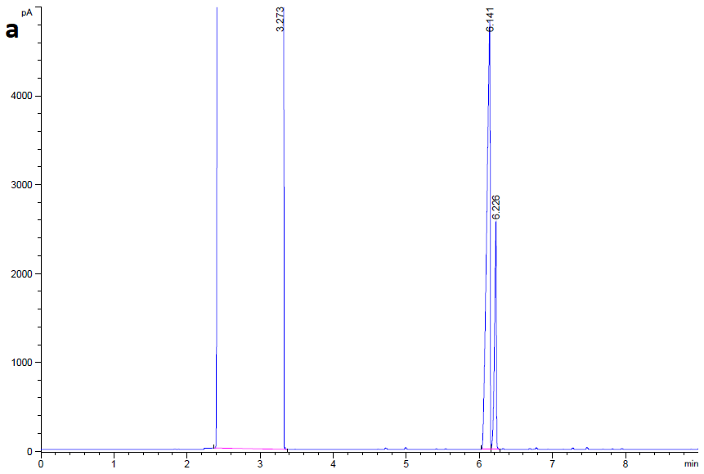
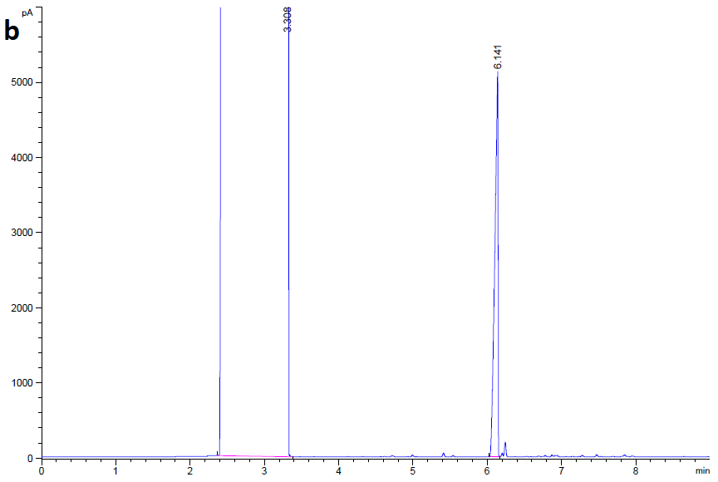
Fig. S3 Quantification of sabinene production by Gas Chromatography. a Gas chromatogram of 1 μL sample extracted by cyclohexane from medium containing 100 mg/L commercial sabinene. b Gas chromatogram of 1 μL sample extracted by cyclohexane from incubated (XYFHB7) culture without exogenous sabinene.

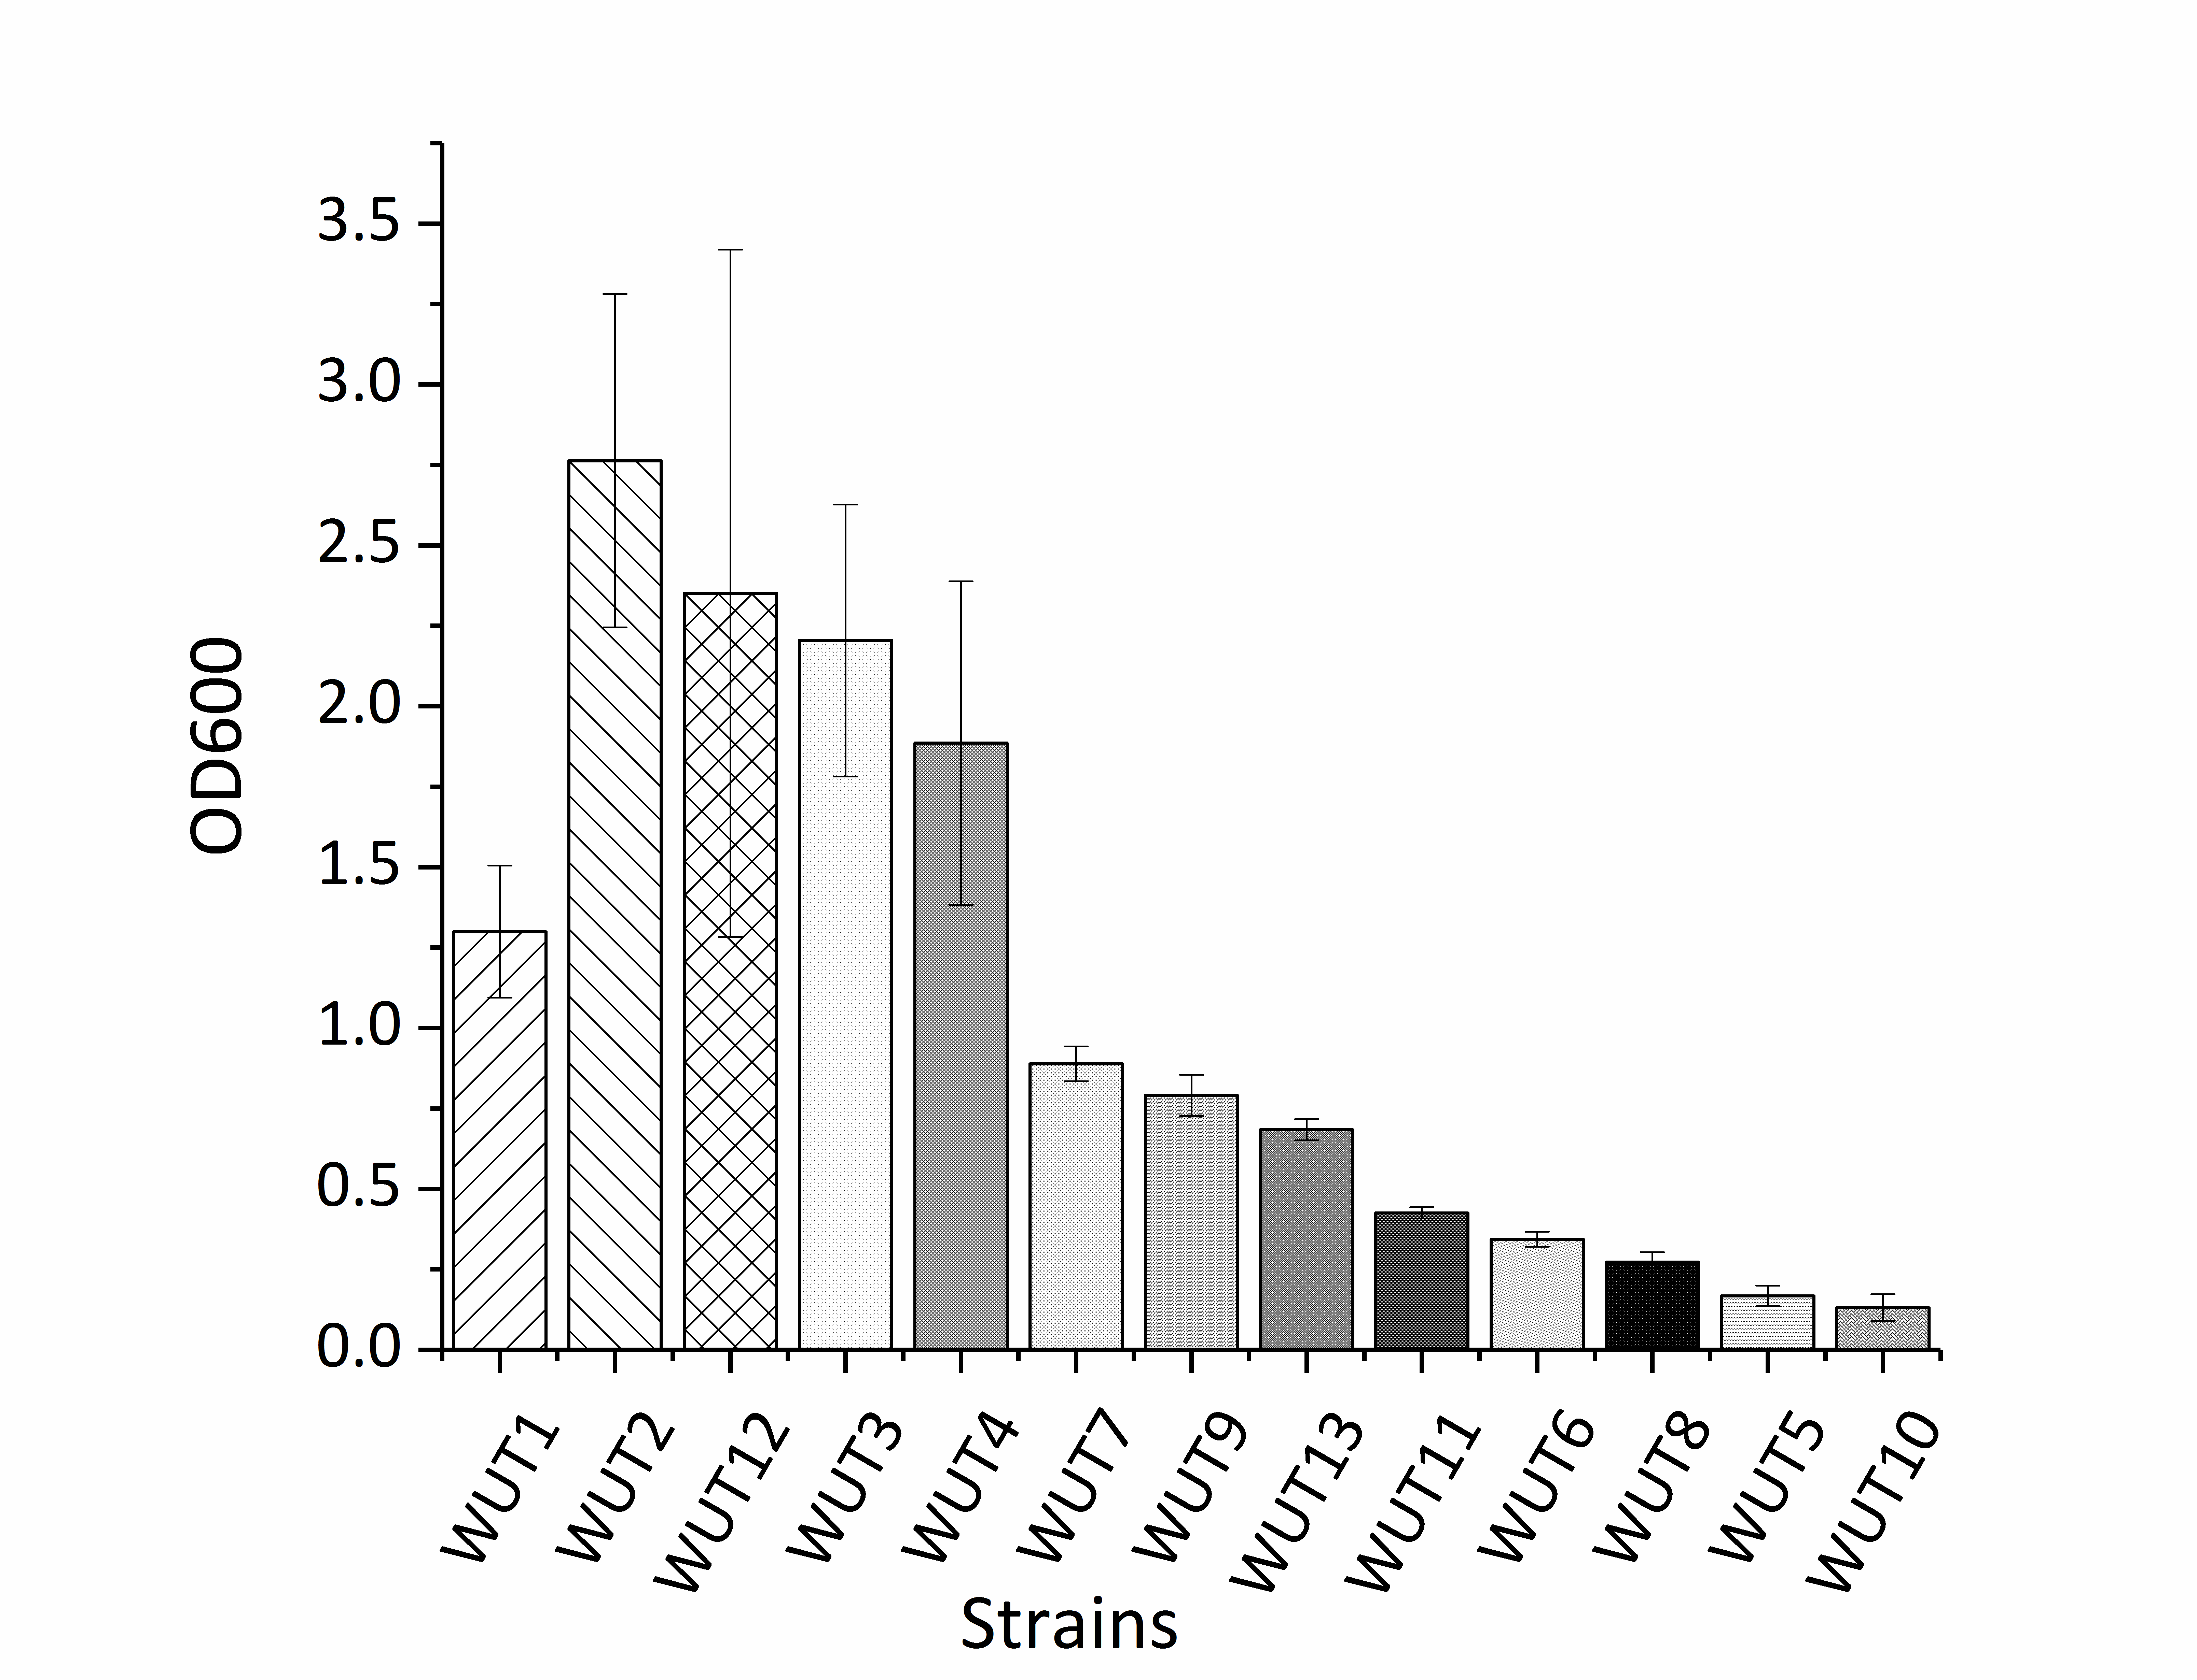
Fig. S4 Cell density of all the reverse-engineered strains grown after 24 h of cultivation with 0.6 g/L sabinene. Experiments were carried out in triplicate. Error bars represent the standard deviation from the mean.

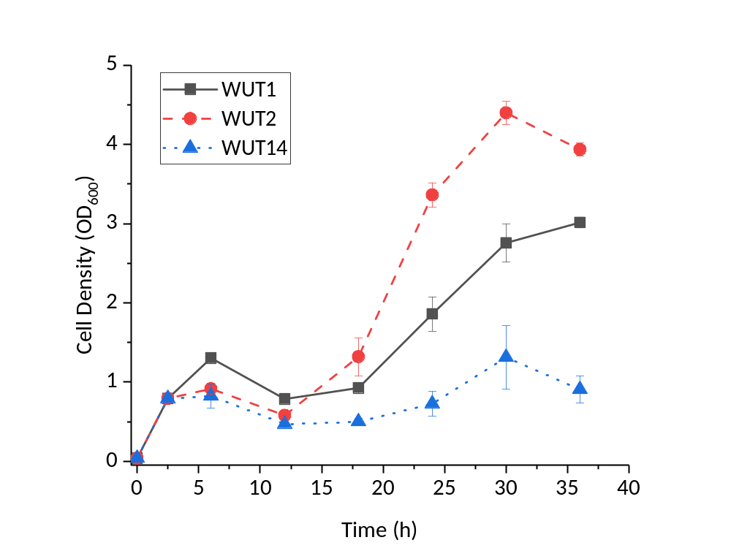
Fig. S5 Growth curves of reverse-engineered strains under sabinene stress. Squares with solid lines indicate strain WUT1, expressing empty plasmid pACYCDuet-1. Circles with dashed lines indicate strain WUT2, overexpressing gene ybcK. Triangles with dashed lines indicate strain WUT14 (ΔybcK), expressing empty plasmid pACYCDuet-1. The experiments were carried out in triplicate. Error bars represent the standard deviation from the mean.

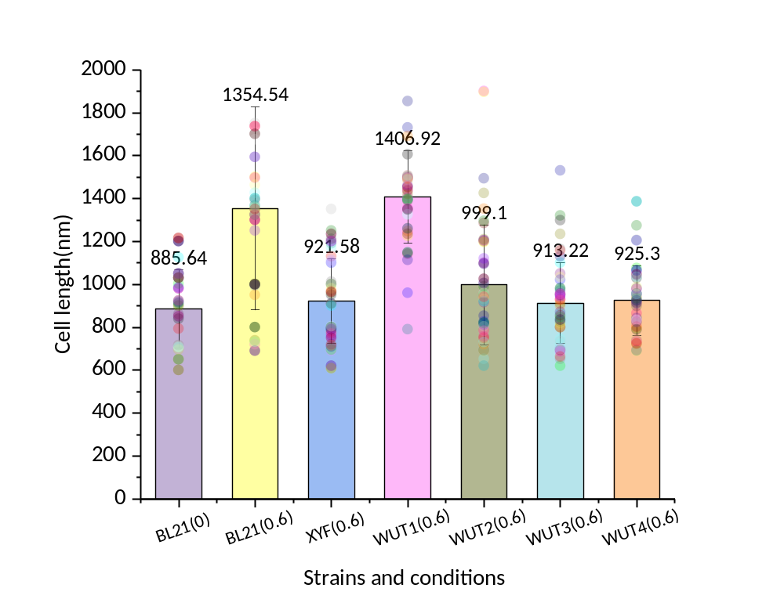
Fig. S6 Cell length statistics of different strains. BL21(0) represents BL21(DE3) grown without sabinene; BL21(0.6) represents BL21(DE3) grown with 0.6 g/L sabinene; XYF(0.6) represents XYF(DE3) grown with 0.6 g/L sabinene; WUT1(0.6) represents WUT1 grown with 0.6 g/L sabinene; WUT2(0.6) represents WUT2 grown with 0.6 g/L sabinene; WUT3(0.6) represents WUT3 grown with 0.6 g/L sabinene; WUT4(0.6) represents WUT4 grown with 0.6 g/L sabinene. The histogram and error line represent the average length and standard deviation of 50 random cells. The color points in the corresponding position represent the length of each sampled cell.

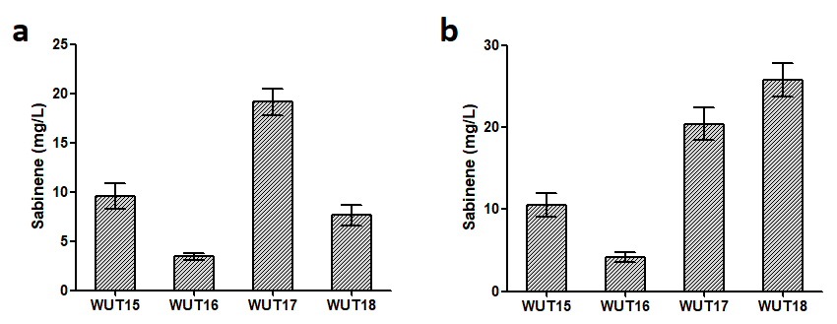
Fig. S7 Sabinene production of ybcK, scpA or ygiZ overexpression strains. a Sabinene production using glucose as carbon source. b Sabinene production using glycerol as carbon source.WUT15, BL21(DE3) harboring pHB5, pTrcLower and pET28a-mvaE-mvaS, used as a control strain; WUT16, BL21(DE3) harboring pACYC-ybcK-GPPS2-SabS1, pTrcLower and pET28a-mvaE-mvaS; WUT17, BL21(DE3) harboring pACYC-scpA-GPPS2-SabS1, pTrcLower and pET28a-mvaE-mvaS; WUT18, BL21(DE3) harboring pACYC-ygiZ-GPPS2-SabS1, pTrcLower and pET28a-mvaE-mvaS. The experiments were carried out in triplicates. Error bars represent the standard deviation from the mean.

Table S1 Other reverse-engineered strains
Plasmids/Strains | Description | Reference
Plasmids
pACYC-ymgJ | P15A origin; CmR; P_{T7}::ymgJ | This work
pACYC-atoD | P15A origin; CmR; P_{T7}::atoD | This work
pACYC-kilR | P15A origin; CmR; P_{T7}::kilR | This work
pACYC-torY | P15A origin; CmR; P_{T7}::torY | This work
pACYC-ybcV | P15A origin; CmR; P_{T7}::ybcV | This work
pACYC-ydiM | P15A origin; CmR; P_{T7}::ydim | This work
pACYC-bglH | P15A origin; CmR; P_{T7}::bglH | This work
pACYC-elaD | P15A origin; CmR; P_{T7}::elaD | This work
pACYC-bglF | P15A origin; CmR; P_{T7}::bglF | This work
Strains
WUT5 | BL21(DE3) harboring pACYC-ymgJ | This work
WUT6 | BL21(DE3) harboring pACYC-atoD | This work
WUT7 | BL21(DE3) harboring pACYC-kilR | This work
WUT8 | BL21(DE3) harboring pACYC-torY | This work
WUT9 | BL21(DE3) harboring pACYC-ybcV | This work
WUT10 | BL21(DE3) harboring pACYC-ydiM | This work
WUT11 | BL21(DE3) harboring pACYC-bglH | This work
WUT12 | BL21(DE3) harboring pACYC-elaD | This work
WUT13 | BL21(DE3) harboring pACYC-bglF | This work

Table S2 Primers used for construction of the reverse-engineered strains and ΔybcK
Genes | Primers |  | R.enzyme
ygiZ | ygiZ-F | 5’-CGCGGATCCGATGTTAAAGCAGAAAATTAAAACAATATT-3’ | BamH I
 | ygiZ-R | 5’-CCCAAGCTTCTAATAGCAAAATATAAACCGTCCC-3’ | Hind III
ybcK | ybcK-F | 5’-CGCGGATCCGATGAAAAAAGCCATAGCATATATGCGATTTT-3’ | BamH I
 | ybcK-R | 5’-CCCAAGCTTTTAGAAATAAATCTCACCATCAACCATATATT-3’ | Hind III
scpA | scpA-F | 5’-AGTCGAATTCGATGTCTAACGTGCAGGAGTGG-3’ | EcoR I
 | scpA-R | 5’-TAGCAAGCTTTTAATCATGATGCTGGCTTATCA-3’ | Hind III
ymgJ | ymgJ-F | 5’- CATGCCATGGGTGAGCAGAAGATATTCATCAGCAACG-3’ | Nco I
ymgJ | ymgJ-R | 5’- CCCAAGCTTTCATGATGAAATGATGATATCCCGCAT -3’ | Hind III
atoD | atoD-F | 5’- CGCGGATCCGATGAAAACAAAATTGATGACATTACAA-3’ | BamH I
atoD | atoD-R | 5’- CCCAAGCTTTTATTTGCTCTCCTGTGAAACGATGATGT-3’ | Hind III
kilR | kilR-F | 5’- CGCGGATCCGATGATTGCACATCACTTC-3’ | BamH I
kilR | kilR-R | 5’- CCCAAGCTTTCACCATGACTCCGC-3’ | Hind III
torY | torY-F | 5’- CGCGGATCCGATGCGAGGGAAAAAACG-3’ | BamH I
torY | torY-R | 5’- CCCAAGCTTCACTGTTTCTCGGTAATATC-3’ | Hind III
ybcV | ybcV-F | 5’- CGCGGATCCGATGGCTCAGGTTGCC-3’ | BamH I
ybcV | ybcV-R | 5’- CCCAAGCTTTTAGCGTGGAAAGATTTGT-3’ | Hind III
ydiM | ydiM-F | 5’- CATG CCATGG GCATGAAAAATCCCTATTTCC-3’ | Nco I
ydiM | ydiM-R | 5’- CGCGGATCCTTACCCACCCGGAG-3’ | BamH I
bglH | bglH-F | 5’- CGCGGATCCGATGTTTAGACGAAATCTTATTACCTCTGCC-3’ | BamH I
bglH | bglH-R | 5’- CCCAAGCTTTTACCACCAGATTTCAGCCTGGG-3’ | Hind III
elaD | elaD-F | 5’- CGCGGATCCGATGATGGTTACAGTTGTCAG-3’ | BamH I
elaD | elaD-R | 5’- CCCAAGCTTTTAACTCACTCTTTTGCCG-3’ | Hind III
bglF | bglF-F | 5’- CGCGGATCCGATGACGGAGTTAGCCAG-3’ | BamH I
bglF | bglF-R | 5’- CCCAAGCTTTTAGCGAATGATGGATAACA-3’ | Hind III
Donor | ybcK1 | 5’- ACACGGTTATGGCCATCTG-3’
gRNA | ybcK2  ybcK3  ybcK4  ybckU1  ybcKD1 | 5’- atccgagatcGGTGACACCTGCTAACGTATG-3’  5’- aggtgtcaccGATCTCGGATTTTAAGTTATGCTATGG-3’  5’- CTAGTGACCTGAAATGCTGCA-3’  5’- cacaccaggtctcaatatgaaggtacACTAGTATTATACCTAGGACTGAGC-3’  5’-cacaccaggtctcaatatcgtgcaagGTTTTAGAGCTAGAAATAGCAAGTTAA-3’
 | GA-Insert-F | 5’-ATCATCACCACAGCCAGGAT-3’
 | GA-Insert-R | 5’-TTATGCGGCCGCAAGCTT-3’
 | GA-Vector-F | 5’-AAGCTTGCGGCCGCATAA-3’
 | GA-Vector-R | 5’-ATCCTGGCTGTGGTGATGAT-3’
 | GA-mvaES-F | 5’-AAGGAGATATACCATGGAGGAGG-3’
 | GA-mvaES-R | 5’-CTGCAGTTAGTTTCGATAAGAGC-3’
 | GA-28a-F | 5’-tatcgaaactaactgcagCTCGAGCACCACCACCA-3’
 | GA-28a-R | 5’-CCTCCTCCATGGTATATCTCCTTCTTAAAG-3’

Table S3 The top 100 up-regulated genes
GeneSymbol | length | log2 FoldChange | p-value adjusted | Description
yjjZ | 237 | 6.077672383 | 3.18E-20 | Uncharacterized protein
yrhA | 114 | 5.698185099 | 1.76E-11 | Uncharacterized protein
rrlD | 2904 | 5.43105452 | 4.45E-09 | 23S ribosomal RNA
ydeS | 531 | 5.293943103 | 8.51E-08 | Predicted fimbrial-like adhesin protein
ariR | 267 | 5.169961415 | 8.50E-07 | Probable RcsB/C two-component-system connector
ymgJ | 186 | 5.157986885 | 1.94E-09 | General stress-inducible proteinsc
rrlG | 2904 | 5.028056637 | 7.06E-08 | 23S ribosomal RNA
yraI | 696 | 5.010418677 | 4.06E-09 | Putative fimbrial chaperone
ygiZ | 333 | 4.775909937 | 3.54E-12 | Inner membrane protein
rrlA | 2905 | 4.764354782 | 1.00E-07 | 23S ribosomal RNA
rrsD | 1542 | 4.686717582 | 7.99E-11 | 16S ribosomal RNA
yccE | 1257 | 4.392377943 | 2.02E-07 | Uncharacterized protein
yceO | 141 | 4.314737308 | 1.01E-08 | Uncharacterized protein
atoD | 663 | 4.231411852 | 1.89E-09 | Acetate CoA-transferase subunit alpha
entC | 1176 | 4.227434989 | 3.78E-12 | Isochorismate synthase
yibV | 111 | 4.190591723 | 1.58E-10 | Uncharacterized protein
psuK | 942 | 4.129336642 | 1.45E-08 | Putative pseudouridine kinase
yncH | 213 | 4.097164763 | 9.04E-09 | Uncharacterized protein
rhaA | 1260 | 4.076578063 | 2.02E-08 | L-rhamnose isomerase
prpB | 891 | 4.041804668 | 4.06E-09 | 2-methylisocitrate lyase
ycgX | 405 | 3.948370444 | 4.32E-09 | Uncharacterized protein
yncI | 315 | 3.945334564 | 4.06E-09 | Putative transposase
ybcK | 1527 | 3.939606713 | 7.99E-11 | DLP12 prophage
entE | 1611 | 3.932331551 | 6.58E-11 | Enterobactin synthase component E
kilR | 222 | 3.931475332 | 1.00E-07 | Killing protein; Rac prophage; inhibitor of FtsZ
torY | 1101 | 3.907124887 | 3.29E-08 | Cytochrome c-type protein
csgE | 390 | 3.862800387 | 9.51E-07 | Curli production assembly/transport component
arpB | 1476 | 3.861588932 | 2.39E-10 | Putative ankyrin repeat protein B
yhiD | 648 | 3.854987708 | 2.02E-08 | Putative magnesium transporter
ompL | 693 | 3.848059972 | 1.40E-06 | Porin
yjbS | 204 | 3.807798404 | 5.51E-07 | Uncharacterized protein
ybeR | 708 | 3.803613905 | 1.69E-06 | Uncharacterized protein
yeeL | 1053 | 3.799846224 | 4.32E-09 | Uncharacterized protein
yqiI | 1065 | 3.790838159 | 3.07E-10 | Putative fimbrial protein
yaiV | 624 | 3.779354343 | 8.54E-07 | Predicted DNA-binding transcriptional regulator
rclC | 594 | 3.720285496 | 7.86E-10 | Inner membrane protein
fimI | 540 | 3.715962798 | 4.11E-08 | Putative fimbrial protein
yddK | 381 | 3.713847282 | 1.01E-07 | Leucine-rich repeat domain-containing protein
yhhZ | 1179 | 3.699891136 | 2.81E-11 | Uncharacterized protein
yjcF | 1293 | 3.694472672 | 4.64E-08 | Uncharacterized protein
yahL | 816 | 3.614688873 | 7.69E-08 | Uncharacterized protein
rhsH | 708 | 3.61162449 | 1.79E-08 | Uncharacterized protein
ynbB | 897 | 3.609279522 | 1.31E-06 | Putative CDP-diglyceride synthase
ydeT | 1227 | 3.594073281 | 8.74E-07 | Fimbrial usher domain-containing protein
ttdR | 933 | 3.58145119 | 1.21E-09 | HTH-type transcriptional activator
ydcC | 1137 | 3.555275596 | 1.52E-06 | H repeat-associated putative transposase
ibsE | 60 | 3.547726781 | 9.51E-07 | Small toxic protein
acrS | 663 | 3.542067864 | 5.64E-07 | acrAB operon transcriptional repressor
ecpR | 591 | 3.519948149 | 4.45E-09 | HTH-type transcriptional regulator
yrhC | 351 | 3.515486326 | 3.67E-07 | Uncharacterized protein
yhaB | 540 | 3.512051072 | 2.46E-08 | Uncharacterized protein
ybcV | 411 | 3.510490058 | 6.46E-08 | DLP12 prophage
yqiH | 750 | 3.503092768 | 1.28E-07 | Putative fimbrial chaperone
yqcE | 1278 | 3.476869813 | 8.54E-07 | Inner membrane protein
wcaE | 747 | 3.466168229 | 2.35E-06 | Putative colanic acid biosynthesis glycosyltransferase
nanC | 717 | 3.462750254 | 2.85E-07 | N-acetylneuraminic acid outer membrane channel protein
bdm | 216 | 3.42504654 | 1.50E-07 | Biofilm-dependent modulation protein
ygcW | 786 | 3.415339657 | 5.80E-07 | Putative deoxygluconate dehydrogenase
sfmH | 984 | 3.410275657 | 1.42E-06 | Putative fimbrial adhesin protein
ybbW | 1455 | 3.391439293 | 1.12E-06 | Putative allantoin permease
elfD | 702 | 3.388374261 | 1.02E-07 | Putative fimbrial chaperone
yhiS | 483 | 3.364852651 | 9.04E-09 | Uncharacterized protein
bglG | 837 | 3.362053132 | 2.76E-07 | Cryptic beta-glucoside bgl operon antiterminator
xylF | 993 | 3.345550429 | 1.52E-08 | D-xylose transport system substrate-binding protein
yiiE | 213 | 3.323634971 | 1.14E-06 | Putative DNA-binding transcriptional regulator
ydiN | 1266 | 3.29137742 | 1.75E-06 | Inner membrane transporter
fepE | 1134 | 3.278440685 | 1.01E-08 | Ferric enterobactin transport protein
arpA | 2187 | 3.275657549 | 3.41E-08 | Regulator of acetyl CoA synthetase
ydiM | 1215 | 3.217260596 | 4.96E-07 | Inner membrane transporter
ycjM | 1680 | 3.210328912 | 2.04E-06 | Glucosylglycerate phosphorylase
ygjJ | 1071 | 3.210035245 | 2.17E-07 | Uncharacterized protein
csgD | 651 | 3.176333655 | 1.87E-06 | csgAB operon transcriptional regulatory protein
bglH | 1617 | 3.151768069 | 8.75E-09 | Cryptic outer membrane porin
yjjQ | 726 | 3.105866235 | 8.68E-07 | Putative transcription factor
yihR | 927 | 3.097458398 | 1.40E-06 | Putative aldose 1-epimerase
fes | 1203 | 3.075814508 | 9.04E-09 | Enterochelin esterase
yjhZ | 246 | 3.072639086 | 2.37E-06 | Uncharacterized protein
elaD | 1212 | 3.070684375 | 4.65E-08 | Protease
ycgH | 75 | 3.069417775 | 1.35E-06 | Uncharacterized protein
yggR | 981 | 3.059501027 | 8.90E-07 | Type II/IV secretion system family protein
bglF | 1878 | 3.039815419 | 1.48E-07 | PTS system beta-glucoside-specific EIIBCA component
motB | 927 | 3.031306433 | 1.62E-06 | Motility protein
ycjT | 2268 | 3.02141439 | 5.14E-07 | Kojibiose phosphorylase
yhhI | 1137 | 3.010251762 | 3.73E-07 | Putative H repeat-associated transposase
emrY | 1539 | 3.004854958 | 1.67E-06 | Multidrug resistance protein
agaI | 756 | 3.000251823 | 2.28E-07 | Putative deaminase
yihQ | 2037 | 2.99862945 | 1.50E-08 | Sulfoquinovosidase
dgoD | 1149 | 2.99595596 | 8.62E-08 | D-galactonate dehydratase
recE | 2601 | 2.963990152 | 1.12E-06 | Exodeoxyribonuclease
yliE | 2349 | 2.865139051 | 1.12E-06 | Cyclic di-GMP phosphodiesterase
uacT | 1449 | 2.853936782 | 2.29E-06 | Uric acid transporter
alsA | 1533 | 2.852248011 | 8.71E-07 | D-allose import ATP-binding protein
ygcG | 873 | 2.842955225 | 1.28E-07 | Uncharacterized protein
ecpA | 588 | 2.780058934 | 1.72E-06 | Common pilus major fimbrillin subunit
yiiG | 1056 | 2.772336276 | 9.51E-07 | Uncharacterized protein
mdtQ | 1287 | 2.768792294 | 1.63E-07 | Multidrug resistance outer membrane protein
sfmD | 2604 | 2.758867149 | 2.22E-06 | Outer membrane usher protein
gspC | 816 | 2.727291702 | 1.65E-06 | Type II secretion system protein
caiT | 1515 | 2.706170099 | 1.92E-06 | L-carnitine/gamma-butyrobetaine antiporter
yjhR | 1029 | 2.59018347 | 2.18E-06 | Putative frameshift suppressor

