Additional file 1
RRNPP-type quorum sensing systems regulate solvent formation, sporulation and cell motility in Clostridium saccharoperbutylacetonicum

Jun Fengª, Wenming Zong^{a,b}, Pixiang Wangª, Zhong-Tian Zhangª, Yanyan Guª, Mark Doughertyª, Ilya Borovok ^{c,*}, Yi Wang^{a,d,*}
ªDepartment of Biosystems Engineering, Auburn University, Auburn, AL 36849, USA
^{b}School of Engineering, Anhui Agricultural University, Hefei 230036, China
^{c}Department of Molecular Microbiology and Biotechnology, Tel Aviv University, Ramat Aviv, Israel
^{d}Center for Bioenergy and Bioproducts, Auburn University, Auburn, AL 36849, USA

*Corresponding author:
Yi Wang,
Department of Biosystems Engineering,
Auburn University,
215 Tom E. Corley Building,
Auburn, AL, 36849 USA
Tel: 1-334-844-3503; Fax: 1-334-844-3530;
E-mail: yiwang3@auburn.edu

Ilya Borovok,
Department of Molecular Microbiology and Biotechnology,
Tel Aviv University,
Ramat Aviv, 6997801 Tel Aviv, Israel
Tel: 972-52-8665-901; Fax: 972-3-640-9407;
E-mail: ilyabo@tauex.tau.ac.il

Methods
Plasmid construction
The names and sequences of all the primers used in this study are listed in Table S1. In this study, the RRNPP-type regulator genes Cspa_c00280, Cspa_c21720, Cspa_c27220, Cspa_c29260 and Cspa_c56960 were named as qssR1, qssR2, qssR3, qssR4 and qssR5, respectively (Fig. 1); their putative cognate signaling peptide genes Cspa_c00290, Cspa_c21710, Cspa_c27230, Cspa_c29250 and Cspa_c56950 were named as qssP1, qssP2, qssP3, qssP4 and qssP5, respectively (Fig. 1); the five putative RRNPP-type systems were named as QSS1 to QSS5.
The Phanta Max Super-Fidelity DNA Polymerase (Vazyme Biotech Co., Ltd., Nanjing, China) was used for the PCR to amplify DNA fragments for cloning purposes. For gene deletion, the plasmid pYW34, which contains a lactose-inducible promoter driving the expression of the Streptococcus pyogenes cas9 gene along with a chimeric gRNA sequence, was used as the mother vector ^{1, 2}. The synthetic J23119 promoter and the gRNA containing the 20-nt guide sequence were amplified by two rounds of PCR with primers N-20nt/YW1342 and YW1339/YW1342 as described previously (as a naming rule of this study, N represents the corresponding gene name: qssR1, qssR2, qssR3, qssR4 and qssR5) (Fig. S1) ². The obtained fragments were then inserted into pYW34 (digested with BtgZI and NotI) through Gibson Assembly. The two 500-bp homologous arms were ligated into the above obtained plasmids (digested with NotI), generating the plasmid pYW34-N for the deletion of gene N.
To construct pYW19d-qssR4, the J23119 promoter and the gRNA with 20-nt guide sequence were amplified by two rounds of PCR with primers qssR4-20nt/YW1342 and YW1339/YW1342. The obtained fragment was then inserted into pYW19d-BseRI plasmid (digested with BseRI and NotI) through Gibson Assembly ³.
To construct the plasmid for genetic complementation, the promoter of the cat1 gene (CTK_C06520) from C. tyrobutyricum ATCC 25755 and the open reading frames of qssR1, qssR2, qssR3, qssR4 or qssR5 were inserted through Gibson Assembly into pMTL82151 (digested with EcoRI and KpnI), respectively, generating pMTL-qssR1, pMTL-qssR2, pMTL-qssR3, pMTL-qssR4, and pMTL-qssR5.

Plasmid transformation and mutant identification
C. saccharoperbutylacetonicum competent cells were prepared following the procedure as described by Herman et al. with modifications ⁴. Briefly, when the optical density (OD₆₀₀) of the cell culture reached ~0.8, cells were harvested by centrifugation at 4,200 g, 22 °C for 10 min. The supernatant was discarded (operated in the anaerobic chamber) and cell pellets were then resuspended in the same volume of SMP buffer (270 mM sucrose, 1 mM MgCl₂ and 7 mM sodium phosphate). The resuspension was centrifuged again under the same conditions as described above. The supernatant was discarded, and the cell pellets were resuspended by 1/20 volume of SMP buffer. After that, the plasmid (~1.0 μg) was mixed with 400 μL of competent cells and the mixture was transferred into a 2 mm electroporation cuvette followed by incubation in ice for 30 min. Electroporation was then conducted using a Gene Pulser Xcell electroporation system (Bio-Rad Laboratories, Hercules, CA) with following parameters: voltage of 1,000 V, capacitance of 25 μF and resistance of 300 Ω. Subsequently, the culture was transferred into 2 mL pre-warmed TGY medium and incubated at 35 °C for 2-3 h. After that, the culture was spun down and spread onto TGYC plates (TGY agar plate containing 30 μg/mL clarithromycin) or TGYT plates (TGY agar plate containing 15 μg/mL thiamphenicol).
The positive gene deletion mutant was screened as previously described ². Briefly, the transformant harboring the CRISPR-Cas9 plasmid for gene deletion was incubated in TGYC liquid medium at 35 °C for about 12 h. The cell culture was then spread onto TGYLC plates (TGYC supplemented with 40 mM lactose). When colonies were observed, colony PCR (cPCR) was then performed with primer pairs of N-U/N-D (N represents the gene names: qssR1, qssR2, qssR3, qssR4 and qssR5), to verify the gene deletion mutation (Table S1). The verified mutant was then subcultured in TGY liquid medium for 3-5 generations to cure the plasmid ². The finally obtained plasmid-free mutant was designated as C. saccharoperbutylacetonicum ∆R1, ∆R2, ∆R3, and ∆R5 (the deletion of qssR4 was unsuccessful despite numerous attempts).

Quantitative reverse transcription PCR (qRT-PCR)
For the qRT-PCR analysis of genes associated with cell motility (fliA and flgC), the cell culture was grown in TGY medium for 12 h and then cells were harvested for the analysis. For the qRT-PCR analysis of qssR1, qssR2, qssR3, qssR4, qssR5, qssP1, qssP2, qssP3, qssP4, qssP5, sol operon (bld as the first gene of the sol operon was analyzed) and genes associated with sporulation including spo0A (Cspa_c27540) and spo0E-like genes (Cspa_c00300, Cspa_c21700 and Cspa_c56940), the cell culture was grown in TGY medium for 12 h and then grown in P2 medium (with 80 g/L glucose, 2 g/L yeast extract, and 6 g/L tryptone) or PG medium for 24 h before cells were harvested for the analysis ⁵. The seven spo0E-like genes Cspa_c00300, Cspa_c00310, Cspa_c21700, Cspa_c29630, Cspa_c41910, Cspa_c56930, and Cspa_c56940 were renamed as spo0E1-spo0E7 in this work.
The cells were collected by centrifugation at 12,000 rpm and 4 °C for 1 min. RNA was extracted using the RNA Isolater Total RNA Extraction Reagent (Vazyme Biotech Co., Ltd., Nanjing, China) following the manufacturer’s instruction. Then, cDNA was synthesized using the HiScript II 1st Strand cDNA Synthesis Kit (Vazyme Biothech Co., Ltd, Nanjing, China). The qRT-PCR analysis was performed in technical triplicate for each cDNA sample using the Power SYBR® Green PCR Master Mix (Thermofisher, Waltham, MA). The gene transcription levels were normalized against the expression of 16S rRNA gene (as the control). The results were standardized as fold changes compared to the control parental strain.

Table S1 Primers used in this study.
Primers | Sequence (5' to 3')
YW1339 | AAAGTTAAAAGAAGAAAATAGAAATTTGACAGCTAGCTCAGTCCTAGGTATAATGCTAGC
YW1342 | GGATCCACTAGTAACCATCACACTGGCGGCCGCTAATTATTAGTCATATCACAAAGAAT
qssR1-UF | TGATATGACTAATAATTAGCGGCCGCATCTGATTGTATTTGAATAAATTCG
qssR1-UR | CTAGCTGTTATACGATTCATTATCAAACATTGTTATTTCC
qssR1-DF | ATGTTTGATAATGAATCGTATAACAGCTAGTATTATGTTACA
qssR1-DR | ACTAGTAACCATCACACTGTGTTCTACAATAGATATTTGCTCTG
qssR1-20nt | GCTCAGTCCTAGGTATAATGCTAGCATTAGCAGGAAGATATGCCAGTTTTAGAGCTAGAAATAGCAAG
qssR1-U | ACTTGATTATTATGGTAGCTTGTGA
qssR1-D | GGACTTTTCCCATATTTTATCATTT
qssR2-UF | TGATATGACTAATAATTAGCGGCCGCTTAGTTTTTCATCATCAGTCACTCT
qssR2-UR | ATGTTTGATAATGAACATTATATTTTCTAATATTATGCTA
qssR2-DF | TTAGAAAATATAATGTTCATTATCAAACATTGTTATAGCC
qssR2-DR | ACTAGTAACCATCACACTGATCATCTACTGCTTCAACATATTCA
qssR2-20nt | GCTCAGTCCTAGGTATAATGCTAGCGGAAAGATTCCTGTAAGTCAGTTTTAGAGCTAGAAATAGCAAG
qssR2-U | GCAATATTACTAATGCTATTGTTTC
qssR2-D | TACTAACAAGCCCCTCAAATAAATC
qssR3-UF | TGATATGACTAATAATTAGCGGCCGCTATTTCTAATGTTTTTAGGATGGAG
qssR3-UR | TTAAAAATTCTTTTCTTGGTTGTCAAACATTTTATTTTCTC
qssR3-DF | ATGTTTGACAACCAAGAAAAGAATTTTTAATGTTTTTTATCG
qssR3-DR | ACTAGTAACCATCACACTGTTGAAAATAAATAAAAATCAAGTGG
qssR3-20nt | GCTCAGTCCTAGGTATAATGCTAGCGGCCAAGAAATACCTTTTGCGTTTTAGAGCTAGAAATAGCAAG
qssR3-U | GTATAAAAGCTTTGAGGGGGATAAT
qssR3-D | TTATTATTTTTTGCTCGGATTACCT
qssR4-UF | TGATATGACTAATAATTAGCGGCCGCAAGGTTTACCATATGCGTTGTAGTT
qssR4-UR | ATGAAATTCTTAACTAACTATATTTCATAATAATTTAGATT
qssR4-DF | TTATGAAATATAGTTAGTTAAGAATTTCATTTTAACCACC
qssR4-DR | ACTAGTAACCATCACACTGCGCAAACTCTATTGTTTTCCATTAT
qssR4-20nt | GCTCAGTCCTAGGTATAATGCTAGCCCTCATAGCAGTTCGCTTTAGTTTTAGAGCTAGAAATAGCAAG
qssR4-U | AAAAATGTTTTGCAATATCTAAATC
qssR4-D | TTACTGCTGAAACTAAAGAAGCATC
qssR5-UF | TGATATGACTAATAATTAGCGGCCGCATCTGATTGTATTTGAATAAATTCG
qssR5-UR | CTAGCTGTTATACGATTCATTATCAAACATTGTTATTTCC
qssR5-DF | ATGTTTGATAATGAATCGTATAACAGCTAGTATTATGTTACA
qssR5-DR | ACTAGTAACCATCACACTGTGTTCTACAATAGATATTTGCTCTG
qssR5-20nt | GCTCAGTCCTAGGTATAATGCTAGCTCATCTATCATTAATTCCCCGTTTTAGAGCTAGAAATAGCAAG
qssR5-U | ACTTGATTATTATGGTAGCTTGTGA
qssR5-D | GGACTTTTCCCATATTTTATCATTT
qssR1-F | ATATAATTTATGAAAGGGTGGTTTTTATGTTTGATAATGAAATCTTGACGC
qssR1-R | CGACTCTAGAGGATCCCCGGGTACCGAATTCAACATAATACTAGCTGTTATACC
qssR2-F | ATATAATTTATGAAAGGGTGGTTTTTATGTTTGATAATGAAATCATGATGC
qssR2-R | CGACTCTAGAGGATCCCCGGGTACCGAATTCCTTCATTTAACATTATAGCATAA
qssR3-F | ATATAATTTATGAAAGGGTGGTTTTTATGTTTGACAACCAAGTTATGCC
qssR3-R | CGACTCTAGAGGATCCCCGGGTACCGAATTCCATAACTATCCTCCTGTAAATGT
qssR4-F | ATATAATTTATGAAAGGGTGGTTTTTATGAAATTCTTAACTAATGGTCAA
qssR4-R | CGACTCTAGAGGATCCCCGGGTACCGAATTCTCTAAATTATTATGAAATATAGT
qssR5-F | ATATAATTTATGAAAGGGTGGTTTTTATGTTTAATAATGAAATTATGAAAC
qssR5-R | CGACTCTAGAGGATCCCCGGGTACCGAATTCTTCTGCCTTTACAGTGTAACAT
QR1-F | CTAATGCTTAGAGCAACCCAAAC
QR1-R | TGCTTGCTCATAGTCTTCTATCAA
QP1-F | GCAACATCAATGTTATTAACAAATG
QP1-R | TAATGTGGATCTATTGAATTTACACT
QE1-F | TGAGGAAATTAAAATTGAAAAATGATG
QE1-R | TAAATTTTGACTTGCAATTACCACC
QR2-F | GCTTTATCTGCCATCAGCATTA
QR2-R | CAGCAGCCATGTATATCAAAGAA
QP2-F | GATATACATTATTTGGATCCACGCT
QP2-R | TTATATTGGCAGTAATGGCAACATC
QE2-F | TAGTTGCTCTTTGTATGCAGCAATG
QE2-R | GTGAGAATAATGGATGATTTAATATCATA
QR3-F | AGTTGAACTTGCAGAAGGTATTTG
QR3-R | TCCGCTTCATCGAGCATTT
QP3-F | ATGGTCGCATGTGTTGTGTTATTAT
QP3-R | GATGAAACTTTTCTCCACTGCTTGA
QR4-F | TCCTAGTGGAGGAATATCAGATGTA
QR4-R | AGATCGTTATACAACGGCTCAAA
QP4-F | TTAGCCCCATGGAGCACTTTC
QP4-R | AGGCGTATCTCTATTTTTATCTTGCT
QR5-F | ACATCTTCATTTACGTGTGTAAGC
QR5-R | ATGATGTATGCGAATTGTCTAACTG
QP5-F | ATGGGTCAGTTGTGTTTAAATGATAC
QP5-R | TAGCAGTAATAGCAACGTCAATGTTA
QE5-F | TAAATTTTGACTTGCAATTACCACC
QE5-R | CGAACACCAGTTTGTGTTTGGA
QSol-F | CTACTGCTTGGTCAGGAGATAAC
QSol-R | CTCAGGACCACCACATGAAATA
QSpo0A-F | GGCGTTCCAGCTCATATTAAAG
QSpo0A-R | AGCATCTATTTGTCCTCTACCC
Q16S-F | CAATGGCTGGTACAGAGAGATG
Q16S-R | TCTCCTACGGCTACCTTGTT
QFliA-F | TCCAAGGAGACCATAGAAATGTAG
QFliA-R | GCAATGATAGACGAACTGAGAAAG
QFlgC-F | CCACCATCATATCTGCCATTTC
QFlgC-R | GCGGAAAGATTGAGAATGGATAC

*The sequences underlined in italic are the guide sequences.

Table S2 Comparative pair-alignment data of amino acid sequences of the Clostridium saccharoperbutylacetonicum RRNPP-type transcriptional regulators. ¹
 | QssR1 | QssR2 | QssR3 | QssR4 | QssR5
QssR1 |  | 68.8% | 43.4% | 20.0% | 60.2%
QssR2 |  |  | 43.4% | 19.4% | 60.1%
QssR3 |  |  |  | 19.3% | 46.7%
QssR4 |  |  |  |  | 19.5%
¹ Only percentages of identical amino acids are shown. The results were obtained using the online ClustalW server (https://npsa-prabi.ibcp.fr/cgi-bin/npsa_automat.pl?page=/NPSA/npsa_clustalw.html).

Table S3 Comparative pair-alignment data of amino acid sequences of the signaling-peptide precursors of the five Clostridium saccharoperbutylacetonicum RRNPP-type quorum sensing systems.¹
 | QssP1 | QssP2 | QssP3 | QssP4 | QssP5
QssP1 |  | 67.9% | 38.9% | 20.0% | 69.8%
QssP2 |  |  | 43.6% | 25.9% | 79.3%
QssP3 |  |  |  | 35.6% | 43.6%
QssP4 |  |  |  |  | 24.1%
⁶ Only percentages of identical amino acids are shown. The results were obtained using the online ClustalW server (https://npsa-prabi.ibcp.fr/cgi-bin/npsa_automat.pl?page=/NPSA/npsa_clustalw.html).

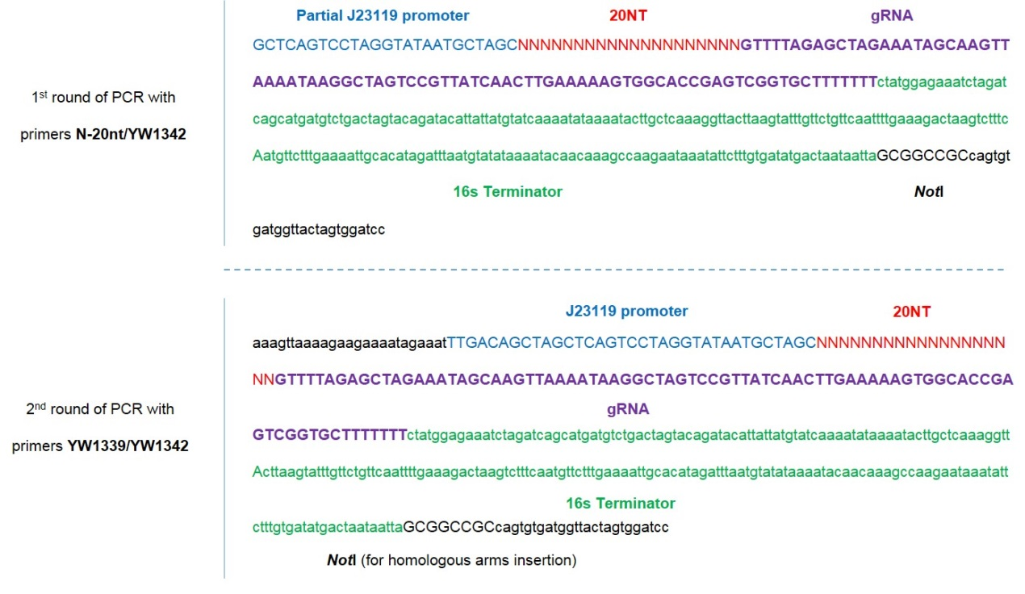

Figure S1. Schematic of two rounds of PCR to obtain the DNA fragment containing 20-nt gRNA sequence for constructing the CRISPR-Cas9 plasmid for gene deletion. The two rounds of PCR were used to amplify the DNA fragment to incorporate the J23119 promoter ² and the 20-nt sequence. The obtained DNA fragment was then assembled into pYW34 at the BtgZI and NotI sites.

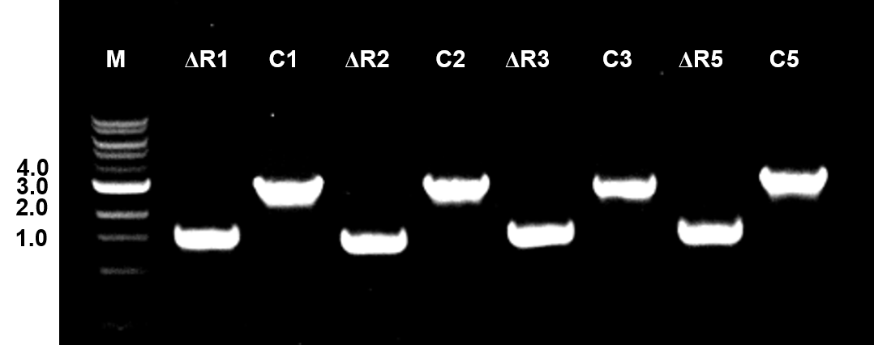

Figure S2. Confirmation of gene deletion by colony PCR. Lane M: The NEB 1-kb DNA ladder, with numbers on the left representing the band length in kb; Lane ΔR1: the PCR result (1,519 bp) confirming the deletion of R1 with primers qssR1-U/qssR-D. Lane C1: the PCR result (2,711 bp) from the control N1-4 (HMT) strain with primers qssR1-U/qssR1-D (2,711 bp). Lane ΔR2: the PCR result (1,394 bp) confirming the deletion of R2 with primers qssR2-U/qssR2-D. Lane C2: the PCR result (2,695 bp) from the control N1-4 (HMT) strain with primers qssR2-U/qssR2-D. Lane ΔR3: the PCR result (1,517 bp) confirming the deletion of R3 with primers qssR3-U/qssR3-D. Lane C3: the PCR result (2,774 bp) from the control N1-4 (HMT) strain with primers qssR3-U/qssR3-D. Lane ΔR5: the PCR result (1,455 bp) confirming the deletion of R5 with primers qssR5-U/qssR5-D. Lane C5: the PCR result (2,631 bp) from the control N1-4 (HMT) strain with primers qssR5-U/qssR5-D.

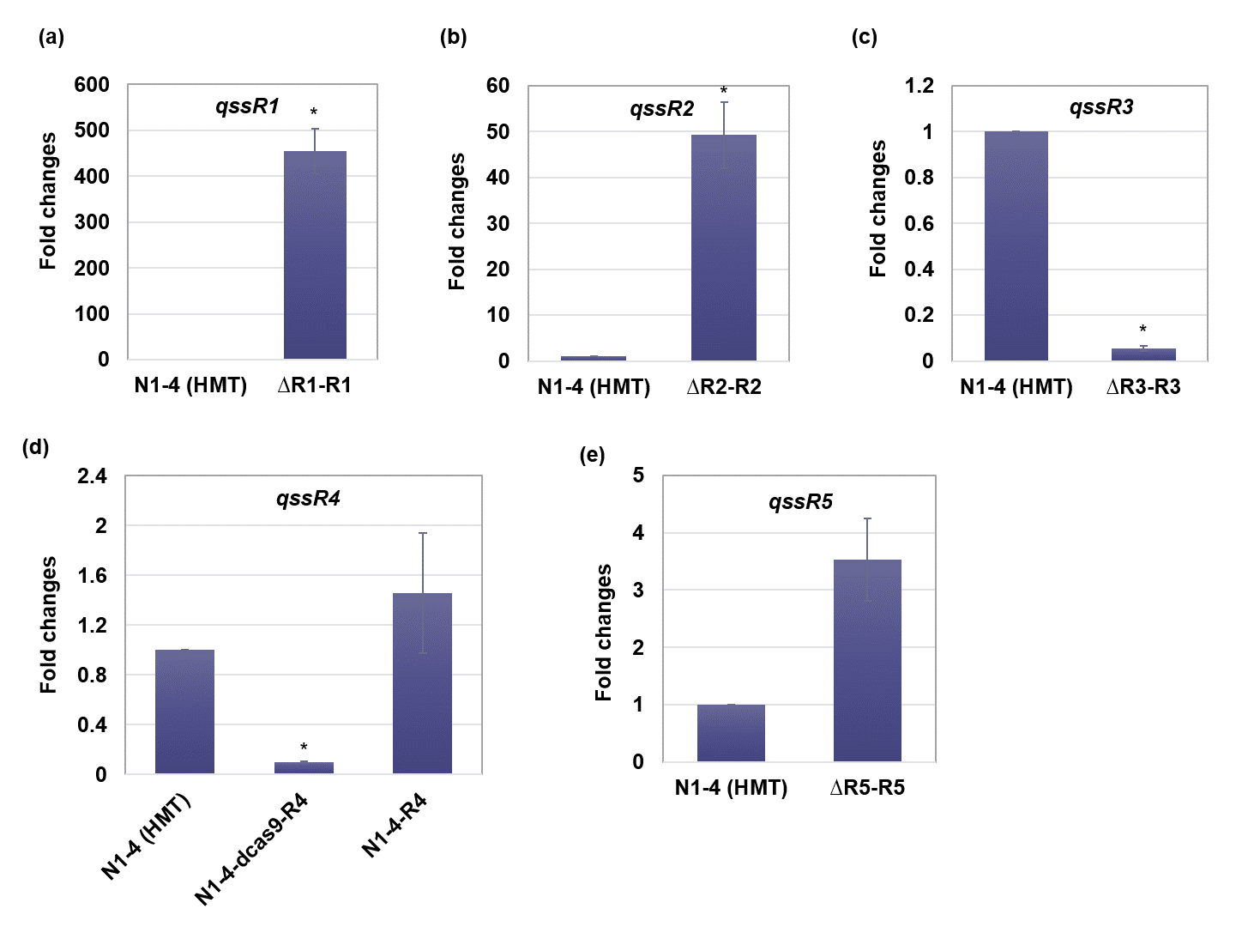

Figure S3 Transcriptional analyses of qssR1, qssR2, qssR3, qssR4 and qssR5 in wild-type N1-4 (HMT) and relevant mutant strains using qRT-PCR. The bacterial RNA was extracted from the cell culture after 24 h cultivation in P2 medium (see Materials and Methods). The reported value is mean ± SD. The asterisk indicates that the corresponding gene expression level in that particular strain was significantly different from the wild-type strain (P < 0.05).

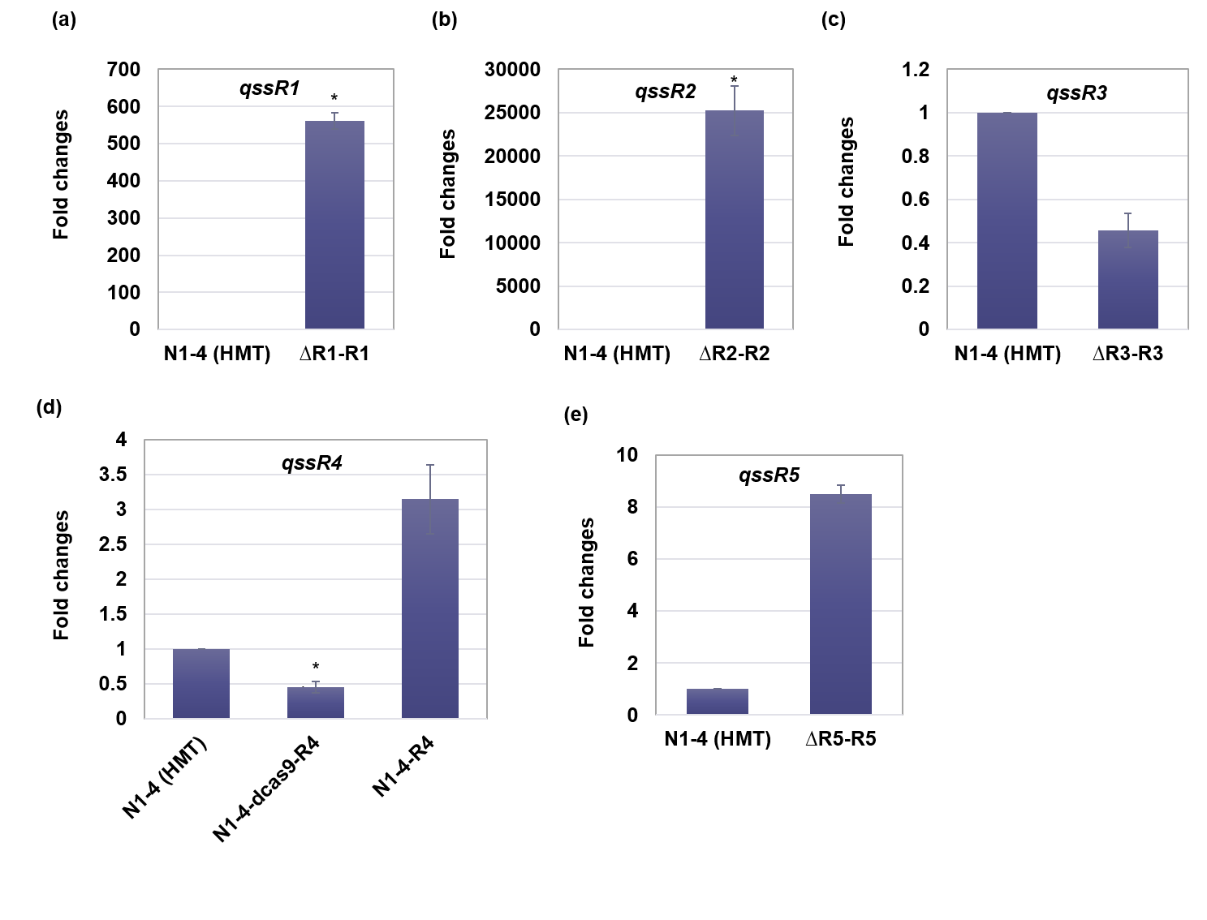
Figure S4 Transcriptional analyses of qssR1, qssR2, qssR3, qssR4 and qssR5 in wild-type N1-4 (HMT) and relevant mutant strains using qRT-PCR. The bacterial RNA was extracted from the cell culture after 24 h cultivation in TGY medium (see Materials and Methods). The reported value is mean ± SD. The asterisk indicates that the corresponding gene expression level in that particular strain was significantly different from the wild-type strain (P < 0.05).

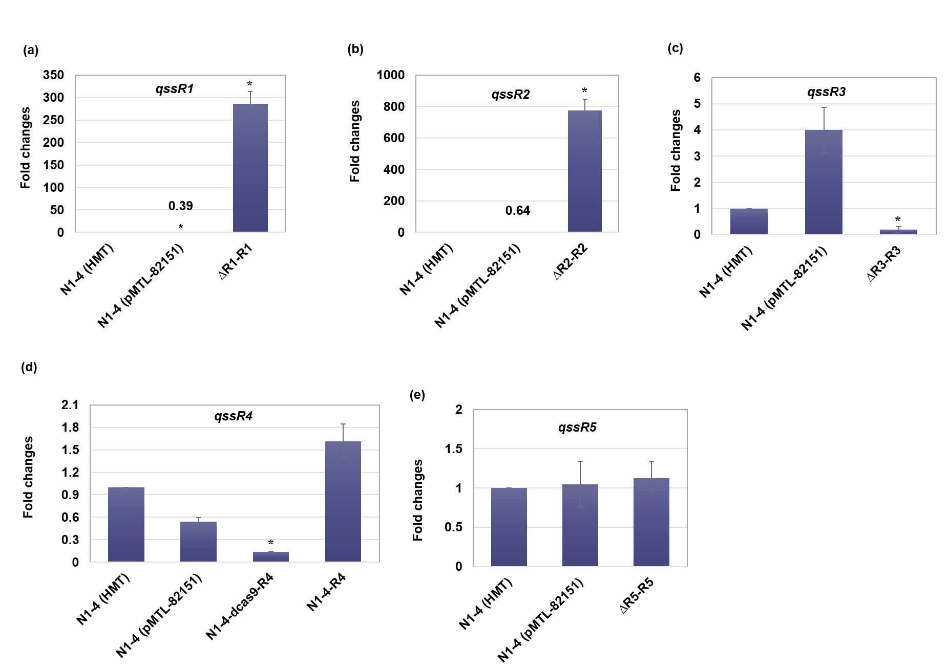
Figure S5 Transcriptional analyses of qssR1, qssR2, qssR3, qssR4 and qssR5 in wild-type N1-4 (HMT) and relevant mutant strains using qRT-PCR. The bacterial RNA was extracted from the cell culture after 24 h cultivation in PG medium (see Materials and Methods). The reported value is mean ± SD. The asterisk indicates that the corresponding gene expression level in that particular strain was significantly different from the wild-type strain (P < 0.05).

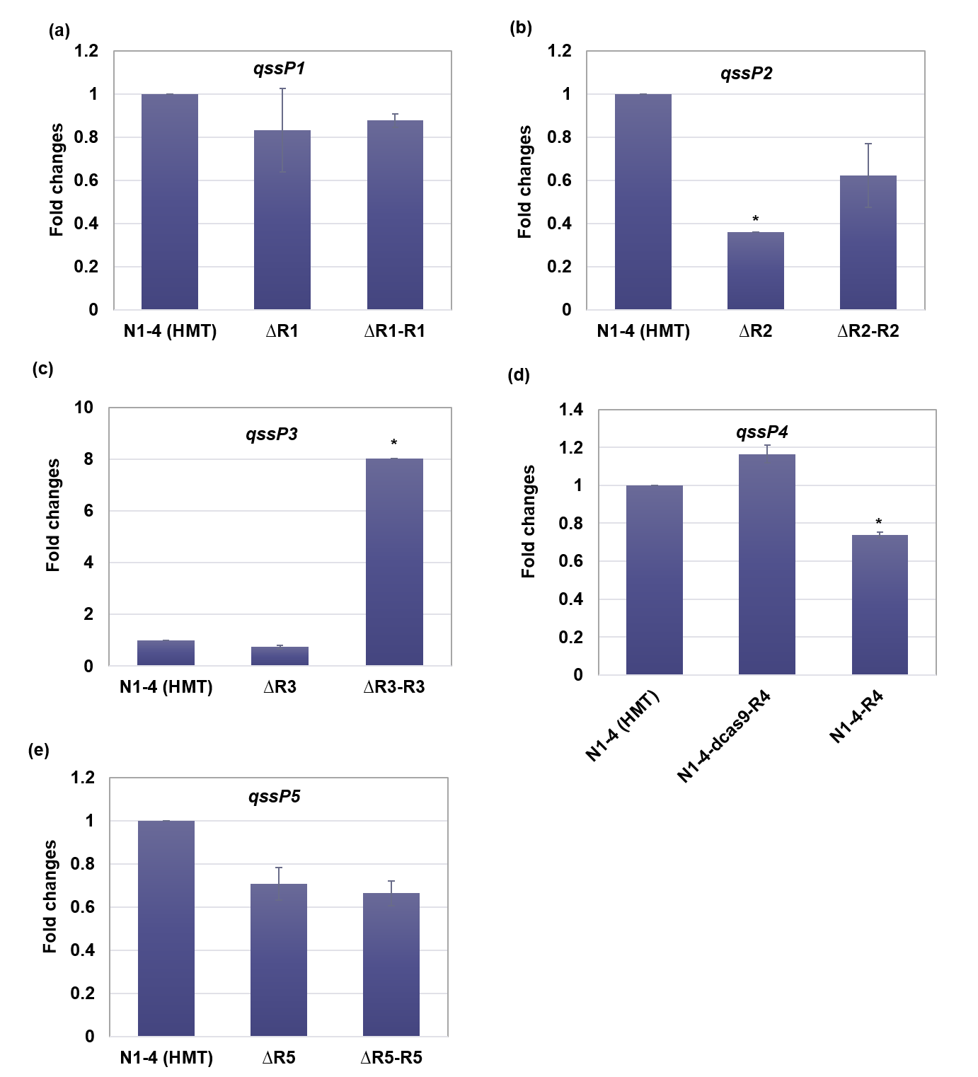

Figure S6 Transcriptional analyses of qssP1, qssP2, qssP3, qssP4 and qssP5 in wild-type N1-4 (HMT) and relevant mutant strains using qRT-PCR. The bacterial RNA was extracted from the cell culture after 12 h cultivation in TGY medium (see Materials and Methods). The reported value is mean ± SD. The asterisk indicates that the corresponding gene expression level in that particular strain was significantly different from the wild-type strain (P < 0.05).
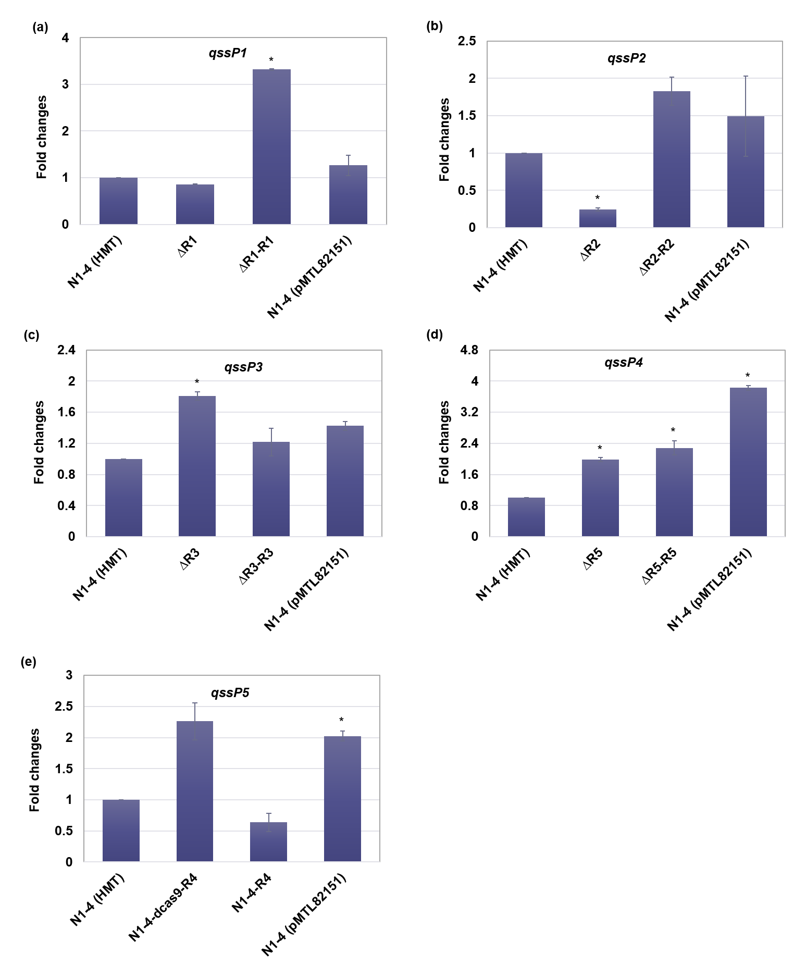
Figure S7 Transcriptional analyses of qssP1, qssP2, qssP3, qssP4 and qssP5 in wild-type N1-4 (HMT) and relevant mutant strains using qRT-PCR. The bacterial RNA was extracted from the cell culture after 24 h cultivation in PG medium (see Materials and Methods). The reported value is mean ± SD. The asterisk indicates that the corresponding gene expression level in that particular strain was significantly different from the wild-type strain (P < 0.05).
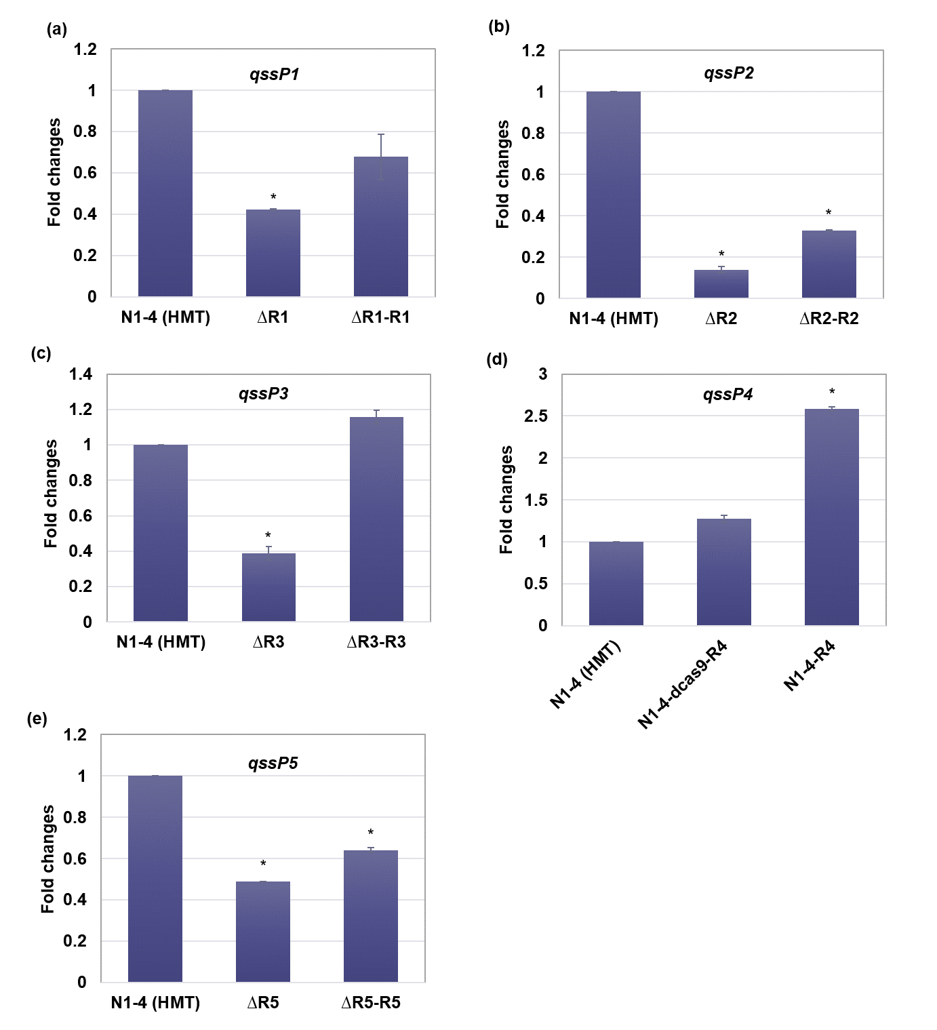
Figure S8 Transcriptional analyses of qssP1, qssP2, qssP3, qssP4 and qssP5 in wild-type N1-4 (HMT) and relevant mutant strains using qRT-PCR. The bacterial RNA was extracted from the cell culture after 24 h cultivation in P2 medium (see Materials and Methods). The reported value is mean ± SD. The asterisk indicates that the corresponding gene expression level in that particular strain was significantly different from the wild-type strain (P < 0.05).

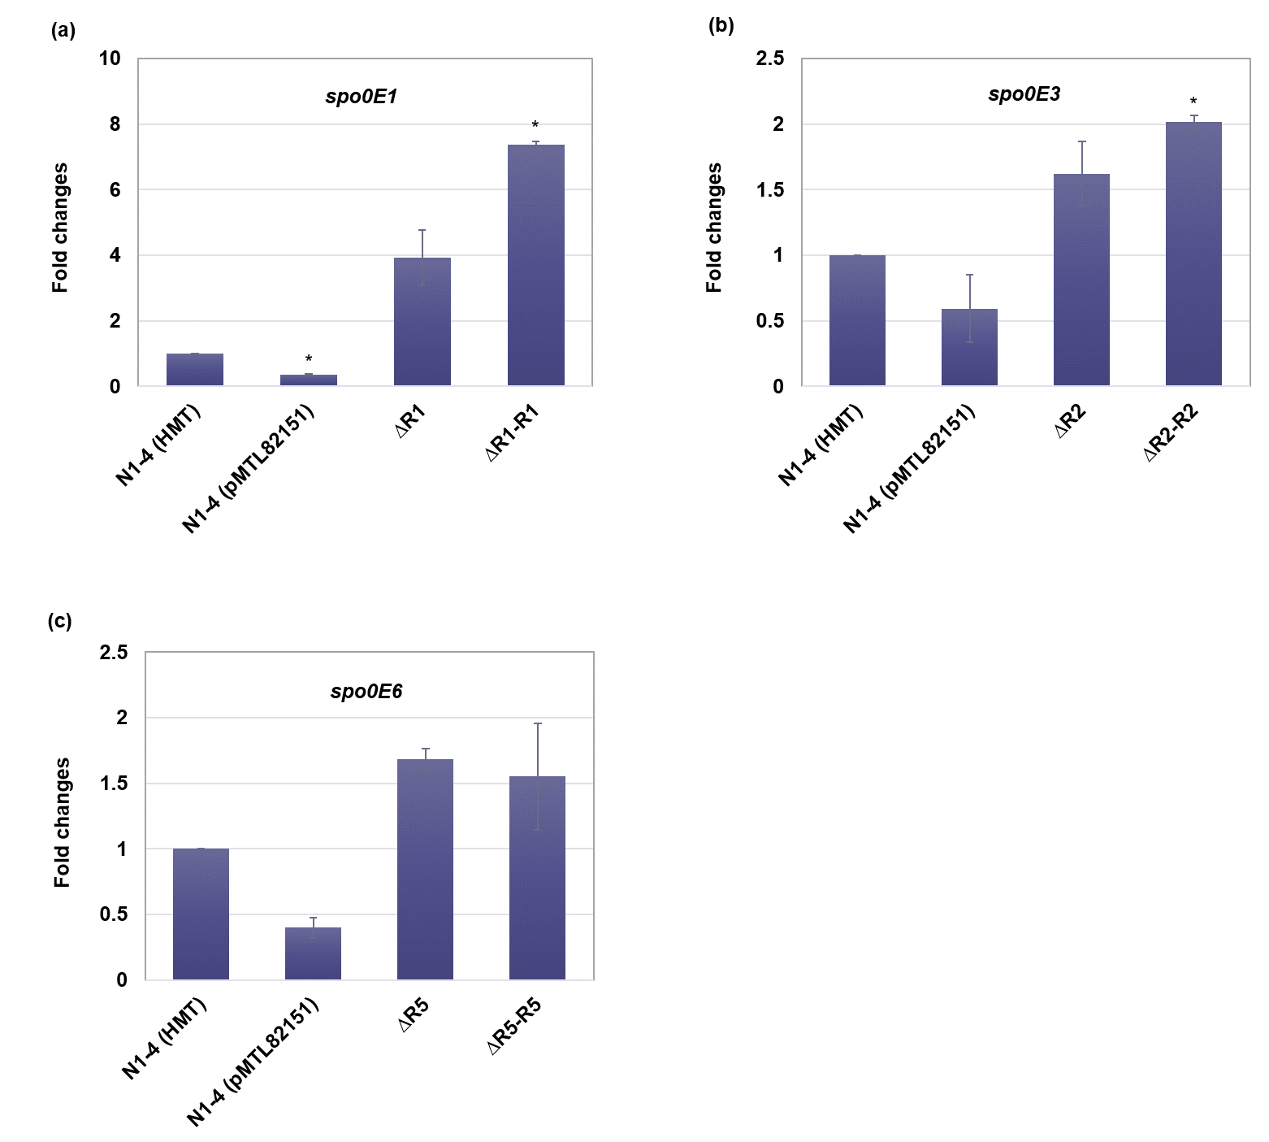
Figure S9 Transcriptional analyses of spo0E-like genes in wild-type N1-4 (HMT) and relevant mutant strains using qRT-PCR. The bacterial RNA was extracted from the cell culture after 24 h cultivation in PG medium (see Materials and Methods). The reported value is mean ± SD. The asterisk indicates that the corresponding gene expression level in that particular strain was significantly different from the wild-type strain (P < 0.05).

References:
1. Wang, Y. et al. Bacterial genome editing with CRISPR-Cas9: deletion, Integration, single nucleotide modification, and desirable “clean” mutant selection in Clostridium beijerinckii as an example. ACS synthetic biology 5, 721-732 (2016).
2. Wang, S., Dong, S., Wang, P., Tao, Y. & Wang, Y. Genome Editing in Clostridium saccharoperbutylacetonicum N1-4 with the CRISPR-Cas9 System. Applied and Environmental Microbiology 83, e00233-00217 (2017).
3. Wang, Y. et al. Gene transcription repression in Clostridium beijerinckii using CRISPR-dCas9. Biotechnology and bioengineering 113, 2739-2743 (2016).
4. Herman, N.A. et al. Development of a High-Efficiency Transformation Method and Implementation of Rational Metabolic Engineering for the Industrial Butanol Hyperproducer Clostridium saccharoperbutylacetonicum Strain N1-4. Applied and environmental microbiology 83, e02942-02916 (2017).
5. Wang, S., Dong, S. & Wang, Y. Enhancement of solvent production by overexpressing key genes of the acetone-butanol-ethanol fermentation pathway in Clostridium saccharoperbutylacetonicum N1-4. Bioresource technology 245, 426 (2017).
6. Thompson JD, Higgins DG. Gibson TJ. CLUSTAL W: improving the sensitivity of progressive multiple sequence alignment through sequence weighting, position-specific gap penalties and weight matrix choice. 1994;22:4673-4680.

