Fig S1. Photosynthesis parameters in WT and overexpression strains
- Photosynthetic productivity of the WT, PtPTP-OE1, and PtPTP-OE2, measured by O₂ evolution. (b) Their efficient quantum yield of photosystem Ⅱ, Y(Ⅱ), measured by IMAGING-PAM-M. Error bars, SD of three biological replicates.

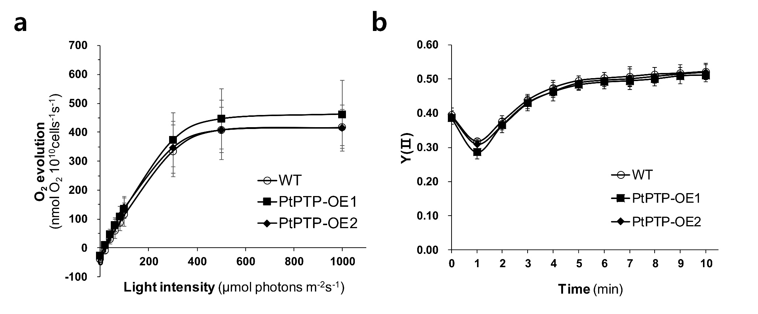
Table S1. List of primers used for genomic PCR, and quantitative real-time PCR
 | Forward primer | Reverse primer
Genomic PCR primers
Primer set for PCR of PTP  (PTP-iFw, PTP-iRv) | 5’-GCAGTCCTGTCGACCACTAC-3’ | 5′-GAAAAGGACGGTCCAGAGGG-3′
PCR of exogenous EF2::PTP  (EF2-iFw, PTP-iRv) | 5′-AAAACCCTACGGGGTGAAAGGAG-3′ | 5′-GAAAAGGACGGTCCAGAGGG-3′
ITS | 5′-TCCGTAGGTGAACCTGCGG-3′ | 5′-TCCTCCGCTTATTGATATGC-3′
Southern blot analysis
PCR primers for synthesizing probe | 5'-CGACGTGACCCTGTTCATCA-3' | 5'-TTAGTCCTGCTCCTCGGCCA-3'
Quantitative real-time PCR primers
PtPTP (pyruvate transporter-plastid type) | 5’-TGGATGGCCTTGATCGGTTC-3’ | 5’-AACGCTCGCTTGGGACTAAA-3’
Pyruvate dehydrogenase complex  (pyruvate dehydrogenase complex; subunit E1, GenBank accession no. XM_002180298) | 5'-TTGCTCCCGTGAAAATGATG-3' | 5'-GCCATGCAGGTACGTCAAAA-3'
PYC2 (pyruvate carboxylase 2, GenBank accession no. XM_002183870) | 5'-TCCAGTCCAAGCAACTCGGT-3' | 5'-TGCCAAGTCACCGACAACCT-3'
PPDK (pyruvate, phosphate dikinase, GenBank accession no. XM_002182336) | 5'-AACGTGTCAAGAAAGAGCGTGG-3' | 5'-GCAGAGTCGCTTTCCGTCTT-3'

Fig S2. Southern blot analysis of wild type (WT) and PtPTP overexpression lines (PTP-OE1 and -OE2).
Genomic DNA (5µg) was digested with EcoRⅠ. The partial DNA fragment of Sh ble was used as a probe. SM : DNA size marker.
