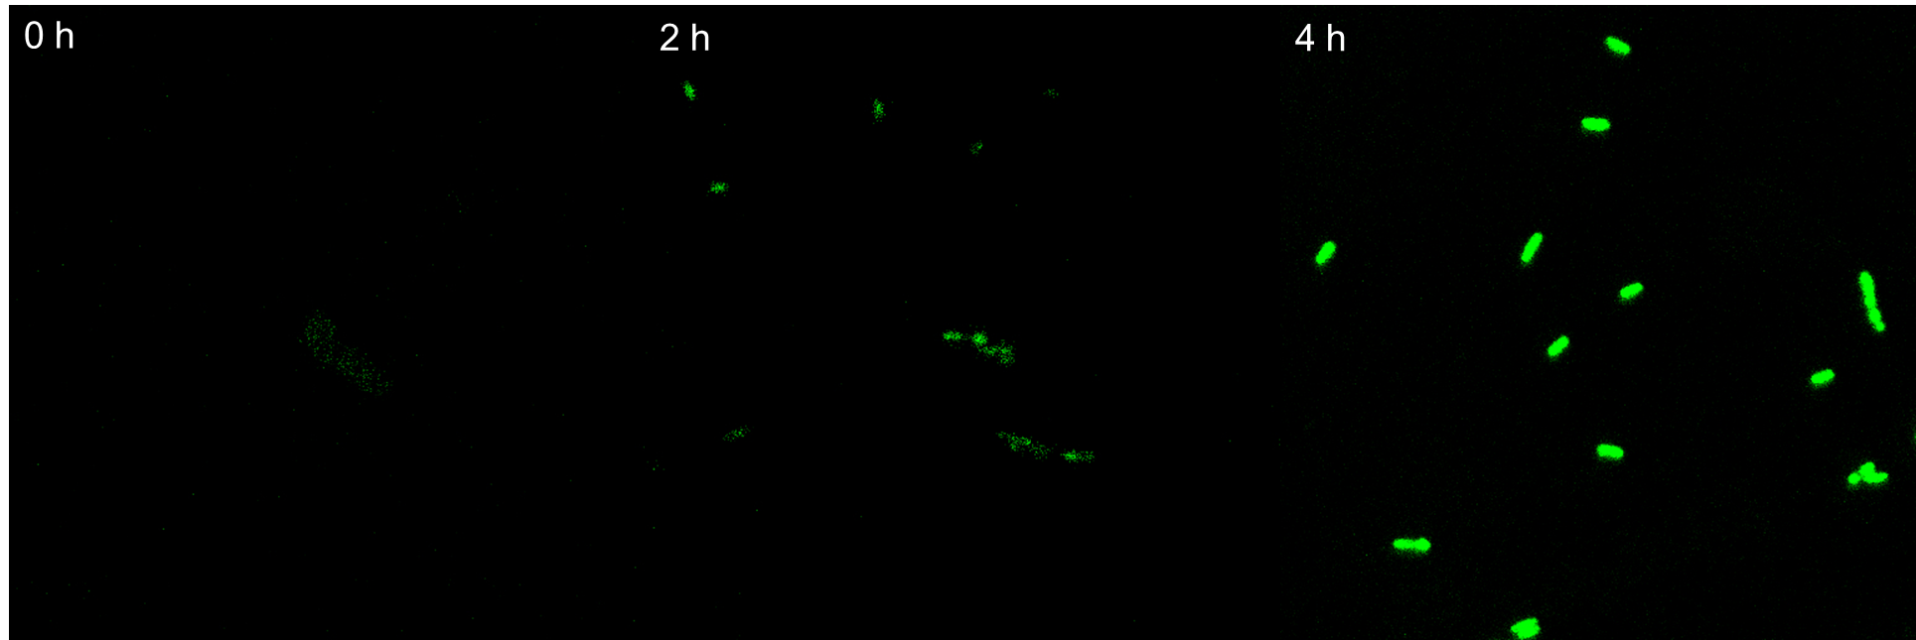

Figure S9 Confocal microscopy analysis for the localization of GFP-fused Zmo099

